**Program 13: Demonstrate abstract base class implimentation and usage.**

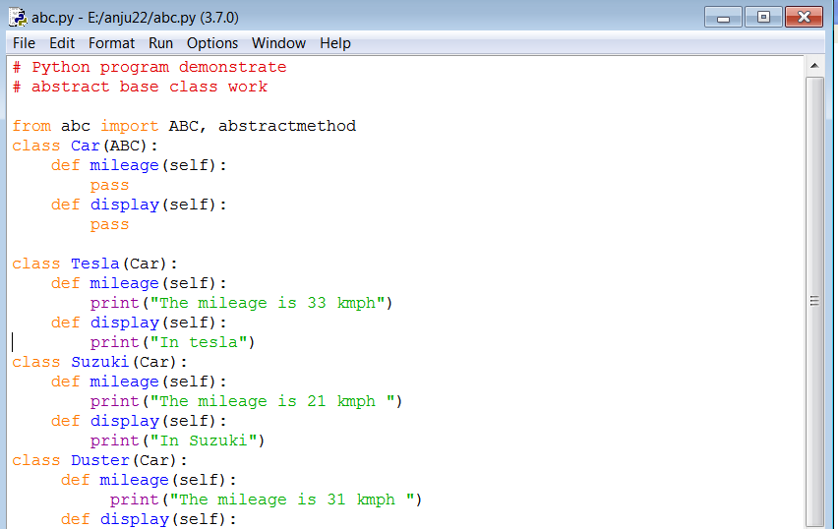

**Output:**

