DevOps – Examination Report
Version 2.0
written by
Achal Ajith
achalajithk@gmail.com
Ashok Venkatesh
ashokvenki.2000@gmail.com
Lecturer: Prof Schwarz Klaus
Course: IT Security Management and DevOps
Date: 26/02/26

1 Project Context and Objectives

1.1 Project Context
This project involved containerizing and deploying the IceCream web application using modern DevOps practices. The application is a Node.js-based web system built using Express and EJS templates, with MongoDB as the database backend.
Initially, the application ran in a local development environment. The objective was to migrate it into a containerized infrastructure using Docker and then orchestrate it using Kubernetes via Minikube.
The project demonstrates practical implementation of containerization, orchestration, load testing, observability, and fault tolerance within a cloud-native architecture.
1.2 Objectives
The objectives of this project were:
- To containerize the IceCream application using Docker.
- To configure a multi-container setup using Docker Compose.
- To deploy the application into a Kubernetes cluster using Minikube.
- To expose services using NodePort.
- To perform load testing with a minimum of 500 concurrent users.
- To monitor system resource usage using Kubernetes metrics-server.
- To validate fault tolerance through manual pod failure simulation.
- To evaluate system behaviour under high concurrency.

2 Containerization and Setup

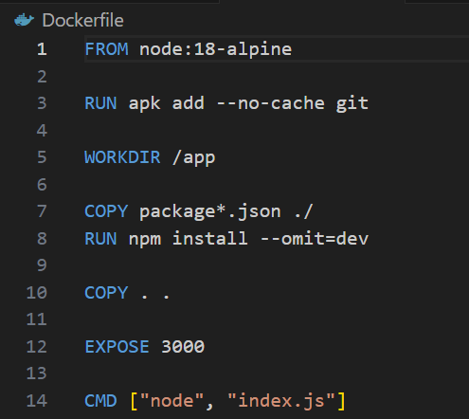
The application was containerized using a Dockerfile based on the lightweight node:18-alpine image.
The Dockerfile performs the following steps:
- Sets working directory to /app
- Copies package.json first to optimize caching
- Installs production dependencies
- Copies application source code
- Exposes port 3000
- Runs the application using node index.js

2.2 Docker Compose Configuration
Docker Compose was used to define a multi-container environment consisting of:
- IceCream application container
- MongoDB database container

The configuration ensured:
- Service dependency between application and database
- Network communication between containers
- Proper port exposure
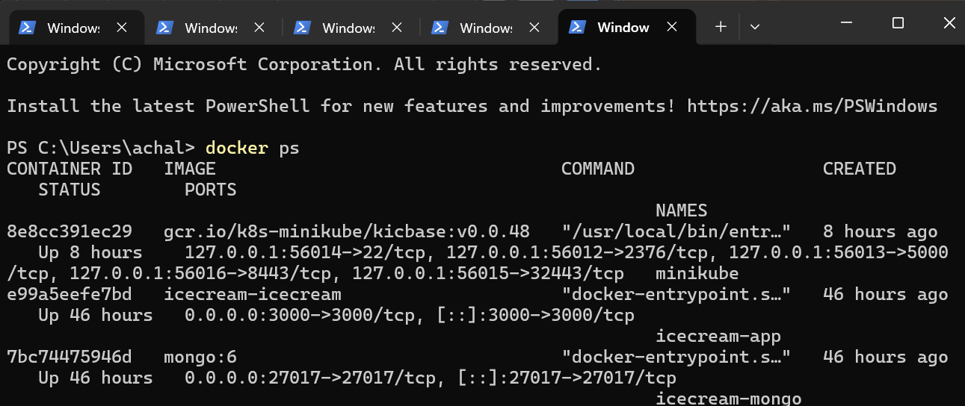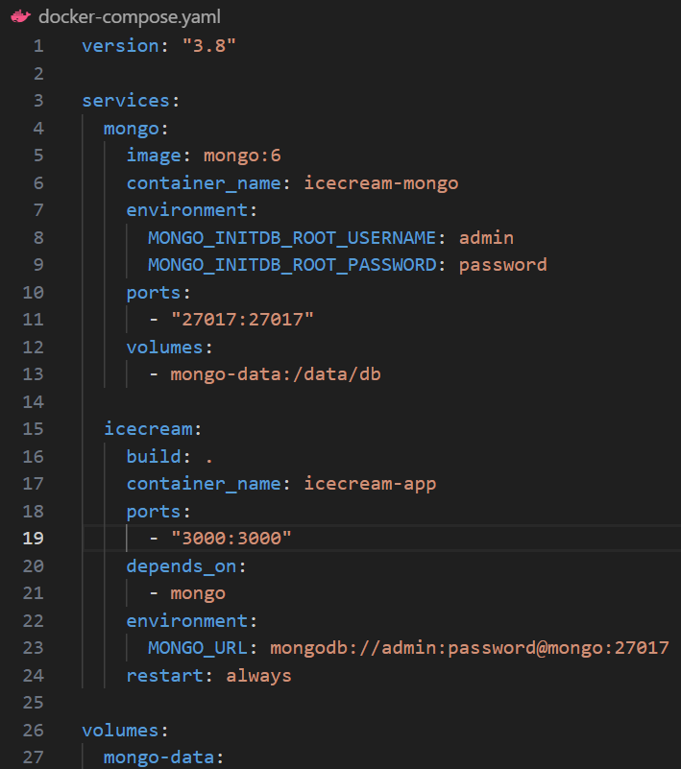
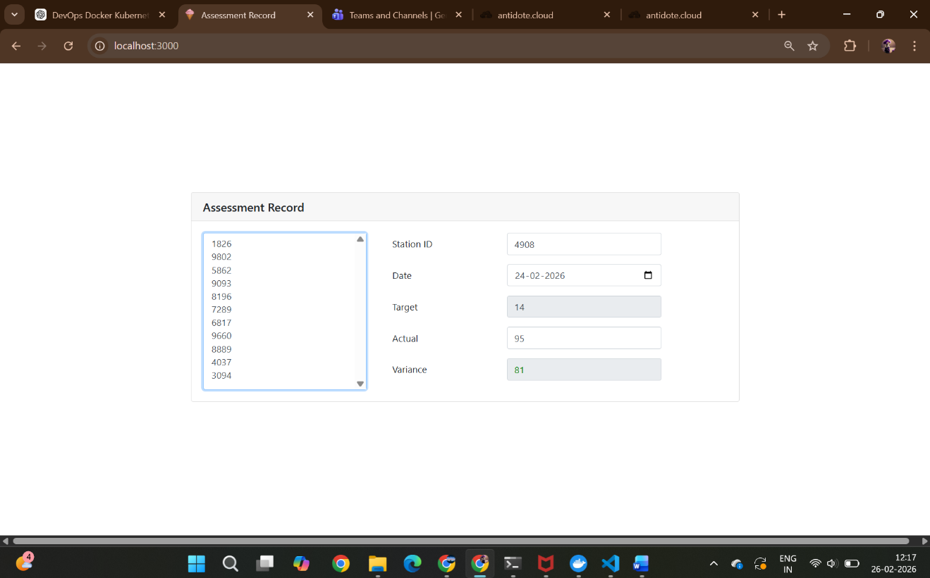

3 Kubernetes Deployment
3.1 Architecture Overview
The Kubernetes architecture consists of:
User → NodePort Service → IceCream Pods (ReplicaSet) → MongoDB Pod
The IceCream application runs with multiple replicas to ensure high availability. MongoDB is deployed as a separate pod and exposed internally within the cluster.
3.2 Deployment Configuration
The IceCream deployment was configured with:
- <2> replicas
- Container image: icecream-app
- Container port: 3000
- Label selector: app=icecream

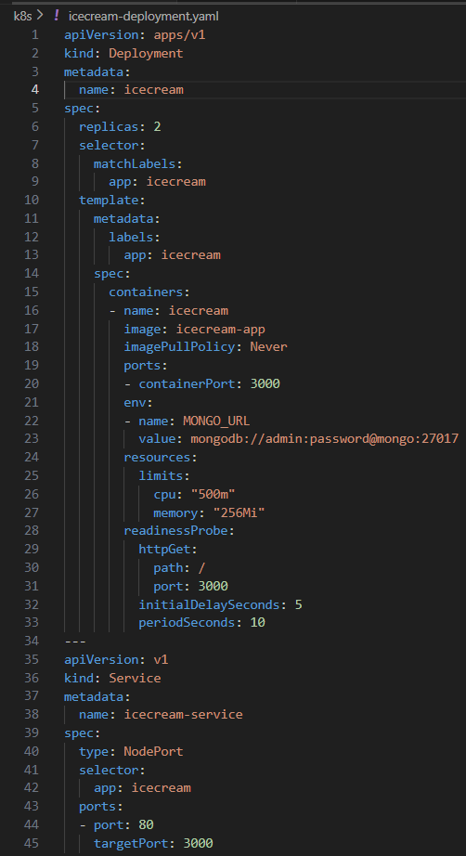

3.3 Service Configuration
The service was configured as:
- Type: NodePort
- Port: 80
- TargetPort: 3000
- Auto-assigned NodePort: <31128 >
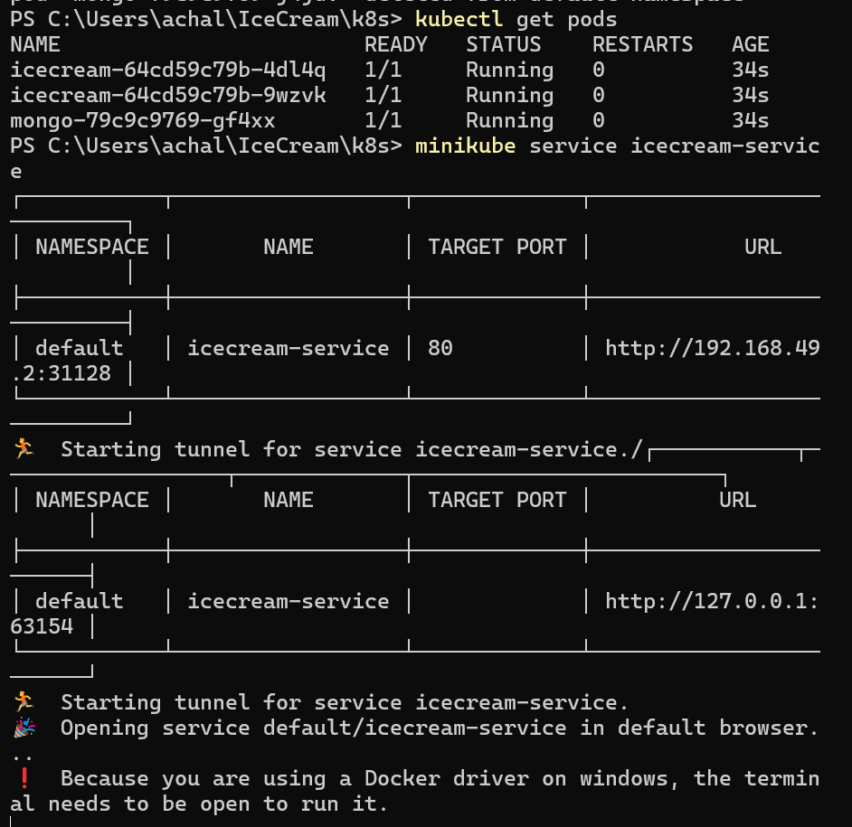
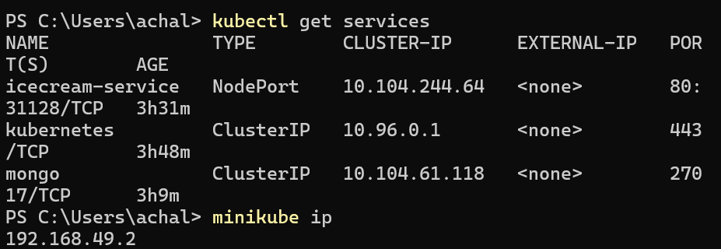

4 Functional Validation and Load Testing

4.1 Load Testing Setup
Load testing was performed using ApacheBench.
Command executed:
ab -n 30000 -c 500 http://127.0.0.1:8080/
Where:
- -n 30000 = total requests
- -c 500 = concurrent users

4.2 Load Testing Results
- Concurrency Level: 500
- Complete Requests: 30000
- Failed Requests: 0
- Requests per second: 47.07
- Average response time: 10621 ms
- Test duration: 637 seconds

The system successfully handled 500 concurrent users with zero failed requests.
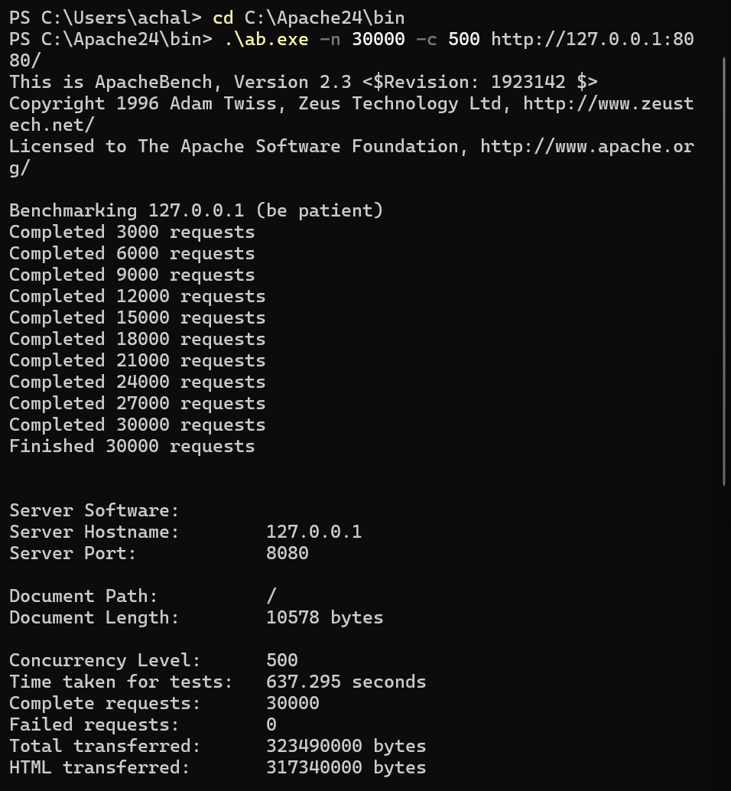
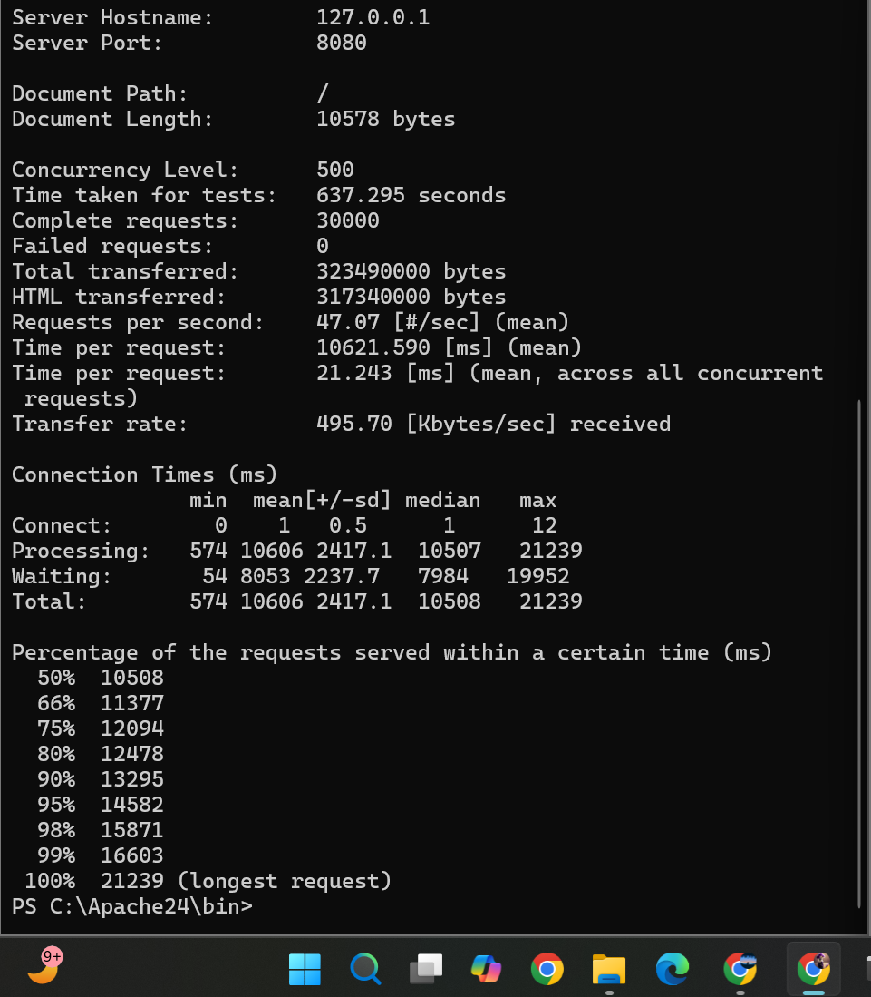

4.3 Interpretation
The system remained stable under heavy load. However, response time increased significantly under high concurrency, indicating resource saturation.
Despite performance degradation, no crashes or service interruptions occurred.

5 Observability and Fault Tolerance

5.1 Monitoring
Metrics-server was enabled using:
minikube addons enable metrics-server
Resource usage was monitored using:
kubectl top pods
Observed:
- IceCream pods: ~4–6m CPU, ~42Mi memory
- MongoDB pod: ~10m CPU, ~175Mi memory

System resources remained stable under normal load.
5.2 Fault Tolerance Validation
To test self-healing capability, one application pod was manually deleted:
kubectl delete pod icecream-64cd59c79b-9wzvk
Immediately after deletion:
- Kubernetes terminated the pod.
- A new pod was automatically created.
- The replica count remained constant.
- No downtime occurred.

This confirms Kubernetes deployment controller and ReplicaSet functionality.
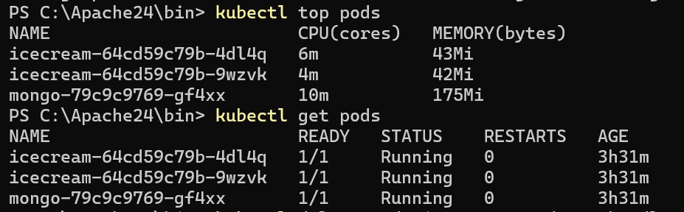
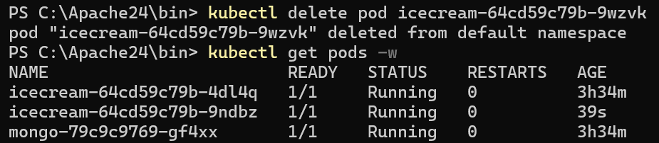

6 Reflections and Challenges

During the project, several challenges were encountered:
- Networking issues with Minikube on Windows.
- ImagePullBackOff error due to local image scope.
- Metrics-server initialization delay.
- High response time during heavy load testing.

Key learnings include:
- Importance of container image scope in Kubernetes.
- Role of ReplicaSets in maintaining availability.
- Practical impact of resource limits under concurrency.
- Benefits of observability in diagnosing system behavior.

Future improvements could include:
- Implementing Horizontal Pod Autoscaler.
- Adding resource limits to deployment.
- Configuring readiness and liveness probes.
- Introducing CI/CD automation.

7 Appendix (e.g., screenshots, configs, test results)

