Retail Company
Sales Performance & Profit Leakage Analysis
🔹 Executive Summary: A retail company selling furniture, office supplies, and technology products is experiencing strong sales growth, but overall profitability has not increased proportionally.
Analysis of sales and profit data shows that profit leakage is mainly driven by:
- High discounts on low-margin products
- Certain products and categories generating losses
- Regional and customer-segment inefficiencies
- Operational factors such as longer shipping times
By implementing the recommended strategies—controlling discounts, prioritizing high-margin products, improving regional performance, and monitoring profitability through dashboards—the company can potentially increase profit margins by 5–8% while maintaining sales growth.

🔹 Data & Tools Used:
- Power BI: Used to build interactive dashboards for analyzing sales performance, profit leakage, discounts, regional performance, and product-level insights.
- Python (Data Analysis & Machine Learning): Used for data cleaning, exploratory analysis, and building basic machine learning models to identify patterns related to profit leakage, discount impact, and profitability drivers.
- SQLite: Used to store and query structured sales data efficiently for analysis. and connect to Power BI
- Microsoft Excel: Used for initial data validation, summary checks, and quick calculations.
- Machine Learning (ML) – to predict products or regions likely to cause profit leakage

🔹 Business Problem:
The company is selling many products, but overall profitability is not improving. Even with strong sales, some products, regions, and customer segments are generating losses. This project aims to identify the sources of profit leakage, including high discounts, low-margin products, and returns, and provide clear, data-driven recommendations to improve profitability.

🔹 Business Goals:
- Increase overall profitability
- Reduce unnecessary and excessive discounts
- Identify loss-making products, categories, and regions
- Support data-driven decision-making for pricing and sales strategy
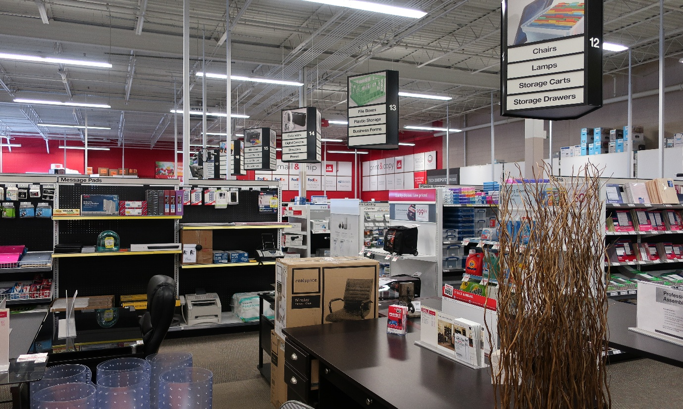
🔹 Business Questions:
The analysis is designed to answer the following questions:
- Which products and Sub-categories are generating high sales but low or negative profit?
- How are discounts impacting profitability?
- Which regions or cities have strong sales but low profit contribution?
- Which customer segments generate sales but contribute to losses?
- Which categories or sub-categories should the company focus on or reduce exposure to?
- Does shipping time affect profit margins?

🔹 Assumptions:
To make the analysis practical, the following assumptions were made:
- All sales and profit figures are accurate as recorded in the dataset.
- Discounts directly affect profit margins, and other costs are assumed constant.
- Shipping time is approximated as the difference between order date and ship date.
- Customer segments are categorized correctly in the dataset.
- Returns and other operational costs are reflected in the profit values provided.

🔹 Power BI Dashboard Overview
The Power BI dashboard provides an interactive view of sales performance and profitability across products, customer segments, and regions. It allows stakeholders to monitor key business metrics, explore trends using filters, and quickly identify areas of profit leakage.
The dashboard is designed to support data-driven decision-making by enabling users to drill down into performance by region, category, customer segment, and discount level.
Top KPIs:
- Total Sales: 2.30M
- Total Profit: 286.41K
- Loss Orders: 2K
- Average Profit Margin: 12.47%
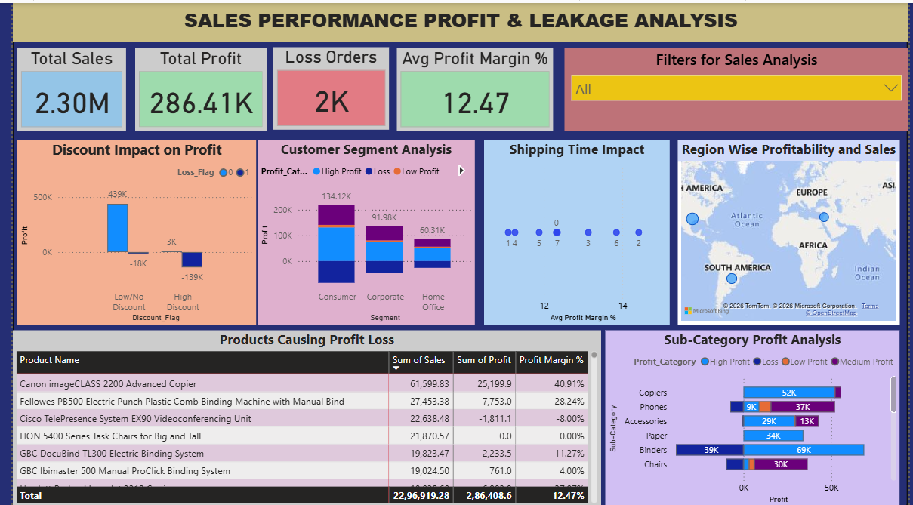

🔹 Key Insights
- Discount Impact on Profit
- High-discount orders caused a $139K loss, while low/no discount orders generated $439K profit.
- Customer Segment Performance
- Consumer segment generated $134K profit, Corporate $92K, and Home Office $60K.
- Some segments contribute to losses despite generating sales.
- Shipping Time Impact
- Longer shipping times may slightly reduce profit margins.
- Regional Profitability
- West: $725K sales, $108K profit (~14.9% margin)
- Central: $501K sales, $40K profit (~7.9% margin)
- South: $392K sales, $47K profit (~11.9% margin)
- Some regions have high sales but lower profitability.
- Product & Sub-Category Performance
- Cisco TelePresence System → -8% margin
- Binders → $39K loss
- Canon imageCLASS 2200 Copier → 41% margin
- Certain products and sub-categories are causing profit leakage.
- Overall Profit Pattern
- Total Sales: $2.3M, Total Profit: $286K, Average Profit Margin: 12.5%
- Profit is not proportional to sales; some high-selling areas/products lose money.

🔹 Recommendations
- Control Discounts
Limit excessive discounts on low-margin products to protect profitability.
- Customer Segment Strategy
Focus on high-margin segments and review discount strategy for low-margin segments.
- Shipping Efficiency
Optimize shipping processes to reduce delays and maintain profit margins.
- Regional Strategy
Adjust pricing, discount policies, and operations in loss-making regions to improve profitability.
- Product & Sub-Category Focus
Prioritize high-margin products; review pricing, discounts, and promotions for underperforming products/sub-categories.
- Profit Monitoring
Use dashboards to track sales vs. profit regularly to prevent future profit leakage.

🔹 Conclusion
This analysis shows that strong sales alone do not guarantee profitability. While the company generated $2.3M in total sales, profit was limited to $286K, indicating clear areas of profit leakage. Excessive discounting, low-margin products, and regional inefficiencies were the primary factors impacting profitability.
The Power BI dashboard and supporting analysis helped identify loss-making products, sub-categories, customer segments, and regions, while also highlighting areas that consistently generate healthy margins. In particular, high discounts resulted in significant losses, certain products and sub-categories negatively impacted profit, and some regions delivered high sales but lower profitability.
By implementing the recommended actions—such as optimizing discount strategies, prioritizing high-margin products and customer segments, improving shipping efficiency, and applying region-specific pricing strategies—the company can improve overall profit margins and support more data-driven decision-making.
This project demonstrates how combining structured data analysis with interactive dashboards enables stakeholders to quickly identify risks, uncover opportunities, and take targeted actions to improve business performance.

