Name: Hunter Hawkins Mark _____________________/50

## Brief introduction __/3

My feature in our teams’ game is all the interactable objects. This includes grabbing items such as batteries for the flashlight, the flashlight itself, batteries to power sections of the space station, throwing objects, etc…

## Use case diagram with scenario __14

### Use Case Diagram(s):

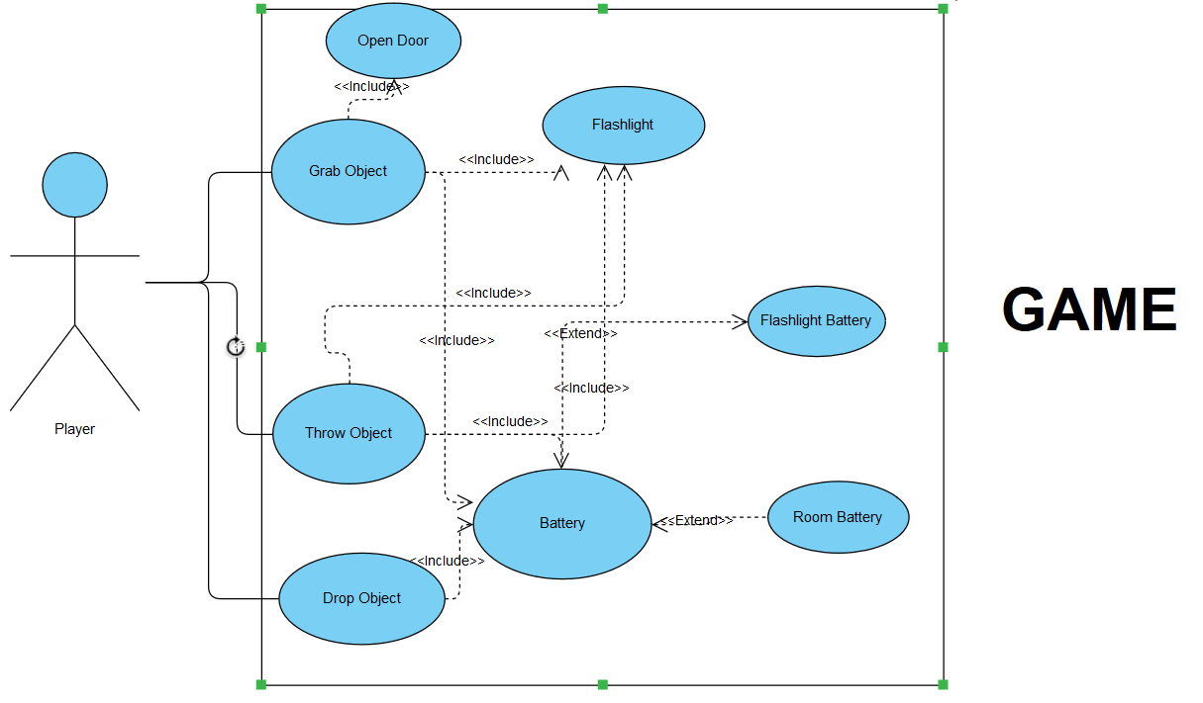

### Scenarios

**Name:** Grab/ Drop/ Throw objects

**Summary:** The player has the capability to grab objects, drop objects, and throw objects.

**Actors:** Player

**Preconditions:** Objects have been created and found

**Basic sequence:**

**Step 1:** Player has found a created object

**Step 2:** Player picks up the object

**Step 3:** Player can now drop object into desired spot, or to clear inventory space

**Step 4:** Player can now throw object

**Exceptions:**

**Step 1:** Player tries to drop or throw an object they don’t have

**Step 2:** Player tries to pick up object when there is nothing there

**Post conditions:** successfully interact with game object(s)

**Priority:** 2

**ID:** C01

**Name:** Open Door

**Summary:** The player has the capability to grab the doors and open the corresponding doors.

**Actors:** Player

**Preconditions:** Doors are interactable and found

**Basic sequence:**

**Step 1:** Player has found a door

**Step 2:** Player grabs the door

**Step 3:** Player can then open the door

**Exceptions:**

**Step 1:** Player tries to open a non interactable door

**Post conditions:** successfully open a door

**Priority:** 1

**ID:** C02

*The priorities are 1 = must have, 2 = essential, 3 = nice to have.

## Data Flow diagram(s) from Level 0 to process description for your feature _______14

### Data Flow Diagrams

My Feature in the design of the game is the Environment and its interactions.

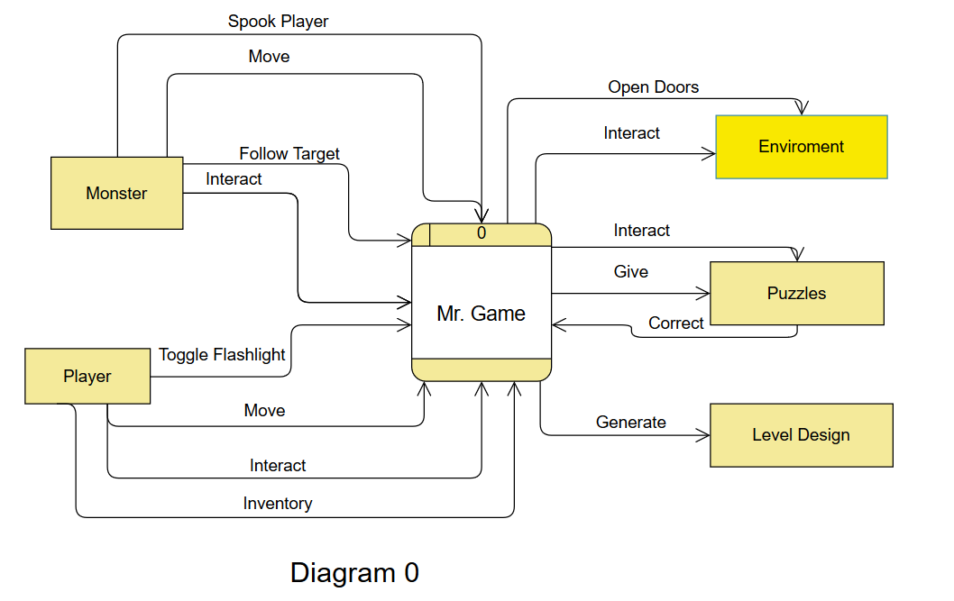

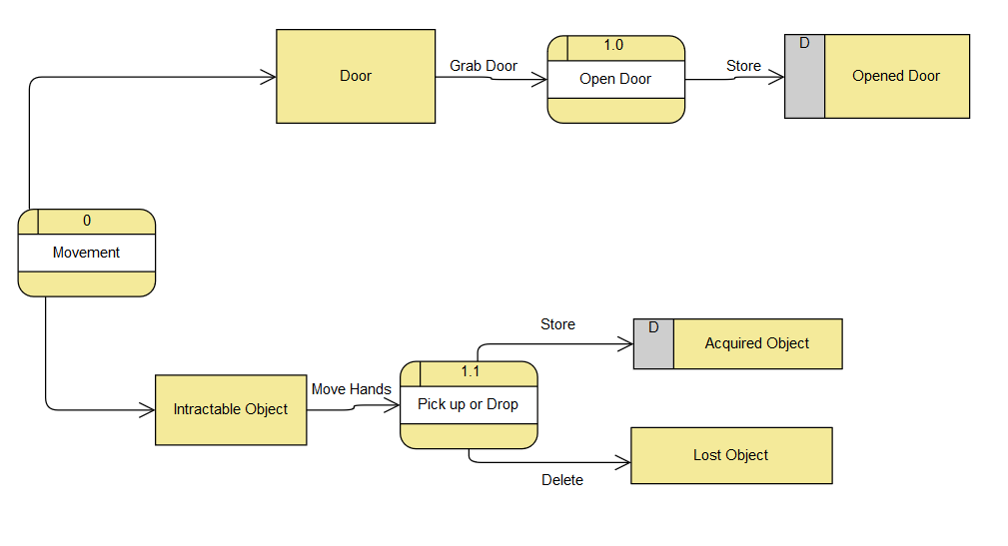

### Process Descriptions

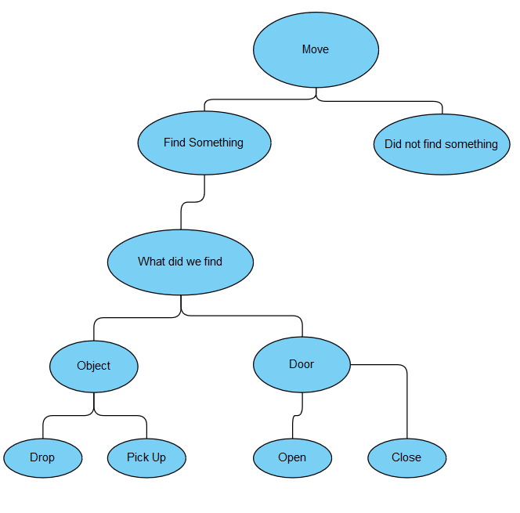

## Acceptance Tests ________9

[Describe the inputs and outputs of the tests you will run. Ensure you cover all the boundary cases.]

* Input: Player attempts to continuously open or close doors
  + Output: Player should be able to continuously open or close the door
* Input: Player attempts to pick up an object that is non interactable
  + Output: Player cannot interact with the non-interactable object
* Input: Player tries to drop object despite having nothing in their inventory
  + Output: Player is unable to drop anything
* Input: Player tries to insert room battery into flashlight
  + Output: Player cannot insert room battery into flashlight
* Input: Player tries to insert flashlight battery into room battery compartment
  + Output: Player cannot stick flashlight battery into room battery compartment

We must then take the results and negotiate them to determine their acceptability. If acceptable tests are completed, if not repeat.

## Timeline _________/10

[Figure out the tasks required to complete your feature]

Example:

### Work items

|  |  |  |
| --- | --- | --- |
| Task | Duration (PWks) | Predecessor Task(s) |
| 1. Team and I decide on a team name, name of our game, our overall game design, and our individual features. | 4 | - |
| 2. Research individual features and assets | 1 | - |
| 3. Find available assets and share them with team | 1 | 2 |
| 4. Program the functionality and share the code | 4 | 3 |
| 5. Test the functionality and interactions | 2 | 4 |
| 6. Repeat tasks #4 and #5 if tests fail | 1 | 3 |
| 7. Document code | 1 | 5 |
| 8. Installation | 1 | 7 |

**Gannt Timeline**

Black = Completed

Yellow = In progress

Red = Planned

I have a total of 57 hours of work planned with 14 hours completed.

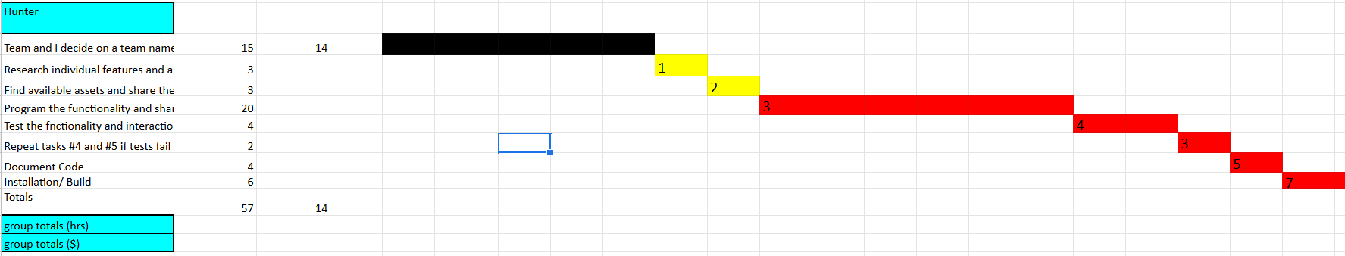

**Pert Diagram:**

