QUESTİON 7

Write a program that allows a user to enter a string containing a day of the week (“Sunday,” “Monday,” “Tuesday,” etc.) and uses a switch construct to convert the day to its corresponding number, where Sunday is considered the first day of the week and Saturday is considered the last day of the week. Print out the resulting day number. Also, be sure to handle the case of an illegal day name! (Note: Be sure to use the 's' option on function input so that the input is treated as a string.)

QUESTİON 8

Suppose that a student has the option of enrolling for a single elective during a term. The student must select a course from a limited list of options: “English,” “History,” “Astronomy,” or “Literature.” Construct a fragment of MATLAB code that will prompt the student for his or her choice, read in the choice, and use the answer as the case expression for a switch construct. Be sure to include a default case to handle invalid inputs.

QUESTİON 9

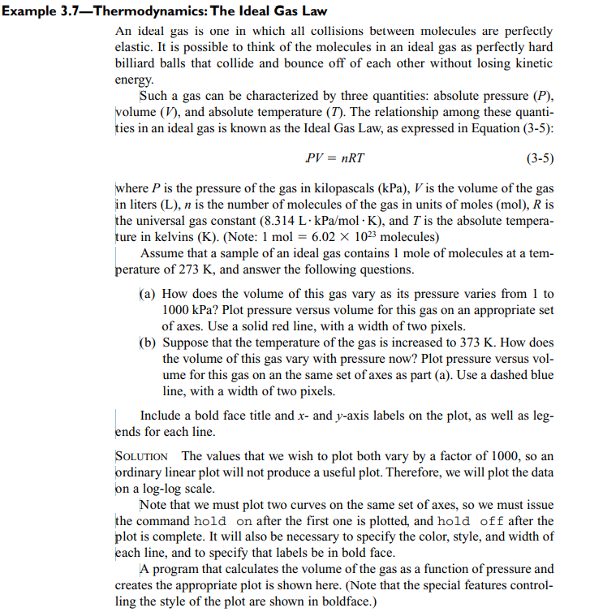

QUESTİON 10

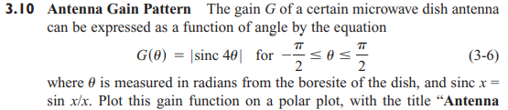

QUESTİON 11

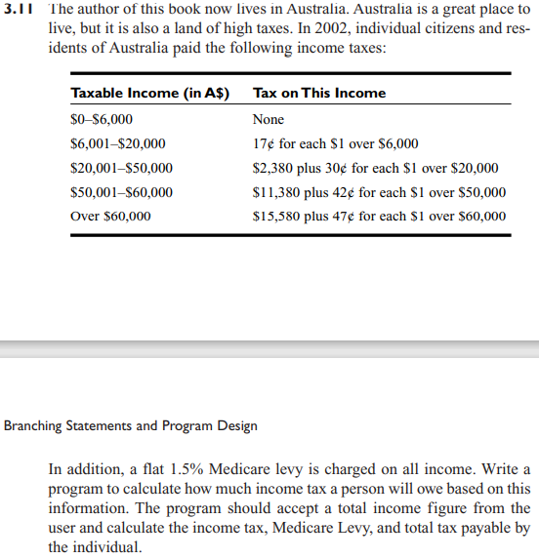

QUESTİON 12

