Maximin

#include <stdio.h>

#include <stdlib.h>

#include<time.h>

void maxmin(int n,int a[20])

{

int max,min,i;

max=a[0];

min=a[0];

for(i=0;i<n;i++)

{

if(a[i]>max)

{

max=a[i];

}

}

printf("maximum is %d\n",max);

for(i=0;i<n;i++)

{

if(a[i]<min)

{

min=a[i];

}

}

printf("minimun is %d\n",min);

}

int main()

{

clock_t start,end;

double timespent;

int n,a[20];

printf("enter the number\n");

scanf("%d",&n);

printf("Enter the array\n");

for(int i=0;i<n;i++)

{

scanf("%d",&a[i]);

}

start=clock();

maxmin(n,a);

end=clock();

timespent=(double)(end-start)/CLOCKS_PER_SEC;

printf("time spent%f\n",timespent);

return 0;

}

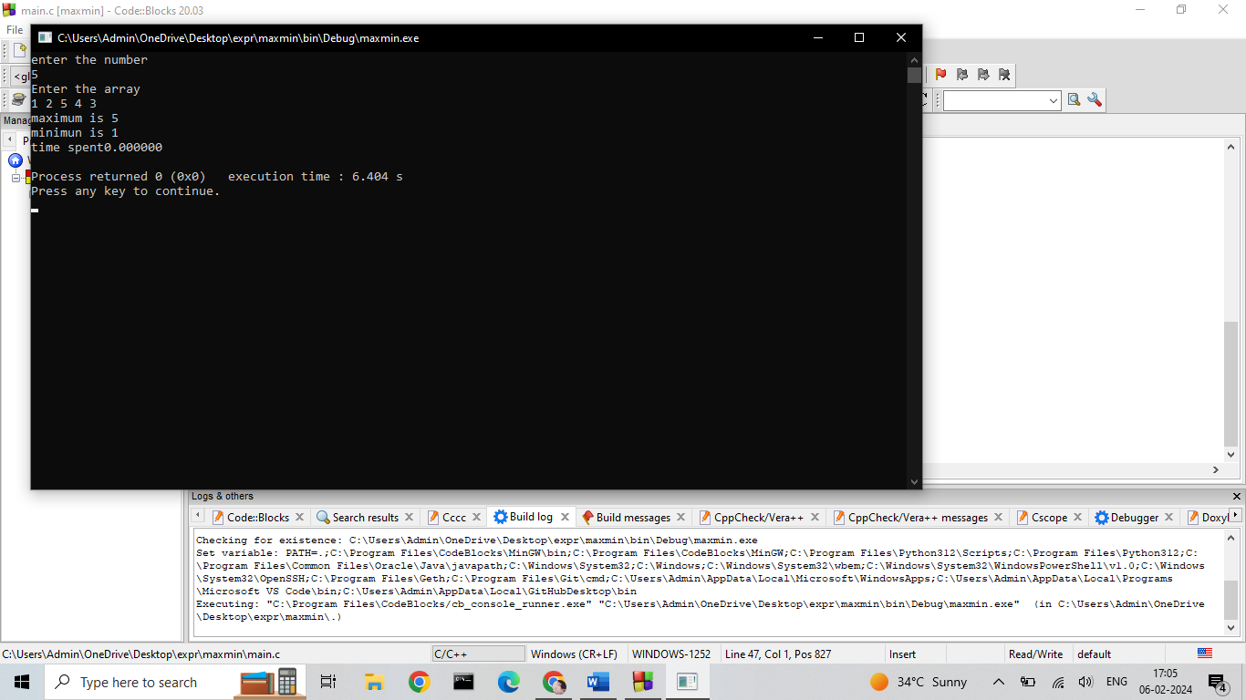

Sum of natural numbers





#include <stdio.h>

#include <stdlib.h>

#include<time.h>

int sum(int n)

{

int sum=0;

for(int i=0;i<=n;i++)

{

sum=sum+i;

}

return sum;

}

int main()

{

int n,sumN;

clock_t start,end;

double timespent;

printf("Enter the number\n");

scanf("%d",&n);

start=clock();

sumN=sum(n);

printf("the natura numers are %d\n",sumN);

end=clock();

timespent=(double)(end-start)/CLOCKS_PER_SEC;

printf("time spent:%f\n",timespent);

return 0;

}

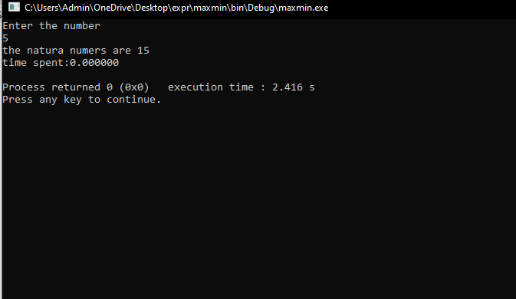

Matrix multiplication



#include <stdio.h>

#include <stdlib.h>

#include<time.h>

void matrixmul(int n,int a[10][10],int b[10][10])

{

int c[10][10];

for(int i=0;i<n;i++)

{

for(int j=0;j<n;j++)

{

c[i][j]=0;

for(int k=0;k<n;k++)

{

c[i][j]=c[i][j]+(a[i][k]*b[k][j]);

}

}

}

for(int i=0;i<n;i++)

{

for(int j=0;j<n;j++)

{

printf("%d\n",c[i][j]);

}

}

}

int main()

{

int a[10][10],b[10][10],c[10][10],n;

printf("enter the number\n");

scanf("%d\n",&n);

printf("enter the matrix A\n");

for(int i=0;i<n;i++)

{

for(int j=0;j<n;i++)

{

scanf("%d",&a[i][j]);

}

}

printf("enter the matrix B\n");

for(int i=0;i<n;i++)

{

for(int j=0;j<n;i++)

{

scanf("%d",&b[i][j]);

}

}

matrixmul(n,a,b);

return 0;

}

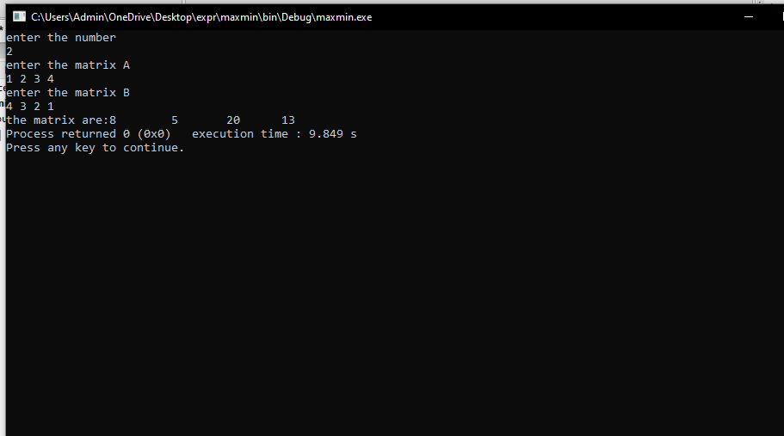

Sequential search



#include <stdio.h>

#include <stdlib.h>

void seqen(int n,int key,int a[300])

{

for(int i=0;i<n;i++)

{

if(a[i]==key)

{

printf("the key is found\n");

exit(0);

}

}

printf("the key is not found\n");

}

int main()

{

int n,key,a[300];

printf("Enter the number of elements\n");

scanf("%d",&n);

printf("Enter the elements\n");

for(int i=0;i<n;i++)

{

scanf("%d",&a[i]);

}

printf("Enter the key to be found\n");

scanf("%d",&key);

seqen(n,key,a);

return 0;

}

