

**AUTONOMOUS GUIDED VEHICLE (INDOOR)**

**Abstract**

Continuous supply of tools and components are an essential aspect of any manufacturing plant for smooth production. Supply quantity and timings needs to be precise to keep assembly lines clutter free. This makes it extremely important for the plant operations team to ensure proper availability of such materials at all stations within manufacturing plant at all times. Delivering of tools and components to each and every station involves challenge of maneuvering in risky areas cluttered with heavy machinery with numerous moving parts. It becomes challenge to operate this manually.

Thus various line following robots are currently used which are programmed to follow a predefined set of paths between various stations. Although line following robot de-risks logistics operations within warehouse to quite some extent but they bring their own set of challenges. Line adherence limits the capability of robots to navigate to new areas without any infrastructural change. They also can’t bypass any obstacle on their way thus involving additional manual efforts to keep their pathway free.

This project involves in removing dependency of robots on any sort of fixed route guidance system and making them autonomous so as to navigate to various stations on assembly lines without sticking to any fixed paths. This project involves exploring low cost sensors with state of the art algorithms and techniques to localize within warehouse, planning a path to any desired station and navigating in a controlled manner. This project brings in amalgamation of robotics, mathematical modeling and machine learning to achieve precision in indoor autonomous navigation.

**Table of Content (Kapil)**

**Problem Statement (Rohit)**

**Solution Introduction**

Autonomous indoor navigation system involves usage of sensors and techniques to achieve Localization, Path planning and Motion Control.

**Localization**

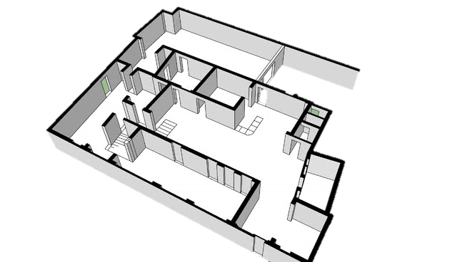

Localization is the process of identifying vehicles position involving x, y co-ordinates, orientation and other motion parameters on a given map.

**Path Planning**



Path planning involves determining an obstacle free and optimal path from current position of vehicle to a given goal.

**Motion Control**



Motion control drives vehicle to goal position by adhering to path planned while keeping all vehicle and path constraints in consideration.

Together these modules along with sensory inputs gives capability to a vehicle to navigate autonomously with in an indoor eco-system.

**AGV Architecture**

**Hardware landscape (Arvind)**

* Motors:
* Arduino Uno based controller board
* Raspberry Pi 3
* Wheel Encoders
* IMU
* RP Lidar
* Wi-Fi modules

**Software pipeline (Kapil /Sree)**

**Arch diag.**

**[NOTE: Add diagrams and mathematical models where ever necessary]**

**Localization (Kapil)**

**Vehicle model (including trolley) (Surbhi)**

**Path Planning (Kiran)**

**Controller (Sree)**

**Motion Control (Carola/Mohan)**

**Environment Setup (Kapil/Sree)**

**Challenges & solutions (Everyone)**

**References (Everyone)**