**“Government Schemes Management System”**

**Phase 4: Process Automation (Admin)**

**Validation Rules**

**Goal:** Ensure data integrity and prevent invalid entries in Scheme Applications.

**Rules Created:**

1. **Requested_Amount_Validation**
   * **Object:** Scheme Application
   * **Field:** Requested Amount
   * **Formula:** Prevents Requested Amount from exceeding Approved Amount.
   * **Error Message:** "Requested Amount cannot be greater than Approved Amount."
   * **Active:** Yes
2. **Submission_Date_Validation**
   * **Object:** Scheme Application
   * **Field:** Submission Date
   * **Formula:** Prevents users from entering a future date.
   * **Error Message:** "Submission Date cannot be in the future."
   * **Active:** Yes

**Impact:**

* Prevents invalid amounts or future submission dates.
* Improves data accuracy and reporting reliability.

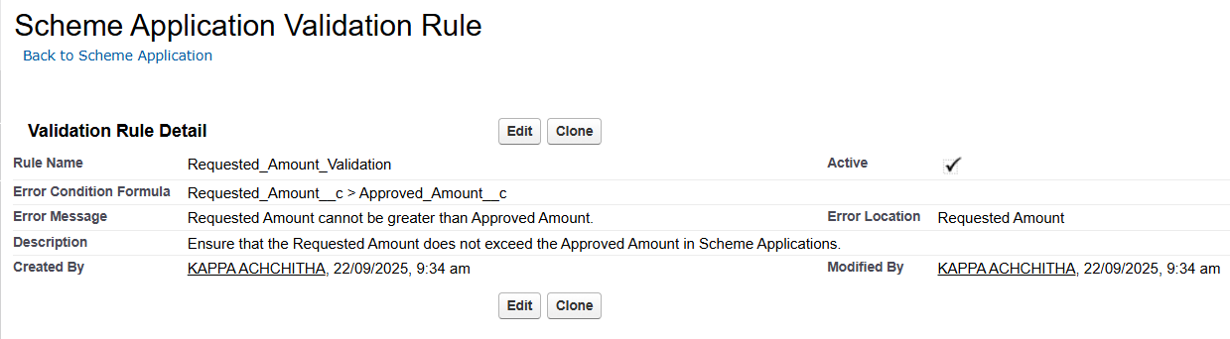

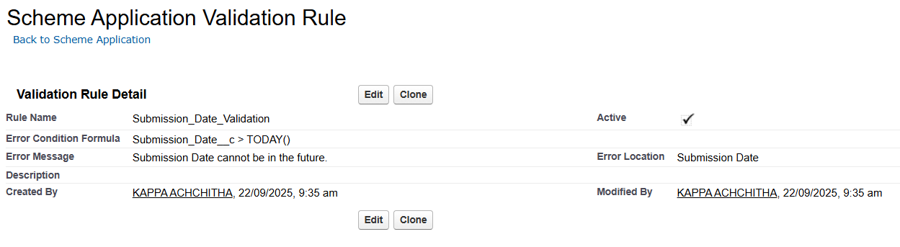

**Workflow Rules / Field Updates**

**Goal:** Automate key field updates and notifications.

**Workflow Rules Implemented:**

1. **Auto Email on Submitted**
   * **Object:** Scheme Application
   * **Action:** Sends email to Officer when a new Scheme Application is submitted.
   * **Active:** Yes
2. **Set_Stage_In_Review**
   * **Object:** Scheme Application
   * **Action:** Updates Stage__c to "In Review" when Status = Submitted.
   * **Active:** Yes

**Impact:**

* Officers automatically receive emails for new applications.
* Submitted applications are clearly marked as "In Review".

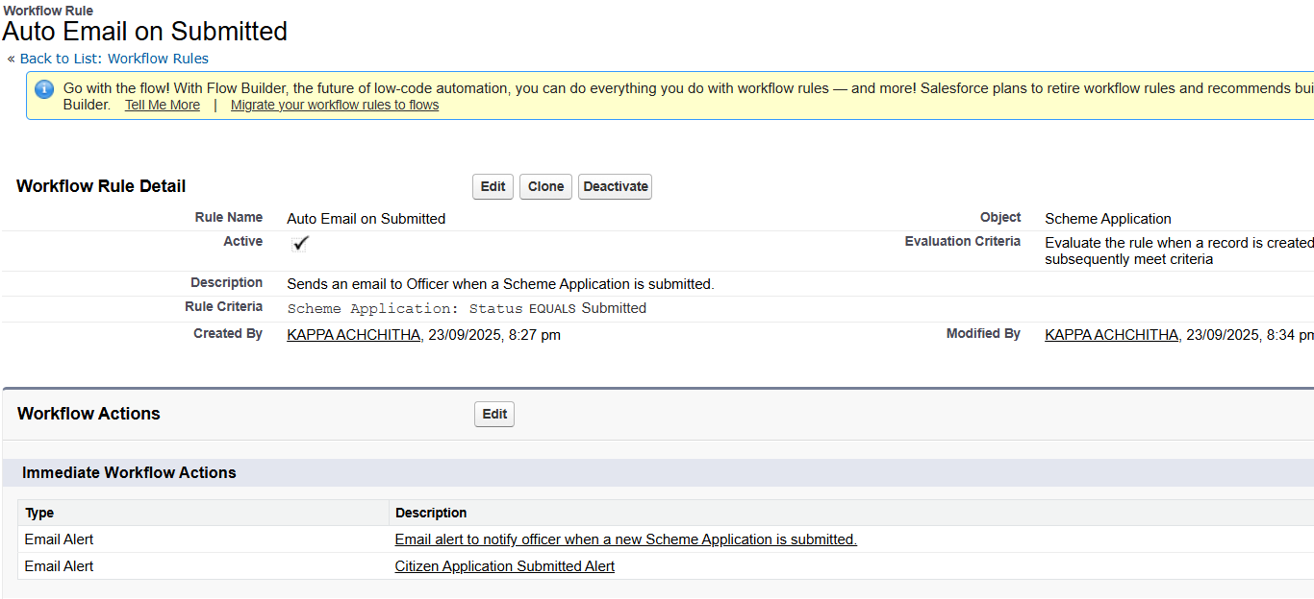

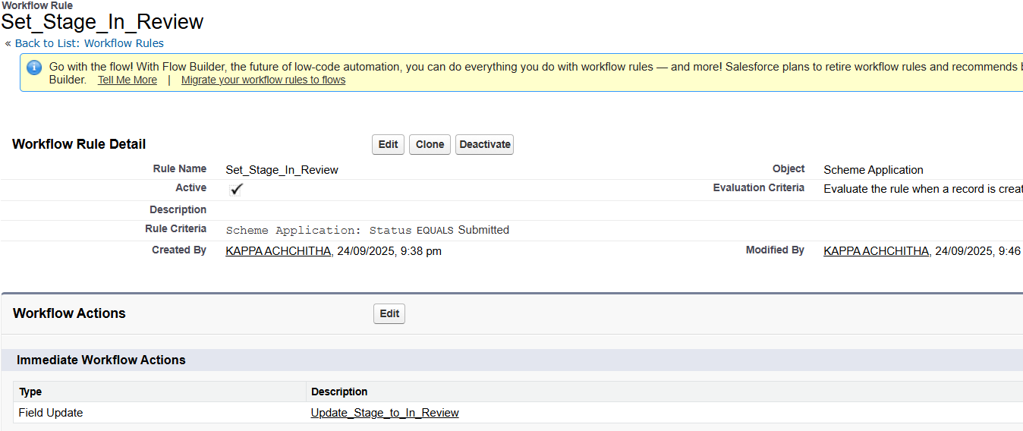

**Record-Triggered Flow: Scheme Application – All Branches**

**Goal:** Automate notifications, task creation, and logging for all submitted scheme applications.

**Flow Logic:**

1. **Trigger:**
   * Object: Scheme Application
   * Trigger: When a record is created or updated
   * Entry Condition: Status = Submitted
2. **Decision Element:** **Scheme Type → Branch Selection**
   * Determines the branch of the submitted application (e.g., Health, Education, Welfare, etc.)
   * Directs flow actions based on the branch type
3. **Actions (Common for all branches):**
   * **Send Citizen Email:** Sends an email notification to the citizen acknowledging submission of their application.
   * **Create Task for Officer:** Automatically creates a task for the assigned officer to review the application.
4. **End:**
   * Flow ends after executing all actions for the specific branch.

**Impact:**

* Ensures timely assignment of tasks to officers for all scheme applications.
* Keeps citizens informed with automated emails and notifications.
* Standardizes application handling across all branches, improving efficiency and accountability.

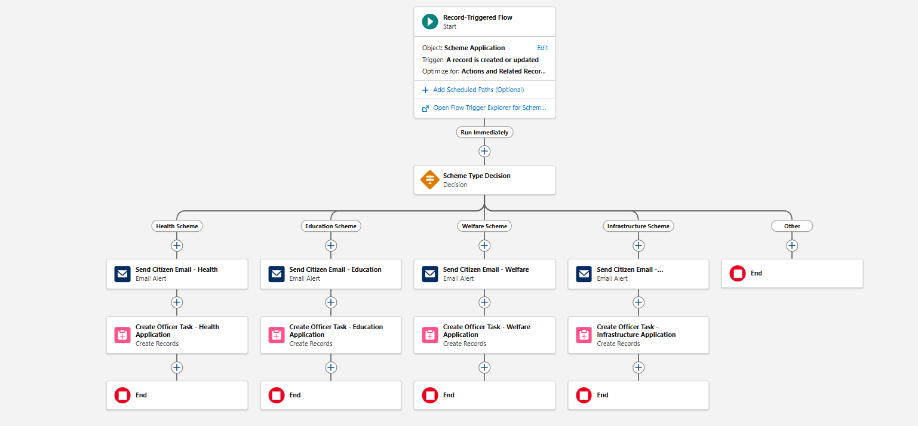

**Record-Triggered Flow: Update Records – Set Status to Approved**

**Goal:** Automatically update the Status of a Scheme Application to “Approved” when it has been approved by the officer.

**Flow Element:** **Update Records**

1. **Label:** Set Status to Approved
2. **API Name:** Set_Status_to_Approved
3. **Description:** Updates the Status field of the Scheme Application to “Approved” when the field Approved__c = True.

**Configuration:**

* **Records to Update:** The Scheme Application record that triggered the flow.
* **Filter Conditions:** None – the record is always updated if it reaches this step.
* **Field Values to Update:**
  + Field: Status
  + Value: Approved

**Impact:**

* Ensures that the Status field reflects the approval action automatically.
* Eliminates manual updates, improving workflow efficiency.
* Supports downstream automations and reporting by maintaining accurate application status.

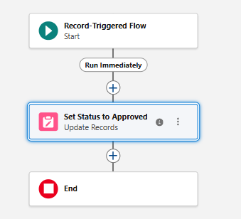

**Approval Process**

**Process Name:** Scheme Application Multi-Step Approval  
**Objective:** To implement multi-step verification and approval for Scheme Applications.

**Steps:**

1. **Entry Criteria:** Status = Submitted
2. **Initial Submitters:** Citizens (Scheme Application Owner)
3. **Approval Steps:**
   * **Step 1:** Officer Approval → Assigned to Officer profile
   * **Step 2:** Auditor Approval → Assigned to Auditor profile
4. **Final Approval Actions:**
   * Status updated → Approved
   * Optional Email Alert → Notify Citizen (Template: App_Approved_Citizen)
5. **Final Rejection Actions:**
   * Status updated → Rejected
   * Optional Email Alert → Notify Citizen (Template: App_Rejected_Citizen)
6. **Page Layout Settings:** Submit for Approval button and Approval History added.
7. **Submission Settings:** Allow submitters to recall approval requests.

**Impact:** Ensures structured review, automates notifications, and provides audit tracking.

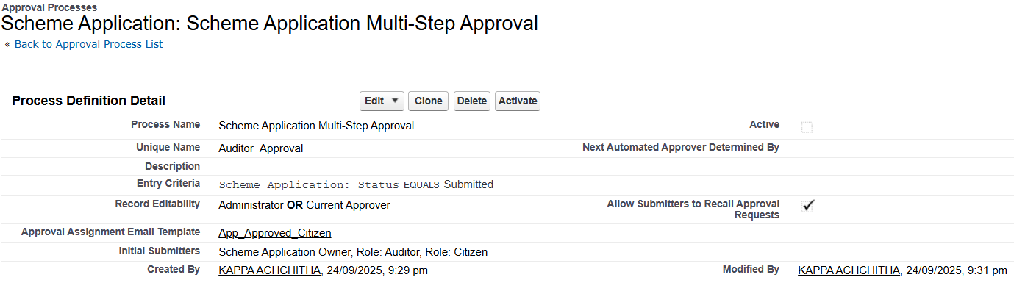

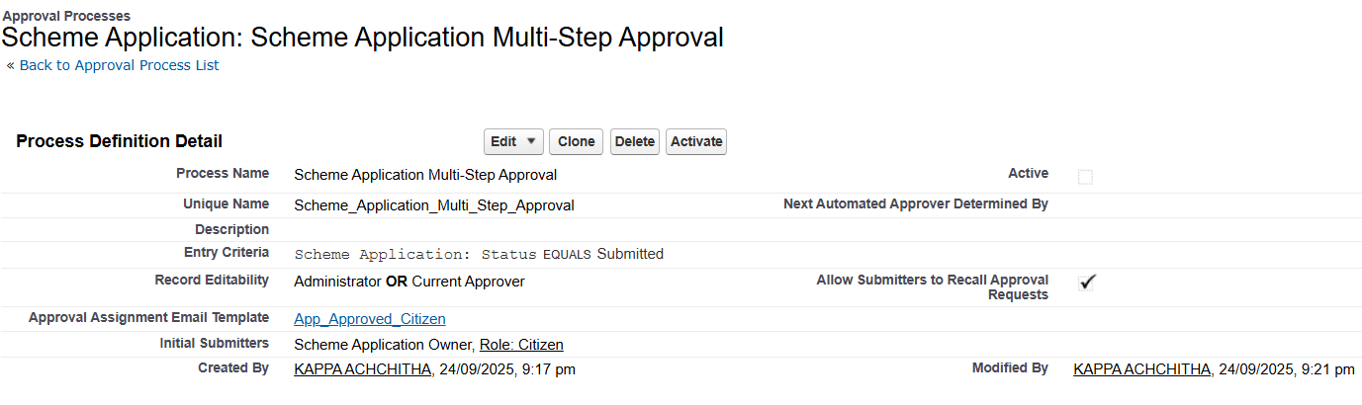

**Email Alerts**

Email alerts automate communication between Officers and Citizens to ensure timely notifications about Scheme Applications.

**1. Citizen Application Submitted Alert**

* **Object:** Scheme Application
* **Email Template:** App_New_Submitted_Citizen
* **Trigger/Use:** Sent to the Citizen to confirm that their application has been submitted successfully.
* **Purpose:** Keeps the citizen informed and provides acknowledgment of submission.

**2. Officer Notification Alert**

* **Object:** Scheme Application
* **Email Template:** App_New_Submitted_Officer
* **Trigger/Use:** Sent to the Officer when a new Scheme Application is submitted.
* **Purpose:** Ensures Officers are notified to review the submitted application promptly.

**Impact:**

* Automates notifications, reducing manual communication.
* Keeps all stakeholders informed in real-time.
* Supports faster processing of submitted applications.

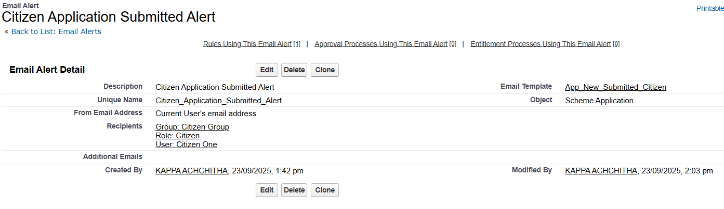

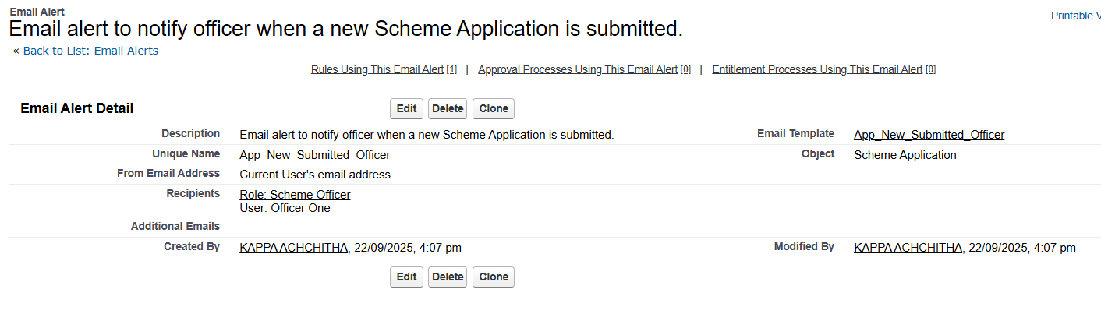

**Email Folders & Templates**

**Email Folder:**

* **Name:** Govt Schemes Templates
* **Purpose:** Organizes all email templates for easy access, management, and reusability.

**Email Templates:**

* Templates are reusable email messages that can be linked to workflows, flows, or approval processes to automate notifications.

**Templates Created:**

1. **App_New_Submitted_Citizen** → Notifies Citizens about application submission.
2. **App_New_Submitted_Officer** → Notifies Officers about new submissions.
3. **App_Approved_Citizen** → Notifies Citizens when application is approved.
4. **App_Approved_Officer** → Notifies Officers when an application is approved.
5. **App_Rejected_Citizen** → Notifies Citizens when an application is rejected.
6. **Fund_Disbursed_Citizen** → Notifies Citizens when funds are released.
7. **Fund_Transaction_Issue_Officer** → Notifies Officers about fund transaction issues.

**Impact:**

* Ensures consistent, professional communication.
* Reduces manual email sending.
* Supports automation in workflows, flows, and approval processes.
* Centralized folder allows easy updates and maintenance of templates.