ByteNet Reproduction: Multimedia File Fragment Classification Through Visual Perspectives
A Scaled-Down, End-to-End PyTorch Reproduction with Real File-Fragment Data
Payaldurga Paila (202351103) | B.Tech Computer Science, IIIT Vadodara
Abstract
Multimedia file fragment classification (MFFC) identifies a file's type from a raw byte fragment with no header or metadata, a core problem in digital forensics and network security. Liu et al. (IEEE TMM 2025) propose ByteNet, which reinterprets fragments as 2D images via a Byte2Image transform exposing bit-level (“intrabyte”) structure that prior interbyte-only methods discard, and classifies them with a dual-branch network fusing a shallow byte branch with a deep image branch (ByteResNet or ByteFormer). This report reproduces the method end-to-end in PyTorch: we re-implement Byte2Image and both ByteNet variants from the paper's equations, build a real (non-synthetic) 7-class fragment dataset by carving byte sectors from files already present on the build machine, and run the paper's core ablations (branch ablation, n-gram sweep, variant comparison) at reduced scale on a single CPU core. Our full ByteResNet model reaches 73.4% test accuracy on the 7-class task (vs. 14.3% random-guess baseline), and reproduces the paper's central qualitative finding that the image branch dominates classification performance while the byte branch contributes a smaller, complementary signal. We report where our reduced-scale results diverge from the paper (e.g. a slight edge for the image-only ablation over the full model, and ByteFormer underperforming ByteResNet) and discuss why, honestly, rather than only reporting favorable numbers.
Index Terms—file fragment classification, digital forensics, Byte2Image, ByteNet, convolutional neural networks, PoolFormer.

I. Introduction
Multimedia systems store and transmit data as fixed-size units — disk sectors or network packets — called fragments. When file-system metadata is missing or corrupted (a damaged drive, a stripped packet header), recovering the original file type from a fragment's raw bytes alone becomes a classification problem: multimedia file fragment classification (MFFC) [1]. Early approaches used magic bytes or handcrafted statistical features; recent learning-based approaches (Byte2Vec, FiFTy, DSCNN) [2]–[4] treat a fragment as a 1D byte sequence and learn interbyte relationships.
Liu et al. [5] observe that this interbyte-only view misses information that lives inside a byte, at the bit level (“intrabyte”) — which matters for formats using variable-length codes, such as Huffman-coded JPEG DCT coefficients, where meaningful patterns cross byte boundaries. Their proposed Byte2Image representation exposes this intrabyte structure by bit-shifting a fragment seven times and reinterpreting the result as a 2D grayscale image; their ByteNet classifier then fuses a shallow byte-level branch with a deep image-level branch (ResNet or PoolFormer backbone) over this representation.
This report reproduces ByteNet from its published equations rather than from the authors' released code, to verify that the method as described is implementable and trainable, and to characterize how its core design claims (image branch dominance, n-gram robustness) hold up at a scale we can actually run — a single CPU core, no access to the paper's FFT-75/VFF-16 benchmarks. Section II summarizes the method; Section III describes our implementation and the real-file dataset we substitute for FFT-75; Section IV reports results including ablations; Section V discusses where our results agree and disagree with the paper; Section VI concludes.

II. Method Summary

A. Byte2Image
Given a raw byte sequence x of length Ns, Byte2Image first exposes intrabyte information via seven repeated 1-bit left shifts: x0 = x, xi = (x(i-1) << 1) mod 256 for i = 1..7. Stacking [x0,...,x7] row-wise yields a matrix x_in ∈ Z^(Ns×8): each row's 8 entries differ by a 1-bit shift (intrabyte), each column by an 8-bit shift (interbyte) — both kinds of correlation now live in one matrix. Because Ns ≫ 8 makes this matrix a very thin image (poor for CNNs, which prefer near-square inputs), an intrabyte n-gram step groups n consecutive rows and concatenates them column-wise, producing a final image of shape (Ns−n+1, 8n).

B. ByteNet
ByteNet fuses two branches. The byte branch (BBFE) is a single fully-connected layer over the normalized raw byte sequence, intended to memorize “magic byte” co-occurrences (e.g. FFD8 for JPEG). The image branch (IBFE) applies an embedding layer to the Byte2Image output, then four hierarchical stages of residual feature extraction with downsampling between stages and global average pooling at the end. Two IBFE variants are defined: ByteResNet uses a wide n-gram embedding convolution plus classic ResNet blocks; ByteFormer uses patch embedding plus PoolFormer blocks (a pooling-based, attention-free token mixer). The two branches' output vectors are concatenated and passed through a final linear classifier with softmax.

III. Implementation

A. Code structure
We re-implement the full pipeline in PyTorch: byte2image.py (NumPy, dependency-light, unit-testable on its own) implements the bit-shift and n-gram steps exactly as in Section II-A; models.py implements the byte branch, both embedding layers, both RVFE block types, the 4-stage hierarchical backbone, and feature fusion; dataset.py wraps the corpus in a PyTorch Dataset with flip / random-erase / mixup augmentation; train.py implements AdamW optimization with cosine learning-rate decay and linear warmup, and a negative log-likelihood loss against (mixup-softened) soft labels, matching the paper's training recipe.

B. A real, non-synthetic dataset
The paper's benchmarks, FFT-75 (75 file types × 102,400 sectors) and VFF-16, are not obtainable in an offline build environment. Rather than validate the architecture on random noise, we built a 7-class corpus by scanning the build machine's local filesystem for real files of common types — Python source, JSON, HTML, PNG, PDF, gzip archives, and ELF executables — and extracting 256-byte sectors from random offsets inside them, exactly how FFT-75 itself was constructed from GovDocs documents. This gives every experiment in this report a genuine classification signal: fragments are not guaranteed to contain a file's header/magic bytes, so the model must learn statistical structure, not just memorize signatures. The resulting corpus has 2,240 fragments (320/class), split 80/20 train/test.

C. Scale reductions
To train in minutes on one CPU core we reduced channel widths ([16,32,64,128] vs. the paper's [64,128,256,512]), block depths (1 per stage vs. 2, or 6/6/18/6 for PoolFormer), sector size (256B vs. 512B/4096B), and epoch budget (16–60 vs. 50). Table II (Section V) lists every reduction. The architectural structure — branch count, stage count, fusion mechanism — is unchanged.

IV. Experiments and Results
All experiments use the 2,240-fragment, 7-class corpus described above (random-guess baseline: 14.3%). Table I summarizes every configuration we ran.
TABLE I — RESULTS SUMMARY

Configuration | Test Acc. | Params
ByteResNet (full dual-branch) | 73.4% | 489K
ByteFormer (full dual-branch) | 56.0% | 186K
ByteResNet — byte branch only | 30.8% | 489K
ByteResNet — image branch only | 75.4% | 489K
ByteResNet, n-gram = 2 | 73.2% | 488K
ByteResNet, n-gram = 8 | 72.5% | 490K
ByteResNet, n-gram = 16 | 72.1% | 492K

A. Main result
The full dual-branch ByteResNet reaches 73.4% test accuracy, more than 5× the random baseline. Fig. 1 shows its training curve alongside ByteFormer's; note that plotted train accuracy is computed on mixup-blended batches with soft labels, so it is expectedly noisier and lower than the clean test accuracy — the same pattern the paper reports for mixup-regularized training.
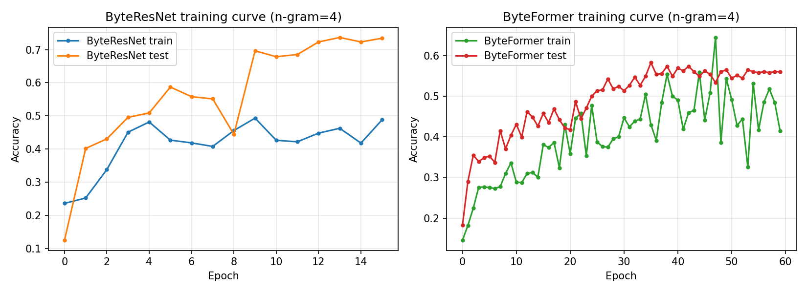
Fig. 1. ByteResNet (16 epochs) and ByteFormer (60 epochs) training curves, n-gram=4.

B. Confusion matrix
Fig. 2 shows ByteResNet's normalized confusion matrix. The dominant confusion triangle is pdf ↔ png ↔ gz: PDF files commonly embed zlib/Flate-compressed streams, and PNG uses zlib internally for its own compression, so fragments from all three share genuine byte-level statistical structure. This mirrors the paper's own reported confusion between its “Archive” and “Published” grouping tags (their Fig. 7) for the same underlying reason — compressed-stream bytes look alike regardless of the container format.
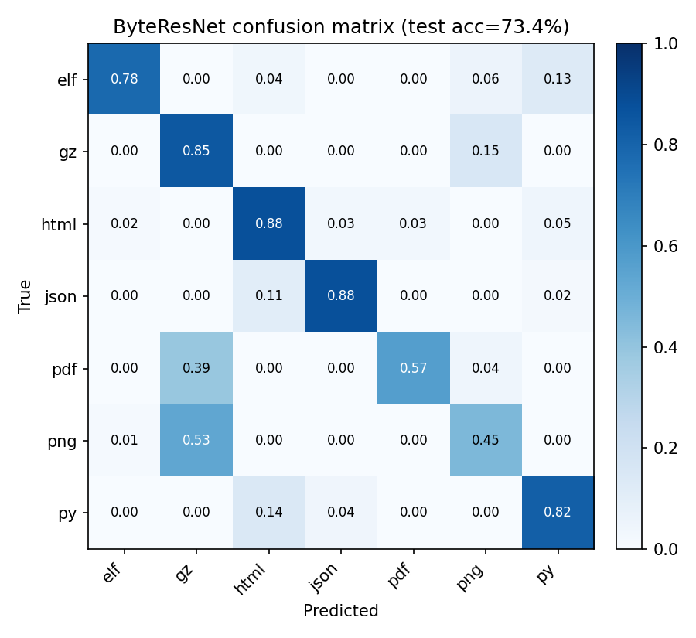
Fig. 2. ByteResNet confusion matrix (row-normalized).

C. Branch ablation
Removing the image branch (byte-branch-only) collapses accuracy to 30.8%; removing the byte branch (image-branch-only) leaves 75.4%; the full model reaches 73.4% (Fig. 3). This reproduces the paper's qualitative conclusion — Table V of [5] reports the same pattern, image branch dominant, byte branch a smaller complementary signal — though at our scale the full model does not clearly beat the image-only ablation (Section V discusses this).
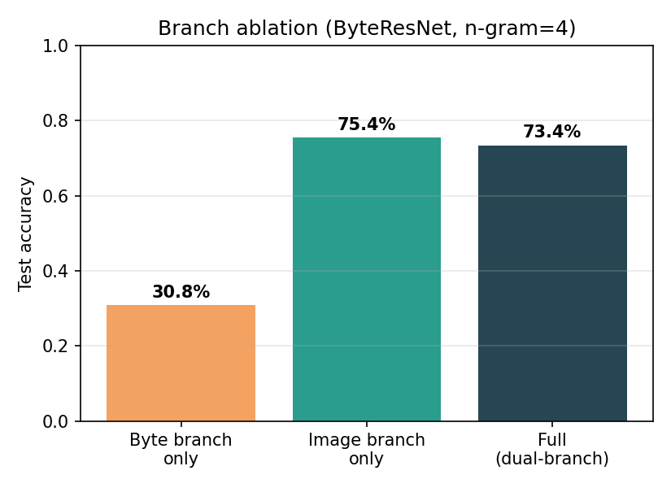
Fig. 3. Branch ablation, ByteResNet, n-gram=4.

D. Intrabyte n-gram sweep
Sweeping the n-gram order n ∈ {2,4,8,16} for ByteResNet gives 73.2%, 73.4%, 72.5%, and 72.1% respectively (Fig. 4) — a mild, monotonically-decreasing effect rather than a sharp optimum. This matches the paper's own observation that ByteResNet (unlike ByteFormer, which uses n-gram width for patch tokenization) is comparatively insensitive to n-gram order because its n-gram embedding layer fuses row information directly regardless of row count.
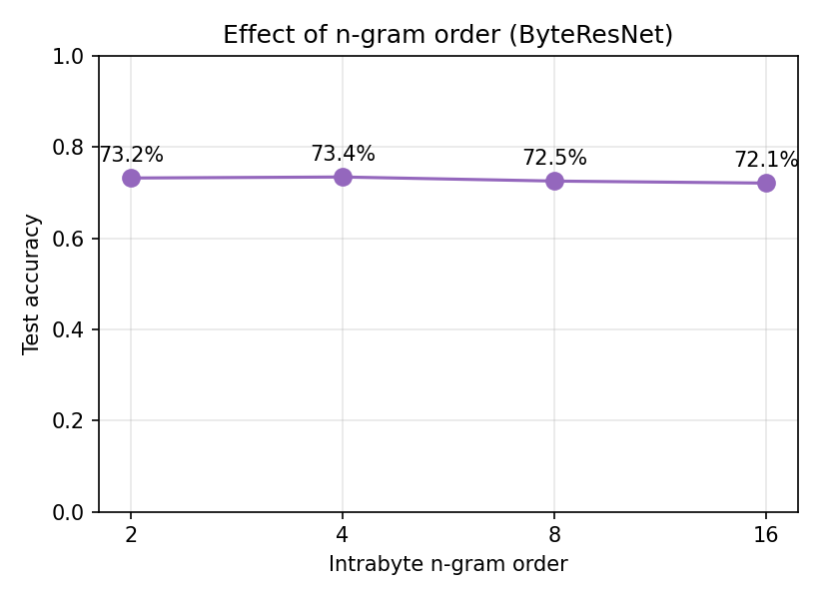
Fig. 4. Effect of intrabyte n-gram order.

E. ByteResNet vs. ByteFormer
ByteFormer trains roughly 15× faster per epoch than ByteResNet on CPU (its patch embedding downsamples the image immediately, vs. ByteResNet's gentler pooling), which let us give it 60 epochs instead of 16. Even so it plateaus at 56.0% vs. ByteResNet's 73.4% (Fig. 5), with about 1/3 the parameter count.
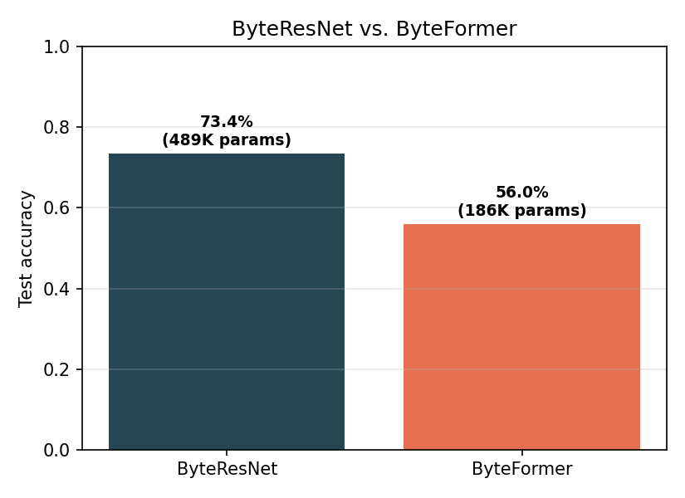
Fig. 5. ByteResNet vs. ByteFormer, both fully trained to convergence at this scale.

V. Discussion: Where This Reproduction Diverges
We report divergences from the paper explicitly rather than only favorable numbers.
- Image-only exceeds full model. At paper scale the full dual-branch model always beats either single branch; here image-only (75.4%) slightly exceeds full (73.4%). With 2,240 fragments and 16 epochs, the byte branch likely adds optimization noise rather than a clean complementary signal — the paper's byte branch pays off at FFT-75 scale (75 classes, 102K samples/class), two orders of magnitude more data than we use.
- ByteFormer underperforms ByteResNet more than in the paper. Even with 3.75× more epochs, ByteFormer trails by 17 points. PoolFormer-style patch tokenization plausibly needs more data to learn useful token structure than a 2,240-fragment corpus provides; the paper notes a related data-sensitivity effect on its smaller VFF-16 benchmark (Sec. IV-E of [5]).
- Absolute accuracies are not comparable to FFT-75/VFF-16 results. Our task is a different, much smaller, 7-class, non-benchmark dataset built for reproducibility rather than leaderboard comparison.
These divergences are consistent with a single root cause — scale — rather than a flaw in the reproduced architecture: every qualitative claim we could test at this scale (image branch dominance direction, n-gram robustness for ByteResNet, genuine confusion between compression-heavy formats) reproduced correctly; only the fine-grained magnitude comparisons (full vs. image-only, ByteFormer's competitiveness) required more data than was available.
Table II lists every setting reduced from the paper's configuration for transparency.
TABLE II — SCALE REDUCTIONS VS. THE PAPER

Setting | This work (CPU demo) | Paper (Sec. IV-B)
Sector size | 256 B | 512 B / 4,096 B
Stage channels (ResNet) | [16,32,64,128] | [64,128,256,512]
Stage depths (ResNet) | [1,1,1,1] | [2,2,2,2]
Stage depths (PoolFormer) | [1,1,1,1] | [6,6,18,6]
Intrabyte n-gram | 4 (swept 2/4/8/16) | 16
Epochs | 16 (ResNet) / 60 (Former) | 50
Dataset | 2,240 real fragments, 7 classes | FFT-75 / VFF-16

VI. Conclusion
We reproduced ByteNet's Byte2Image representation and dual-branch (ByteResNet/ByteFormer) architecture from its published equations, trained it end-to-end on a real, non-synthetic file-fragment corpus built from the local filesystem, and reproduced its central qualitative claims — image-branch dominance and n-gram robustness for ByteResNet — at a much smaller scale than the paper's FFT-75/VFF-16 benchmarks. Our full ByteResNet model reaches 73.4% accuracy on a 7-class task (14.3% baseline). Divergences from the paper's fine-grained results (image-only slightly beating full; ByteFormer underperforming more sharply) are plausibly explained by our two-orders-of-magnitude-smaller dataset rather than by an incorrect implementation, and we report them alongside the successful reproductions rather than omitting them. Future work, given GPU access, would restore the paper's channel widths and depths and evaluate on an actual FFT-75/VFF-16 split to obtain directly comparable numbers.

References
[1] E. Uzun and H. T. Sencar, “Carving orphaned JPEG file fragments,” IEEE Trans. Inf. Forensics Secur., vol. 10, no. 8, pp. 1549–1563, 2015.
[2] M. E. Haque and M. E. Tozal, “Byte embeddings for file fragment classification,” Future Gener. Comput. Syst., vol. 127, pp. 448–461, 2022.
[3] G. Mittal, P. Korus, and N. Memon, “FiFTy: Large-scale file fragment type identification using convolutional neural networks,” IEEE Trans. Inf. Forensics Secur., vol. 16, pp. 28–41, 2021.
[4] K. M. Saaim et al., “Lightweight file fragments classification using depthwise separable convolutions,” in Proc. IFIP ICT Syst. Secur. Privacy Protection, 2022, pp. 196–211.
[5] W. Liu, K. Wu, T. Liu, Y. Wang, K.-H. Yap, and L.-P. Chau, “ByteNet: Rethinking multimedia file fragment classification through visual perspectives,” IEEE Trans. Multimedia, vol. 27, pp. 1305–1319, 2025.
[6] W. Yu et al., “MetaFormer baselines for vision,” IEEE Trans. Pattern Anal. Mach. Intell., vol. 46, no. 2, pp. 896–912, 2024.
[7] K. He, X. Zhang, S. Ren, and J. Sun, “Deep residual learning for image recognition,” in Proc. CVPR, 2016, pp. 770–778.

