Calculated Raman spectra of MB⁺: comparison of free molecule and flat adsorption on Ag₄₀
Comparison based on the three supplied TmoleX/TURBOMOLE Excel exports

1. Overlay of calculated spectra
For comparability, the original (ort,unpol) line intensities between 500 and 1800 cm⁻¹ were normalized separately to 100 %. The overlay below uses the same Gaussian broadening (σ = 8 cm⁻¹) for all three data sets. Thus, peak positions and relative intensity patterns can be compared directly; absolute intensities are not compared.
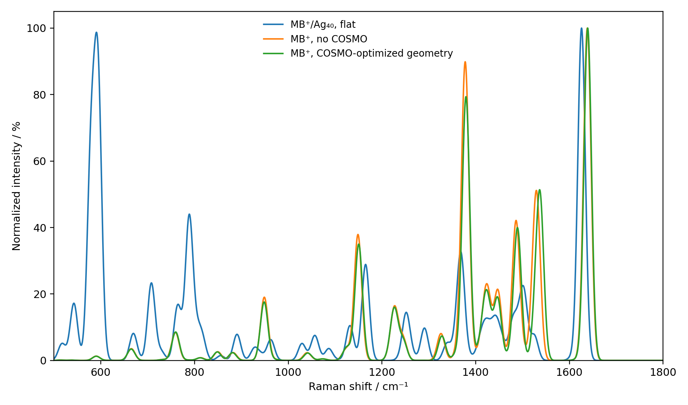
Figure 1. Calculated Raman spectra, normalized within 500–1800 cm⁻¹.

2. Tabular comparison
Spectral region | MB⁺ no COSMO  /cm⁻¹ | MB⁺ COSMO geometry  /cm⁻¹ | MB⁺/Ag₄₀ flat  /cm⁻¹ | Observation
Main high-frequency band | 1638.35 | 1639.12 | 1626.04 | Ag: red shift ≈ 12–13 cm⁻¹
~1530 cm⁻¹ region | 1530.50 | 1537.51 | 1501.86* | Ag: marked intensity redistribution
~1490 cm⁻¹ region | 1486.09 | 1490.22 | 1490–1502* | Position broadly retained
~1450 cm⁻¹ region | 1447.71 | 1447.25 | near 1450* | Small frequency change
~1370–1380 cm⁻¹ region | 1377.20 | 1378.88 | 1366.28 / 1370.44 | Ag: red shift / splitting
~1150 cm⁻¹ region | 1149.06 | 1150.67 | 1164.85 | Ag: blue shift ≈ 14–16 cm⁻¹
~950 cm⁻¹ region | 948.77 | 948.46 | near 940–950* | Moderate change
*For the Ag₄₀ system, several regions contain multiple modes and strongly redistributed intensities; entries marked with an asterisk are therefore spectral-region comparisons rather than one-to-one mode assignments.

3. Main findings
The dominant high-frequency Raman band of free MB⁺ occurs at 1638.35 cm⁻¹ (no COSMO) and 1639.12 cm⁻¹ (COSMO-optimized geometry). In the flat MB⁺/Ag₄₀ structure it occurs at 1626.04 cm⁻¹, corresponding to a red shift of about 12–13 cm⁻¹.
The free-molecule spectra are similar in their principal peak positions. The COSMO-optimized geometry therefore changes the characteristic Raman frequencies only modestly in comparison with adsorption on silver.
Adsorption on Ag₄₀ causes a pronounced redistribution of relative Raman intensity. In the 500–800 cm⁻¹ region, the Ag-containing calculation shows strong contributions at 578.88, 593.18, 707.82 and 788.75 cm⁻¹ that are much more prominent than in the free-molecule spectra.
A further clear change is seen near 1150 cm⁻¹: 1149.06/1150.67 cm⁻¹ for free MB⁺ versus 1164.85 cm⁻¹ for the flat Ag₄₀ configuration.
The changes are consistent with a substantial perturbation of the molecular vibrational/polarizability response upon interaction with the Ag cluster. They should not, by themselves, be interpreted as a quantitative classical SERS enhancement factor, because the calculation does not establish the experimental electromagnetic enhancement or molecule-number normalization.

4. Interpretation for the SERS comparison
The most useful comparison with the experimental SERS spectrum is therefore not the absolute calculated intensity but (i) the positions of characteristic MB⁺ bands, (ii) adsorption-induced frequency shifts, and (iii) changes in the relative intensity pattern. The calculated red shift of the high-frequency band to 1626.04 cm⁻¹ and the strong redistribution in the 500–800 cm⁻¹ region are particularly diagnostic features of the flat MB⁺/Ag₄₀ model.

