SpectroElectroChem Suite
USER MANUAL
Version 4.0.1
Open-source software for Raman, SERS, absorption and fluorescence
spectro-electrochemical data analysis
Author | Prof. Dr. Achim Habekost
Release | v4.0.1
Version DOI | Zenodo Concept DOI  https://doi.org/10.5281/zenodo.21283231
Repository | https://github.com/Achim-Habekost/SpectroElectroChem-Suite
License | MIT License
Parts of the source code were developed with the assistance of OpenAI ChatGPT and were subsequently reviewed, scientifically validated, modified and substantially extended by the author.
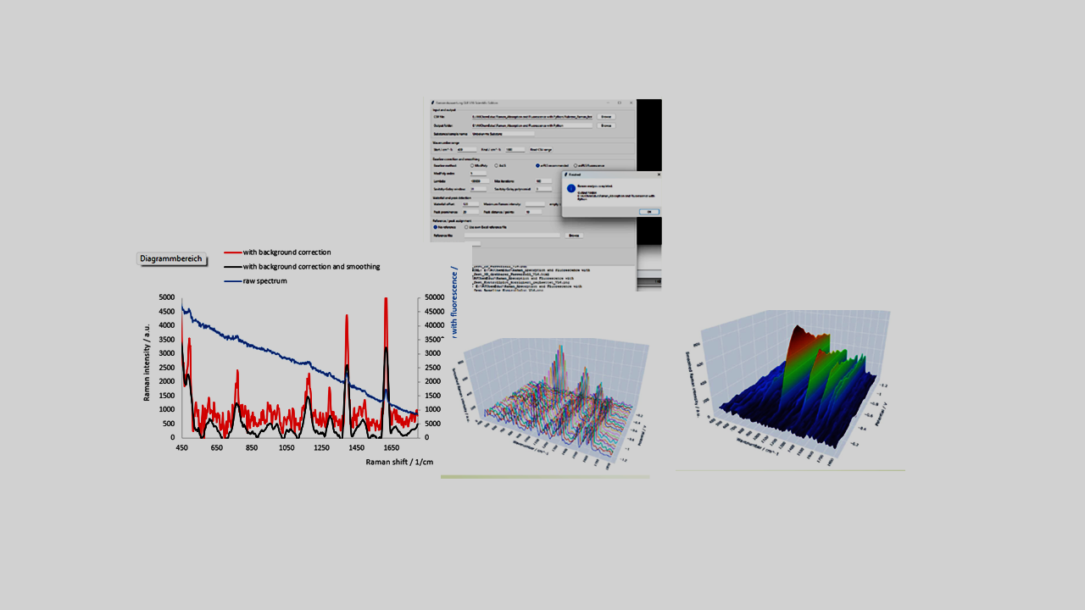

Document status and scope
This manual describes SpectroElectroChem Suite version 4.0.1. It is intended for scientists, students, and technical staff who wish to analyse their own comma-separated value (CSV) files without modifying the Python source code. The software provides graphical workflows for various types of spectra and voltammograms, e.g. for smoothing, background subtraction and creating waterfall, surface and other diagrams.
Important: The current public release is source-based. On Windows, Python 3.10 or newer must be installed before the included package-installation and start batch files can be used. The release is not yet a self-contained Windows executable.

Table of contents
1. Overview
2. Obtaining the software
3. System requirements
4. Installation on Windows
5. Starting and closing the application
6. Input-file specifications
7. Raman spectrum analysis
8. Raman/SERS voltammograms
9. Absorpto- and fluorovoltammograms
10. Signal-processing options
11. Graphical outputs
12. Excel and file exports
13. Recommended scientific workflow
14. Troubleshooting
15. Reproducibility and data integrity
16. Citation and licensing
Appendix A. CSV templates
Appendix B. Output-file glossary
Appendix C. Quick-start checklist

1. Overview

1.1 Purpose
SpectroElectroChem Suite is a modular desktop application for processing, visualizing and exporting spectroscopic and spectro-electrochemical data. It is designed to reduce the amount of manual spreadsheet work required for multi-spectrum data sets while preserving transparent numerical outputs for independent inspection.

1.2 Supported analytical workflows
- Single- or multi-column Raman spectra: smoothing, baseline correction, peak analysis and waterfall visualization.
- Raman and SERS voltammograms: potential-resolved Raman intensity matrices.
- Absorptovoltammograms: potential-resolved absorption spectra.
- Fluorovoltammograms: potential-resolved fluorescence spectra.

1.3 Principal outputs
- Processed Excel workbooks containing numerical data and metadata.
- Static PNG and PDF figures for reports and publications.
- Interactive HTML figures for rotation, zooming and visual inspection.
- 3D surfaces, heatmaps, contour plots and waterfall diagrams.
- Raw, smoothed, baseline-corrected and vertically offset data, depending on the selected module.

1.4 Intended use and limitations
The software is intended as a scientific analysis and visualization aid. It does not replace validation of instrumental data, inspection of raw spectra, calibration, uncertainty analysis or expert interpretation. Parameters such as the smoothing window, baseline model, peak prominence and waterfall offset must be selected with reference to the spectral resolution, the signal-to-noise ratio and the scientific question at hand.

2. Obtaining the software

2.1 Zenodo archive
The archived version can be accessed through the persistent DOI:
https://doi.org/10.5281/zenodo.21283232
On the Zenodo record page, download the ZIP archive associated with version 4.0.1. Zenodo provides a permanently archived snapshot together with citation metadata.

2.2 GitHub repository
The development repository and release page are available at:
https://github.com/Achim-Habekost/SpectroElectroChem-Suite
Use GitHub for source inspection, issue reporting and future releases. Use the Zenodo DOI when citing the archived version used in a scientific study.

2.3 After downloading
- Save the ZIP archive to a local folder.
- Right-click the archive and choose Extract All.
- Open the extracted project folder. Do not run batch files directly from inside the ZIP archive.
Security notice: Windows may mark downloaded batch files as originating from the Internet. Inspect the files and source code before execution, and use only the official GitHub or Zenodo release.

3. System requirements
Component | Minimum / required | Recommended
Operating system | Windows 10 or 11 | 64-bit Windows 11
Python | Python 3.10 or newer | Current stable 64-bit Python
Memory | 4 GB RAM | 8 GB or more for large matrices
Storage | Approx. 1 GB plus output files | Several GB for large Excel/HTML exports
Internet | Needed initially for package installation | Needed to load Plotly from a CDN in some HTML outputs
Spreadsheet viewer | Optional | Microsoft Excel or LibreOffice Calc
Web browser | Modern browser | Firefox, Edge or Chrome

3.1 Required Python packages
The release requirements file lists the packages used by the different modules. The principal packages are:
- NumPy – numerical arrays and matrix operations.
- pandas – CSV input and tabular data handling.
- SciPy – Savitzky–Golay filtering, peak processing and numerical routines.
- pybaselines – baseline-estimation algorithms, where used.
- Matplotlib – static plots and PDF/PNG export.
- Plotly – interactive HTML visualizations.
- openpyxl – Excel workbook creation.
- PySide6 and/or Tkinter – graphical user interfaces, depending on the module implementation.

4. Installation on Windows

4.1 Install Python
- Download Python 3.10 or newer from the official Python website.
- During installation, enable Add Python to PATH if that option is shown.
- Complete the installation and restart Windows, or at least reopen File Explorer and Command Prompt.

4.2 Install required packages
In the extracted program folder, double-click:
Install_required_Python_packages.bat
A console window will open and install the packages listed in requirements.txt. Internet access is normally required during this step. The step is generally needed only once for a given Python environment.

4.3 Test the installation
Run:
Test_Installation.bat
The test verifies that Python and the principal dependencies can be imported. If the console window closes immediately, launch the batch file from Command Prompt to retain the error message.

4.4 Manual installation alternative
Alternatively, open Command Prompt in the program folder and run:
py -m pip install -r requirements.txt
If the py launcher is unavailable, try:
python -m pip install -r requirements.txt
Multiple Python installations: If package installation succeeds but the application still reports missing modules, the batch files may be using a different Python installation from the one in which the packages were installed. Use “py -0p” in Command Prompt to list the installed Python interpreters.

5. Starting and closing the application

5.1 Standard start
Double-click:
Start_SpectroElectroChem_Suite.bat
The launcher adds the src folder to the Python search path and opens the central application window. Depending on the release build, the main window offers module buttons or menu entries for Raman spectrum analysis, Raman/SERS voltammograms, and absorption/fluorescence voltammograms.

5.2 Start from Command Prompt
cd "C:\path\to\SpectroElectroChem_Suite"
python main.py

5.3 Closing
Close module windows using their normal Close or X button. Allow ongoing Excel or HTML export operations to finish before closing. Interactive HTML plots remain available as independent files after the application has been closed.

6. Input-file specifications

6.1 General CSV rules
- Use a genuine CSV text file, not an .xlsx file merely renamed to .csv.
- Decimal points and decimal commas are accepted by many import paths, but a decimal point is recommended for portability.
- Do not mix text comments into the numerical matrix unless the module explicitly supports metadata rows.
- Avoid merged cells, hidden rows and formulas; export numerical values only.
- Remove completely empty trailing rows and columns where practical.
- Keep a copy of the unmodified raw instrument export.

6.2 Matrix format for Raman/SERS voltammograms
The first row contains the potentials, the first column contains the Raman shifts (wavenumbers), and all remaining cells contain Raman intensities.
 | −0.40 | −0.30 | −0.20 | −0.10
300 | 120 | 125 | 131 | 140
305 | 118 | 124 | 130 | 139
310 | 119 | 126 | 134 | 143
315 | 123 | 129 | 138 | 148

6.3 Matrix format for absorption and fluorescence voltammograms
The first row contains the potentials and the first column contains the wavelengths. The remaining cells contain absorbance, fluorescence intensity or another measured optical response. If there is only one absorbance or fluorescence spectrum, the potential row is missing.
 | 0.00 | 0.10 | 0.20 | 0.30
400 | 0.021 | 0.028 | 0.039 | 0.051
405 | 0.023 | 0.031 | 0.043 | 0.056
410 | 0.026 | 0.035 | 0.048 | 0.062
415 | 0.030 | 0.040 | 0.054 | 0.069

6.4 Raman spectrum table format
For Raman spectrum analysis, the first numerical column contains the Raman shift and the remaining columns contain one or more intensity spectra. Header labels may be used to identify individual spectra at various potentials. The exact import options are displayed by the module.

6.5 Axis order
Some modules sort the potential and spectral axes automatically. Nevertheless, ascending, unique numerical axis values are recommended. Duplicate potentials or duplicate wavelengths/wavenumbers should be resolved before analysis unless they represent intentional replicate measurements.

7. Raman spectrum analysis

7.1 Purpose
This module processes individual Raman spectra or collections of spectra stored in columns. It can generate raw, smoothed, baseline-corrected and combined data sets, locate peaks, calculate peak parameters and create waterfall plots.

7.2 Typical workflow
- Open the Raman Spectrum Analysis module.
- Select the CSV input file.
- Enter or confirm the Raman-shift range.
- Choose the baseline-correction parameters.
- Choose the Savitzky–Golay smoothing parameters.
- Set the peak-finding parameters, if peak analysis is required.
- Select an optional reference peak list, if identification is required.
- Set the maximum Raman intensity for plotting, if a fixed scale is desired.
- Set the waterfall vertical offset and plot orientation, where available.
- Run the analysis and inspect the generated control plots before accepting the results.

7.3 Baseline correction
Baseline correction estimates a slowly varying background and subtracts it from the measured spectrum. Depending on the current plugin, the module may provide polynomial or penalized-baseline methods. Baseline correction should remove broad fluorescence or instrumental background (e.g. scattering) without distorting genuine broad Raman bands.
Scientific check: Always inspect the baseline overlay. A visually smooth corrected spectrum is not sufficient evidence that the baseline is physically appropriate. Check low-intensity regions, broad bands and the spectrum edges.

7.4 Savitzky–Golay smoothing
Savitzky–Golay filtering performs a local polynomial fit. The window length must be odd and larger than the polynomial order. A window that is too large can reduce peak heights, merge neighbouring bands or alter the FWHM. Select a window consistent with the sampling interval and the expected peak width.
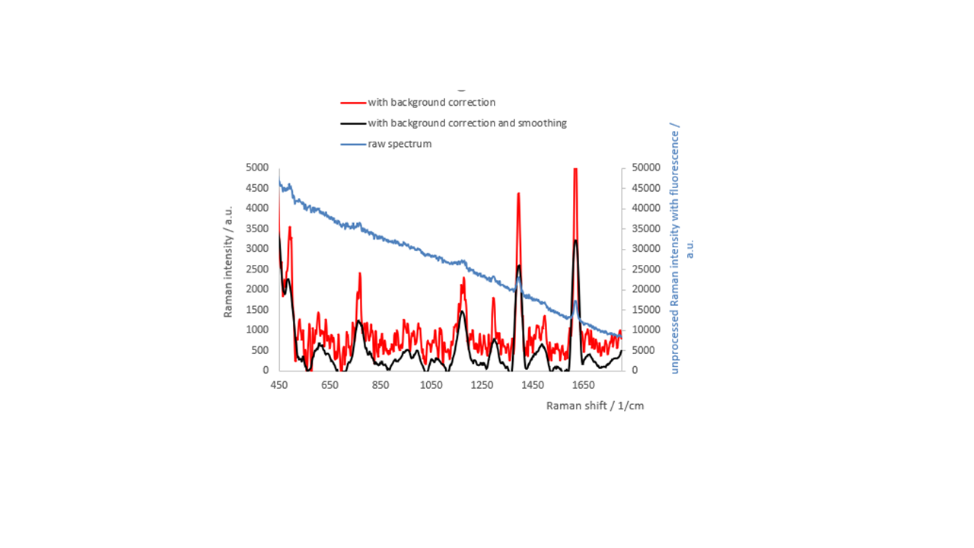

7.5 Peak analysis
Peak finding typically uses prominence and minimum-distance criteria. The output may include peak position, intensity and full width at half maximum (FWHM). Peak identification against a reference list is tolerance-based and must be treated as a candidate assignment, not as definitive chemical proof.

7.6 Raman Excel workbook
Depending on the plugin version. The Excel workbook typically contains the following worksheets:
- Original spectra
- Smoothed-only spectra
- Baseline-corrected-only spectra
- Baseline-corrected and smoothed spectra
- Calculated baselines
- 2D waterfall data
- Peak parameters
- Peak identification results
- Reference data used
- Summary/interpretation

8. Raman/SERS voltammograms

8.1 Purpose
The Raman/SERS voltammogram module treats a spectral intensity matrix as a function of Raman shift and electrode potential. It is suitable for potential-dependent Raman or surface-enhanced Raman data.

8.2 Loading and range selection
- Select the CSV matrix file.
- Select an output folder, or leave the field empty to use the input-file folder.
- Use the range-reading function, if available, to display the detected Raman-shift and potential ranges.
- Enter the desired lower and upper Raman-shift limits.

8.3 Smoothing options
- None – preserves the measured matrix.
- Moving average – simple smoothing over a selected number of points.
- Savitzky–Golay – polynomial smoothing with a selected odd window length and polynomial order.

8.4 Intensity scaling
- Raw / linear – preserves the original plotted magnitude.
- Clip at the 99th percentile – reduces the influence of extreme spikes on the colour scale.
- log1p – compresses the dynamic range after shifting negative values, if necessary.
- Clip99 + log1p – combines spike suppression and logarithmic compression.
Interpretation: Scaling modes modify the visualization matrix and may also be exported as plotted values. They do not convert arbitrary intensity units into quantitative concentrations.

8.5 Baseline correction and peak parameter
- SERS does not require any baseline correction.
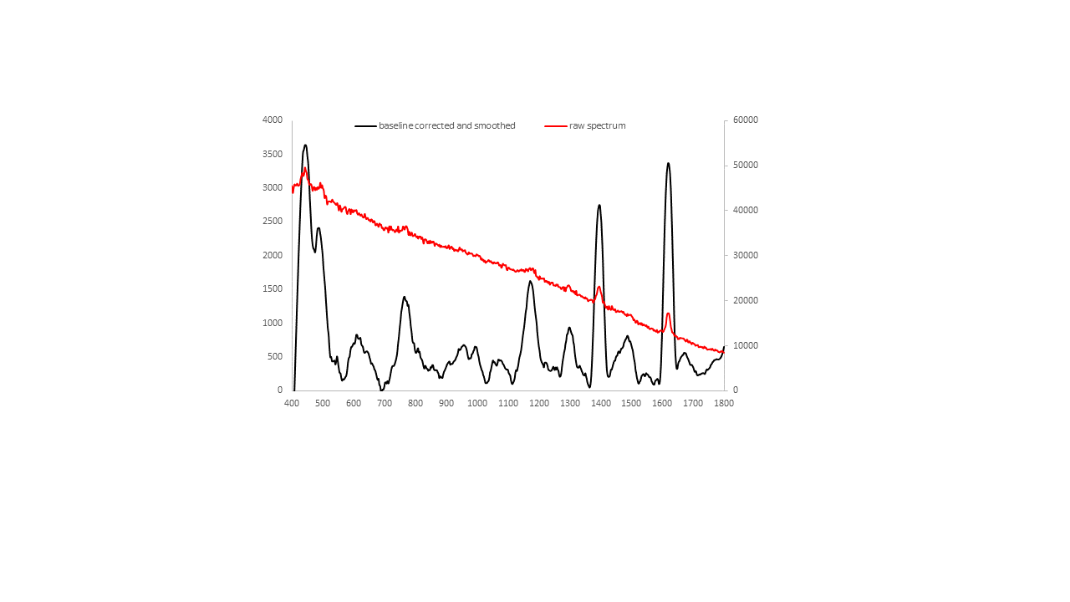
Peak_Nr | Gemessen_cm-1 |  | Intensitaet |  | FWHM_cm-1
1 | 443.572 | 3237.016 |  | 70.73005
2 | 485.158 | 2005.668 |  | 13.27788
3 | 545.501 | 104.1584 |  | 3.79017
4 | 607.772 | 423.8645 |  | 59.87418
5 | 642.605 | 179.7476 |  | 6.285982
6 | 708.867 | -260.501 |  | 2.38847
7 | 763.801 | 989.6835 |  | 41.52643
8 | 807.793 | 225.7842 |  | 3.46681
9 | 853.913 | -26.1113 |  | 9.527231
10 | 879.333 | -189.92 |  | 3.532601
11 | 909.649 | 27.43816 |  | 5.6194
12 | 954.741 | 271.4507 |  | 79.89512
13 | 991.971 | 247.2508 |  | 15.23369
14 | 1067.933 | 55.90622 |  | 56.92809
15 | 1171.156 | 1220.993 |  | 47.16028
16 | 1220.683 | 11.66072 |  | 9.632227
17 | 1246.398 | -48.9973 |  | 6.112788
18 | 1299.668 | 530.7832 |  | 35.58292
19 | 1331.767 | -33.6803 |  | 3.2529
20 | 1395.234 | 2346.762 |  | 33.20733
21 | 1457.745 | 178.5831 |  | 3.400773
22 | 1486.447 | 410.5359 |  | 60.54273
23 | 1547.589 | -144.147 |  | 35.24608
24 | 1584.265 | -229.842 |  | 11.93203
25 | 1618.48 | 2967.378 |  | 34.49392
26 | 1671.359 | 157.6585 |  | 34.36061

8.6 Manual intensity limits
When automatic intensity scaling is disabled, enter minimum and maximum intensity values. Interactive 3D figures may also include buttons for automatic Z scaling, manual Z scaling and percentile-based ranges.

8.7 Waterfall and surface plots
The waterfall plot displays each spectrum with a vertical displacement. Use the vertical offset to prevent overlap while preserving relative peak patterns. Interactive plots can be rotated; static plots are intended for publications and reports. Avoid offsets so large that potential-dependent trends become visually exaggerated.
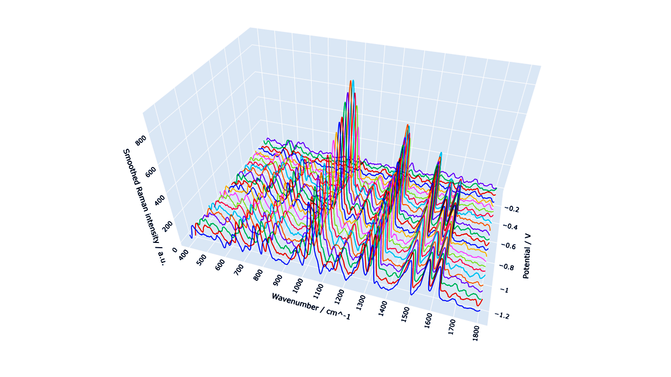
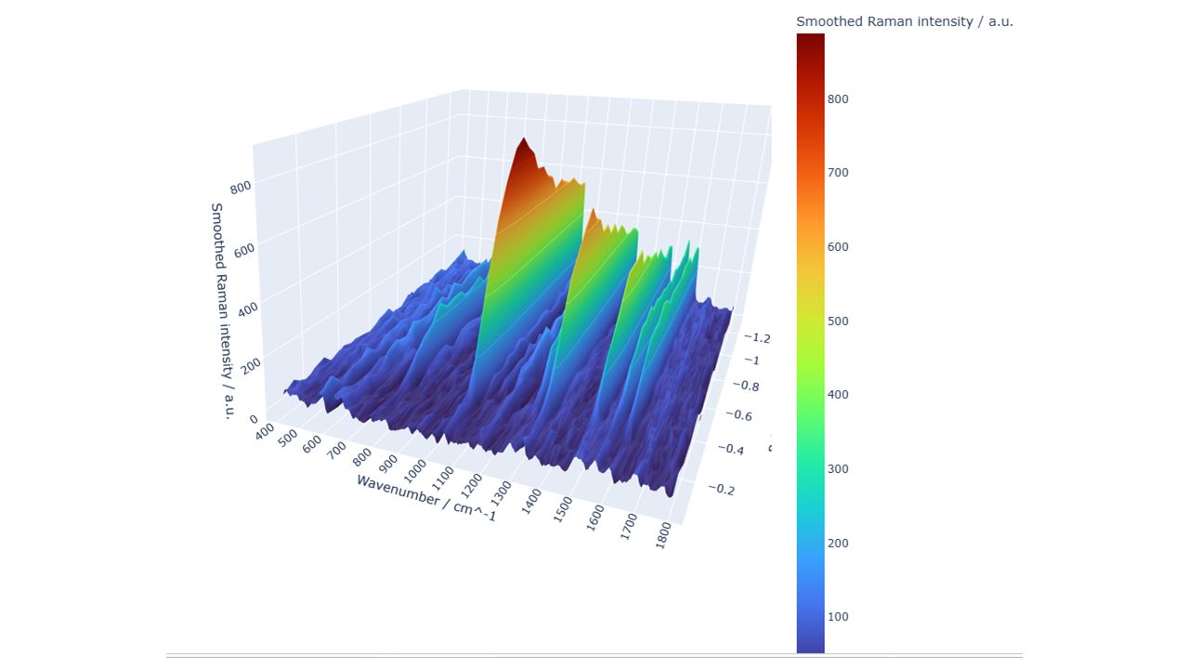

8.8 Expected outputs
- Processed Excel workbook
- Interactive 3D surface (HTML)
- Interactive heatmap (HTML)
- Interactive contour plot (HTML)
- Interactive rotatable waterfall plot (HTML)
- Optional raw-versus-smoothed comparison waterfall
- Static PNG/PDF plots, where enabled

8.9 Excel sheets
The exported workbook typically contains Metadata, Raw_Intensity_Matrix, Smoothed_Intensity_Matrix, Plotted_Intensity_Matrix and the corresponding long-format tables. Current waterfall-enabled releases may also include shifted values, unshifted values and offset tables for custom plotting in Excel.

9. Absorpto- and fluorovoltammograms

9.1 Purpose
This combined module analyses potential-resolved absorption or fluorescence matrices. The mathematical structure is analogous to that of the Raman voltammogram module, but the spectral axis is wavelength rather than Raman shift, and the response values are absorbance or fluorescence intensity.

9.2 Select the analysis mode
Choose Absorption or Fluorescence so that titles, axis labels and output metadata reflect the experimental observable. The underlying matrix orientation remains the same: potentials in the first row, wavelengths in the first column.

9.3 Wavelength range
Select only the spectral interval needed for interpretation. Restricting the range can reduce file size and improve visual resolution. Ensure that the selected interval includes the complete band shape when comparing peak positions or widths.

9.4 Waterfall data for Excel
In addition to the graphical waterfall output, the module exports numerical waterfall values for user-defined Excel plots. The shifted matrix contains the vertical offsets, the unshifted matrix preserves the processed spectral values, and a separate offset table documents the applied displacement.

9.5 Typical outputs
- Processed absorption or fluorescence matrix
- Interactive surface, heatmap and contour files
- Interactive and/or static waterfall plot
- Excel workbook containing raw/processed data, metadata and waterfall values

10. Signal-processing options

10.1 No processing
Use unprocessed data when the signal quality is sufficient or when the purpose is to document the original measurement. Raw outputs should be retained even when processing is applied.

10.2 Moving average
A moving average replaces each point by a local mean. It is simple and robust but can broaden peaks and shift apparent edges. It is best used for exploratory visualization rather than for quantitative peak-shape analysis.

10.3 Savitzky–Golay filter
The filter preserves polynomial features better than a simple average, but its behaviour depends strongly on the relationship between window length, polynomial order, sampling interval and peak width.

10.4 Baseline subtraction
Baseline methods estimate a low-frequency component. Edge behaviour and broad features require particular care. Record all baseline parameters in reports and retain the calculated baseline in the exported workbook.

10.5 Intensity clipping
Percentile clipping limits extreme values to improve colour-scale usage. It should be reported explicitly when figures are used in publications, because it suppresses the displayed magnitude of outliers.

10.6 Logarithmic scaling
log1p scaling increases the visibility of weak features while compressing strong peaks. If negative values are shifted before the transformation, the transformed scale is no longer directly comparable to the original intensity scale.

11. Graphical outputs

11.1 3D surface
The surface plot maps potential, spectral coordinate and response value onto three axes. Rotate and zoom to inspect trends, but confirm interpretations with 2D views, because perspective can hide or exaggerate features.

11.2 Heatmap
The heatmap is often the clearest representation of potential-dependent band evolution. Inspect the colour-bar range and check whether clipping or logarithmic scaling has been applied.

11.3 Contour plot
Contours emphasize lines of constant response and can reveal band shifts or transitions. Too many contour levels can suggest a precision that is not present in the measurement.

11.4 Waterfall plot
Waterfall plots show individual spectral traces. They are useful for following peak growth, decay and shift, but the applied offset must be stated or documented.
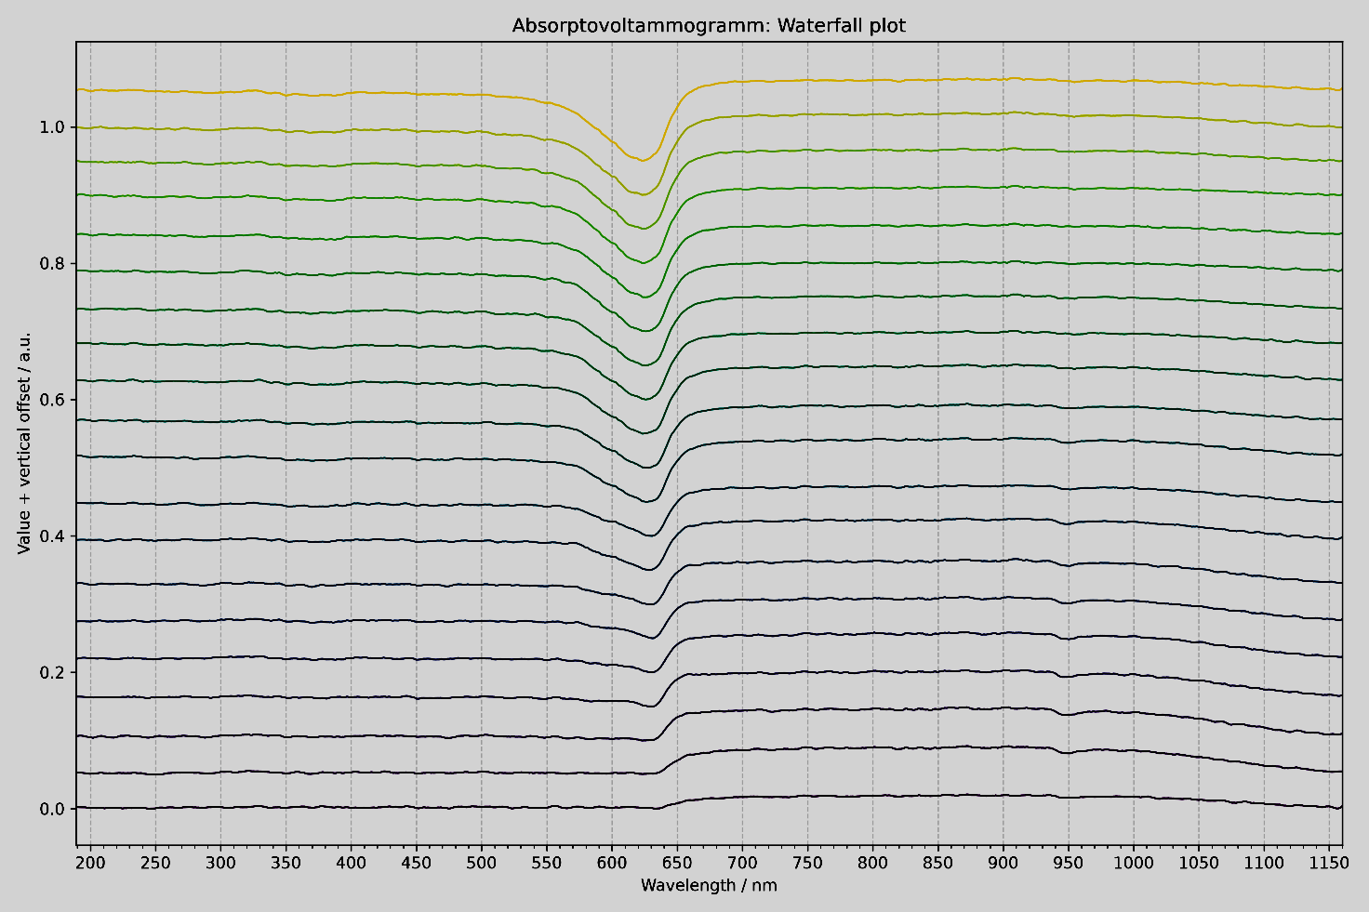
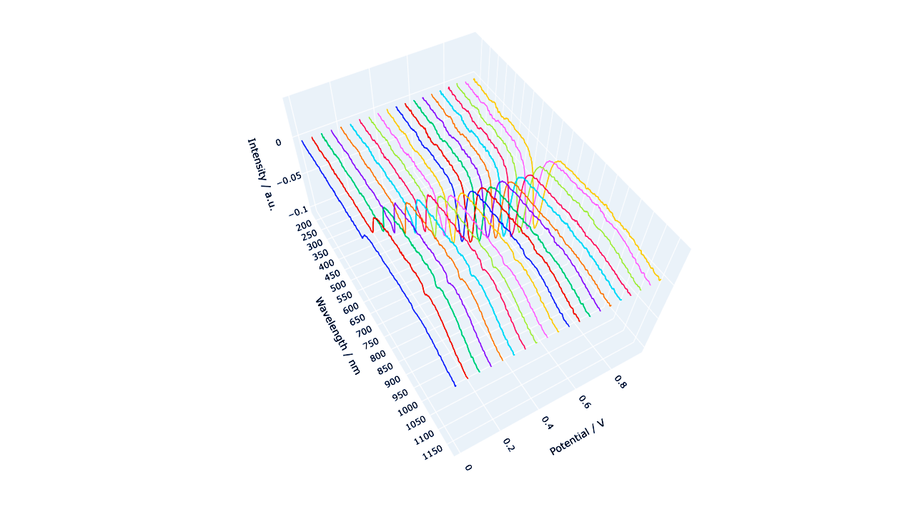
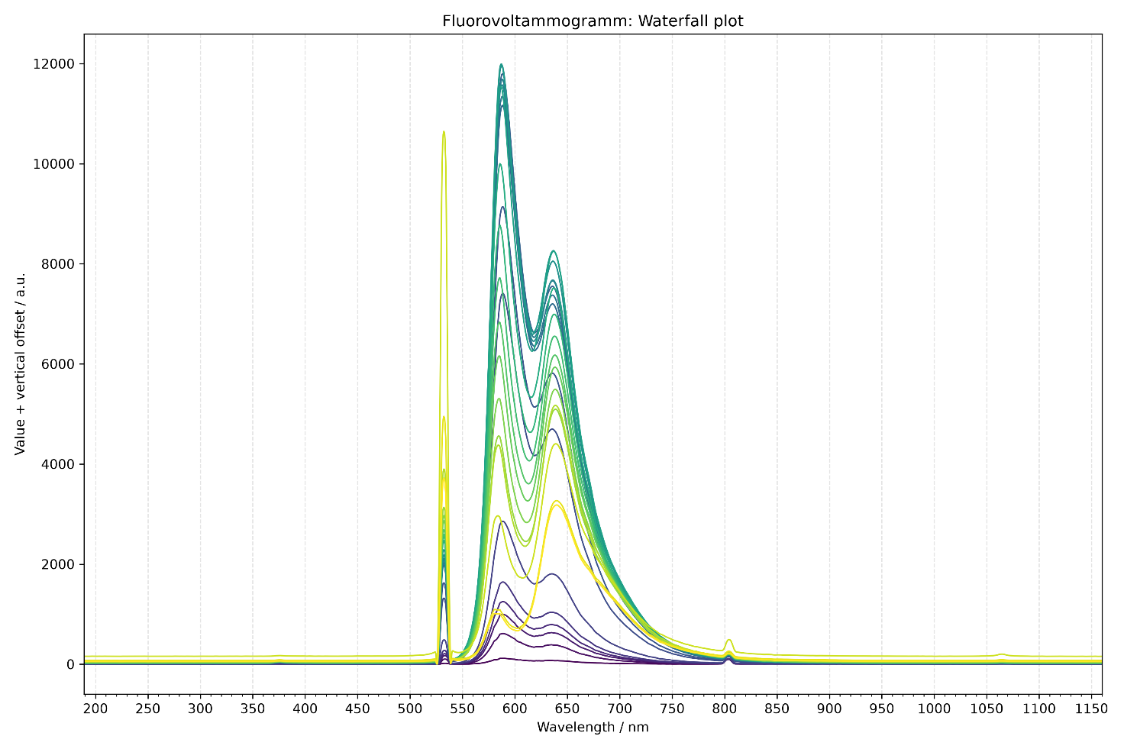
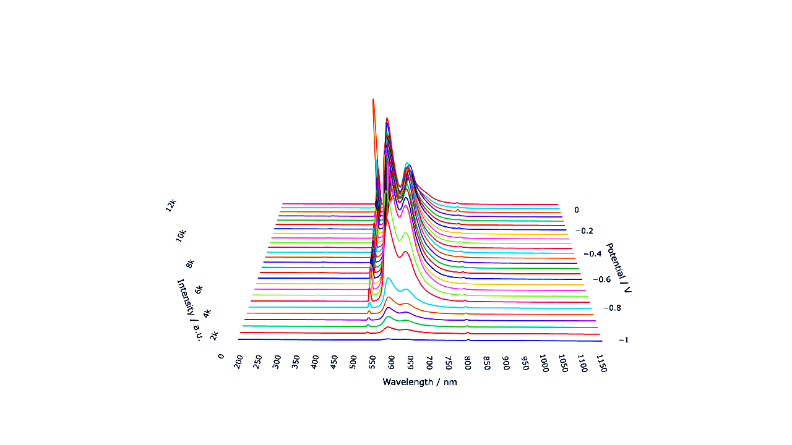

11.5 Interactive HTML
HTML files open in a web browser. The Plotly controls allow rotation, zooming, panning and image export. Some files may load the Plotly JavaScript library from a content-delivery network; offline use may therefore depend on how the HTML file was generated.

12. Excel and file exports

12.1 Output location
If an output folder is selected, all generated files are written there. Otherwise, many modules use the folder containing the source CSV file. Use a dedicated analysis folder to avoid mixing raw and processed data.

12.2 Metadata
Metadata sheets document the source file, the selected range, the matrix dimensions, the smoothing method and the scaling method. Keep this sheet with the numerical outputs when data are transferred to collaborators.

12.3 Matrix and long formats
- Matrix format is convenient for surface and heatmap creation.
- Long format contains one row per spectral-coordinate/potential pair and is convenient for statistical software and database import.

12.4 File naming
Generated file names commonly include the source stem, the selected spectral range, the smoothing method, the scaling method and the plot type. Do not rename files in a way that removes processing information unless the information is preserved elsewhere.

13. Recommended scientific workflow
- Archive the original instrument export as read-only raw data.
- Create a working copy in CSV format.
- Check the axis orientation, units, missing values and matrix dimensions.
- Run the analysis first with no smoothing and no clipping.
- Inspect the raw plots for spikes, discontinuities and import errors.
- Apply the least aggressive processing that adequately addresses the analytical problem.
- Inspect the baseline and smoothing control plots.
- Export all numerical stages, not only the final figure.
- Record the software version, DOI and all parameters in the laboratory notebook.
- For publication, state whether values were baseline-corrected, smoothed, clipped, logarithmically transformed or vertically offset.

14. Troubleshooting
Problem | Likely cause | Recommended action
Batch file opens and closes immediately | Python or a package is missing | Open Command Prompt in the program folder and run the batch file there to read the error message.
“python” is not recognized | Python is not on PATH | Reinstall Python with “Add Python to PATH” enabled, or edit the batch file to use the py launcher.
ModuleNotFoundError | Packages were installed into another Python environment | Run “python -m pip install -r requirements.txt” using the same interpreter that starts the program.
CSV file not accepted | Non-numeric cells, wrong delimiter, incorrect matrix orientation or encoding | Open the file in a text editor, verify the first row/column, and export it again as CSV UTF-8.
No data points in the selected range | Range lies outside the detected axis values | Use the range-check function and enter limits within the available interval.
Savitzky–Golay error | Window is even, too small or longer than the available data | Use an odd window larger than the polynomial order and smaller than the number of spectral points.
Plot dominated by a single spike | Cosmic ray or extreme outlier | Inspect the raw data; correct the raw measurement if scientifically justified, or use percentile clipping for visualization only.
Baseline removes real bands | Baseline parameters are too aggressive | Reduce the polynomial flexibility or penalty settings and inspect the baseline overlay.
Interactive HTML is blank offline | Plotly JavaScript is referenced online | Connect to the Internet, or regenerate the HTML with embedded Plotly JavaScript.
Excel file cannot be overwritten | The workbook is open in Excel | Close the workbook, or select a different output file name or folder.
Application does not start from another folder | An old batch file used a fixed path | Use the release batch file, which starts relative to its own location, and keep the project files together.
Memory Error during export | Very large matrices | Reduce the spectral range or process the dataset in smaller sections

15. Reproducibility and data integrity
- Retain the original CSV file and the instrument-native file.
- Record the exact software version and the version-specific DOI.
- Record all processing parameters and the selected spectral ranges.
- Preserve the exported metadata, raw matrices and processed matrices.
- Do not infer quantitative concentrations from arbitrary intensity values without calibration.
- Use the same processing settings when comparing samples, unless a justified exception is documented.
- Verify that the exported figures correspond to the numerical workbook used in the publication.
- Archive the generated Excel workbook together with the corresponding HTML and PDF outputs.
Version-specific citation: For analyses performed with version 4.0.1, cite DOI 10.5281/zenodo.21283232. The concept DOI 10.5281/zenodo.21283231 refers to the software project across versions and resolves to the latest archived release.

16. Citation and licensing

16.1 Recommended citation
Habekost, A. (2026). SpectroElectroChem Suite (Version 4.0.1) [Computer software]. Zenodo. https://doi.org/10.5281/zenodo.21283232

16.2 Software availability statement
SpectroElectroChem Suite is open-source software for the analysis and visualization of Raman, SERS, absorption and fluorescence spectro-electrochemical data. The source code is available from the GitHub repository, and the version used in this work is permanently archived on Zenodo (DOI: 10.5281/zenodo.21283232).

16.3 License
The software is distributed under the MIT License. Users may use, copy, modify and redistribute the software subject to the license terms. The software is provided without warranty. Consult the LICENSE file included in the repository for the full legal text.

16.4 Acknowledgement
Parts of the source code were developed with the assistance of OpenAI ChatGPT and were subsequently reviewed, scientifically validated, modified and substantially extended by the author.

Appendix A. CSV templates

A.1 Raman/SERS voltammogram template

 | −0.40 | −0.30 | −0.20 | −0.10
300 | 120 | 125 | 131 | 140
305 | 118 | 124 | 130 | 139
310 | 119 | 126 | 134 | 143
315 | 123 | 129 | 138 | 148

A.2 Absorption/fluorescence voltammogram template

 | 0.00 | 0.10 | 0.20 | 0.30
400 | 0.021 | 0.028 | 0.039 | 0.051
405 | 0.023 | 0.031 | 0.043 | 0.056
410 | 0.026 | 0.035 | 0.048 | 0.062
415 | 0.030 | 0.040 | 0.054 | 0.069

A.3 Raman spectrum template
300 | 120
305 | 118
310 | 119
315 | 123

A.4 Absorbance spectrum template
300 | 0.120
305 | 0.118
310 | 0.119
315 | 0.123

A.5 Fluorescence spectrum template
300 | 120
305 | 118
310 | 119
315 | 123

Appendix B. Output-file glossary
Output | Meaning
Raw_Intensity_Matrix | Imported numerical matrix after axis and empty-cell validation.
Smoothed_Intensity_Matrix | Matrix after the selected smoothing operation.
Plotted_Intensity_Matrix | Values actually used for the visual output, after optional clipping or logarithmic scaling.
Waterfall_Unshifted_Values | Processed spectra before vertical displacement.
Waterfall_Shifted_Values | Spectra after addition of the waterfall offsets.
Waterfall_Offsets | Numerical offset applied to each spectrum.
Metadata | Source, range, dimensions and processing settings.
*.html | Interactive browser-based plot.
*.png | Static raster figure.
*.pdf | Static vector or page figure, depending on the export method.
*.xlsx | Excel workbook with numerical data and metadata.

Appendix C. Quick-start checklist
- Download the official ZIP archive from Zenodo or GitHub.
- Extract the ZIP archive completely.
- Install Python 3.10 or newer.
- Run Install_required_Python_packages.bat once.
- Run Test_Installation.bat.
- Start the application with Start_SpectroElectroChem_Suite.bat.
- Select the correct analysis module.
- Load a correctly formatted CSV file.
- Choose a valid spectral range.
- Use conservative processing parameters.
- Run the analysis and inspect the control plots.
- Keep the raw, processed and metadata outputs together.
- Cite version 4.0.1 with DOI 10.5281/zenodo.21283232.
End of User Manual

