
SpectroElectroChem Suite
USER MANUAL
Version 5.5.2
Open-source software for Raman, SERS, absorption and fluorescence spectroelectrochemistry, and RRDE data analysis
Author | Prof. Dr. Achim Habekost
Release | v5.5.2
Concept DOI | https://doi.org/10.5281/zenodo.21283232
Repository | https://github.com/Achim-Habekost/SpectroElectroChem-Suite
License | MIT License
Parts of the source code were developed with the assistance from OpenAI ChatGPT and were subsequently reviewed, scientifically validated, modified and substantially extended by the author.

Document status and scope
This manual describes SpectroElectroChem Suite version 5.5.2. It is intended for scientists, students, and technical staff who wish to analyze their own comma-separated value (CSV) files without modifying the Python source code. The software provides graphical workflows for the processing and visualization of Raman, SERS, absorption, fluorescence and RRDE data for various types of spectra and voltammograms, e.g. for smoothing, background subtraction and creating waterfall, surface and other diagrams.
Important: SpectroElectroChem Suite is now available in two forms. (1) A ready-to-run Windows program: a self-contained executable (SpectroElectroChem_Suite.exe) that can be started directly, plus an optional Windows installer that adds Start-menu and desktop shortcuts. Neither requires a separate Python installation. (2) The Python source distribution, which is started with the included batch files and requires Python 3.10 or newer. Both forms provide the same four analysis modules (Raman, SERS/Raman voltammograms, absorpto-/fluorovoltammograms and RRDE).

Table of contents
1. Overview
2. Obtaining the software
3. System requirements
4. Installation on Windows
5. Starting and closing the application
6. Input-file specifications
7. Raman spectrum analysis
8. Raman/SERS voltammograms
9. Absorption and fluorescence voltammograms
10 RRDE Analysis
11 Signal processing
12 Graphical output
13 Excel export
14 Recommended scientific workflow
15 Troubleshooting
16 Reproducibility
17. Citation and licensing
Appendix A. CSV templates
Appendix B. Output-file glossary
Appendix C. Quick-start checklist
Appendix D. Typical RRDE Parameters

1. Overview

1.1 Purpose
SpectroElectroChem Suite is a modular desktop application for processing, visualizing and exporting spectroscopic and spectro-electrochemical data. It is designed to reduce the amount of manual spreadsheet work required for multi-spectrum data sets while preserving transparent numerical outputs for independent inspection.

1.2 Supported analytical workflows
- Single Raman spectra or multiple Raman spectra stored in columns: smoothing, baseline correction, peak analysis and waterfall visualization.
- Raman and SERS voltammograms: potential-resolved Raman intensity matrices.
- Absorptovoltammograms: potential-resolved absorption spectra.
- Fluorovoltammograms: potential-resolved fluorescence spectra.
- RRDE voltammograms: rotation-rate-resolved disk and ring currents for the rotating ring–disk electrode.

1.3 Principal outputs
- Processed Excel workbooks containing numerical results and metadata.
- Static PNG and PDF figures for reports and publications.
- Interactive HTML figures for rotation, zooming and visual inspection.
- 3D surfaces, heatmaps, contour plots and waterfall diagrams.
- Raw, smoothed, baseline-corrected and vertically offset data, depending on the selected module.
- Levich, Koutecký–Levich, Tafel and Butler–Volmer analyses.

1.4 Intended use and limitations
The software is intended as a scientific analysis and visualization aid. It does not replace validation of instrumental data, inspection of raw spectra, calibration, uncertainty analysis or expert interpretation. Parameters such as the smoothing window, baseline model, peak prominence and waterfall offset must be selected with reference to the spectral resolution, the signal-to-noise ratio and the specific scientific question.

2. Obtaining the software

2.1 Zenodo archive
The archived version can be accessed through the persistent DOI:
https://doi.org/10.5281/zenodo.21283232
On the Zenodo record page, download the ZIP archive associated with version 5.5.2. Zenodo provides a permanently archived snapshot together with citation metadata.

2.2 GitHub repository
The development repository and release page are available at:
https://github.com/Achim-Habekost/SpectroElectroChem-Suite
Use GitHub for source inspection, issue reporting and future releases. Use the Zenodo DOI when citing the archived version used in a scientific study.

2.3 After downloading
- Save the downloaded ZIP archive to a local folder.
- Right-click the archive and choose Extract All.
- Open the extracted project folder. Do not run batch files directly from inside the ZIP archive.
Security notice: Windows may mark downloaded batch files as downloaded from the Internet. Inspect the files and source code before execution, and use only the official GitHub or Zenodo release.

3. System requirements
Component | Minimum / required | Recommended
Operating system | Windows 10 or 11 | 64-bit Windows 11
Python | Python 3.10 or newer | Current stable 64-bit Python
Memory | 4 GB RAM | 8 GB or more for large matrices
Storage | Approx. 1 GB plus output files | Several GB for large Excel/HTML exports
Internet | Needed initially for package installation | Needed to load Plotly from a CDN in some HTML outputs
Spreadsheet viewer | Optional | Microsoft Excel or LibreOffice Calc
Web browser | Modern browser | Firefox, Edge or Chrome

3.1 Required Python packages
The release requirements file lists the packages used by the different modules. The principal packages are:
- NumPy – numerical arrays and matrix operations.
- pandas – CSV input and tabular data handling.
- SciPy – Savitzky–Golay filtering, peak processing and numerical routines.
- pybaselines – baseline-estimation algorithms, where used.
- Matplotlib – static plots and PDF/PNG export.
- Plotly – interactive HTML visualizations.
- openpyxl – Excel workbook creation.
- PySide6 and/or Tkinter – graphical user interfaces, depending on the module implementation.

4. Installation on Windows
Revision (v5.5.2): The self-contained Windows program — the ready-to-run executable and the optional installer described in Section 4.5 — is the recommended installation route and requires no separate Python installation. Installation from the Python source distribution (Sections 4.1–4.4) is provided as an alternative for advanced users and developers and is summarised in Appendix E.

4.1 Install Python
Alternative (advanced) route: the following Python-source steps (Sections 4.1–4.4) are only required if you do not use the executable or installer from Section 4.5. A condensed version is given in Appendix E.
- Download Python 3.10 or newer from the official Python website.
- During installation, enable Add Python to PATH if that option is shown.
- Complete the installation and restart Windows, or at least reopen File Explorer and Command Prompt.

4.2 Install required packages
In the extracted program folder, double-click:
Install_required_Python_packages.bat
A console window will open and install the packages listed in requirements.txt. Internet access is normally required during this step. The step is generally needed only once for a given Python environment.

4.3 Test the installation
Run:
Test_Installation.bat
The test verifies that Python and the principal dependencies can be imported. If the console window closes immediately, launch the batch file from Command Prompt to retain the error message.

4.4 Manual installation alternative
Alternatively, open Command Prompt in the program folder and run:
py -m pip install -r requirements.txt
If the py launcher is unavailable, try:
python -m pip install -r requirements.txt
Multiple Python installations: If package installation succeeds but the application still reports missing modules, the batch files may be using a different Python installation from the one in which the packages were installed. Use “py -0p” in Command Prompt to list the installed Python interpreters.

4.5 Installation using the Windows executable or installer
From version 5.5.2, the suite is also distributed as a ready-to-run Windows program that does not require a separate Python installation. Two variants are provided.
Portable version. Extract the distributed program folder and double-click the executable:
SpectroElectroChem_Suite.exe
All required libraries are bundled inside the folder. Keep the executable together with the accompanying files and sub-folders; do not move the .exe out of its folder.
Windows installer (setup). Alternatively, run the setup program (for example SpectroElectroChem_Suite_Setup.exe). The installer copies the program into the standard applications folder and creates Start-menu and desktop shortcuts. The application can then be started like any other installed Windows program.
The executable and the installer are built from the same source code as the Python distribution and provide the identical four analysis modules. No Python interpreter, batch file or package installation is needed for these variants.
Security notice: Because the executable is newly published and not code-signed, Windows SmartScreen or the antivirus software may display a warning on first start. Verify that the file was obtained from the official GitHub or Zenodo release, then choose “More info” and “Run anyway” if you trust the source.

5. Starting and closing the application

5.1 Standard start
Double-click:
Start_SpectroElectroChem_Suite.bat
The launcher adds the src folder to the Python search path and opens the central application window. Depending on the release build, the main window offers module buttons or menu entries for Raman spectrum analysis, Raman/SERS voltammograms, and absorption/fluorescence voltammograms.

5.2 Start from Command Prompt
cd "C:\path\to\SpectroElectroChem_Suite"
python main.py

5.3 Starting from the Windows executable
If the ready-to-run program or the installed version is used, start the suite directly:
- Portable version: double-click SpectroElectroChem_Suite.exe inside the program folder.
- Installed version: use the Start-menu entry or the desktop shortcut created by the installer.
The central application window opens with buttons or menu entries for the four modules. No Command Prompt, batch file or Python installation is required in this case.

5.4 Closing
Close module windows using their normal Close or X button. Allow ongoing Excel or HTML export operations to finish before closing. Interactive HTML plots remain available as independent files after the application has been closed.

6. Input-file specifications

6.1 General CSV rules
- Use a true CSV text file, not an .xlsx file merely renamed to .csv.
- Decimal points and decimal commas are accepted by many import paths, but a decimal point is recommended for portability.
- Do not mix text comments into the numerical matrix unless the module explicitly supports metadata rows.
- Avoid merged cells, hidden rows and formulas; export numerical values only.
- Remove completely empty trailing rows and columns where practical.
- Keep a copy of the unmodified raw instrument export.

6.2 Matrix format for Raman/SERS voltammograms
The first row contains the potentials, the first column contains the Raman shifts (wavenumbers), and all remaining cells contain Raman intensities.
 | −0.40 | −0.30 | −0.20 | −0.10
300 | 120 | 125 | 131 | 140
305 | 118 | 124 | 130 | 139
310 | 119 | 126 | 134 | 143
315 | 123 | 129 | 138 | 148

6.3 Matrix format for absorption and fluorescence voltammograms
The first row contains the potentials and the first column contains the wavelengths. The remaining cells contain absorbance, fluorescence intensity or another measured optical response. If there is only one absorbance or fluorescence spectrum, the potential row is missing.
 | 0.00 | 0.10 | 0.20 | 0.30
400 | 0.021 | 0.028 | 0.039 | 0.051
405 | 0.023 | 0.031 | 0.043 | 0.056
410 | 0.026 | 0.035 | 0.048 | 0.062
415 | 0.030 | 0.040 | 0.054 | 0.069

6.4 Raman spectrum table format
For Raman spectrum analysis, the first numerical column contains the Raman shift and the remaining columns contain one or more intensity spectra. Header labels may be used to identify individual spectra at various potentials. The exact import options are displayed by the module.

6.5 Axis order
Some modules sort the potential and spectral axes automatically. Nevertheless, ascending, unique numerical axis values are recommended. Duplicate potentials or duplicate wavelengths/wavenumbers should be resolved before analysis unless they represent intentional replicate measurements.
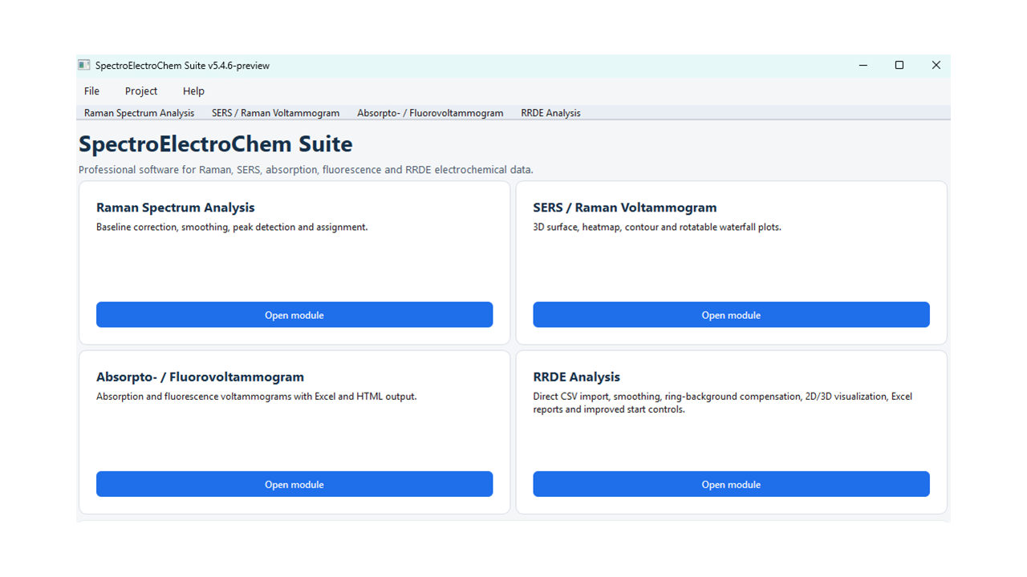
Figure 1: Initial input

7. Raman spectrum analysis

7.1 Purpose
This module processes individual Raman spectra or collections of spectra stored in columns. It can generate raw, smoothed, baseline-corrected and combined data sets, locate peaks, calculate peak parameters and create waterfall plots.

7.2 Typical workflow
- Open the Raman Spectrum Analysis module.
- Select the CSV input file.
- Enter or confirm the Raman shift range.
- Choose the baseline correction parameters.
- Choose the Savitzky–Golay smoothing parameters.
- Set the peak-finding parameters, if peak analysis is required.
- Select an optional reference peak list, if identification is required.
- Set the maximum Raman intensity for plotting, if a fixed scale is desired.
- Set the waterfall vertical offset and plot orientation, where available.
- Run the analysis and inspect the generated control plots before accepting the results.

7.3 Baseline correction
Baseline correction estimates the slowly varying background and subtracts it from the measured spectrum. A visually smooth baseline-corrected spectrum is not sufficient evidence that the baseline is physically appropriate. Depending on the current plugin, the module may provide polynomial or penalized-baseline methods. Baseline correction should remove broad fluorescence or instrumental background (e.g. scattering) without distorting genuine broad Raman bands.
Scientific check: Always inspect the baseline overlay. A visually smooth baseline-corrected spectrum candidate assignmentis not sufficient evidence that the baseline is physically appropriate. Check low-intensity regions, broad bands and the spectrum edges.

7.4 Savitzky–Golay smoothing
Savitzky–Golay smoothing performs a local polynomial fit. The window length must be odd and larger than the polynomial order. A window that is too large can reduce peak heights, merge neighbouring bands or alter the FWHM. Select a window consistent with the sampling interval and the expected peak width.

7.5 Peak analysis
Peak finding typically uses prominence and minimum-distance criteria. The output may include peak position, intensity and full width at half maximum (FWHM). Peak identification against a reference list is tolerance-based and must be treated as a tentative assignment, not as definitive chemical proof.
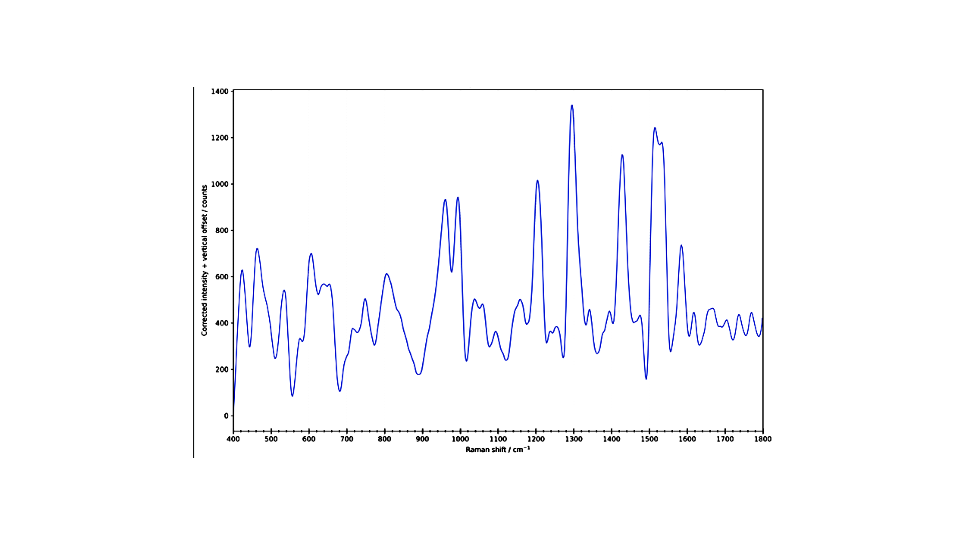
Figure 2: Smoothed and baseline-corrected Raman spectrum (rubrene).

7.6 Raman Excel workbook
Depending on the software version the Excel workbook typically contains the following worksheets:
- Original spectra
- Smoothed-only spectra
- Baseline-corrected-only spectra
- Baseline-corrected and smoothed spectra
- Calculated baselines
- 2D waterfall data
- Peak parameters
- Peak identification results
- Reference data used
- Summary/interpretation

8. Raman/SERS voltammograms

8.1 Purpose
The Raman/SERS voltammogram module processes a spectral intensity matrix as a function of Raman shift and electrode potential. It is suitable for potential-dependent Raman or surface-enhanced Raman data.

8.2 Loading and range selection
- Select the CSV matrix file.
- Select an output folder, or leave the output-folder field empty to use the input-file folder.
- Use the range-reading function, if available, to display the detected Raman-shift and potential ranges.
- Enter the desired lower and upper Raman-shift limits.

8.3 Smoothing options
- None – preserves the measured matrix.
- Moving average – simple smoothing over a selected number of points.
- Savitzky–Golay – polynomial smoothing with a selected odd window length and polynomial order.

8.4 Intensity scaling
- Raw / linear – preserves the original plotted magnitude.
- Clip at the 99th percentile + log1p reduces the influence of extreme spikes on the color scale.
- log1p – compresses the dynamic range after shifting negative values, if necessary.
- Clip99 + log1p – combines spike suppression and logarithmic compression.
Interpretation: Scaling modes modify the visualization matrix and may also be exported as plotted values. They do not convert arbitrary intensity units into quantitative concentrations.

8.5 Baseline correction and peak parameters
- SERS spectra usually require little or no baseline correction.

Peak No | Position (cm⁻¹) |  | Intensity |  | FWHM (cm⁻¹)
1 | 443.572 | 3237.016 |  | 70.73005
2 | 485.158 | 2005.668 |  | 13.27788
3 | 545.501 | 104.1584 |  | 3.79017
4 | 607.772 | 423.8645 |  | 59.87418
5 | 642.605 | 179.7476 |  | 6.285982
6 | 708.867 | -260.501 |  | 2.38847
7 | 763.801 | 989.6835 |  | 41.52643
8 | 807.793 | 225.7842 |  | 3.46681
9 | 853.913 | -26.1113 |  | 9.527231
10 | 879.333 | -189.92 |  | 3.532601
11 | 909.649 | 27.43816 |  | 5.6194
12 | 954.741 | 271.4507 |  | 79.89512
13 | 991.971 | 247.2508 |  | 15.23369
14 | 1067.933 | 55.90622 |  | 56.92809
15 | 1171.156 | 1220.993 |  | 47.16028
16 | 1220.683 | 11.66072 |  | 9.632227
17 | 1246.398 | -48.9973 |  | 6.112788
18 | 1299.668 | 530.7832 |  | 35.58292
19 | 1331.767 | -33.6803 |  | 3.2529
20 | 1395.234 | 2346.762 |  | 33.20733
21 | 1457.745 | 178.5831 |  | 3.400773
22 | 1486.447 | 410.5359 |  | 60.54273
23 | 1547.589 | -144.147 |  | 35.24608
24 | 1584.265 | -229.842 |  | 11.93203
25 | 1618.48 | 2967.378 |  | 34.49392
26 | 1671.359 | 157.6585 |  | 34.36061

8.6 Manual intensity limits
When automatic intensity scaling is disabled, enter minimum and maximum intensity values. Interactive 3D figures may also include buttons for automatic Z scaling, manual Z scaling and percentile-based ranges.

8.7 Waterfall and surface plots
The waterfall plot displays each spectrum with a vertical displacement. Use the vertical offset to prevent overlap while preserving relative peak patterns. Interactive plots can be rotated; static plots are intended for publications and reports. Avoid offsets so large that potential-dependent trends become visually exaggerated.
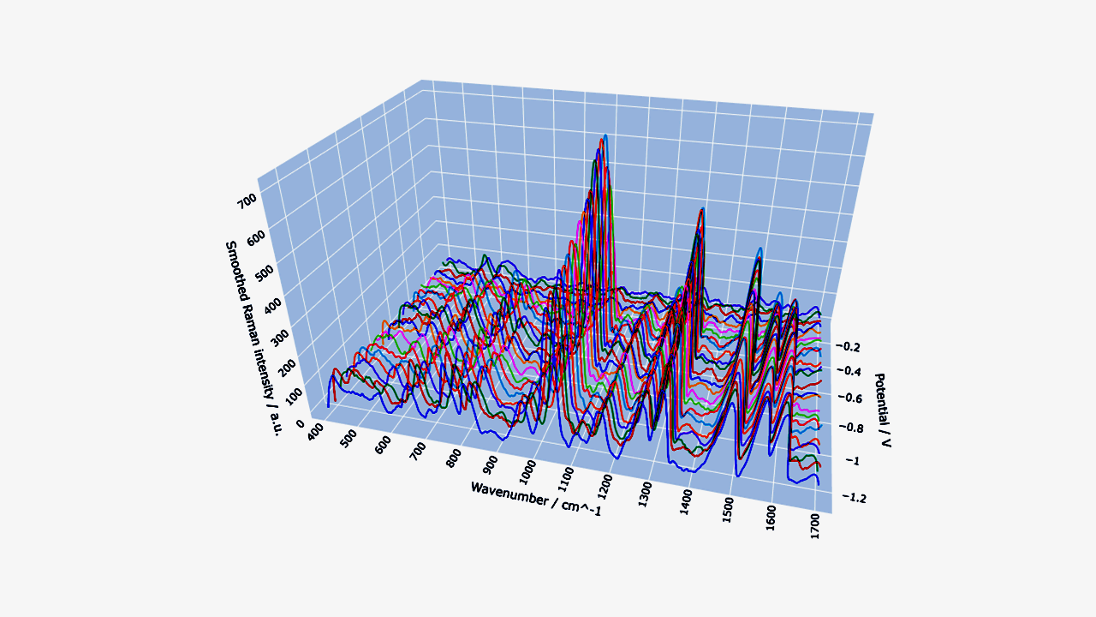
Figure 3: Interactive 3D waterfall plot of methylene blue Raman spectra recorded at different electrode potentials.

8.8 Expected outputs
- Processed Excel workbook
- Interactive 3D surface (HTML)
- Interactive heatmap (HTML)
- Interactive contour plot (HTML)
- Interactive rotatable waterfall plot (HTML)
- Optional raw-versus-smoothed comparison waterfall
- Static PNG/PDF plots, where enabled

8.9 Excel sheets
The exported workbook typically contains Metadata, Raw_Intensity_Matrix, smoothed_Intensity_Matrix, Plotted_Intensity_Matrix and the corresponding long-format tables. Current waterfall-enabled releases may also include shifted values, unshifted values and offset tables for custom plotting in Excel.

9. Absorpto- and fluorovoltammograms

9.1 Purpose
This combined module analyzes potential-resolved absorption or fluorescence matrices. The data structure is analogous to that of the Raman voltammogram module, but the spectral axis is wavelength rather than Raman shift, and the response values are absorbance or fluorescence intensity.

9.2 Select the analysis mode
Choose Absorption or Fluorescence so that titles, axis labels and output metadata match the selected measurement type. The underlying matrix orientation remains the same: potentials in the first row, wavelengths in the first column.

9.3 Wavelength range
Select only the spectral interval needed for interpretation. Restricting the range can reduce file size and improve visual resolution. Ensure that the selected interval includes the complete band shape when comparing peak positions or widths.

9.4 Waterfall data for Excel
In addition to the graphical waterfall output, the module exports numerical waterfall values for user-defined Excel plots. The shifted matrix contains the vertical offsets, the unshifted matrix preserves the processed spectral values, and a separate offset table documents the applied vertical offset.

9.5 Typical outputs
- Processed absorption or fluorescence matrix
- Interactive surface, heatmap and contour files
- Interactive and/or static waterfall plot
- Excel workbook containing raw/processed data, metadata and waterfall.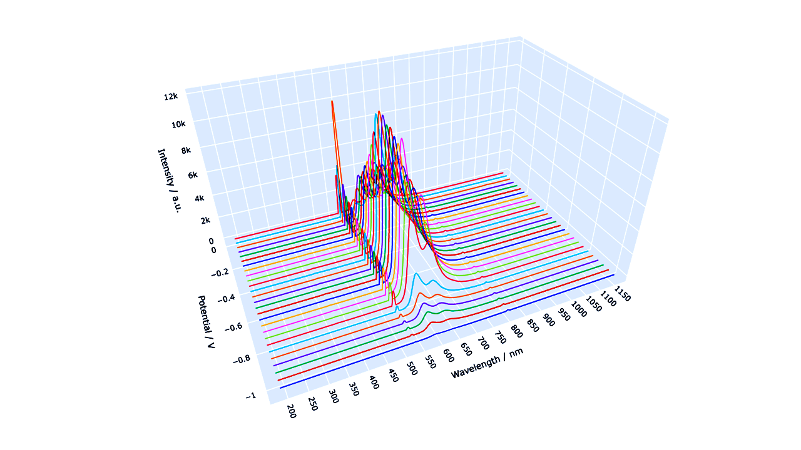
Figure 5: Fluorovoltammogram of rubrene at different potentials.

10. Rotating Ring–Disk Electrode (RRDE) Analysis

10.1 Introduction
The rotating ring–disk electrode (RRDE) is a well-established electrochemical technique for investigating electrochemical reaction mechanisms and soluble intermediates. In contrast to conventional Rotating Disk Electrode (RDE) experiments, the RRDE combines a central disk electrode with a concentric ring electrode. During an experiment, both electrodes rotate simultaneously at a precisely controlled speed.
Species generated at the disk electrode are transported by convection to the surrounding ring electrode, where they can be detected electrochemically. This enables simultaneous investigation of the primary electrochemical reaction occurring at the disk and the fate of soluble intermediates.
Typical applications include:
- Oxygen reduction reaction (ORR)
- Hydrogen peroxide detection
- Evaluation of catalyst selectivity
- Metal deposition and dissolution
- Electrochemical reaction mechanism studies
- Homogeneous redox mediators
Compared with conventional RDE measurements, RRDE experiments provide considerably more mechanistic information because both the main reaction and intermediate products can be monitored simultaneously.

10.2 Principle of the RRDE
The RRDE consists of two independently controlled working electrodes:
- Disk electrode (WORKING ELECTRODE1): where the primary electrochemical reaction occurs.
- Ring electrode (WORKING ELECTRODE2): detects products formed at the disk.
Both electrodes rotate with the same angular velocity. Rotation generates a well-defined hydrodynamic flow that transports dissolved species from the disk to the ring.
Only a fraction of the products generated at the disk reaches the ring. This fraction is called the collection efficiency (N).
Typical collection efficiencies range from approximately 0.20 to 0.40, depending on the electrode geometry.
For the Metrohm Pt/GC RRDE (3.109.4080), the nominal collection efficiency is approximately 25 %.

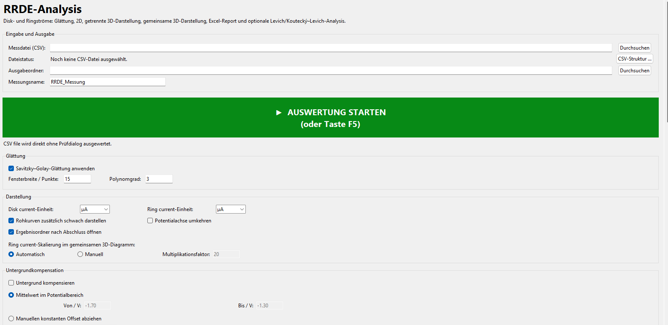Figure 6: The first part of the input for the RRDE analysis.

10.3 Data Import
SpectroElectroChem Suite imports RRDE data directly from CSV files exported by NOVA.
The expected data structure is
Column | Content
1 | Potential
2 | Disk current (Rotation 1)
3 | Ring current (Rotation 1)
4 | Disk current (Rotation 2)
5 | Ring current (Rotation 2)
... | Additional rotation speeds
The first row contains the rotation speed for each measurement pair.
Example:
Potential (V) | Disk 500 rpm | Ring 500 rpm | Disk 1000 rpm | Ring 1000 rpm
0.20 | ... | ... | ... | ...
After import, the software automatically identifies
- rotation speed,
- disk current,
- ring current,
- measurement order.
No manual column assignment is required, which minimizes user interaction and reduces the risk of assignment errors.

10.4 Main RRDE Window

The RRDE module provides a graphical interface for importing, processing and evaluating RRDE measurements.
The main window contains the following sections:

Data Import
- Load CSV file
- Automatic recognition of rotation speeds
- Automatic assignment of disk and ring currents

Background Correction
The user may choose between
- no correction,
- manual background correction,
- subtraction of a Nitrogen Background Measurement.
Background correction is applied only to the ring current, since the ring current is generally much smaller than the disk current and therefore more susceptible to background contributions.

Collection Efficiency
The collection efficiency N may either
- be entered manually,
- or taken from the electrode manufacturer's specifications.
Typical values range between 0.20 and 0.40.

10.5 Ring Background Correction
In many RRDE experiments, the ring current contains contributions unrelated to the electrochemical intermediate of interest.
Examples include
- capacitive currents,
- oxidation of impurities,
- oxygen-independent reactions,
- electrode surface processes.
SpectroElectroChem Suite therefore offers two background correction methods.

Manual Background
A constant background current can be subtracted from all ring currents.
This method is suitable if the background remains approximately constant throughout the experiment.

Nitrogen Background Measurement
A second RRDE experiment recorded under nitrogen atmosphere can be imported.
The software subtracts the complete background point by point:
I_{Ring,corr} = I_{Ring,O2} − I_{Ring,N2}
This approach is recommended whenever accurate determination of hydrogen peroxide yield is required.

10.6 Collection Efficiency
The collection efficiency N describes the fraction of reaction products formed at the disk that reaches the ring electrode.
It depends exclusively on the RRDE geometry.
Typical values are
- Metrohm Pt/Pt RRDE: approximately 0.25
- Metrohm Pt/GC RRDE: approximately 0.25
The user-defined collection efficiency is applied in all RRDE calculations. The ratio IRing​/IDisk​ may be used only under suitable experimental conditions to estimate the effective collection efficiency and should not be interpreted as its general definition. Only for calibration and subsequently applies the user-defined collection efficiency in all calculations.
An incorrect value of N directly affects
- hydrogen peroxide yield,
- electron-transfer number,
- kinetic analysis.
Therefore the manufacturer-recommended value should normally be used.
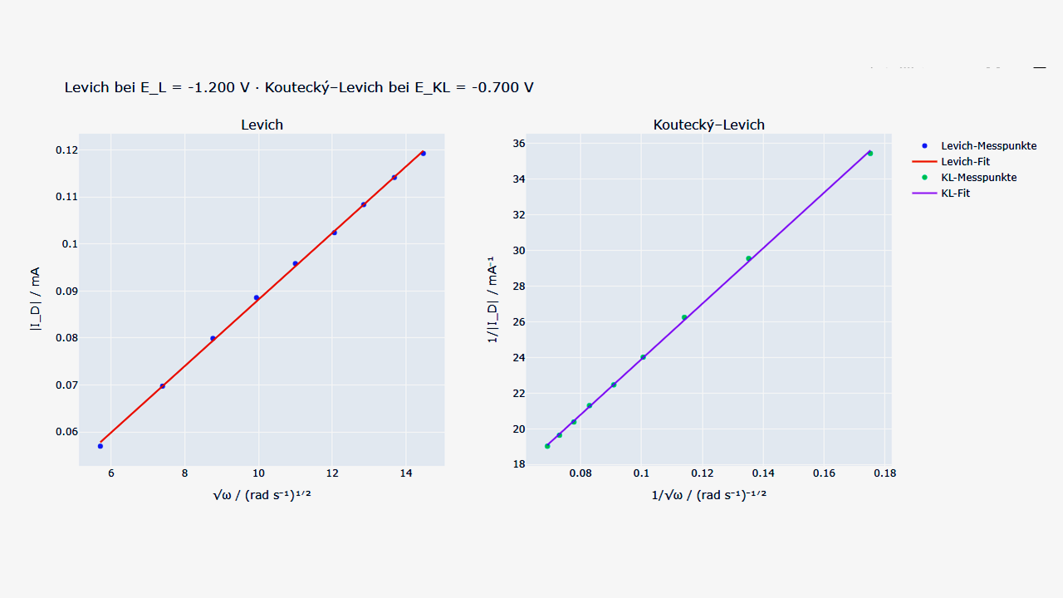 Figure 7: Levich (left) and Koutecký-Levich (right) graphs.

10.7 Electron-Transfer Number
One of the most important RRDE parameters is the apparent number of transferred electrons.
SpectroElectroChem Suite calculates
n = 4 · I_{D} / (I_{D} + I_{R}/N)
where
- I_{D} = disk current
- I_{R} = ring current
- N = collection efficiency.
Typical interpretation:
n | Interpretation
≈4 | Direct four-electron reduction
3–4 | Mixed mechanism
≈2 | Hydrogen peroxide formation dominates
For oxygen reduction, values close to four indicate efficient reduction directly to water (acidic media) or hydroxide ions (alkaline media), whereas values near two indicate predominant hydrogen peroxide formation.

10.8 Hydrogen Peroxide Yield
The percentage of hydrogen peroxide generated during oxygen reduction is calculated as
%H₂O₂ = 200 · (I_{R}/N) / (I_{D} + I_{R}/N)
The software calculates and displays the hydrogen peroxide yield as a function of potential and allows comparison of different catalyst materials.
Typical interpretation:
H₂O₂ yield | Interpretation
<5 % | Excellent four-electron catalyst
5–20 % | Mixed reaction pathway
>20 % | Significant peroxide production

10.9 Equilibrium Potential and Reference-Electrode Conversion
For kinetic evaluation, disk potentials are usually expressed as overpotentials relative to the thermodynamic equilibrium (reversible) potential of the reaction under study. SpectroElectroChem Suite can calculate this equilibrium potential automatically from the selected reaction, the pH and the temperature, and convert it to the reference electrode actually used in the experiment.
The pH dependence follows the Nernstian slope 2.303·R·T/F per pH unit (approximately 59 mV per pH unit at 25 °C). The user selects the reaction (for example oxygen reduction, oxygen evolution, hydrogen evolution or hydrogen oxidation), the reference electrode, the pH and the temperature; alternatively a user-defined equilibrium potential can be entered directly.
Scientific check: Verify that the chosen reaction, pH and reference electrode correspond to the real experimental conditions. An incorrect equilibrium potential shifts the entire overpotential axis and therefore the apparent exchange current and Tafel intercept, even though the Tafel slope itself is unaffected.

10.10 Levich and Koutecký–Levich Analysis
The dependence of the diffusion-limited disk current on the rotation rate is evaluated. with the Levich and Koutecký–Levich relations. In the Levich representation the limiting current is plotted against the square root of the angular velocity, √ω. A straight line passing through the origin indicates purely mass-transport-controlled behaviour. In the Koutecký–Levich representation the reciprocal current is plotted against 1/√ω; the intercept yields the kinetic current, which is free of mass-transport limitation.
The software determines the limiting current from a user-selected diffusion-limited plateau and reports the plateau drift, the relative scatter and the plateau slope as quality indicators. Absolute cathodic disk currents are used so that reduction currents are handled consistently. Always inspect the selected plateau region before accepting the analysis: a sloping or drifting plateau indicates that a true limiting current has not been reached.

10.11 Tafel Analysis, Exchange Current and Butler–Volmer Parameters
The Tafel module fits the linear region of the potential–log|current| relationship for each rotation rate and reports the Tafel slope, the intercept and the coefficient of determination R². From the intercept and the equilibrium potential the exchange current, or the exchange current density, is derived.
Current density option. Currents may be evaluated either as measured currents or as current densities. When the current density mode is selected, the disk currents are divided by the geometric electrode area (default 0.196 cm², corresponding to a 5 mm diameter disk). Enter the area that matches the electrode actually used.
Mass-transport correction. Optionally, the Tafel region can be corrected for mass transport using the Koutecký–Levich relation, so that the extracted kinetic current more closely reflects the charge-transfer kinetics rather than the combined kinetic and diffusion response. This requires a valid limiting-current plateau (see Section 10.10).
Standard heterogeneous rate constant. If requested, the standard rate constant k₀ is estimated from the exchange current density through the Butler–Volmer relation
j₀ = n·F·k₀·c_O^(1−α)·c_R^α, using the entered electron number n, transfer coefficient α, and bulk concentrations of the oxidized and reduced species. This calculation is only meaningful for a simple, well-defined one-step redox couple; it is not applied to multi-electron reactions such as ORR, OER, HER or HOR, for which the Butler–Volmer concentration terms are not defined in this simple form.
The Tafel Excel report contains a structured summary sheet with the general settings, the per-curve Tafel results, the limiting-current table (rotation rate, limiting current, drift, relative scatter and plateau slope) and a dedicated section collecting all quality warnings.

10.12 Graphical Output
SpectroElectroChem Suite automatically generates:
- Disk current vs. potential
- Ring current vs. potential
- Combined disk/ring plots
- Hydrogen peroxide yield
- Electron-transfer number
- Interactive three-dimensional RRDE plots
- Excel export of all processed data
All figures can be exported in publication-quality figure resolution.
Interactive HTML figures allow free rotation, zooming and panning.
By convention, disk currents are reported in milliamperes (mA) and ring currents in microamperes (µA), reflecting the much smaller magnitude of the ring current. This convention is applied consistently in the plots, the combined data sheet and the Excel charts.
Static PNG and PDF graphics are intended for publication-quality figures.

10.13 Best Practice
For reliable RRDE measurements the following recommendations are suggested:
- Polish the disk electrode before each experiment.
- Ensure that the ring electrode is clean.
- Use freshly prepared electrolyte.
- Remove dissolved oxygen when recording background measurements.
- Use identical rotation speeds for all comparative measurements.
- Verify the collection efficiency before quantitative analysis.
- Inspect the limiting current plateau before performing Levich or Koutecký–Levich analysis.

10.14 Worked example: oxygen reduction (ORR) in alkaline solution
This example illustrates a complete RRDE workflow for the oxygen reduction reaction and the values a user would typically enter.
Experimental setup. Glassy-carbon disk carrying the catalyst film and a platinum ring; collection efficiency N = 0.25. Electrolyte: 0.1 M KOH saturated with O₂. The ring is held at a constant potential at which peroxide (HO₂⁻) is re-oxidised, for example +0.40 V vs. RHE. The disk is swept from +1.0 V to +0.1 V vs. RHE at 10 mV s⁻¹. Rotation rates: 400, 900, 1600 and 2500 rpm.
Procedure in the software. (1) Import the NOVA CSV file. (2) Subtract an N₂ background for the ring current. (3) Enter the collection efficiency N = 0.25. (4) Select the potential window used for the peroxide evaluation. (5) Run the Levich and Koutecký–Levich analysis over the diffusion-limited plateau. (6) Optionally run the Tafel analysis using the ORR equilibrium potential for the chosen pH.
Typical results and interpretation. For a well-behaved four-electron catalyst the disk limiting current scales linearly with √ω in the Levich plot, the electron number n(E) computed from the disk and ring currents lies close to 4 across the plateau, and the hydrogen-peroxide yield stays below about 5 %. Values of n approaching 2 with a rising %H₂O₂ indicate a two-electron pathway. The Koutecký–Levich intercept gives the kinetic current, and the Tafel slope characterises the charge-transfer kinetics.

11. Signal-processing options

Signal processing is intended to improve data quality while preserving chemically meaningful spectral information. Excessive smoothing or baseline correction may distort quantitative results.

11.1 No processing
Use unprocessed data when the signal quality is sufficient or when the purpose is to document the original measurement. Raw outputs should be retained even when processing is applied.

11.2 Moving average
A moving average replaces each point by a local mean. It is simple and robust but can broaden peaks and shift apparent edges. It is best used for exploratory visualization rather than for quantitative peak-shape analysis.

11.3 Savitzky–Golay filter
The filter preserves polynomial features better than a simple average, but its behaviour depends strongly on the relationship between window length, polynomial order, sampling interval and peak width.

11.4 Baseline subtraction
Baseline methods estimate a low-frequency component. Edge behaviour and broad features require particular care. Record all baseline parameters in reports and retain the calculated baseline in the exported workbook.

11.5 Intensity clipping
Percentile clipping limits extreme values to improve color-scale usage. It should be reported explicitly when figures are used in publications, because it suppresses the displayed magnitude of outliers.

11.6 Logarithmic scaling
log1p scaling increases the visibility of weak features while compressing strong peaks. If negative values are shifted before the transformation, the transformed scale is no longer directly comparable to the original intensity scale.

12. Graphical outputs

12.1 3D surface
The surface plot maps potential, spectral coordinate and response value onto three axes. Rotate and zoom to inspect trends, but confirm interpretations with 2D views, because perspective can hide or exaggerate features.

12.2 Heatmap
The heatmap is often the clearest representation of potential-dependent band evolution. Inspect the color-bar range and check whether clipping or logarithmic scaling has been applied.

12.3 Contour plot
Contours emphasize lines of constant response and can reveal band shifts or transitions. Too many contour levels can suggest a precision that is not present in the measurement.

12.4 Waterfall plot
Waterfall plots show individual spectral traces. They are useful for following peak growth, decay and shift, but the applied offset must be stated or documented.

12.5 Interactive HTML
HTML files open in a web browser. The Plotly controls allow rotation, zooming, panning and image export. Some files may load the Plotly JavaScript library from a content-delivery network; offline use may therefore depend on how the HTML file was generated.

13. Excel and file exports

The exported Excel workbooks are intended to provide full numerical traceability of all graphical results.

13.1 Output location
If an output folder is selected, all generated files are written there. Otherwise, many modules use the folder containing the source CSV file. Use a dedicated analysis folder to avoid mixing raw and processed data.

13.2 Metadata
Metadata sheets document the source file, the selected range, the matrix dimensions, the smoothing method and the scaling method. Keep this sheet with the numerical outputs when data are transferred to collaborators.

13.3 Matrix and long formats
- Matrix format is convenient for surface and heatmap creation.
- Long format contains one row per spectral-coordinate/potential pair and is convenient for statistical software and database import.

13.4 File naming
Generated file names commonly include the source stem, the selected spectral range, the smoothing method, the scaling method and the plot type. Do not rename files in a way that removes processing information unless the information is preserved elsewhere.

14. Recommended scientific workflow
- Archive the original instrument export as read-only raw data.
- Create a working copy in CSV format.
- Check the axis orientation, units, missing values and matrix dimensions.
- Run the analysis first with no smoothing and no clipping.
- Inspect the raw plots for spikes, discontinuities and import errors.
- Apply the least aggressive processing that adequately addresses the analytical problem.
- Inspect the baseline and smoothing control plots.
- Export all numerical stages, not only the final figure.
- Record the software version, DOI and all parameters in the laboratory notebook.
- For publication, state whether values were baseline-corrected, smoothed, clipped, logarithmically transformed or vertically offset.
- Archive both raw data and processed results.

15. Troubleshooting
Problem | Likely cause | Recommended action
Batch file opens and closes immediately | Python or a package is missing | Open Command Prompt in the program folder and run the batch file there to read the error message.
“python” is not recognized | Python is not on PATH | Reinstall Python with “Add Python to PATH” enabled, or edit the batch file to use the py launcher.
ModuleNotFoundError | Packages were installed into another Python environment | Run “python -m pip install -r requirements.txt” using the same interpreter that starts the program.
CSV file not accepted | Non-numeric cells, wrong delimiter, incorrect matrix orientation or encoding | Open the file in a text editor, verify the first row/column, and export it again as CSV UTF-8.
No data points in the selected range | Range lies outside the detected axis values | Use the range-check function and enter limits within the available interval.
Savitzky–Golay error | Window is even, too small or longer than the available data | Use an odd window larger than the polynomial order and smaller than the number of spectral points.
Plot dominated by a single spike | Cosmic ray or extreme outlier | Inspect the raw data; correct the raw measurement if scientifically justified, or use percentile clipping for visualization only.
Baseline removes real bands | Baseline parameters are too aggressive | Reduce the polynomial flexibility or penalty settings and inspect the baseline overlay.
Interactive HTML is blank offline | Plotly JavaScript is referenced online | Connect to the Internet, or regenerate the HTML with embedded Plotly JavaScript.
Excel file cannot be overwritten | The workbook is open in Excel | Close the workbook, or select a different output file name or folder.
Application does not start from another folder | An old batch file used a fixed path | Use the release batch file, which starts relative to its own location, and keep the project files together.
Memory Error during export | Very large matrices | Reduce the spectral range or process the dataset in smaller sections

If interactive HTML plots do not open automatically, verify that a default web browser is configured in Windows.

16. Reproducibility and data integrity
- Retain the original CSV file and the instrument-native file.
- Record the exact software version and the version-specific DOI.
- Record all processing parameters and the selected spectral ranges.
- Record all processing parameters together with the software version and DOI.
- Preserve the exported metadata, raw matrices and processed matrices.
- Do not infer quantitative concentrations from arbitrary intensity values without calibration.
- Use the same processing settings when comparing samples, unless a justified exception is documented.
- Verify that the exported figures correspond to the numerical workbook used in the publication.
- Archive the generated Excel workbook together with the corresponding HTML and PDF outputs.
Version-specific citation: For analyses performed with version 5.5.2, cite DOI 10.5281/zenodo.21283232. The concept DOI 10.5281/zenodo.21283232 refers to the software project across versions and resolves to the latest archived release.

17. Citation and licensing

17.1 Recommended citation
Users are encouraged to cite both the software DOI and any associated scientific publications where appropriate.
Habekost, A. (2026). SpectroElectroChem Suite (Version 5.5.2) [Computer software]. Zenodo. https://doi.org/10.5281/zenodo.21283232

17.2 Software availability statement
SpectroElectroChem Suite is open-source software for the analysis and visualization of Raman, SERS, absorption and fluorescence spectro-electrochemical data. The source code is available from the GitHub repository, and the version used in this work is permanently archived on Zenodo (DOI: 10.5281/zenodo.21283232).

17.3 License
The software is distributed under the MIT License. Users may use, copy, modify and redistribute the software subject to the license terms. The software is provided without warranty. Consult the LICENSE file included in the repository for the full legal text.

17.4 Acknowledgement
Parts of the source code were developed with the assistance of OpenAI ChatGPT and were subsequently reviewed, scientifically validated, modified and substantially extended by the author.

Appendix A. CSV templates

A.1 Raman/SERS voltammogram template

 | −0.40 | −0.30 | −0.20 | −0.10
300 | 120 | 125 | 131 | 140
305 | 118 | 124 | 130 | 139
310 | 119 | 126 | 134 | 143
315 | 123 | 129 | 138 | 148

A.2 Absorption/fluorescence voltammogram template

 | 0.00 | 0.10 | 0.20 | 0.30
400 | 0.021 | 0.028 | 0.039 | 0.051
405 | 0.023 | 0.031 | 0.043 | 0.056
410 | 0.026 | 0.035 | 0.048 | 0.062
415 | 0.030 | 0.040 | 0.054 | 0.069

A.3 Raman spectrum template
300 | 120
305 | 118
310 | 119
315 | 123

A.4 Absorbance spectrum template
300 | 0.120
305 | 0.118
310 | 0.119
315 | 0.123

A.5 Fluorescence spectrum template
300 | 120
305 | 118
310 | 119
315 | 123

Appendix B. Output-file glossary
Output | Meaning
Raw_Intensity_Matrix | Imported numerical matrix after axis and empty-cell validation.
Smoothed_Intensity_Matrix | Matrix after the selected smoothing operation.
Plotted_Intensity_Matrix | Values actually used for the visual output, after optional clipping or logarithmic scaling.
Waterfall_Unshifted_Values | Processed spectra before vertical displacement.
Waterfall_Shifted_Values | Spectra after addition of the waterfall offsets.
Waterfall_Offsets | Numerical offset applied to each spectrum.
Metadata | Source, range, dimensions and processing settings.
*.html | Interactive browser-based plot.
*.png | Static raster figure.
*.pdf | Static vector or page figure, depending on the export method.
*.xlsx | Excel workbook with numerical data and metadata.

Appendix C. Quick-start checklist
- Download the official ZIP archive from Zenodo or GitHub.
- Extract the ZIP archive completely.
- Install Python 3.10 or newer.
- Run Install_required_Python_packages.bat once.
- Run Test_Installation.bat.
- Start the application with Start_SpectroElectroChem_Suite.bat.
- Alternatively, start the ready-to-run Windows executable (SpectroElectroChem_Suite.exe) or use the installed shortcut – no Python installation is required in that case.
- Select the correct analysis module.
- Load a correctly formatted CSV file.
- Choose a valid spectral range.
- Use conservative processing parameters.
- Run the analysis and inspect the control plots.
- Keep the raw, processed and metadata outputs together.
- Cite version 5.5.2 with DOI 10.5281/zenodo.21283232.

Appendix D. Typical RRDE Parameters
Parameter | Typical value
Collection efficiency | 0.25
Rotation | 500–3000 rpm
O₂ concentration | 1 mmol/L
Potential range | 0.7 V to -1.5 V

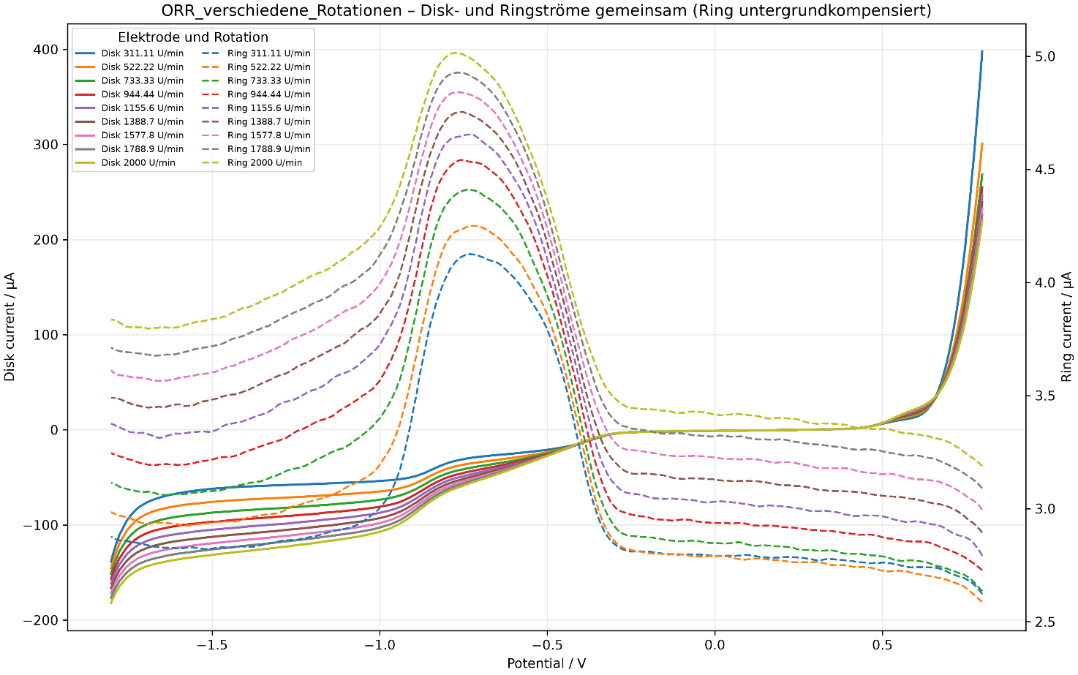

Figure 8: RRDE results for the oxygen reduction reaction (ORR): disk and ring currents between 0.7 and –1.8 V.

Appendix E. Installation from Python source (alternative route)
This appendix condenses the Python-source installation for advanced users and developers. Most users should instead use the executable or installer described in Section 4.5.
1. Install Python. Install Python 3.10 or newer and enable “Add Python to PATH” during setup.
2. Install packages. In the extracted program folder, run Install_required_Python_packages.bat (or py -m pip install -r requirements.txt).
3. Test. Run Test_Installation.bat to verify that Python and the principal dependencies import correctly.
4. Start. Launch the suite with Start_SpectroElectroChem_Suite.bat, or from a Command Prompt with python main.py.

