

SOFTWARE REQUIREMENTS SPECIFICATION

SapioCode: A Neuro-Symbolic Intelligent Tutoring System (NS-ITS)

Submitted in partial fulfilment

of the requirements of

Software Project Development

Submitted by:-

Achindra Sharma 2547105

Nilesh Gupta 2547138

Abhishek Suresh Kumar 2547104

1. Introduction
A major dilemma in modern computer science education is that automated platforms are efficient to check the correctness of the code, yet they neglect the cognitive process of the learner; on the other hand, generative AI technology is readily available but can lead to the stunted development of the learner. SapioCode is a solution to this "Assessment vs. Cognition" gap as it is an intelligent learning operating system that can actively control student cognitive load and academic dishonesty. The platform uses Neuro-Symbolic AI designed to offer guidance in the style of Socrates instead of answers, and it dynamically adapts the process of a learner according to the signals of mastery as an engine of continuous update of the state of skills according to performance signals, behavioral telemetry, and conceptual verification outcomes. A perception layer detects indicators of idle time, frequency of rewrites, and patterns of execution failure to obtain the cognitive friction, and change tone of instruction in real time. Lastly, a strict verification suite is used to make sure that progression is based on real understanding and not a brute force guessing method that involves running tests and providing a textual semantic defense. By means of this multi-layered, integrated approach, SapioCode is capable of turning coding education into an automatic generation of answers instead of the developmental learning that can be measured.

1.1 Purpose

The main idea of SapioCode is to fill the pedagogical gap between the simple automated assessment devices and the human-centred mentorship through the creation of a Neuro-Symbolic Intelligent Tutoring System (NS-ITS). The project is to design a large scale Learning Operating System, which covers the entire life cycle of computer science education, starting with the acquisition of initial skills through to automated cognitive validation. Developing behavioral telemetry, state-based AI agents, and secure code sandboxing into a single platform, SapioCode will help to move the paradigm of education towards no longer merely checking output but actively imposing control over the cognition and academic honesty of students.

1.2 Scope
SapioCode project covers the creation of a web application that is cloud-native and that should be utilized as a closed-loop learning system. The boundaries of the system are outlined by the four main operational capabilities of the system:
- Neuro-Symbolic Tutoring: Creation of a hybrid AI engine, which unites deterministic Abstract Syntax Tree (AST) analysis and generative AI to give Socratic advice without giving explicit answers.
- Intelligent Navigation: Tiered Skill Tree curriculum engine including document-based data structures to unlock learning paths dynamically in response to personal mastery and ongoing scoring of skills.
- Affective Perception: Implementation of a privacy-aware monitoring system, based on the principle of silent behavioral telemetry (e.g. idle time of the editor, typing speed, bursts of backspace), to predict real-time cognitive load and frustration.
- Automated Verification: Development of a Viva Voce engine which uses natural language processing and semantic analysis to check student comprehension by an automated metacognitive defense system, which is text-based.
Out of Scope: In order to ensure the focus on the core neuro-symbolism and pedagogical innovations, the following points are not included in the present version of the system:
- Biometric data processing with the help of client-side hardware (microphones are not needed or used at all).
- Creation of native mobile applications (the system is determined by the browser in its entirety).
- In the first release, non-imperative programming languages (e.g. Haskell, Prolog) were supported.

2. Project Description

2.1 Project Overview
SapioCode is created to eliminate the gap of Assessment vs. Cognition in the current Education Technology (EdTech). Compared to other systems, such as LeetCode or HackerRank, which rigidly require an output to be correct, or generative AI systems, such as ChatGPT, which will tend to offer answers without any pedagogical restraint, SapioCode is actually a complete Learning Operating System. It coordinates the whole learning lifecycle by four unique serving pillars:
- Implementation (Neuro-Symbolic AI): A dedicated, close-ended, code writing interface. It features a Socratic AI tutor which makes use of code state and Abstract Syntax Tree (AST) context to provide hints to the students rather than answers, which leaves them to construct their own knowledge.
- Navigation (Curriculum Engine): A smart curriculum engine which is a skill tree of the syllabus represented as a tiered structure. It helps with progression by use of document based queries on the database dynamically unlocking further subjects when mastery is shown and mastery is continually scored through use of ongoing skills marking.

- Perception (Behavioral Telemetry): It uses the telemetry hooks in the code editor to see typing pace, back space explosions and idle minutes. This enables the system to calculate a frustration score and forecast cognitive load in real time and have the AI tutor change its pedagogical tone without needing the invasive hardware.
- Verification (Metacognition): A smart system of academic integrity and understanding. On passing a standard hidden test cases, a text based Viva Voce metacognitive defense is launched by the system. The learner is also asked to clearly describe his logic of implementing through text. The system uses semantic analysis which makes sure that the conceptual knowledge of the student is the same as the one conceived by the student in terms of the code.

2.2 Operating Environment
The system will be built as a contemporary, cloud-based web-based application, which will be reached via conventional web browsers.
- Client Side:
  - Hardware: Typical Desktop/ Laptop (No webcams, microphones, or other biometric hardware necessary).
  - Software: Updated Web Browser (Google Chrome, Microsoft Edge, Firefox). The frontend is developed with Next.js, with the included Monaco Editor of interacting with a code and monitoring silent telemetry events.
- Server Side:
  - Application Server: Python FastAPI to perform the high including api routing, api telemetry data processing, and web engine orchestration.
  - Database Management:
    - MongoDB (via MongoDB Atlas): Used as the central document based storage, which can be used to store user profiles, cohort information, repository of problems, telemetry session logs, and state of skill tree progression.
- AI & Execution Infrastructure:
  - AI Orchestration & Inference: LangGraph is applied in controlling loops of states and memory of the Socratic tutor, and is driven by Hawking the fast Large Language Models (e.g., Kimi or Llama 3 with the Groq API) in generating hints and querying semantically correct Viva Voce answers.
  - Sandboxing & Execution: Code compilation, Execution, Evaluation Students compile and execute their code in a safe way using the cloud-based compiler infrastructure (e.g., JDoodle API) and run their code on hidden test cases.

3. System Requirements

3.1 Functional Requirements
The functional needs can be divided into the basic functional requirements of the single-player cognitive learning loop and instructor curriculum package:

- FR-1 (Code Execution & Verification): The system will also have a single-player, browser-based code editor that will be able to submit student code submissions to a secure, cloud-based compiler (e.g., JDoodle) to run on instructor-defined test cases.
- FR-2 (Symbolic AST Analysis): The system will compile user code in to an Abstract Syntax Tree (AST) to extract structural metadata (e.g. the existence of loops, recursion, or particular data structures) in a deterministic manner before directing data to the AI inference layer.
- FR-3 (Neuro-Symbolic Socratic Tutoring): The system will use a state based AI Tutor (controlled by LangGraph) that will be fed a set of AST metadata, compiler error logs, and real-time telemetry to provide contextual, Socratic hints. The system should also severely limit the occasion when the LLM produces a direct code solution.
- FR-4 (Curriculum Progression & Skill Tree): The system shall be a tiered curriculum in the form of dependency graph in database (MongoDB). It will dynamically open the later problem node of a user in the light of continuous scoring on skills and successful completion of the prerequisite modules.
- FR-5 (Behavioral Telemetry & Perception): The client-side editor will passively track non-invasive behavioral indicators, including idle time, typing speed, bursts of backspaces, and others, and calculate an on-the-fly "Frustration Score" on this basis. A pedagogical intervention (e.g., changing the tone of the AI tutor or providing proactive instructions) will occur when the score goes above some kind of a predetermined threshold.
- FR-6 (Text-Based Metacognitive Defense - Viva Voce): Once the hidden test cases have been passed, the system will then switch the user into an locked "Oral Defense" (Viva Voce) mode. The system will also force the student to specifically describe their logical implementation through text to confirm conceptual understanding.
- FR-7 (Semantic AI Grading): The system will involve a semantic analysis based on LLM that will evaluate the text-based Viva Voce explanation by the student with the predefined target_concepts of the problem, and present an automated Pass/Fail decision with regards to the academic integrity and comprehension of the learners.
- FR-8 (AI Problem Architect for Instructors): The system shall consist of an instructor dashboard with a generator powered by AI. This module enables the teacher to create complete coding problems (markdown descriptions, starter code, target concepts required, and strong edge-case test cases) as a result of a single natural language prompt. These generated problems can be reviewed and published by teachers to student cohorts assigned to them.

3.2 Non-Functional Requirements

- NFR-1 (Performance and Latency): AI hint generation and code compilation feedback has to be displayed to the client within reasonable operation limits (e.g. less than 4 seconds ) so that the cognitive learning process can be kept flowing smoothly without breaking the state of the student.
- NFR-2 (Privacy and Data Compliance): The telemetry will ensure that the tracking is only done on non-identifiable events on the editor (keystrokes and timing). The system will not capture, process or store any kind of biometric data, facial scan, video feeds or audio recordings at any point.
- NFR-3 (Security & Isolation): The code provided by students should be executed in secure, isolated and short-term sandbox containers in clouds to avoid malicious code trying to execute in the server or exploit it.
- NFR-4 (Scalability): The distributed architecture (Next.js frontend, FastAPI backend) will be implemented to enable vertical scaling to support parallel API calls to the LLM to perform inference and state management and execute code simultaneously as classrooms are in use.
- NFR-5 (Reliability & Timeout Handling): The system will be made to gracefully accept an infinite loop or highly resource-intensive syntax errors generated by the user by placing tight limits on the compiler execution time (e.g., 5 seconds) and displaying safe and formatted error reports to the user interface.

4. System Design

4.1 User Interface
SapioCode user interface is designed to enable a student to get into a Flow State with a high level of situational awareness provided to the instructor. The design philosophy is minimalistic and it uses efficient spatial separation and motion in components rendition to capture the current perception and progression of the mind.

4.1.1 Student Interface
The student experience is subdivided into three significant views:
- The "Selection" (Curriculum Navigator):
  - Description: An untidy, dashboard-type Tiered Skill Tree indicating the syllabus.
  - Features:
  - Features:
    - Nodes: This is a special topic in Data Structure, and Algorithms (e.g., Arrays, Linked Lists).
    - Edges: Prerequisite dependency lines.
    - States:
      - Locked (Grey/Disabled): Concepts that were not verified by the system yet.
      - Unlocked (Active/Highlight): The present Zone of Proximal Development of the student.
      - Mastered (Green Check): Exercises in which the student has successfully gone through the execution tests as well as the Viva Voce defense.
  - Interaction: By clicking on an unlocked node, the user will be redirected to the problem workspace.

- The "Action" (Workspace):
  - Description: An environment Teaching focused, browser-based Integrated Development Environment (IDE).
  - Layout:
    - Left Panel: Markdown statement of the problem, containing constraints and sample I/O.
    - Right Panel: Monaco Code Editor with syntax highlighting and line numbers. This component has telemetry trackers in the background that do not make noise.
    - Bottom Panel (Console): Shows compilerstdout,stderr, and obscure test-case execution output submitted by the JDoodle API.
    - Floating Overlay / Sidebar: The Socratic AI Chat interface. The student may manually activate this by asking to be given a hint, or automatically highlighted when the local telemetry calculates a high frustration score.

- The "Lock" (Viva Voce Mode):
  - Description: A modal state which is activated when all the execution test cases have been passed, which temporarily blocks the read/write access to the code editor to inhibit the copying of reference.
  - Features:
    - Dynamic Prompts: Provides specifically targeted and AI-generated questions dependent on the implementation of the Abstract Syntax Tree (AST) of the student (e.g., "Why did you decide to use a Hash Map over a nested loop is this case?).
    - Input Method: The student has a normal text-area input where he/she articulates his/her semantic understanding.
    - Action Button: Select the button: "Submit Defense" to send the text payload to the LangGraph verification node.

4.1.2 Teacher Interface
The instructor experience focuses on high-level class monitoring:
The "Input" (AI Problem Architect & Cohort Setup):
- Description: A curriculum generation and management dashboard.
- Features:
  - Cohort Manager: This is a straightforward interface to create and copy a special cohort_code to distribute them to the students.
  - AI Generator Prompt: A text prompt where the instructors can provide a description on what a problem constraint should be.
  - Review Panel: The output of AI generated problems (Markdown description, starter code, target concepts, and edge-case test cases) will be shown to the review panel where the instructor can revise and ultimately submit the problem to the cohort.
The "Output" (Cohort Analytics Heatmap):
- Description: A high-level data visualization dashboard of real-time monitoring of the performance of classes.
- Features:
  - Heatmap Grid: Organized by Rows (Students) and Columns (Problems).
  - Color Codes:
    - Green (Optimal): Examination and Viva Voce passed with low frustration score.
    - Yellow/Orange (Friction): Passed, however, telemetry showed that it was extremely frustrating or a long AI chat session had to be engaged.
    - Red (Intervention Needed): FFailed the logic of metacognitive Viva Voce defense or execution.
  - Cognitive Drill-Down: When a particular cell is clicked, one gets a detailed modal view consisting of the exact LangGraph MemorySaver chat transcript, Viva answers, and behavioral telemetry timeline of that particular student session.

4.2 Database Design

4.2.1 Data Flow Diagram (DFD)

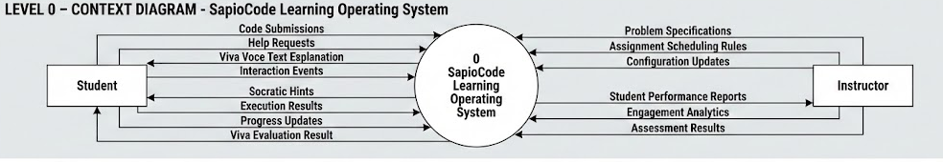
Fig 1: Level 0 DFD - Context Diagram

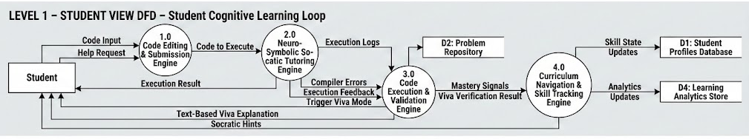
Fig 2: Level 1 DFD - Student View

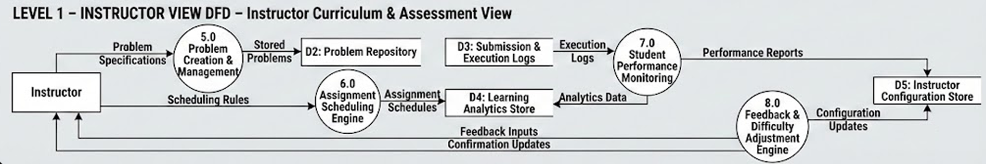
Fig 3: Level 1 DFD - Instructor View

4.2.2 Entity Relationship Diagram (ERD)
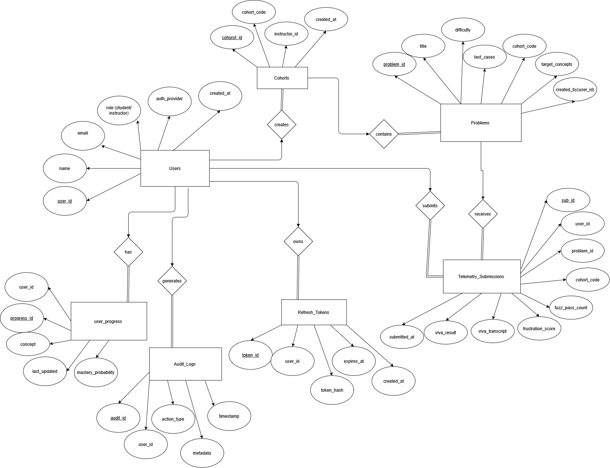

Fig 4: Entity Relationship Diagram

4.2.3 Class Diagram

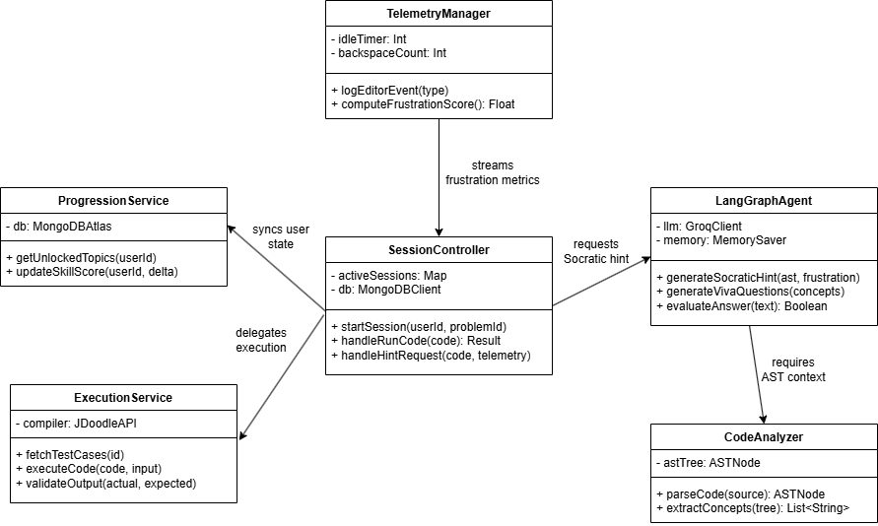

Fig 5: Class Diagram

5. Future Enhancements
- Voice-Interactive Tutor (Audio Viva Voce): Enhancing the existing text-based metacognitive defense with both real-time Speech-to-Text (e.g. Whisper) and Text-to-Speech (TTS) pipelines. This will facilitate absolutely conversational hands-free Socratic learning and verifying experience.
- Advanced Instructor Analytics Dashboard: eveloping the MVP class heatmap into a full-blown Next.js analytics platform. This will include sophisticated data visualization, drill-down received particular student-AI chat logs, in-depth telemetry graphs, and automatic cohort-level intervention recommendations.
- IDE Extension: Generalizing the SapioCode tutoring and telemetry solution to a Visual Studio Code extension, which will enable students to access neuro-symbolic feedback and frustration-driven interventions in their local development tools.
- Plagiarism & Logic-Cloning Analysis: The extraction of not only direct copy-pasting but also logic cloning patterns among a group of users over an extended time by simply comparing structural ASTs and telemetry timing data (e.g., pasting large blocks of code immediately).

Appendix: Glossary & Acronyms
- AST (Abstract Syntax Tree): A tree structure of the abstract syntax of a source code. It is employed as the Symbolic engine of the platform deterministically to check code structure and constraints before AI processing.
- LangGraph: A state-machine platform that is based on creating stateful and multi-actor applications using LLMs. It coordinates the memory, state transitions and assessment loops of the Socratic tutor.
- LLM (Large Language Model): It is a type of deep learning that can identify, summarize, predict and generate text. It is the Socratic Tutor and the Viva Voce semantic grading Neural thought process.
- NS-ITS (Neuro-Symbolic Intelligent Tutoring System): This educational architecture is based on the idea that deterministic rule engines (like Symbolic/AST/Compilers) should be used in conjunction with generative AI (like Neural/LLMs) to help learners correctly, without necessarily hallucinating logic.
- Telemetry: The automated, noisyless data gathering of behavioral information in the editor (e.g. keystroke pace, idle interval, bursts of backspace) to compute locally the cognitive friction and frustration measures without intrusive hardware.
- Viva Voce: This is a metacognitive defensive control in which students are required to justify the logic of their implementation (through text or audio) to the AI, to ensure that true understanding is in place, and does not lead to the development of a guess-and-check process.
- ZPD (Zone of Proximal Development): The instructional difference between what a learner can perform without help and what he or she can perform with Socratic help; the main goal state of the platform curriculum development module.

