**AUTOMATIC FISH TANK FEEDING SYSTEM**

**A thesis by**

**A.B.T.M.A.S BANDARANAIKA**

**D/CE/18/0005**

**A.R.M.S.G.D ABEYKOON**

**D/SE/18/0016**

**B.W.M MANUL BINUSHA**

**D/CS/18/0012**

**A.G.K.M WIMALASOORIYA**

**D/SE/18/0011**

**UDARI DE SILVA**

**D/CS/18/0007**

**Supervised by**

**Mr.Ranga**

**Mr.Thilina Herath**

**Submitted in partial fulfillment of the requirements for the award of BSc (Hons) in Computer Science / Software Engineering and Computer Engineering Degree**

**GENERAL SIR JOHN KOTELAWALA DEFENCE UNIVERSITY**

**2019**

**General Guidelines**

**Paper**: The dissertation should be printed on good quality A4 size paper, on single side

**Lettering:** Times New Roman. Size will change as per headings of the chapters, sections, subsection and the main text. Cover and Spine should be in GOLD lettering.

**Printing**: A laser quality printing, DO NOT use color printing.

**Spacing**: 1.5 line spacing must be used for the body of the text and the entries in the list of Reference. Only footnotes, quotations, table and figure captions, may be single spaced.

**Margins**: Left, 1-1/2 inches; top, bottom, and right, 1 inch per each.

**Length of the thesis:** Maximum 35 pages excluding Appendices. With the Appendices, the thesis should not exceed 60 pages.

A rough breakdown for number of pages for each major area would be as follows;

Abstract 1

Introduction 2

Literature Review 5

Technology Adopted 5

Approach 5

Design 6

Implementation 5

Evaluation 4

Conclusion and Further work 2

**Chapters and Sections:** All chapters must be numbered (Arabic). Chapter names and the headings of the chapters must be 18pt and bold. Preferably, each chapter should have a section called **Introduction** at the beginning and a **Summary** at the end. Sections through Introduction to Summary must be structured with subsections, if necessary, and numbered accordingly. Headings of sections and subsections must be 12pt and bold. *See the sample for chapters and sections (Appendix A).*

**Tables and Figures:** All Tables and Figures must be named with captions, and cited inside the text. *See the sample for using tables and figures (Appendix B).*

**Reference and citations:** The list of Reference must be arranged in the order of those appearing in the document body (i.e. first reference should be the first citation in your document), and numbered in square brackets. The corresponding number of a reference must be used to cite the particular work inside the text. All items in list of reference must be cited inside the text.

**Appendices:** Appendices must be named in alphabetical order as Appendix A, Appendix B and so on, and also give a Title for each

**Abstract**

This report details the process of our group used to design, build, and test an automated fish feeder. We discuss our initial designs and the subsequent decision matrices that went into determining our final design. Last chapters described the process of designing, prototyping, building, and testing our final product. It is not feasible for fish owners to leave extra food in their fish’s tank before leaving for an extended period .This creates the need for a device that can automatically and reliably feed a fish. The purpose of this project is to design an automated fish feeder for household use. Using an Arduino based to control motor, feeding the fish while avoiding failures that could result in too much food being dispensed. The compact design attaches directly to the tank for easy setup.

An automatic fish feeder is a device that automatically feed the fish at a predetermined time. In a way, it is to control the fish feeding activity by using a fish feeder that combined the mechanical system and electrical system to form a device instead of manually feeding the fish by hand. Fish owners whom are away for a long time will have trouble knowing the situation of the pond or aquarium. Thus such device is very convenient. The device will feed the fish by dropping the feed from the storage through a hole. A timer is used to control the number of feeding time at an interval of time. Plus, there is a feedback system that sense the level of feed left in storage. It will give warning to the user through blinking LED bulb so the user will put new feed into the storage.

**Table of Contents**

Author’s Declaration ii

Abstract iii

Table of Contents iv

List of Figures v

List of Tables vi

Chapter 1 Introduction 1

1.1 Preamble 1

Chapter 2 State of the art 4

2.1 Introduction 4

2.2 Fundamentals of the xxxx 4

2.2.1 This is L2 Heading 4

2.3 Current Approaches ….. 4

2.4 About References 5

2.5 Summary 5

Chapter 3 Study of the English and Sinhala Languages 6

3.1 Introduction 6

3.2 Summary 6

References 7

Appendix A System Figures 8

List of Figures

Figure 1: ……………………………………………………………………………………………..

Figure 2………… 12

Figure 3 --------------------------------------------------------------------------------------------------------------------

Figure 4

Figure 5

Figure 6

Chapter 1

Introduction

* 1. **Background and motivation**

Recently, there has been increase of number of people who kept fish as a pet at their own home. Be it a hobby or for business purposes. Fish have a feeding schedule of once per day every day, making it difficult for the fish owner to be away from home, whether it is for school, work, or leisure. This creates the need for an automated device that can reliably feed a fish. The goal for this project is to design a system for automatically feeding a fish.

* 1. **Problem in brief**

It is not feasible for fish owners to leave extra food in their fish’s tank before leaving for an extended period. Overfeeding fish is one of the leading causes of fish fatality. When the food begins to break down in the tank, the proteins release ammonia, nitrites, and reduce the amount of oxygen in the water, all of which are harmful to the fish . This can put a strain on fish owners who need to leave home and do not have a consistent pet sitter. While there are many options available for feeding cats and dogs while away from home, there are not as many choices for fish owners.

* 1. **Objectives**

The aim for this research is to develop fish feeder to automatically dispense flakes twice a day or more according to user interest every day. The system should be able to send a signal to the owner if the flakes amount goes below pre set minimum amount.

The objectives of this paper are;

1. To design and develop automatic fish feeder for indoor aquarium.

2. To monitor the environment of the aquarium and update the user

3.To evaluate the performance of the developed mechanism.

4. To learn about the art of programming in C language.

5. To combine together all hardware skills, electronic knowledge with some software development in building this project.

* 1. **Problem statement**

Nowadays, there are people willing to spend hundreds or thousands of money for their fish . The price of exotic fishes also gets higher and can reach thousands ringgit and steel the attention from buyers. Problems occurs if the owner is away from home or been busy and forget to feed the fish. It will be such a waste if fish that is very expansive died because of the owner is too busy to feed the fish.

* + 1. **solution**

Design a system for automatically feeding a fish.

* 1. **Summary**

Rest of the thesis is organized as follows. Chapter 2 provides a literature review on automatic fish feeding system and identify the research problem/gap and the possible technology to solve the problem. Chapter 3 is on the technologies for solving the problem. Chapter 4 present our approach with hypothesis, inputs, output, process and features. Chapter 5 gives the top level design of the solution. Chapter 6 presents the implementation of the design. Chapter 7 reports some findings from the system in practice. Chapter 8 is about evolution of the system. Chapter 9 concludes the research finding with a note on further work.

Chapter 2

Literature Review

2.1 **Introduction**

Chapter 1 provided an overall picture of the research work presented in this thesis. In this chapter, we critically review the developments of the automated fish feeding system from its early invention until latest modern today . This chapter also discussed about the concept and theories of the fish feeding system.

2.2 **Early developments**

Basically, there is a lot of inventions had been made and been classified as “automatic fish feeder”. From those previous designs, a few are chosen due to their criterions which are quite interesting and also useful.

The first design is by David C. Smeltzer which is patented in 4th

April 1985. His design is capable of dispensing feed having various sizes of grains over a wide range of dispensing volumes with a high degree of accuracy. The device was able to do this by utilizing an adjustable counterbalance weight which the amount of water required are changeable to produce a dispensing action and simultaneously adjusts the vibration movement made by the fish feeder to differentiate the amount of food given out

There are numerous existing patents for automated fish feeders. The ones that will be discussed in this section are: the Automatic Aquarium Feeder, an Air-operated Fish Feeder, and an Automated Fish Feeder. Although many of these patents are now expired, we still need to be aware and ensure we are not infringing on any of them.

The first patent is for an Automatic Aquarium Feeder, US patent publication number US20090255474A1. This patent describes a pre-filled automatic feeder that can be hung over a pond or an aquarium to feed fish on a predetermined schedule. This idea utilizes a spiral-shaped piece in the food reservoir to pull the food down (Gleesing). Figure 1 shows the schematic of the system.

figure01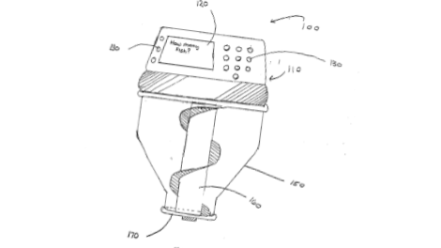

The second patent we saw was for an Air-operated Fish Feeder, with patent publication number US4089299A. This design consists of a measuring cup that scoops the food out of a food supply and dumps it into the fish tank (Suchowski). Figure 7 shows the schematic of the system. This design is air-powered, which is a unique innovation on the fish feeder.

The patent with publication number US4628864A, an Automated Fish Feeder, used a unique water powered system. This patent gives us ideas about different ways to drive our design besides batteries or electricity. This design uses the water to move an arm, which rotates a predetermined amount, then vibrates once it has completed rotating to deposit the food in the tank and avoid clumps (Smeltzer, ). It is shown in Figure 8 below.

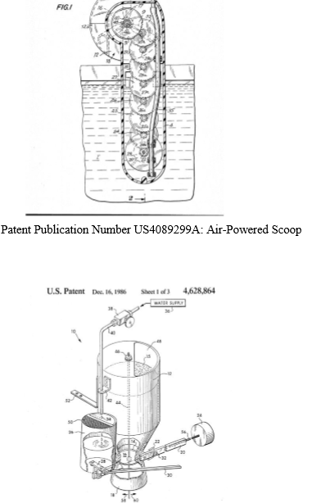

Chapter 3

Technology Adopted

**Arduino Technology**

Arduino is an open-source circuit board for use with its own programming language. The Arduino board can be programmed to control a variety of devices, such as turning an LED on or off or controlling motors. The small size and easy-to-understand language make it a popular choice among hobbyists, but the versatility makes it viable for a variety of projects. With a wide range of support products and add-ons available to expand the capability of the Arduino unit, we decided that an Arduino would be perfect for the needs of our project.

**Tools and equipment**

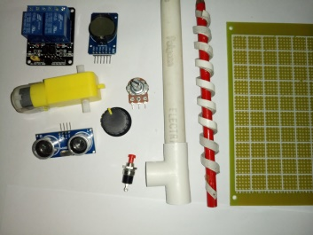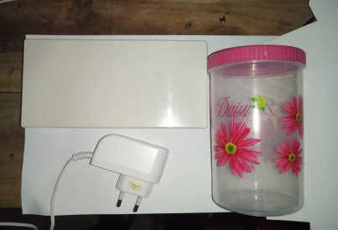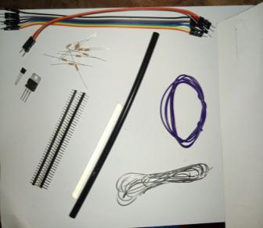

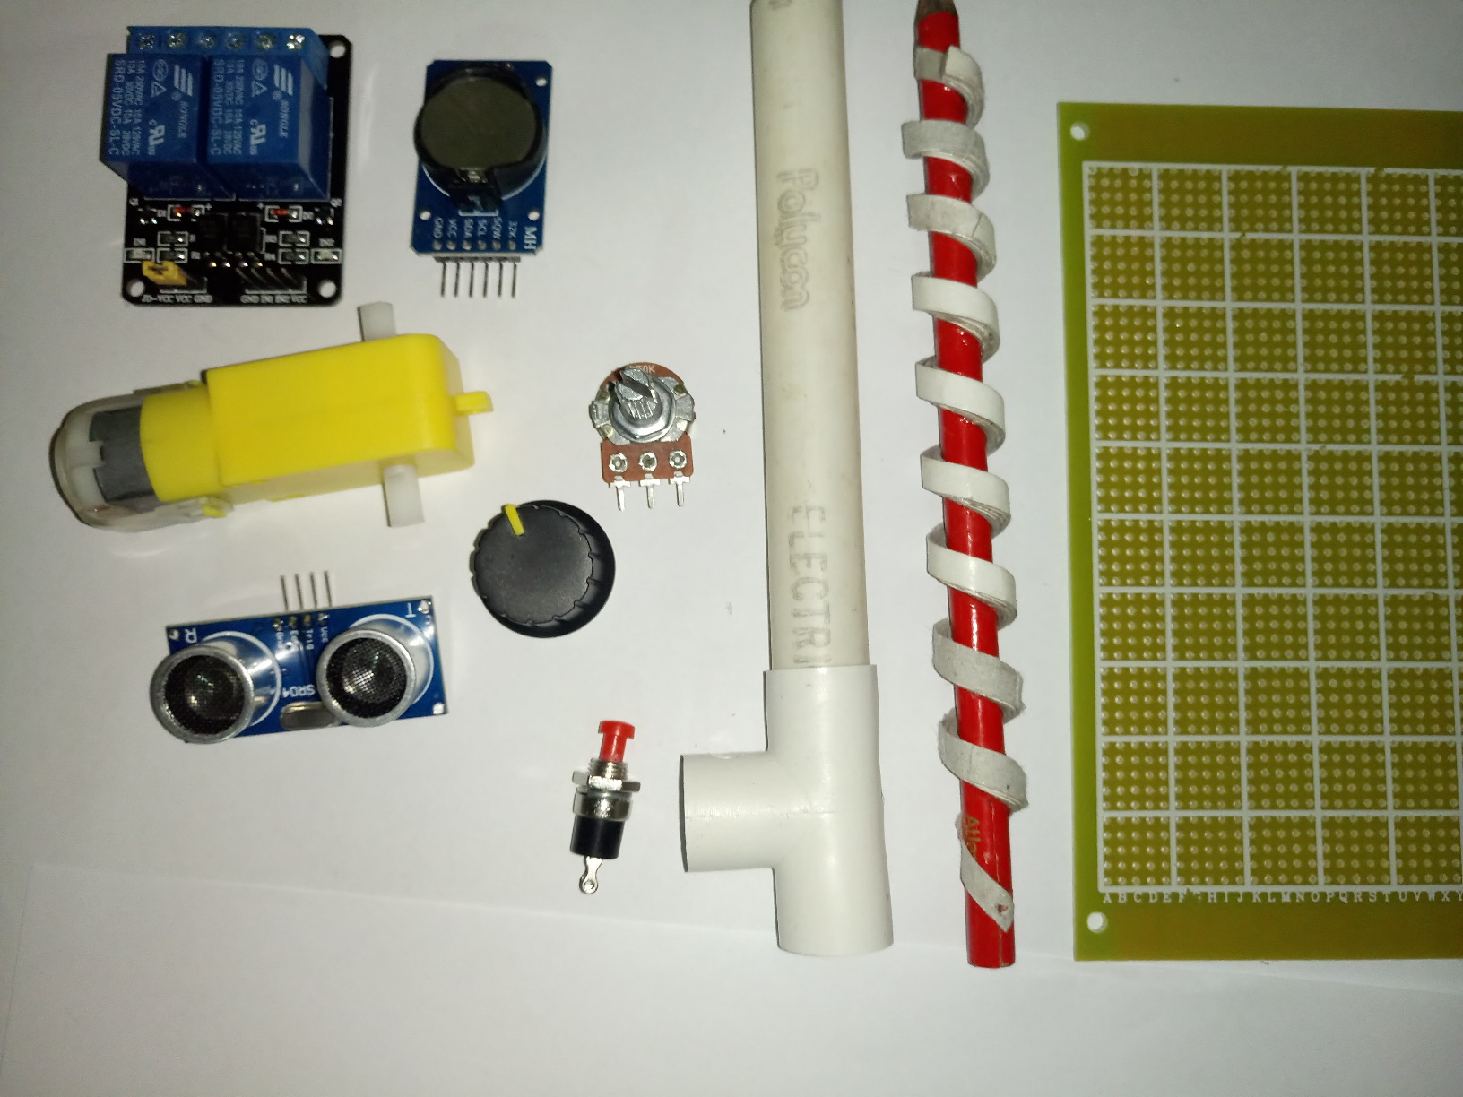**Screw mechanism**

We prepared the screw by adding 5 layers of cardboard wrapped to a pencil.We reduced

overall cost by creating the screw by wasting materials.

Chapter 4

Approach

4.1 Introduction

Chapter 3 described the technology to a develop automated fish tank feeding system.. In this chapter we presents our hypothesis, users, inputs to the system, expected output, process, and features of the system.

4.2 Hypothesis

IF a fish feeding system is introduced (solution) then efficiency of day-today food transactions can be improved (problem). Note that this hypothesis is will be tested by the prototype system that we develop.

4.3 Users

Fish owners who need to leave home and do not have a consistent per sitter

4.4 Inputs

Food flakes

4.5 Output

The aim for this research is to develop fish feeder to automatically dispense flakes twice a day or more according to user interest every day. The system should be able to send a signal to the owner if the flakes amount goes below pre set minimum amount.

4.6 Process

This machine is capable of measuring and putting fish food to a fish tank automatically.This machine has a inbuilt timer and when the user sets a time,fish food will be released to the fish tank automatically everyday.And if the user desires,it is possible to add fish food manually as well.Also this machine is capable of recording the amount of fish food in to the tank,manually of otherwise.Also the user will be notified when the food level is low in the container.A bulb is fix to the tank such that it could be switched on or off automatically according to a timer.

When we dispense the food manually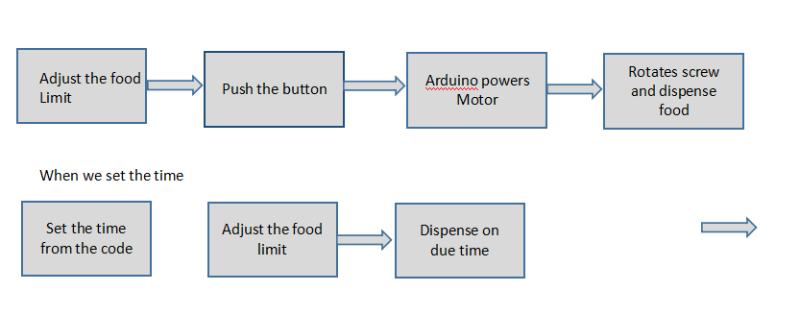

4.8 Summary

This chapter presented our hypothesis, input, out, features, users, and process of the proposed solution.

Chapter 5

**Design**

In this chapter, the project description will be elaborated as well as the design and component selection and justification will be presented. The components for this project will be discussed into two separate categories which are mechanical and electronics.

**Architectural design model**

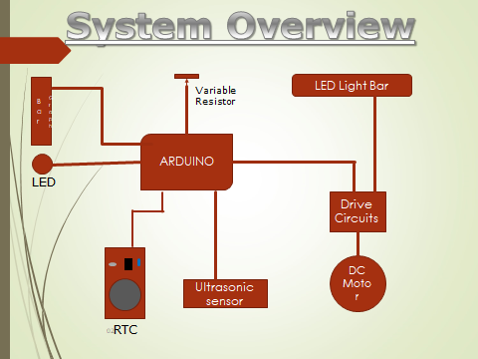

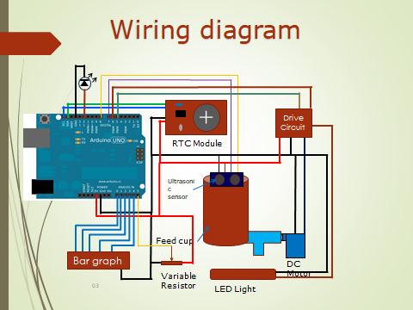

**Detail design model**

The material that is required is very simple where the device is mostly constructed by using plastic. This is because the body of the device needs to be highly stable to hold all the electronics components. There are many types of materials can be used to make a robot body, for example, wood, metals, glass and other suitable materials. Each of these components has their own advantages and disadvantages and they normally been selected based on the type of

projects. In this project, plastic is selected due to its light weighted and is cheap

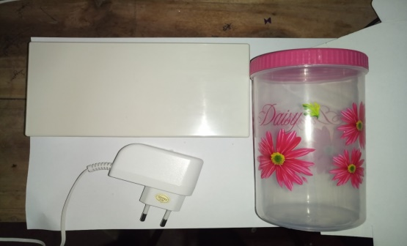

**Relay module Arduino –** electrically operated as a switch of mains voltage

**Ultrasonic sensor** –use to determine the distance of an object just like the bats to do.detect with high accuracy and stable readings in an easy to use

**CMOS battery**-to avoid by resetting time

**Variable resistor**-use to adjust the food limit by a bar graph

**Transistor**-to uplift the current gain and voltage gain

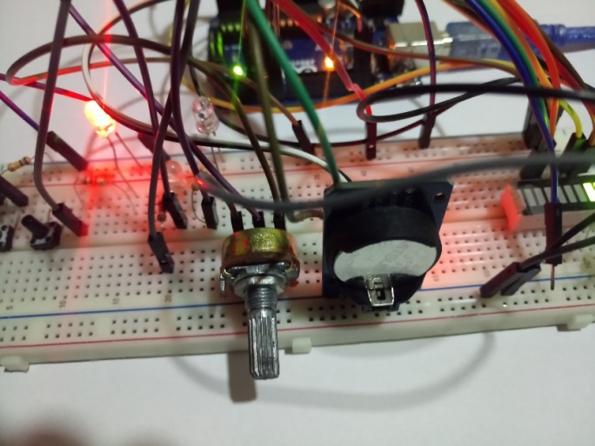

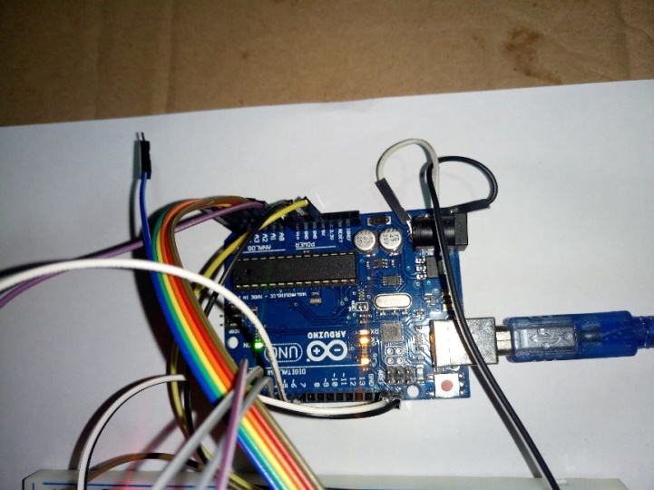

Chapter 6

Implementation

Describe the overall strategy for implementation tasks, such as incremental builds, risk mitigation measures. Discuss the reasons why you chose the specific programming language, development tools, testing tools, and the implementation platform. Discuss strategies for reuse of existing products and components. Use of design patterns in the implementation demonstrates sophistication in the subject matter and is highly encouraged. Generally, you do not need to provide source code in the thesis, unless that code is central to your thesis, e.g. if you created new design patterns and need to describe the logic of those design patterns using code. However, note that describing design logic using detailed design models demonstrates a higher level of expertise than using code to do the same.

Chapter 8

Conclusion and Further work

To create an automatic fish feeder device is not an easy task. . It requires a lot of research and reading. we also have to consider balancing the optimum cost with it practical usage as, in terms of marketing, no customer will want to buy an overpriced product. This will be a challenge to us, because with our limited knowledge, we do not know all the cheapest component that are available in the market that fulfill the requirement and achieved the desirable result.

Due to the limitations of the scope of this project, there were a number of aspects of the design and realization of the prototype that we believe could be improved given additional time and resources. The following are our recommendations for anyone who is considering revisiting this design in the future

1. **Include a battery backup:** the primary concern for an automated fish tank feeding system is reliably dispensing the proper amount of food when the fish owner is away. Our device is powered by a wall outlet
2. **Allow device to accept any type of fish food**: Medium-sized pellets represent just one of the many varieties of fish food on the market. A future iteration of our design should be able to accommodate any type of food, allowing the consumer to use the food that they currently have rather than buying additional food.
3. **Include user interface to change feeding frequency**: As currently designed, a user would need to edit the Arduino code to change the feeding frequency. We recommend implementing an input panel on the device that allows the user to change the frequency in which their fish is fed.
4. **Put on/off button on device**: Currently, the only way to turn the device off is to unplug the power supply. An on/off button would allow the user to visually confirm if the device is in operation, and would be a simpler and more conventional means of powering the device on or off.

**Reference**

Ahmed M.A., Haidar, Chellali B., M. Zahir (2013). Software Interfacing of Servo Motor with Microcontroller. J. Electrical Systems 9-1 (2013): 8499

2. B.C Mohapatra, Bikash S., K.K. Sharma and D. Majhi. (2009). Development and Testing of Demand Feeder for Carp Feeding in Outdoor Culture System. Agricultural Engineering International : the CIGR Ejournal. Manuscript No 1352. Vol. XI 3. Chen S., Zhong K, Cai Y.L. (2011). The Design and Application of the Water Temperature Control System for Large Aquaculture Pond. Measuring Technology and Mechatronics Automation (ICMTMA), 2011 Third International Conference on Measuring Technology and Mechatronics Automation, Volume: 3

Publication Year: 2011, Page(s): 737-739 4. C.L. Ku, Y.K. Tan, S.K. Panda (2006). High – Precision Position Control of Linear Permanent Magnet BLDG Servo Motor for Pick and Place Application. Pg2191-2924 5. Constantin D. O. (2011). GSM Infrastructure Used for Data. Transmission The 7th international symposium on advanced topics in electrical engineering

***Appendix D - Sample for an Appendix***

**Appendix A:   
Major approaches to software developments (18pt + B)**

* 1. **Introduction (12pt + B)**

Here you give details (12pt)……