**3.1 Introduction**

Analysis of the overall system is discussed under this chapter. The protocols used in requirement gathering and the justification of using those protocols are elaborated. Gathered requirements are analyzed so that the data gathered can be used appropriately in designing and developing the system. The identified current process of UGC university application & the difficulties faced by the applicants is explained in detailed. The modules of the proposed system are identified through the functional and nonfunctional requirements identified in analyzing. UML is used in demonstrating the functionality and the modularity in both current system and the proposed system.

**3.2 Overview to the Project**

The University Grant Commission (UGC) is the apex body of the University System in Sri Lanka. The functions of the UGC are planning & coordination of university education, allocation of funds to higher educational institutions & maintenance of academic standards.

Today, there are 10,390 government schools. The curriculum offered is approved by the ministry of Education. Literacy rates and educational attainment levels rose steadily after Sri Lanka became an independent nation in 1948 and today the youth literacy rate stands 97%. The government gives high priority to improving the national education system and access to education.

In addition to the Government schools there are 33 non-fee-levying Assisted Private Schools and 33 fee-levying autonomous Private schools.

Sri Lanka has 15 universities, all of which are public institutions. Admission at undergraduate level to these public universities are based solely on the results of the G.C.E (A/L) Examination and the Z-score, which considers the difficulty level of the subjects. Only 6% of the students who sit the examination are admitted to the universities. Due to restricted facilities admissions have become competitive.

Accordingly, the selection of students to universities for the academic years are based on the Z-Scores of the G.C.E. (A/L) Examination to be held in the previous years, will be made in accordance with the decisions subject to the rules and regulations to be issued with the Handbook on “Admission to Undergraduate Courses of the Universities in Sri Lanka”.

The percentage of students to be admitted to universities from those sitting for the G.C.E. (A/L) Examination for each degree programme on district merit from each district and all island merit shall be the composite average percentage of students admitted to universities through their very first attempt.

Since the course selection should be done while referring to the handbook, its not easy to filter the most suitable degree for one’s z-score and most of the time applicants choose the degree according to their desire.

Admissions to all courses will beamed on a dual-criteria namely All island merit & merit on district basis. Up to 40% of the available places will be filled in order of z scores ranked on an al island merit basis while 55% of the available places in each course of study are allocated to the 25 administrative districts while rest of 5% of available place for the disadvantaged districts in proportion to the population.

According to the UGC annual report the percentage selected under normal provision out of qualified & applied are 17.1% & 38.8% respectively. The rest of them are unqualified may due to the incorrect submission of the application or if they didn’t possess the required results. Therefore, there is a huge need of providing a support to choose the most suitable degree for each candidate to help them to get into universities in their first attempt.

The proposed University Eligibility Checking System (UECS) is a supportive system which can be used to simplify the overall procedure of the UGC Handbook.

**3.3 Problem Statement**

The applicants are confused when finding the most appropriate degree program for their results when filling the university application form. Therefore most of the time the course selections are made according to their likeness but if he/she is doesn’t fulfill the requirements needed for that degree then he/she will be unqualified for the university but at the same time if he applied for the particular degree that he is most eligible then he would be able to enter the university in his very first attempt. So, the selection of most eligible degree is required when filling the application form.

**3.3 Data Collection Protocols**

Justification of the fact-finding techniques used, and the deliverance of the information gathered through the fact-finding techniques are clearly mention as follows.

**3.3.1 Data Collection Protocols Used**

The proposed UECS aim is to deliver a system which is eligible in maximum user friendliness through efficiency, accuracy, reliability achieving through the functionality of the system. Information regarding the existing procedure is very much essential for the achievements of the goal of the proposed project.

Following are the fact-finding techniques used.

• Interviews

• Questionnaires

• Documentary reviews

**3.3.1.1 Interviews**

University Applicants and Deputy registrar of the Department of Examinations of UGC are the main key figures that have identified in order conduct interviews since they are the personals who are handling the hierarchies of the sections related to University admission. Conducting interviews with pre-defined content is the most suitable way of interacting with the relevant authorities to take information.

Information regarding the current procedure of university application submission were gathered by interviewing the relevant parties. Our main aim of having interviews is to identify the existing process and to clarify the drawbacks and difficulties faced by the users.

Initial interview is carried out with the Deputy registrar of the examination department of UGC to understanding the process of existing overall university applying process. While a Questionnaire is made to find the opinions of the applicants.

**3.3.1.2 Questionnaires**

Questionnaires are a survey of questions made to extract information from the correspondent party. It can be an effective means of measuring the behavior, attitudes, preferences, and, intentions of large numbers of subjects more cheaply and quickly than other methods of data gathering.

Difficulties which have to face with the whole process of application submission, what are the improvements need by the applicants, how the system should be developed are discussed under the questionnaire.

It is consisting of both open ended & closed ended questions. To achieve the best response rate the questions must flow from least sensitive to the most sensitive and from more general to the more specific.

The outcome is analyzed as quantitative measurement and get the feedback about the prevailing system which we need to pay our attention when designing the UECS.

**3.3.1.3 Documentary Reviews**

It is a way of collecting data by reviewing existing documents. Every document that is reviewed under this section is taken from the UGC while the interview was carrying out.

Method of categorizing the applications and the selections made in previous years are emphasized through the documentary review.

**3.3.2 Requirement Analysis**

Analyzing the data gathered and summarizing those data is the major outcome of this phase.

**3.3.2.1 Analysis of Data Gathered: Interviews**

Data, which is gathered in the interview with UGC authorities, were provided with the examples in the real domain. The following are the points revealed when the analysis of quantitative data collected.

* Entire process of application submission is indicated in the UGC handbook.
* The user has to go through the whole book when applying for universities.
* Previous years selections are not filtered which allow user to easily understand the university selecting process.
* Since the user can apply for 125 courses, a prioritize list of eligible degrees are not provided with the current system.

Candidates who have the minimum qualification can apply for the university but the selecting of degrees in the most appropriate order is important because it may conclude that he/she is being selected for a government university or not.

The applicant should have a knowledge about how the selections are made and this knowledge can be gain by referring to the UGC handbook as all the instructions are noted.

Selecting a prioritize list of most eligible degrees while referring to the UGC handbook was somewhat difficult and time consuming.

If the applicant didn’t have any idea about previous year selections, then he/she may not able to fill the application as required by the UGC.

Due to the incorrect submission of applications most of the students are unqualified for the university entrance.

Once the degree is mentioned it is not allowed to change the order of the list of degree programs the applicant is willing to apply and now this is cleared up to some extent but if a certain candidate want to make a correction on their application form they have to inquire it and wait for a acceptance email and it is time consuming.

**3.3.2.2 Analysis of Data Gathered: Questionnaires**

The questionnaire which was distributed among the colleagues rely on collecting facts, views and suggestions about the prevailing system and the intended proposed system of University Eligibility Checking System. Analyzed report of the facts that are gathered in the questionnaire is as follows.

1. Would you like to view eligible degrees in order of priority-based results?

Current UGC system doesn’t provide a priority list of eligible degree program a one is capable with his results. It only provides a list of all the degrees available without filtering it. So, the applicant has to go through all the degrees to select his eligible degrees.

Here we check on user opinion about this issue whether they are happy with existing procedure or not.

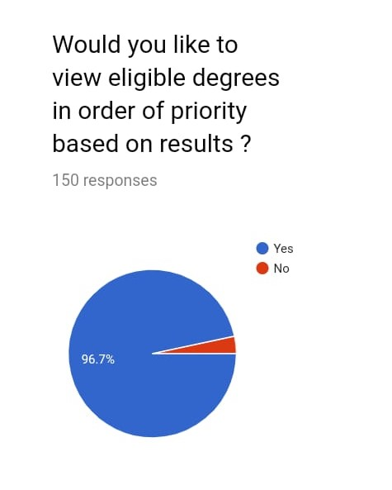

1. Have you had difficulties filling the registration form?

This question was asked to find whether the user is satisfies with the existing system or not. The most of them answered as ‘yes’. Therefore it reveals that the users are not happy with existing system procedure.

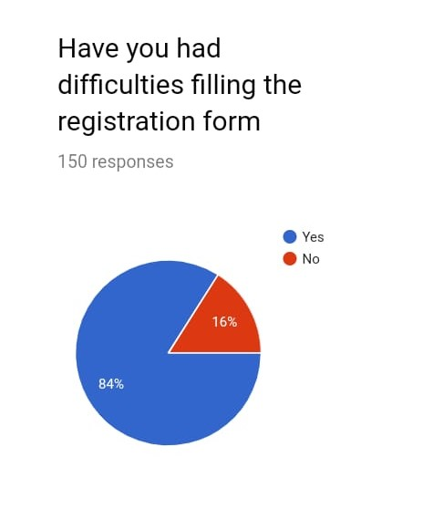

1. Did you know what degrees you might be eligible for before you applied?

This question is to find whether the applicants are literary known to apply for the most suitable degree for their z-score, how the previous year selections are made from each district to each course of study.

Most of the responses said that they didn’t know about what they are eligible before they applied.

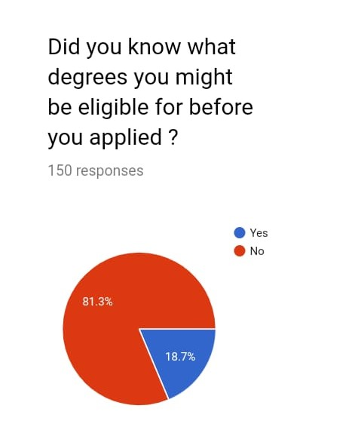

1. Do you have any suggestions for the improvement of the existing system?

This question was asked in order to get the idea of what the users of the system are expecting from the system to be.

Here the most highlighted which is a functional requirement of our system is “make a filter that we can find our subject degrees directly”.

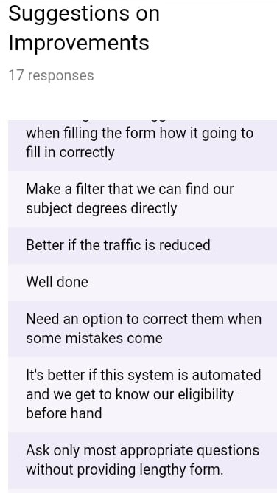

1. What are the problems you faced when filling the registration form?

This question was asked to make sure what sections we should consider when developing our system.

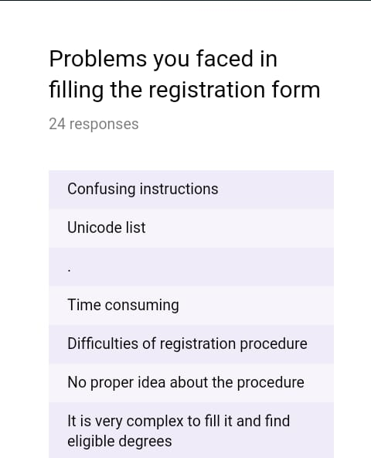

**3.3.2.3 Analyzing of Data gathered: Documentary Review**

Documentation of the curriculums of all undergraduate courses.

The documents consist of statistical data about the selections made by the UGC in previous years in order to clarify the number of eligible candidates from each district to each course with respect to their z-scores.

The categorization of each course of study for each university is identified according to the procedure of selecting the candidate and according to the format of the UGC handbook.

**3.3.3 Productivity and the Accuracy of the Data Collection Protocols**

Following section shows the productivity and the accuracy of the data gathering methods used in the requirement gathering process.

**3.3.3.1 Interviews**

**a. Interview No :01**

|  |  |
| --- | --- |
| Interview No: 01 | Objectives |
| Pre Plan  Client : Deputy Registrar  Date : 2019-03-20  Venue : UGC | Plan of having initial meeting with the registrar office members and convincing them about the proposed system & asked for any suggestions that they have if they want to improve the system. |
| Actual Plan  Client : Deputy Registrar  Date : 2019-03-20  Venue : UGC | conduct the initial meeting with deputy registrar by giving an initial idea about the proposed system.  Discuss about the flow of the procedure of application submission. |

**b. Interview No :02**

|  |  |
| --- | --- |
| Interview No: 02 | Objectives |
| Pre Plan  Client : Registrar Office members  Date : 2019-04-05  Venue : UGC | Collect data about previous year university selections made by UGC.  Discuss about the selecting procedure. |
| Actual Plan  Client : Registrar Office members  Date : 2019-04-05  Venue : UGC | Discuss about the courses and selection procedure. |

**3.3.3.2 Questionnaires**

Questionnaires are used to gather the details about the existing system drawbacks and to see what the user requirements and expectations of new system are to be.

1. **Questionnaire No: 01**

|  |  |
| --- | --- |
| Questionnaire No: 01 | Objectives |
| Pre Plan  Client : Users of the system  Date of issue : 2019-03-27  Date of Submission: 2019-04-03  Venue : Online Questionnaire | To get the idea about the difficulties faced by the users when using prevailing UGC system.  Identifying the client’s user requirements.  Discussing suggestions for the improvements. |
| Actual Plan  Client : Users of the system  Date of issue : 2019-03-27  Date of Submission: 2019-04-03  Venue : Online Questionnaire | Identified the user requirements.  Identified the drawbacks of the existing system. |

**3.3.3.4 Documentary Review**

1. **Documentary Review No: 01**

|  |  |
| --- | --- |
| Documentary Review No: 01 | Objectives |
| Pre Plan  Client : Clerk  Date : 2019-05-05  Venue : UGC | To find how the selections are made in district wise to each course study.  What are the common courses that most of the students are applied?  And how the selected percentage differs from the applied percentage. |
| Client : Clerk  Source: Documentation consist of previous year selections.  Date : 2019-05-29  Venue : UGC | Identified the district wise selection of courses.  Most probable courses that can be selected easily. |

Comment: the UGC didn’t agreed to give more details about the selection procedure because they are very sensitive & mentioned that it would be illegal.

**3.3.4 Complications Faced in Data Gathering and Solutions**

This section consists of the problems/complications faced in the data gathering methods in the phase of data collection process.

* Most of the open-ended questions were answered than closed ended questions.
* Time consumption in retrieving of requested documents from the UGC.
* Interviews conducted with UGC authorities were not explained up to the detailed expectations.
* Unavailability of reviewing certain documents which is important in gathering data for the system implementation was avoided due to confidential reasons.
* Collecting of data was delayed due to unexpectable bomb explosions.
* Preparing the questionnaire up to the required standards is a problem faced in data gathering through questionnaires.

**Solutions identified**

* Preparing the questionnaire limited to close ended questions than asking open ended questions.
* We try our best to explain the procedure and to get the required most suitable answer for the question by the interviewee.
* Agreed with the UGC to return documents of degree details by post, addressed to KDU.

**3.4 Current System of UGC**

The existing system only provide eligibility checking while there is no filtering of degrees in the prioritize order when selecting for the application. through the UGC handbook, it guides the user with instructions to fill up the application. since the selection process is competitive, choosing the most suitable degree program to each z-score is most essential.

Current system is handling the recruitment process of all the students.

Applicant if not selected try for jobs/private universities

Did I fill the application correctly

Would I have to sit for A/Ls again



Am I get selected or not

Private companies

Sending the application Rejection/Acceptance Letter



Have to check the application

 Universities

It is the time to send the letter of acceptance /rejection

UGC

**3.4.1.Detailed process flow of current system of UGC**

**3.4.1.1.Method of online application for university admission**

1. **Register as a user**

Every candidate should register as a user for the online service through the official webite of the UGC. ([www.ugc.ac.lk](http://www.ugc.ac.lk)).

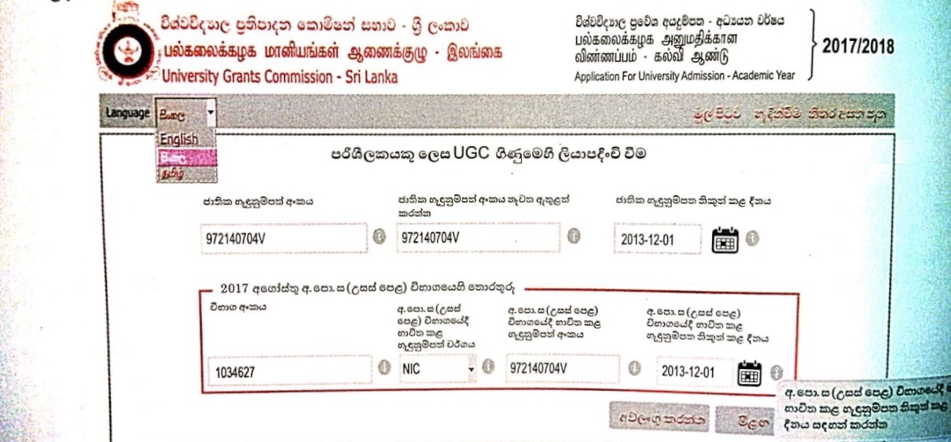

After the registration, the user can activate their UGC account using the verification link sent to their email account and activation code sent to the given mobile phone number.

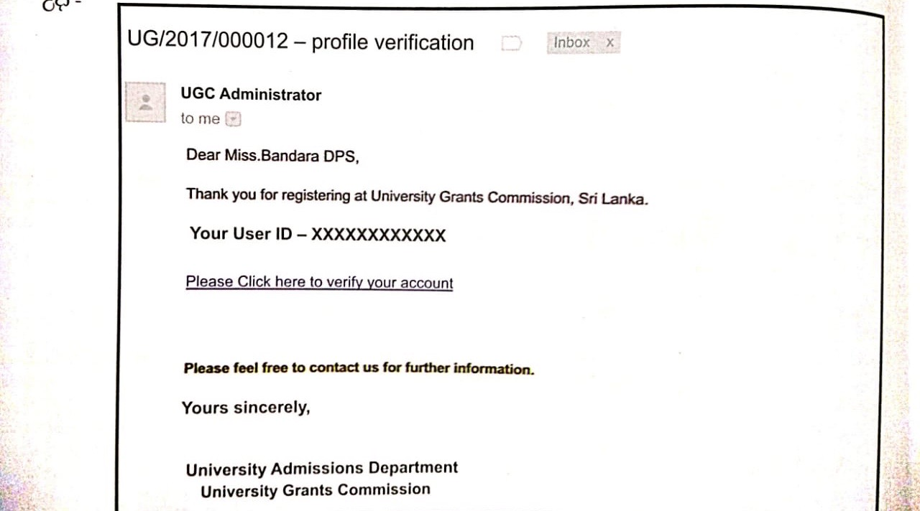

Once you click on the above link it displays a window for asking you to activate your UGC account using your user ID sent to your email account .

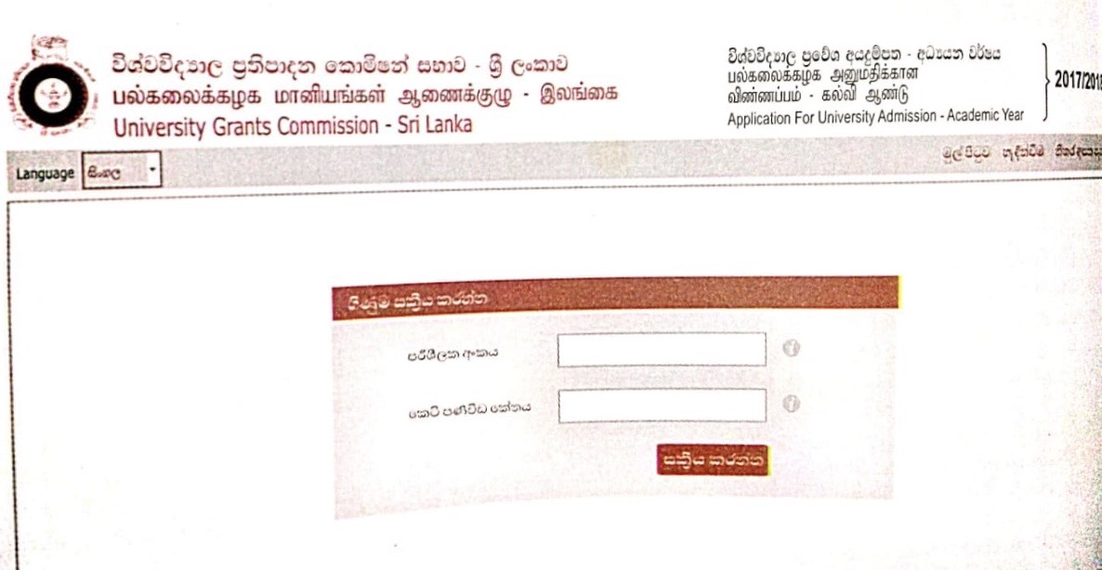

Messages wil be sent to the user email account notyfying the successful activation of their UGC account.

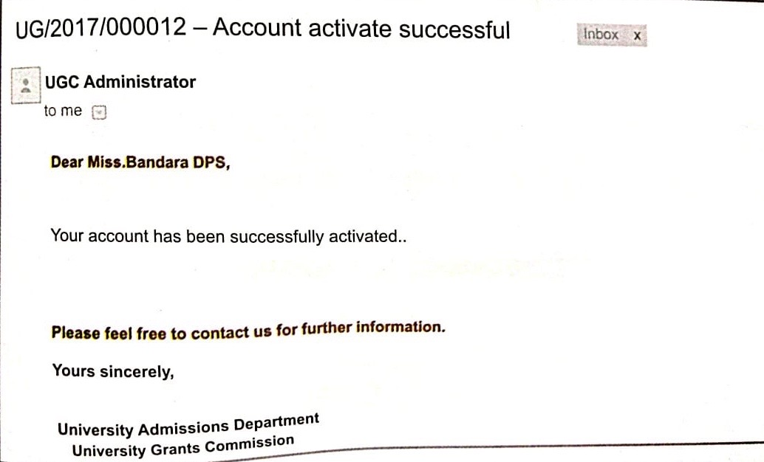

Once the registratiion is successful, the user will be able to log into UGC account to fill your online application for university admission.

1. **Fill your online application for University Admission**

Filling online application for university admission is a process of steps.

Step 1: Personal details of the Applicant

Step 2: G.C.E. (O/L) and G.C.E. (A/L) Results

Step 3: School details of Applicant

Step 4: Course of study and University according to user order of preference

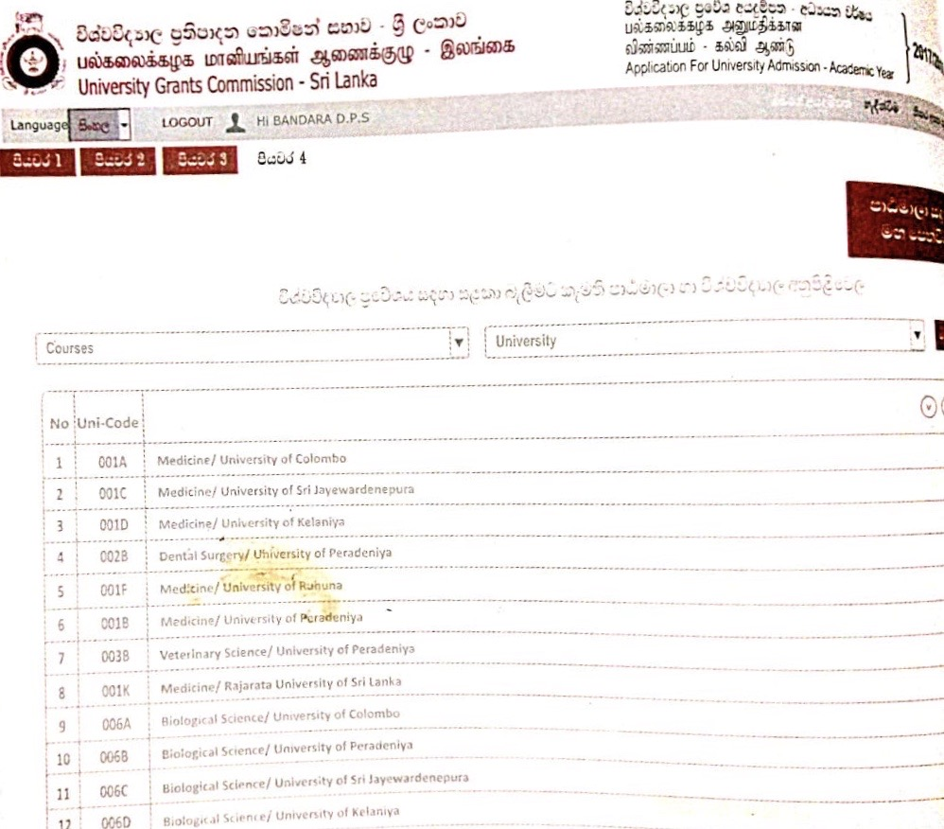

1. Select a course from the “courses” drop down list
2. Select a university drop down list will display the universitries in which the selected course of study is conducted.
3. Select preferennce as per your preference.
4. Once you select the courses, the user can view all the selcted courses in your order of preference.

The list of unicodes for each course study is listed in a separate page.

The candidates have to refer and find the unicodes for each course of study by their own self.

**3.4.1.2. facilities provided by the government for candidates for apply for university admission online**

**For candidates do not have internet facilities.**

1. **Regional centers of Open university**

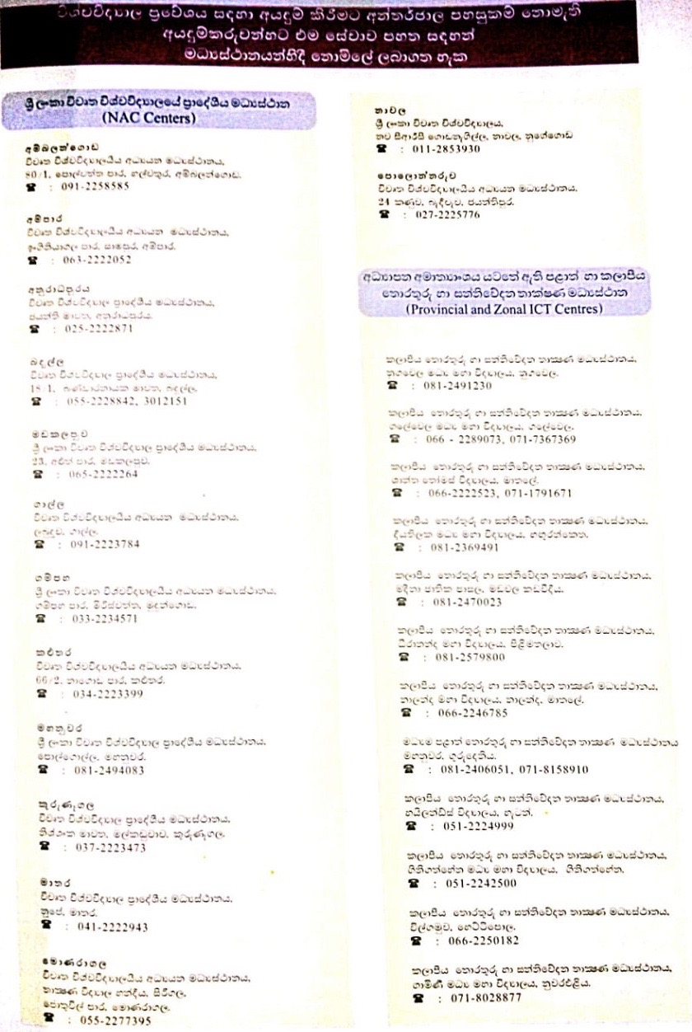

1. **‘Nanasala’**

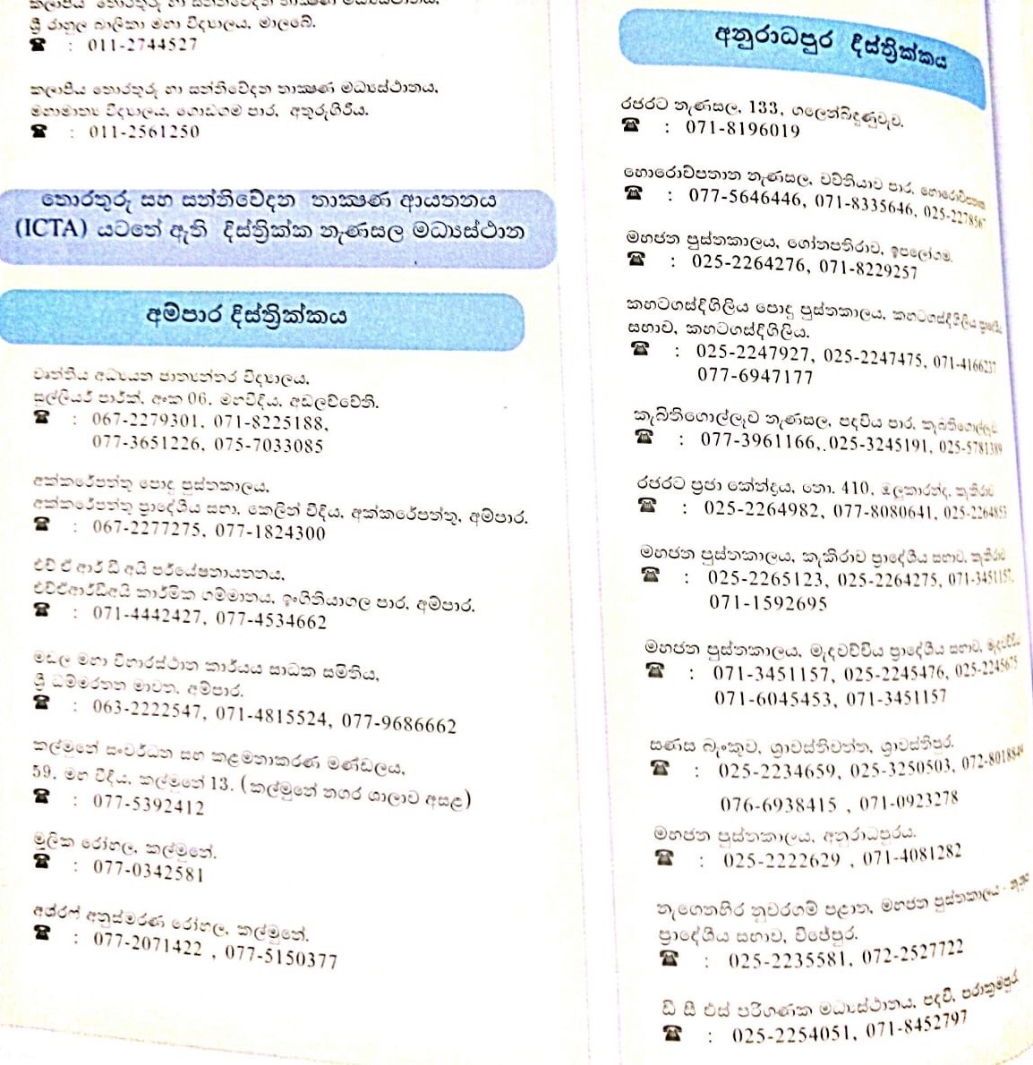

**3.4.2. Difficulties observed when filling the application**

1. As mentioned in the UGC handbook above, changing the Unicode order is a time-consuming process. Therefore, the candidate has to be more considerate on the preferences of course of studies before submitting their application. to make the right choice of selecting course, the candidates have to understand overall process of application submission by going through the book for numerous times.

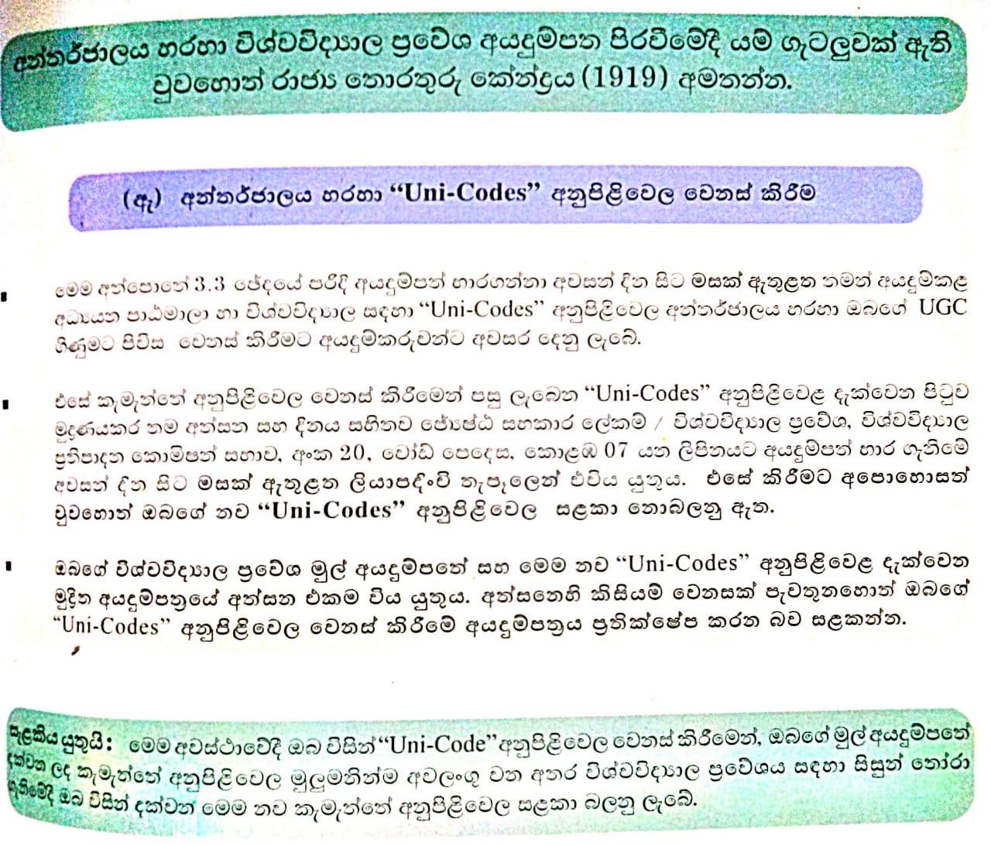

1. Have to select the list of courses that the user going to apply. There’s no way to check the prioritize order of most suitable degree programs for the z-score.

**3.4.3. Constraints identified in the development**

**Resource Constraints**

* Lack of accurate data.

**Environmental Constraints**

* Key-decision makers are difficult to contact.
* Major resources are sensitive data of candidates.

**3.5. Requirement Specification for the proposed UECS**

This section provides the detailed description of what the proposed system going to accomplish. Moreover, demonstration of UML will enhance the understanding about the functionalities afford to the user by the proposed system.

**3.5.1. Functional Requirement Specification**

Since the UECS is a supporting system for candidates, the functional requirements are mainly identified from the aspect of the applicant.

But for the ease of classification the requirements are divide to two parts.

* From the view of applicant
* From the view of admin

**3.5.1.1. Functional Requirement Specification: Applicant**

* Output degree(s) most probable to be selected into.

Provide a filtered priority list of eligible degree programs that he/she can apply depending on their z-score. This may increase the efficiency of the existing registration procedure. Then the candidate need not to be confuse about their selection because through our system we provide the most applicable degree for their z-score as the first option. Candidates can apply for the universities without any issue on their behalf. This may also increase the usability of the system.

* Filtered degree contents according to each z-score.

If we consider about a candidate in Art stream he/she didn’t need any details about the degree contents in maths/bio/tech/commerce fields. Therefore through our proposed system we will provide a filtered degree content in stream wise. This also may increase the system efficiency. The process of referring the book sentence by sentence will be simplified.

* Background research about statistical data of No.of candidates selected for universities in each year.

Since most of the times candidates who are willing to apply for universities has no basic idea about the university selection. That is they have no proper knowledge about how to apply for the most probable degree they can achieve. Through our system we will do a background research and provide a detailed information about how the selections are made relevant to each z-score, district & also how the priorities are given.

**3.5.1.2. Functional Requirements Specification: Administrator**

* Should able to login to the system by having a separate username and password in order to manage the flow of events.
* Should be able to update the course details. Adding a new course module when the new courses are introduced.

**3.5.2. Non-Functional Requirement Specification**

* System security

Each student access is limited to his/her own user accounts.

* Efficiency of the system

Maximum speed will be provided for the data classification and retrieval process in order to give a accurate output.

* Usability

Usability is provided through the user-friendly interfaces and simple format of website which anybody can easily interact.

* Availability

By implementing the UECS for the best ease of its users and focus on developing a mobile app if the system becomes more familiar and accurate to its best.

**3.5.3. Modules of the proposed UECS**

This consists of list of requirements for the proposed system

Module 1: “User Authentication Module”

* 1. : Enter Username
  2. : Enter Password
  3. : Create the account

Module 2: “User Verification Module”

* 1. : Fill the Form provided by the system
  2. : Submit

Module 3: “Report Generation Module”

3.1 : Able to select category

3.2 : Able to filter courses

3.3 : Able to view results

**3.5.4. Technical** **Requirement Specification**

* Mainly our aim is to create a dedicated web application for the system. The web application will be mainly based on the languages HTML, PHP and CSS. We will be coding all the web pages in the web application using these three languages.
* The database connection will be done by using SQLite & there will be a database created for three different categories.
* The graphics will be created using Photoshop. And then the will be brought into the web pages in order to combine with the three languages.
* The basic part of the web application will be coded using HTML and CSS languages. But the database connection part will be done by using the PHP language. And also we suppose to use Android Studio to create the android.

**3.5.5. Usability Requirement Specification**

* Support for all browsers.
* User friendly environment.
* Easy to interact with the system design interfaces.

**3.5.5. Models for the proposed UECS**

This section emphasizes the diagrammatical representation of the process flow of the proposed system using UML techniques such as sequence diagrams, use case diagrams and class diagrams. Further Data flow diagrams are used to demonstrate administrator functionalities of the system.

**3.5.5.1. Sequence Diagrams**

This section details how the operations are carried out & their order of interaction

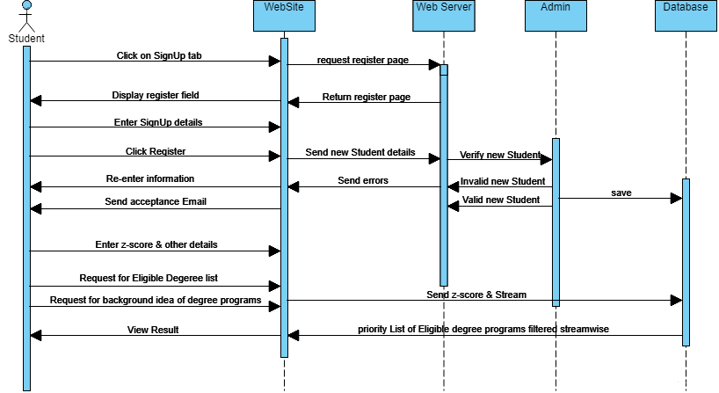

**3.5.5.2. Use case diagram**

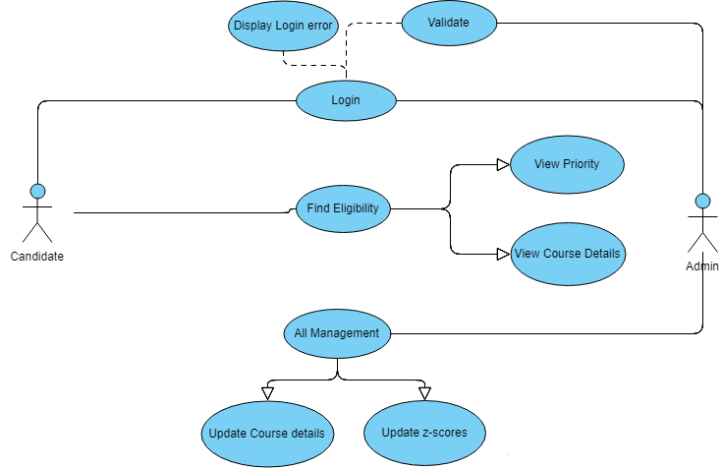

**3.5.5.3. Class Diagram**

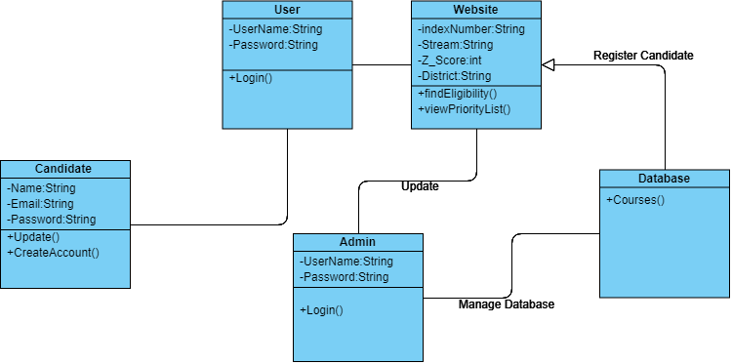

3.5.5.4. Data Flow Diagram

