Climate Data Analysis Using Machine Learning
and Dimensionality Reduction
Achintya
December 15, 2024
Abstract
This project explores climate data analysis for rainfall prediction using machine learning
techniques and dimensionality reduction methods, including Principal Component Analysis
(PCA) and Singular Value Decomposition (SVD). A comprehensive workﬂow comprising data
cleaning, preprocessing, feature engineering, clustering (KMeans), and predictive modeling was
undertaken. PCA proved eﬃcient in reducing dataset complexity while retaining over 95%
variance. Machine learning models such as Logistic Regression, Decision Tree, Random Forest,
and XGBoost were evaluated, with XGBoost emerging as the top performer with a notable ac-
curacy. This analysis highlights the eﬃcacy of advanced dimensionality reduction and ensemble
methods in improving predictive accuracy and interpretability for climate datasets.
1 Introduction
Climate change has increasingly impacted global weather systems, making accurate rainfall prediction crit-
ical for applications such as agriculture, disaster preparedness, and water resource management. However,
climate datasets are typically high-dimensional, with signiﬁcant interdependencies among variables. This
project addresses these challenges by employing machine learning algorithms combined with dimensionality
reduction techniques to predict rainfall.
We used Principal Component Analysis (PCA) and Singular Value Decomposition (SVD) to reduce
the dataset’s complexity, followed by KMeans clustering for pattern discovery. Predictive models such as
Logistic Regression, Decision Tree, Random Forest, and XGBoost were implemented and evaluated using
key metrics like accuracy, ROC-AUC, and Mean Squared Error (MSE).
The objectives of this project include identifying signiﬁcant trends within the dataset, reducing its
complexity without losing crucial information, and developing robust predictive models. The project lever-
ages Python libraries such as Pandas, Scikit-Learn, Seaborn, along with several others for analysis and
visualization.
2 Objectives
• Perform exploratory data analysis (EDA) to understand climate features.
• Address missing values and outliers through preprocessing.
• Reduce dimensionality using PCA and SVD to handle multicollinearity.
• Identify natural patterns using KMeans clustering.
• Build predictive models (Random Forest, Logistic Regression, XGBoost) for rainfall prediction.
• Compare performance metrics and determine the best-performing model.
1

3 Accomplishments
3.1 Data Preprocessing
3.1.1 Data Loading and Exploration
The weather dataset was loaded from a CSV ﬁle and explored to understand its structure, distribution, and
key statistics. The dataset contained multiple features including temperature, humidity, wind speed, and
precipitation.
3.1.2 Handling Missing Values
Missing values were identiﬁed in several features such as ’Sunshine’ and ’Evaporation’. Appropriate impu-
tation techniques, including median imputation, were applied to handle these missing values and maintain
data integrity.
3.1.3 Encoding Categorical Variables
Categorical variables like ’RainToday’ and ’RainTomorrow’ were converted into numerical values using label
encoding, where ’No’ was encoded as 0 and ’Yes’ as 1.
3.1.4 Feature Scaling
Features were scaled using StandardScaler to ensure uniformity and improve the performance of machine
learning algorithms.
3.2 Dimensionality Reduction
3.2.1 Principal Component Analysis (PCA)
PCA was applied to reduce the dimensionality of the dataset, transforming it into a set of linearly uncorre-
lated components. The explained variance ratio was plotted to determine the optimal number of principal
components. The ﬁrst three principal components were found to explain a signiﬁcant portion of the variance.
3.2.2 Truncated Singular Value Decomposition (SVD)
SVD was implemented as another dimensionality reduction technique, particularly useful for sparse data.
Similar to PCA, SVD reduced the dataset to a lower-dimensional space, facilitating easier analysis and
visualization.
3.3 Clustering
3.3.1 K-Means Clustering
K-Means clustering was performed on both PCA- and SVD-reduced data to identify natural groupings
within the dataset. The Elbow Method was used to determine the optimal number of clusters, which
was found to be three. Clusters were visualized using scatter plots of the ﬁrst two principal components,
providing insights into distinct weather patterns.
3.4 Predictive Modeling
3.4.1 Data Splitting
The dataset was split into training and testing sets to evaluate the performance of predictive models.
2

3.4.2 Model Training and Evaluation
Various classiﬁers were trained, including Random Forest, Logistic Regression, Decision Tree, Support Vec-
tor Machine (SVM), Stochastic Gradient Descent (SGD) Classiﬁer, and XGBoost. Models were evaluated
using accuracy, ROC AUC, Cohen’s Kappa, and confusion matrices. ROC curves were plotted to assess the
models’ performance in distinguishing between diﬀerent classes.
3.4.3 Regression Analysis
Linear Regression and Gradient Boosting Regressor were applied to PCA- and SVD-reduced data to predict
continuous outcomes like temperature. Model performance was evaluated using Mean Squared Error (MSE)
and R-squared (R2) scores.
4 Observation
4.1 Data Distribution and Correlation
The dataset contained a mixture of numerical and categorical variables, with several missing values particu-
larly in ’Sunshine’ and ’Evaporation’. High correlations were observed between certain temperature-related
features, such as ’MinTemp’ and ’MaxTemp’ with ’Temp9am’ and ’Temp3pm’. Visualizations, including
histograms and heatmaps, were used to understand the distribution and relationships among features.
4.2 PCA and SVD Analysis
PCA revealed that the ﬁrst three principal components accounted for a signiﬁcant proportion of the variance,
indicating that much of the dataset’s information could be captured in fewer dimensions. SVD similarly
reduced the dataset’s complexity, making it easier to handle and interpret. Visualizations of the PCA and
SVD components demonstrated clear separation and clustering tendencies, which were crucial for subsequent
analysis.
4.3 Clustering Insights
K-Means clustering on PCA- and SVD-reduced data identiﬁed three distinct clusters. These clusters cor-
responded to diﬀerent weather patterns, suggesting natural groupings within the data. Clustering results
were visualized using scatter plots, with clusters color-coded for clarity.
4.4 Predictive Modeling Results
4.4.1 Logistic Regression
Achieved high accuracy and ROC AUC, indicating strong performance in predicting whether it will rain
tomorrow. The model showed a balanced precision and recall, with a high Cohen’s Kappa score reﬂecting
good agreement between predicted and actual values.
4.4.2 Random Forest
Demonstrated excellent performance with high accuracy and ROC AUC. The model was robust, handling
complex interactions between features eﬀectively.
4.4.3 Decision Tree
Provided interpretable results but with slightly lower performance compared to ensemble methods. Useful
for understanding feature importance and decision-making process.
4.4.4 Support Vector Machine (SVM)
Showed good performance, particularly with linear kernel, and provided a clear margin of separation between
classes.
3

4.4.5 SGD Classiﬁer
Performed moderately well, suitable for large-scale and real-time applications due to its eﬃciency.
4.4.6 XGBoost
Achieved high accuracy and ROC AUC, known for its superior performance and ability to handle large
datasets with complex patterns.
4.5 Regression Analysis Results
4.5.1 Linear Regression
Showed decent performance with low MSE and reasonably high R2 scores, indicating a good ﬁt to the data.
4.5.2 Gradient Boosting Regressor
Outperformed Linear Regression with lower MSE and higher R2 scores, demonstrating its ability to capture
non-linear relationships in the data.
5 Dataset and Preprocessing
5.1 Dataset Description
• Source: Kaggle Weather Dataset
• Size: 145,460 rows, 24 features
• Target Variable: RainTomorrow (Binary: Yes/No)
5.2 Data Cleaning and Preprocessing
The following steps were applied to prepare the data:
• Rows with more than 20% missing data were removed.
• Median imputation was applied to numerical features like ‘Sunshine‘ and ‘Evaporation‘.
• Mode imputation was used for categorical features.
• Categorical variables (‘RainToday‘, ‘RainTomorrow‘) were encoded using Label Encoding.
• Features were scaled using StandardScaler to ensure uniformity.
• Outliers were removed using z-score thresholds.
• Temporal features (Year, Month, Day, Season) were extracted to incorporate seasonality.
5.3 Handling Missing Values and Outliers
The heatmap below shows missing data patterns and outliers depicted using boxplots:
Missing values in features like ‘Sunshine‘ and ‘Evaporation‘ were addressed using median imputation.
Outliers were identiﬁed and corrected using boxplots.
4

Figure 1: Missing Values and Outlier Detection Corrections
5.4 Feature Scaling and Engineering
To enhance model performance, the following techniques were applied:
• Interaction terms such as Rainfall x Humidity were introduced.
• Lag features for rainfall and temperature trends were added.
• Month and season-based features were derived for temporal modeling.
6 Exploratory Data Analysis (EDA)
6.1 The Initial Analysis and Visualizations revealed relationships be-
tween key Climate Variables:
Visualizations show
• Wind Gust Direction depending on time of the day
• Rainfall Distribution by Month
• Comparative trend of Sunshine vs Rainfall
• Dependency of Rainfall with Wind
5
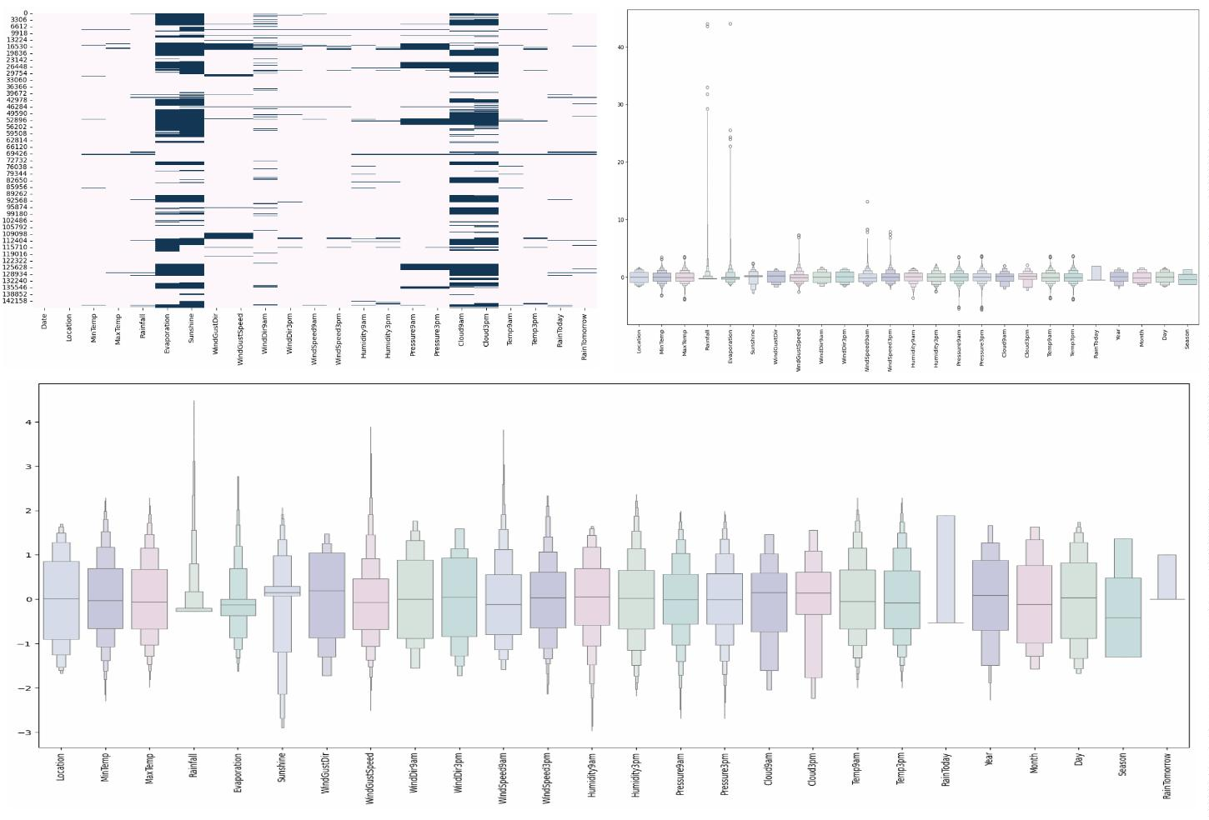

Figure 2: Wind Gust Direction
Figure 3: Sunshine vs Rainfall and Wind vs Rainfall
6
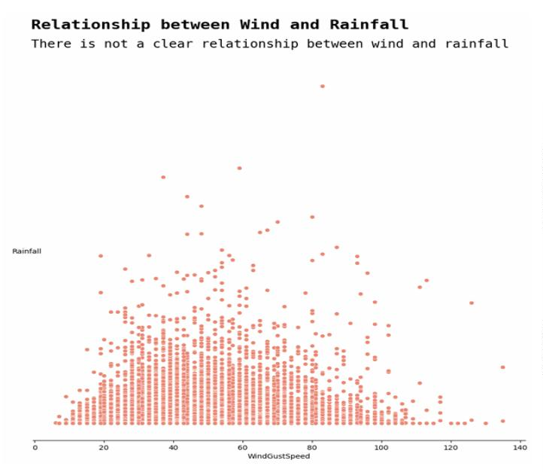
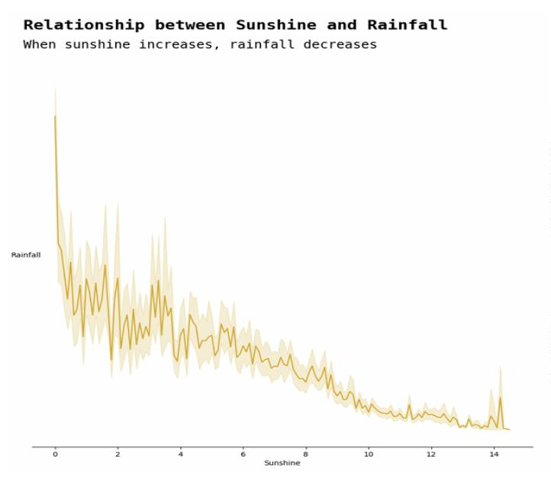
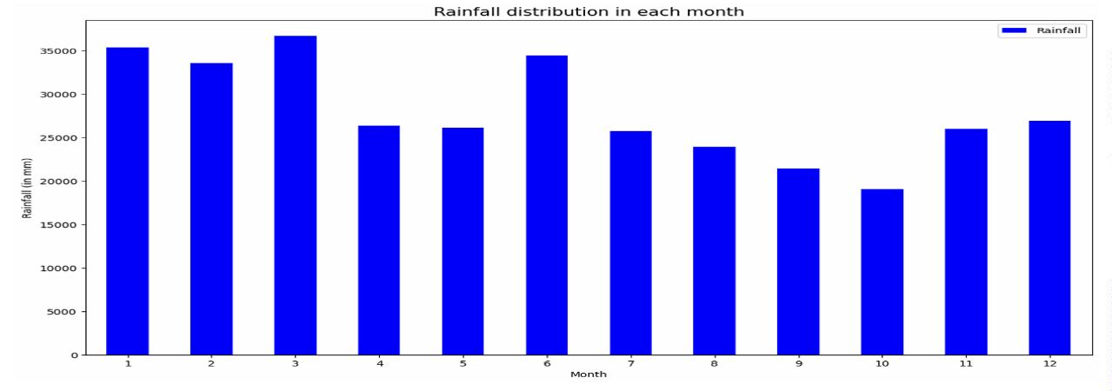
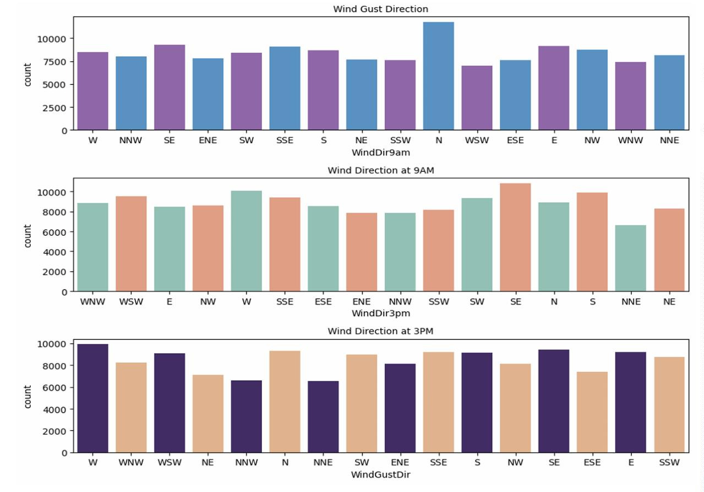

6.2 Additional visualizations included:
• Rainfall vs Temperature: Scatter plots highlighting trends between rainfall and temperature
extremes.
• Rainfall by Location: Geographic distribution of rainfall.
• Monthly Rainfall Averages (Year-wise): Depicts seasonality in rainfall patterns.
• Comparison: MinTemp and Maxtemp Based on location
Figure 4: Rainfall vs Temp and Rainfall vs Location Distribution
Figure 5: Monthly Rainfall and MinTemp/MaxTemp by location Distribution
7 Data Insights
7.1 Key insights from the EDA include:
• Temperature and Rainfall: Sunshine showed a negative correlation with rainfall, indicating re-
duced rainfall during sunny periods.
• Correlations:
– ‘MinTemp‘ and ‘MaxTemp‘ were highly correlated with ‘Temp9am‘ and ‘Temp3pm‘.
– Pressure features (‘Pressure9am‘ and ‘Pressure3pm‘) exhibited strong positive correlations.
• Seasonality: Monthly rainfall distribution revealed strong seasonality with clear peaks during speciﬁc
months.
7
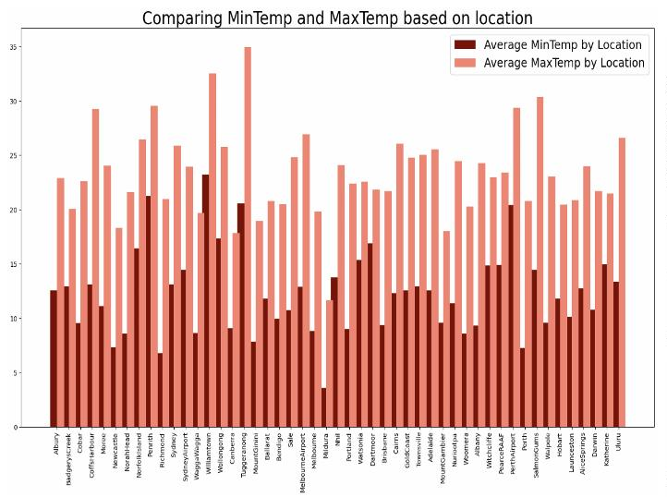
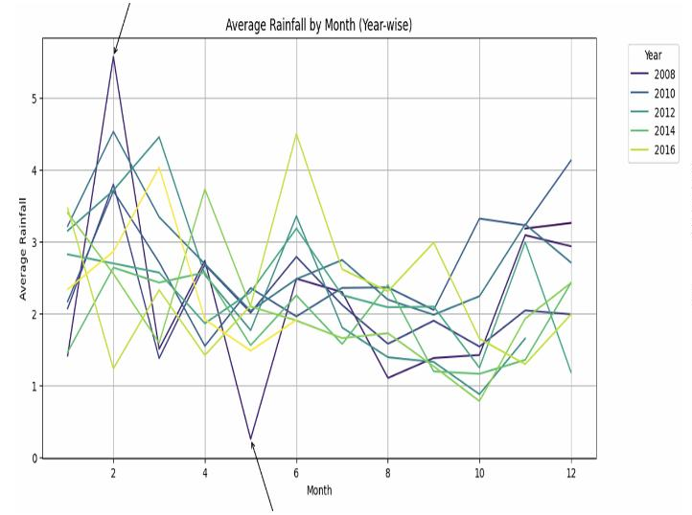
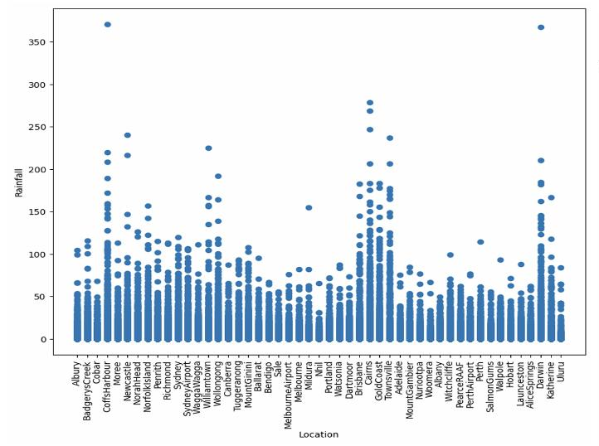
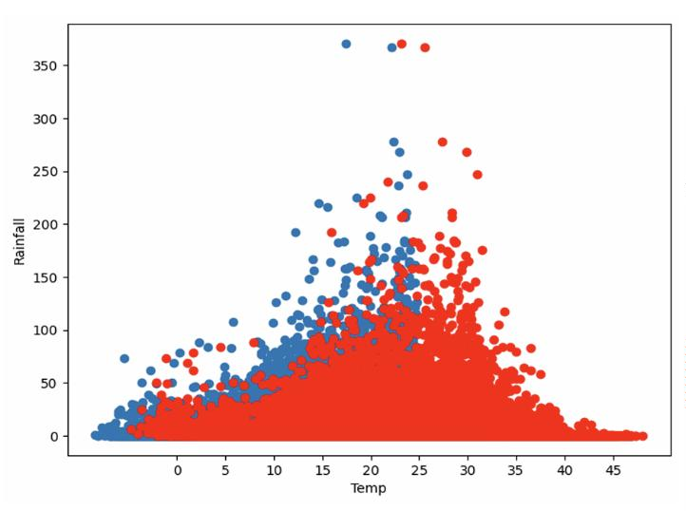

7.2 Correlation Matrices
Outlier removal and scaling were applied to ensure model stability.
Figure 6: Correlation Heatmap of Numeric Features
Figure 7: Correlation Heatmap of Highly Correlated Features
8
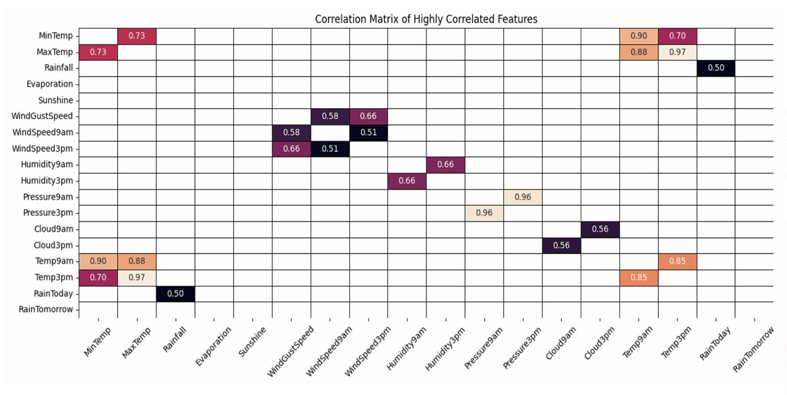
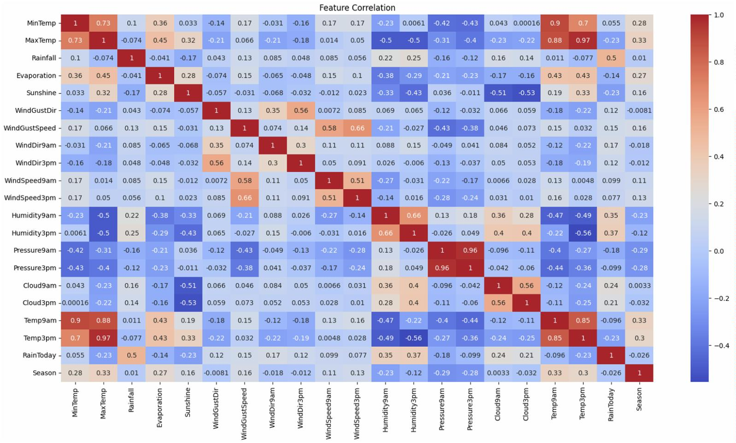

7.3 Histograms and Pairplots were generated to understand data dis-
tribution:
Figure 8: Histograms of Key Features
9
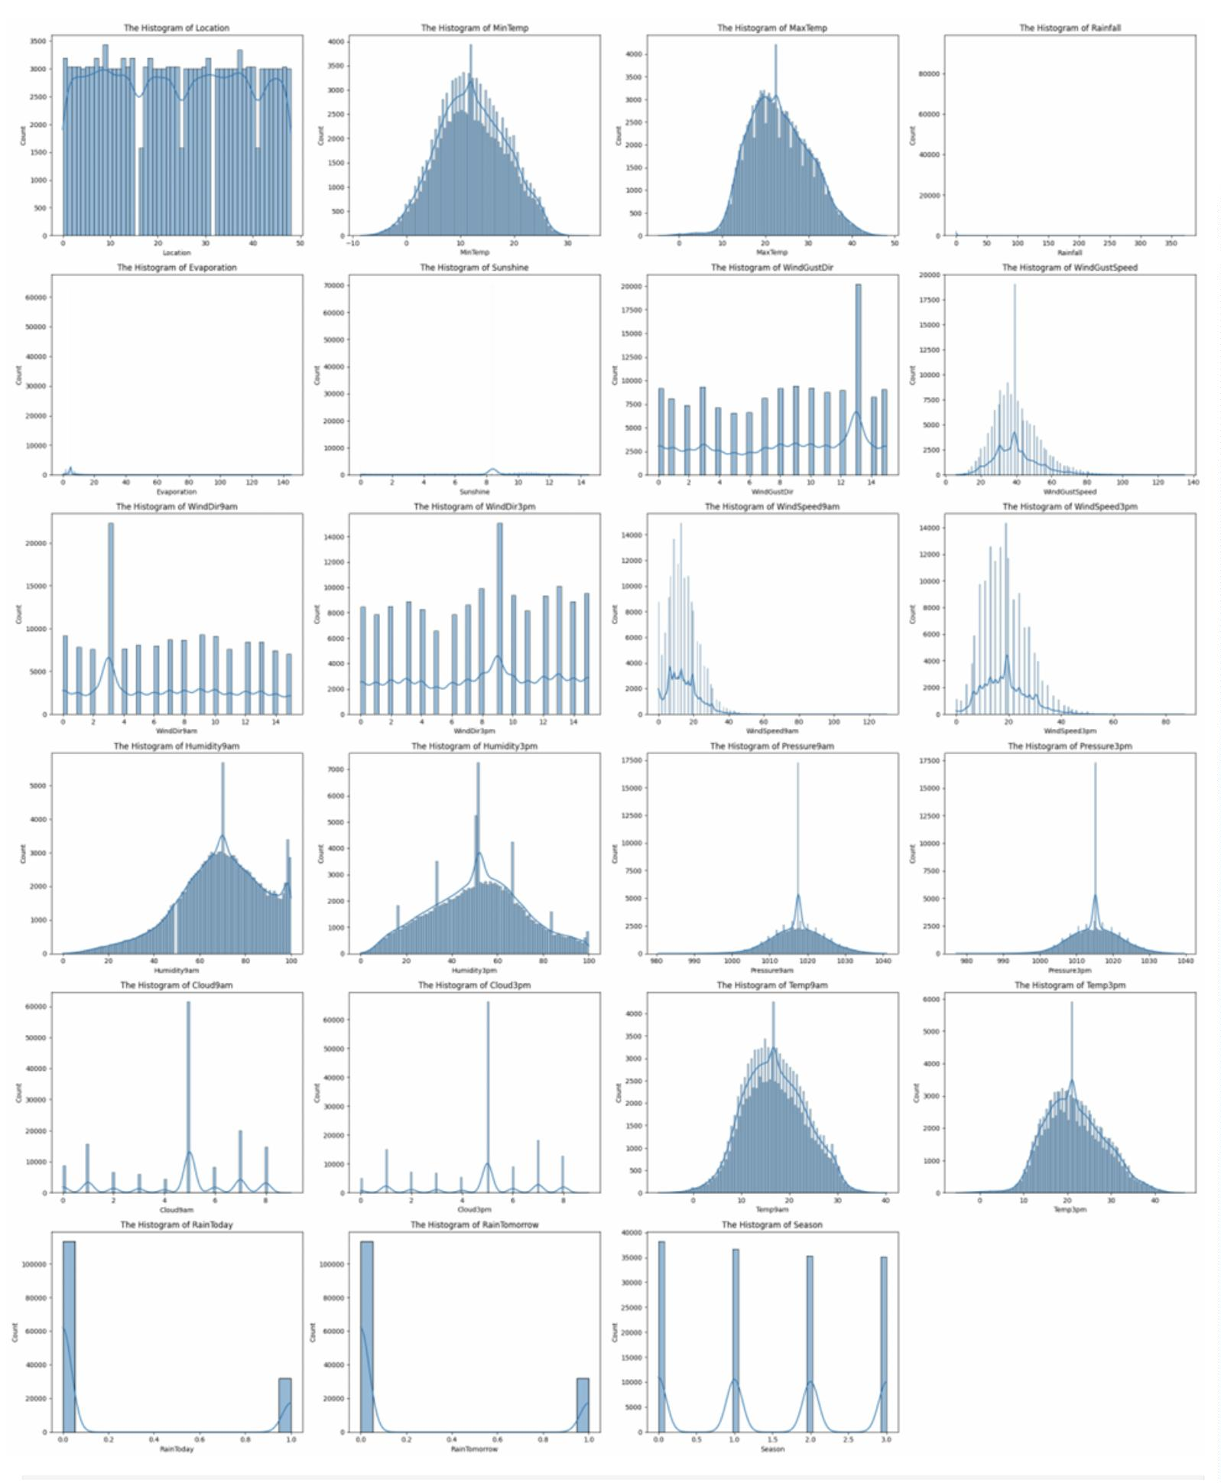

Figure 9: Pairplot of Key Features
8 Dimensionality Reduction
8.1 Principal Component Analysis (PCA)
PCA was applied to reduce feature dimensionality:
• 24 features were reduced to 8 components, retaining 95% variance.
• PCA eﬀectively captured the relationship between correlated variables like RainToday and Rainfall.
Figure 10: Explained Variance by Principal Components
10
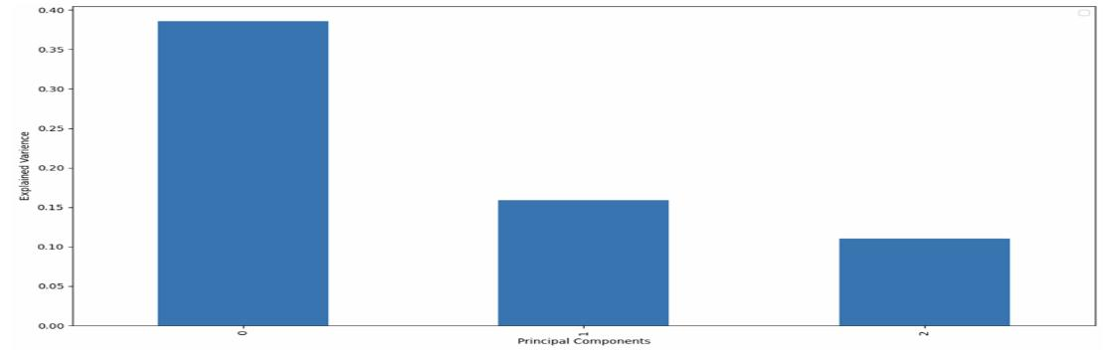
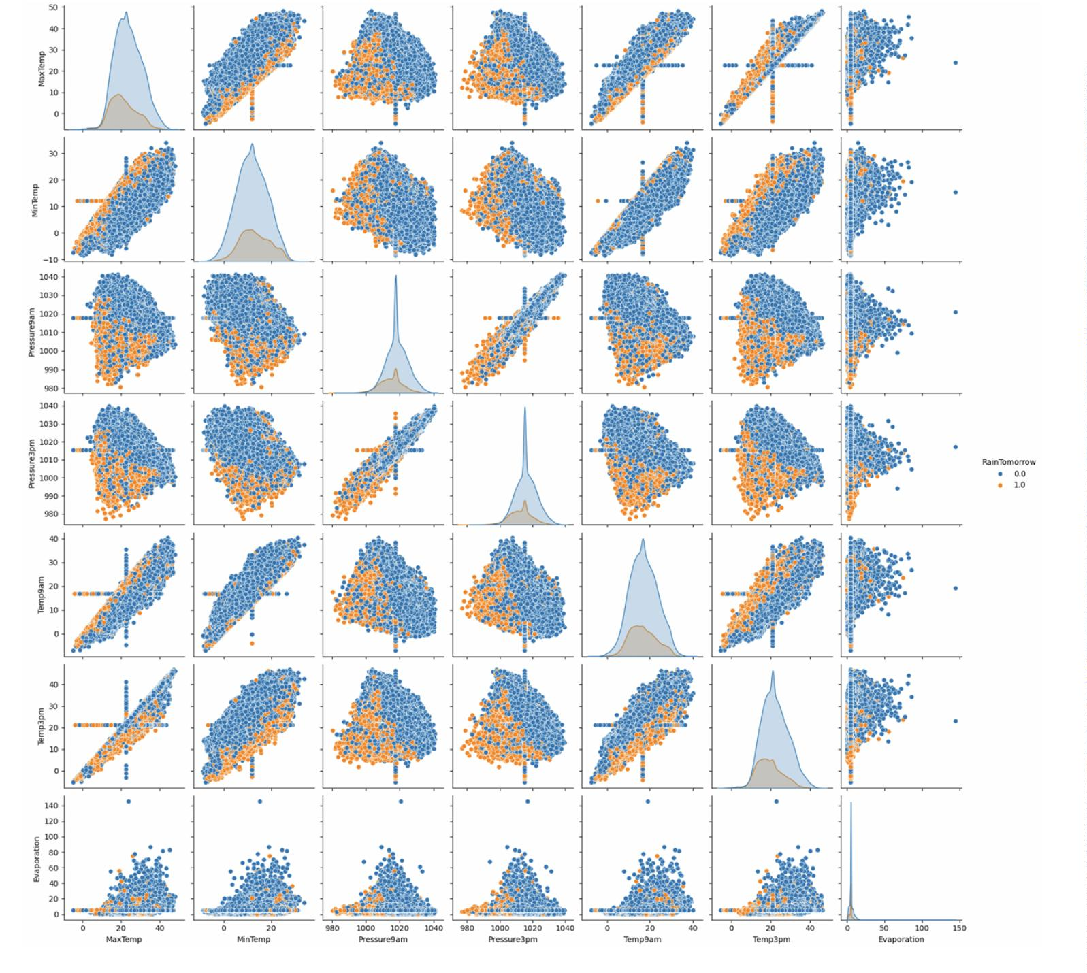

8.2 Singular Value Decomposition (SVD)
SVD was performed as an alternative method
• Reduced features to 8 components with a reconstruction error of 12,655.
• SVD retained slightly less variance than PCA.
8.3 PCA and SVD Results
PCA and SVD reduced the feature space eﬀectively:
Figure 11: PCA and SVD on Weather Data
8.4 PCA Visualization
PCA visualization:
Figure 12: PCA Visualizations
11
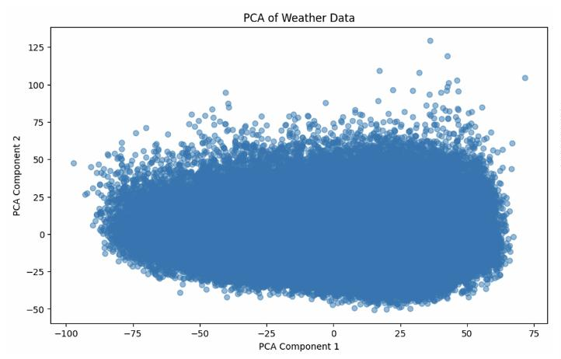
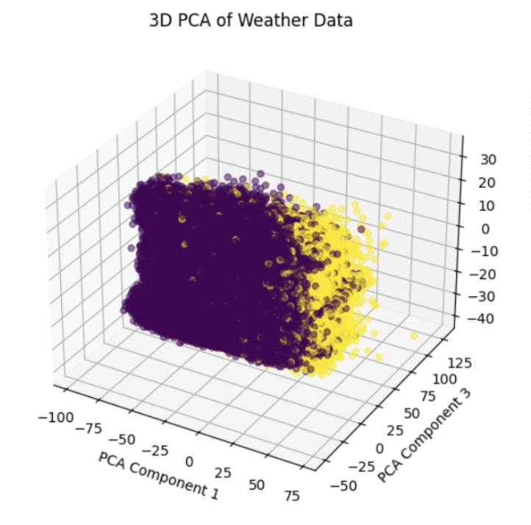
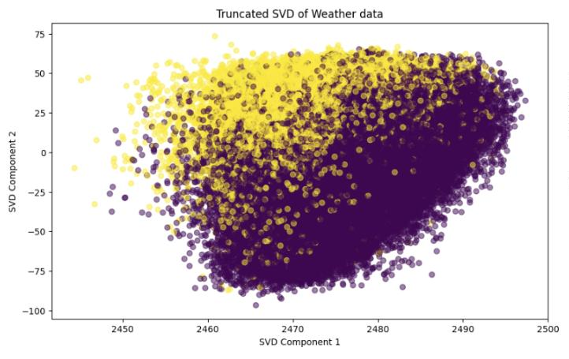
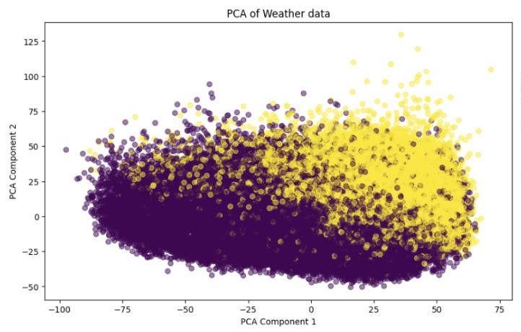

Figure 13: PCA K-Means Clustering
8.5 Matrix Approximation
Low-rank matrix approximations
Figure 14: Matrix Approximation
9 Clustering and Pattern Analysis
9.1 KMeans Clustering
K-Means clustering was performed on both PCA- and SVD-reduced data to identify natural groupings
within the dataset. The Elbow Method was used to determine the optimal number of clusters, which
was found to be three. Clusters were visualized using scatter plots of the ﬁrst two principal components,
providing insights into distinct weather patterns.
• Cluster 1: High rainfall, high humidity.
• Cluster 2: Low rainfall, moderate humidity.
• Cluster 3: Low humidity, moderate temperature.
12
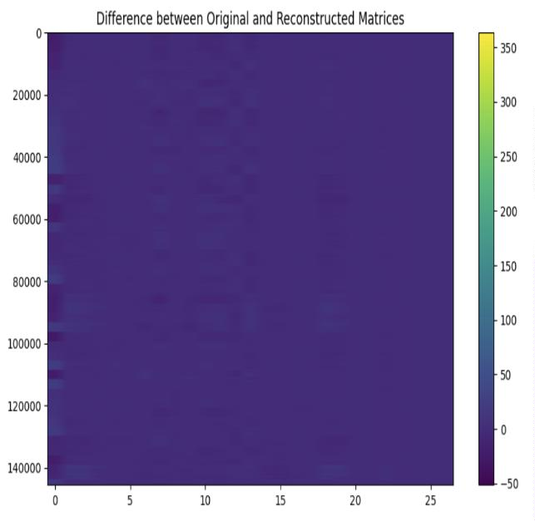
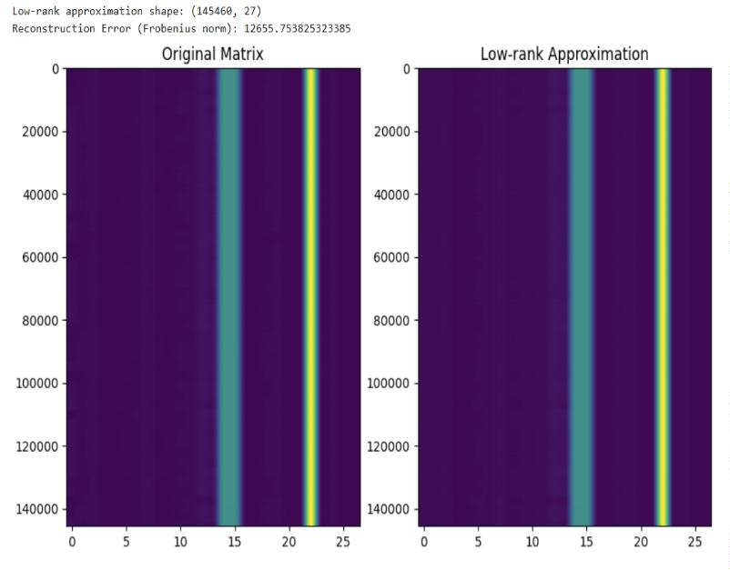
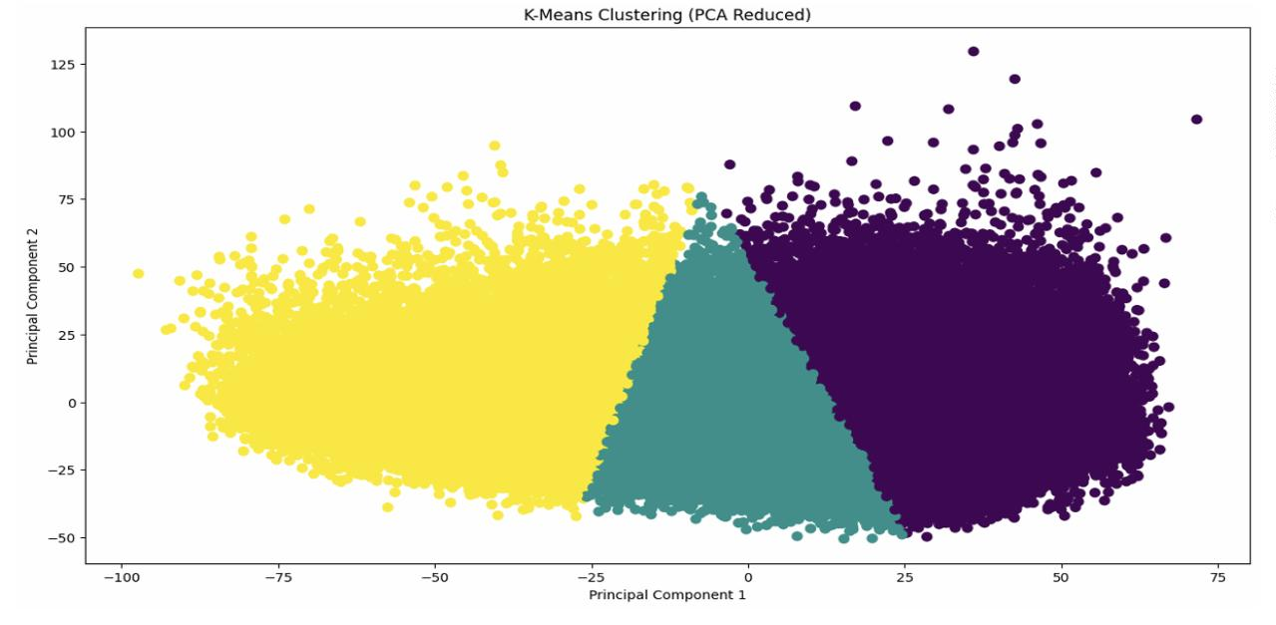

9.1.1 KMeans Clustering Result
The Elbow Method determined the optimal number of clusters as 3.
Figure 15: Elbow Method for Optimal K and Explained Variance Ratio by Principal Components
9.2 KMeans clustering was applied on both PCA- and SVD-reduced
datasets:
Figure 16: KMeans Clusters (PCA Reduced) and (SVD Reduced)
13
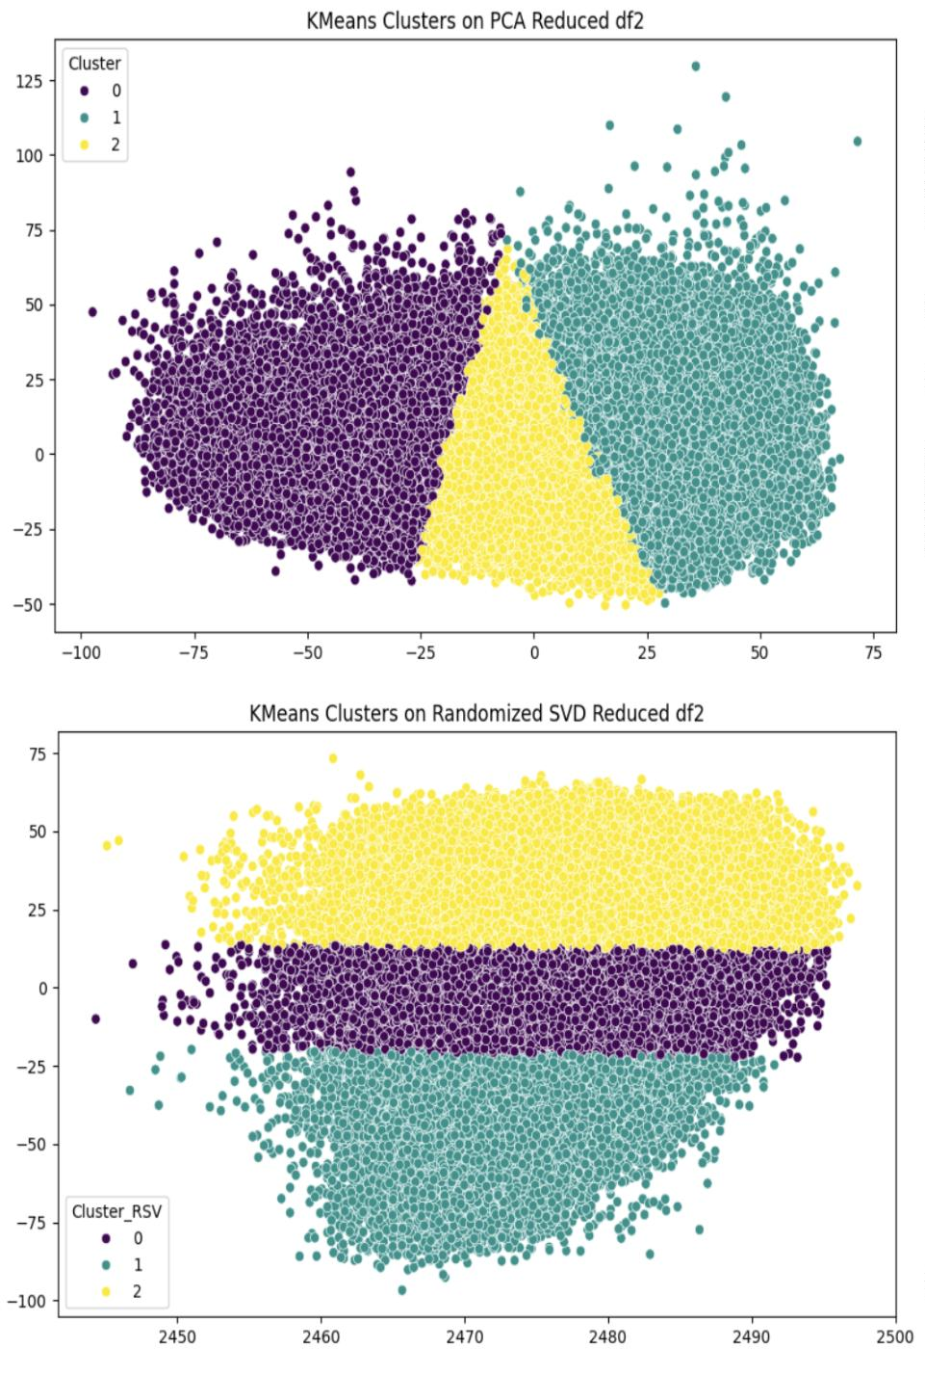
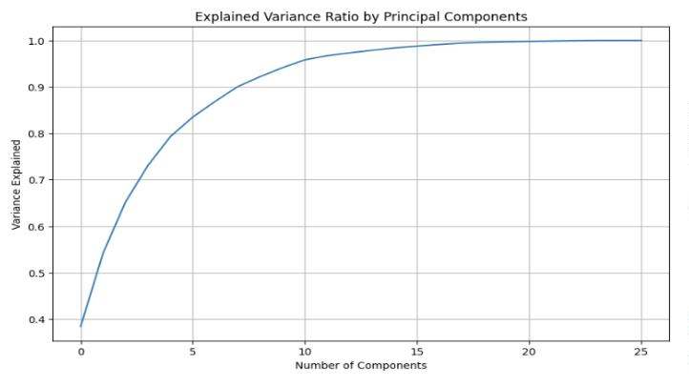
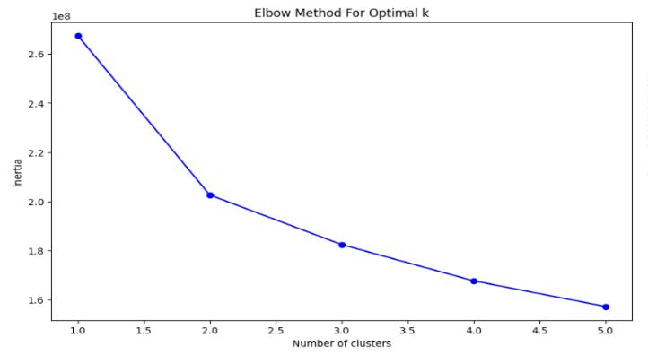

K-Means Clustering Results in Reduced Space, we can see that the Clustering revealed distinct weather
patterns across three clusters.
10 Predictive Modeling
10.1 Classiﬁcation Model
Machine learning models were trained and evaluated. The classiﬁcation Report and Confusion Matrix were
visualized for the PCA-reduced dataset.
Figure 17: Classiﬁcation Report and ROC Curves
10.2 Model Comparison
The following visualizations highlight performance across models:
10.3 Classiﬁcation Results and ROC Curves
Figure 18: ROC Curves for All Models(PCA and SVD)
Performance metrics for PCA- and SVD-reduced data:
14
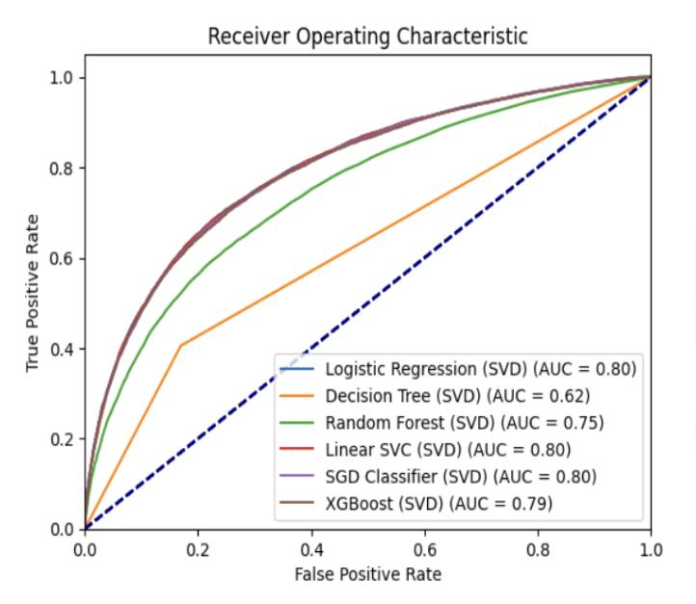
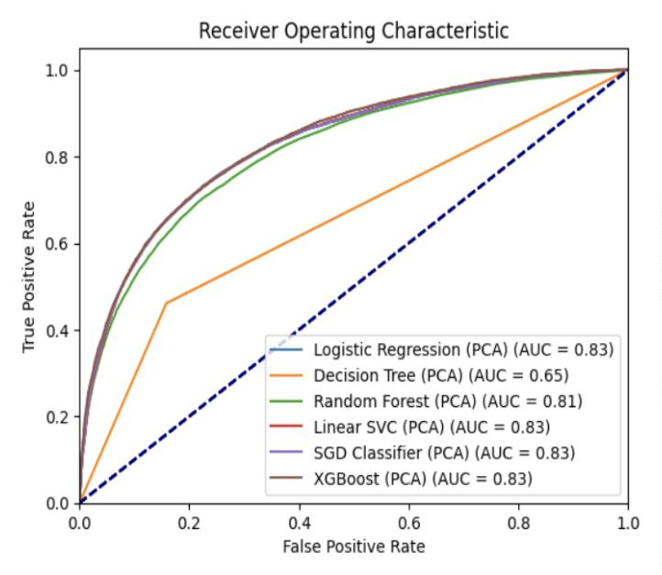
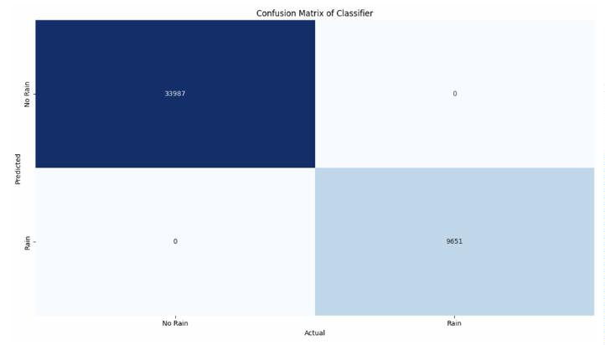
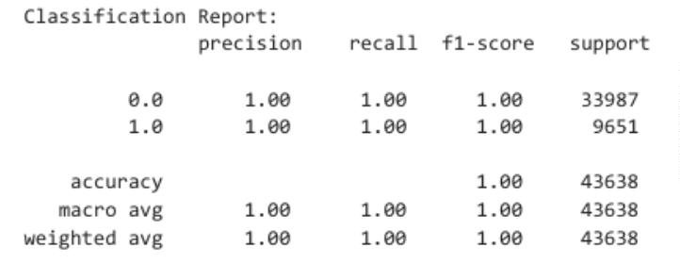

Figure 19: Classiﬁcation Report
15
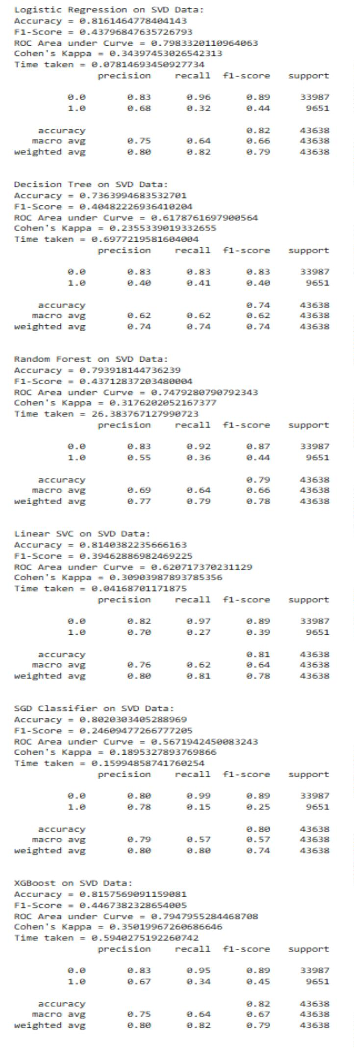
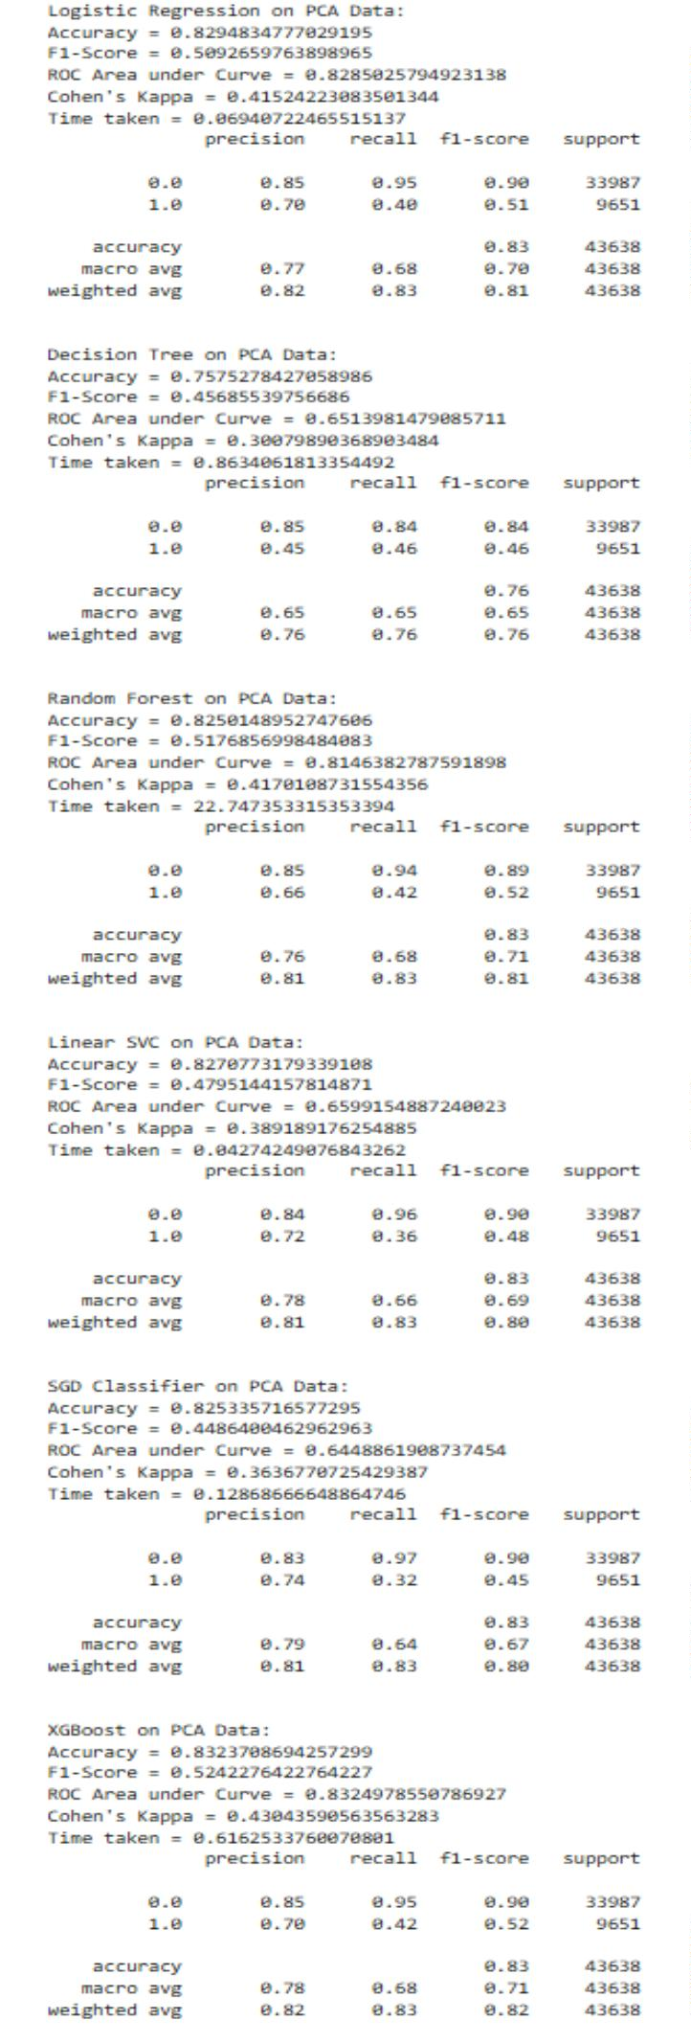

10.4 Decision Region for Model
Figure 20: Decision Region for PCA Models
Figure 21: Decision Region for SVD Models
16
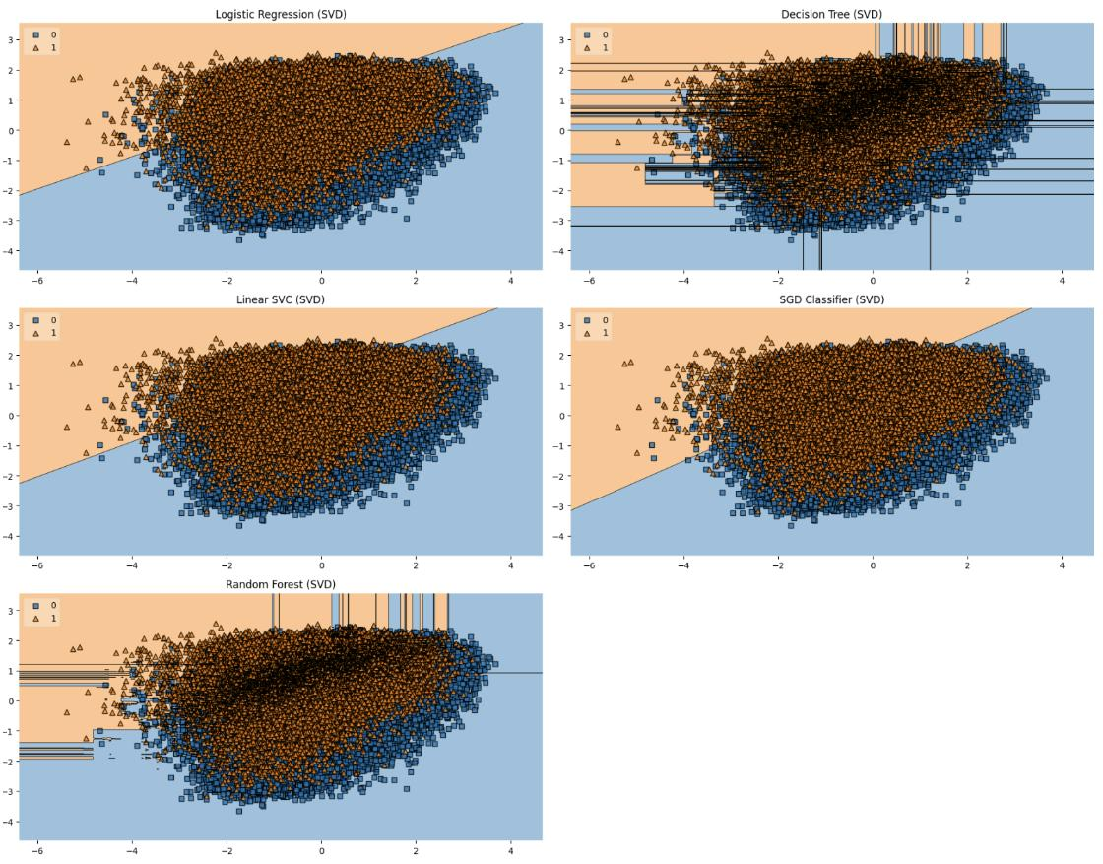
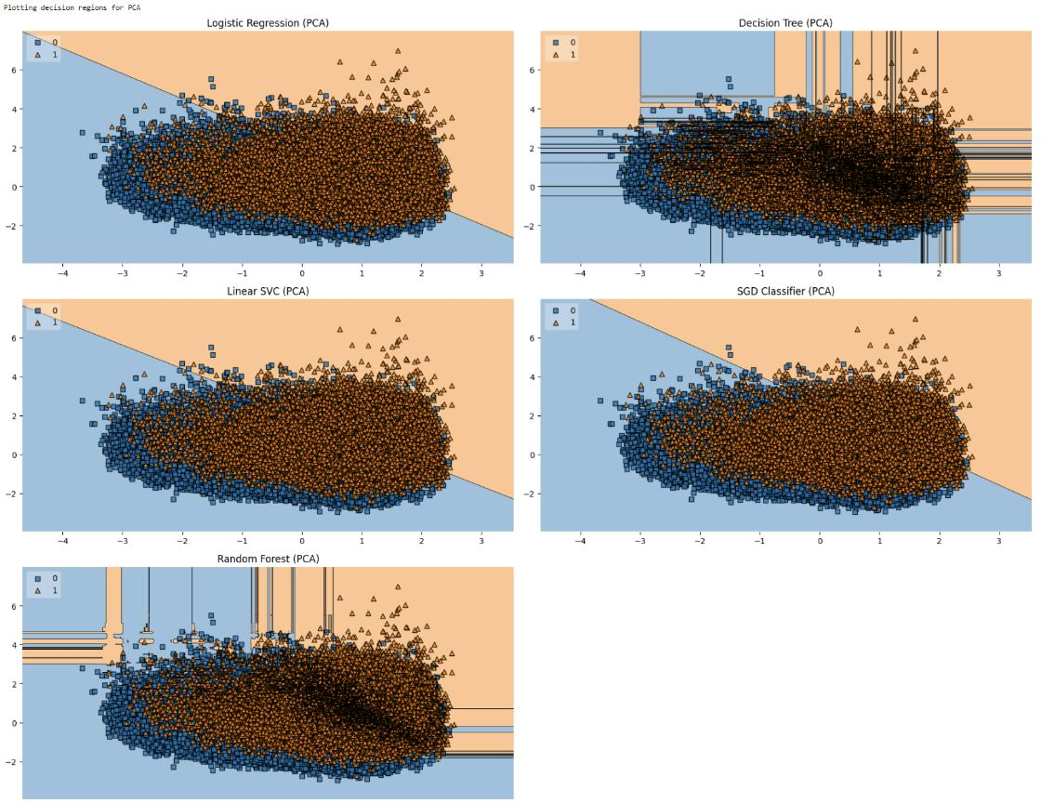

10.5 Model Comparison Graphs
Figure 22: Model Comparison PCA: Accuracy and F1-Score
Figure 23: Model Comparison SVD: Accuracy and F1-Score
17
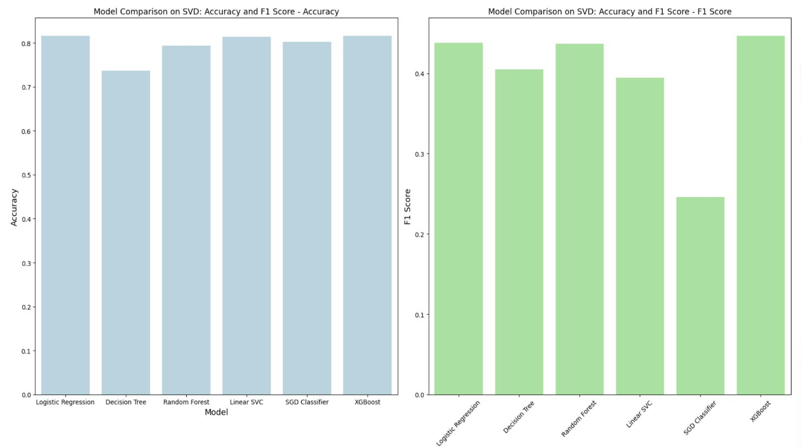
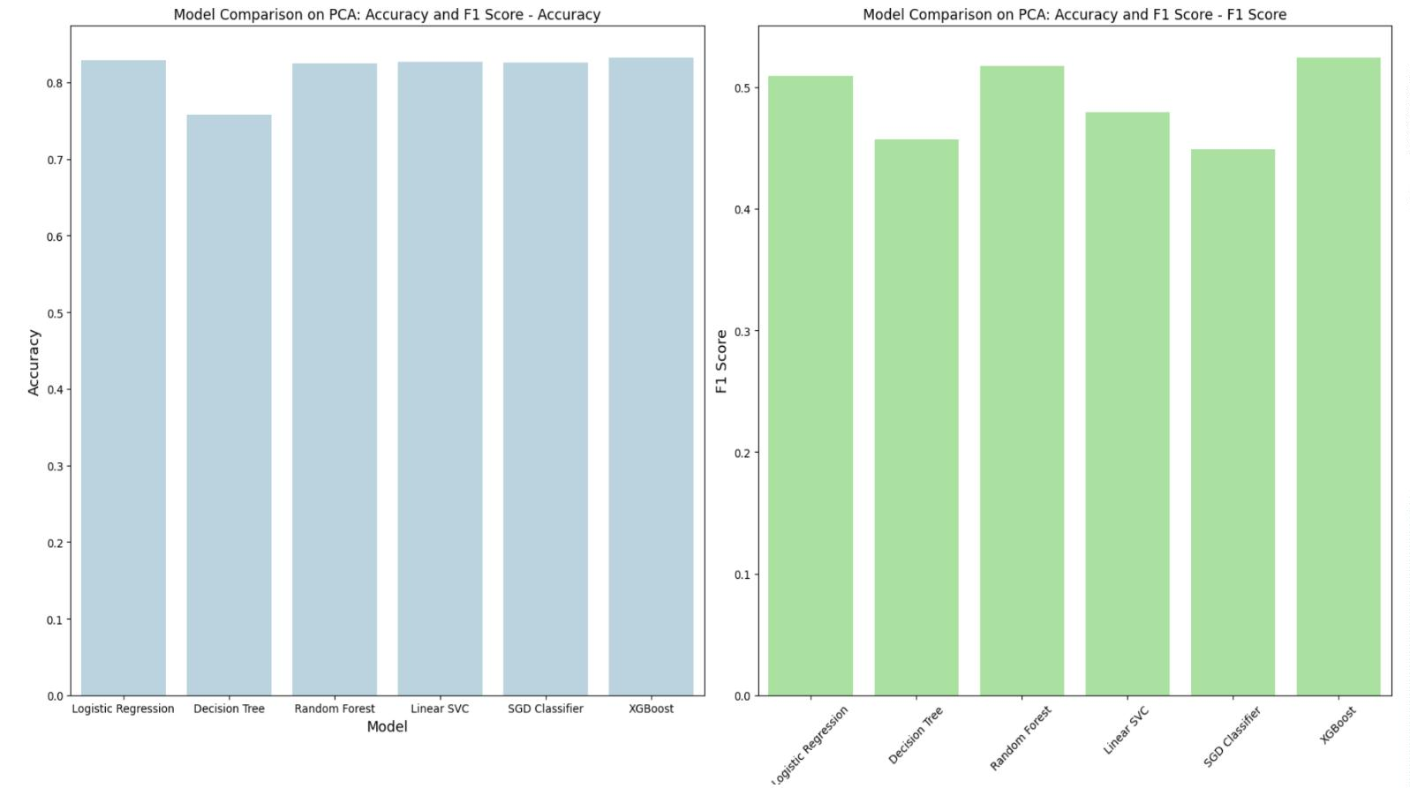

Figure 24: AUC and Cohen’s Kappa for Models
Figure 25: Model Comparison: AUC and Cohen’s Kappa
10.6 Model Selection and Evaluation
Machine learning models were implemented and evaluated on PCA and SVD-reduced data, using accuracy
and ROC-AUC:
Table 1: Model Performance Metrics
Model
Logistic Regression 82.9%
Accuracy ROC-AUC Remarks
0.83
0.65
0.82
0.66
0.65
0.83
(2nd) Great performance, Interpretable, fast
Prone to overﬁtting
Strong performance, robust
Good performance, scalable
Fast, suitable for large datae
(1st) Best overall performance,High precision,Robust
Decision Tree
Random Forest
Linear SVC
75.8%
82.5%
82.7%
82.5%
83.2%
SGD Classiﬁer
XGBoost
18

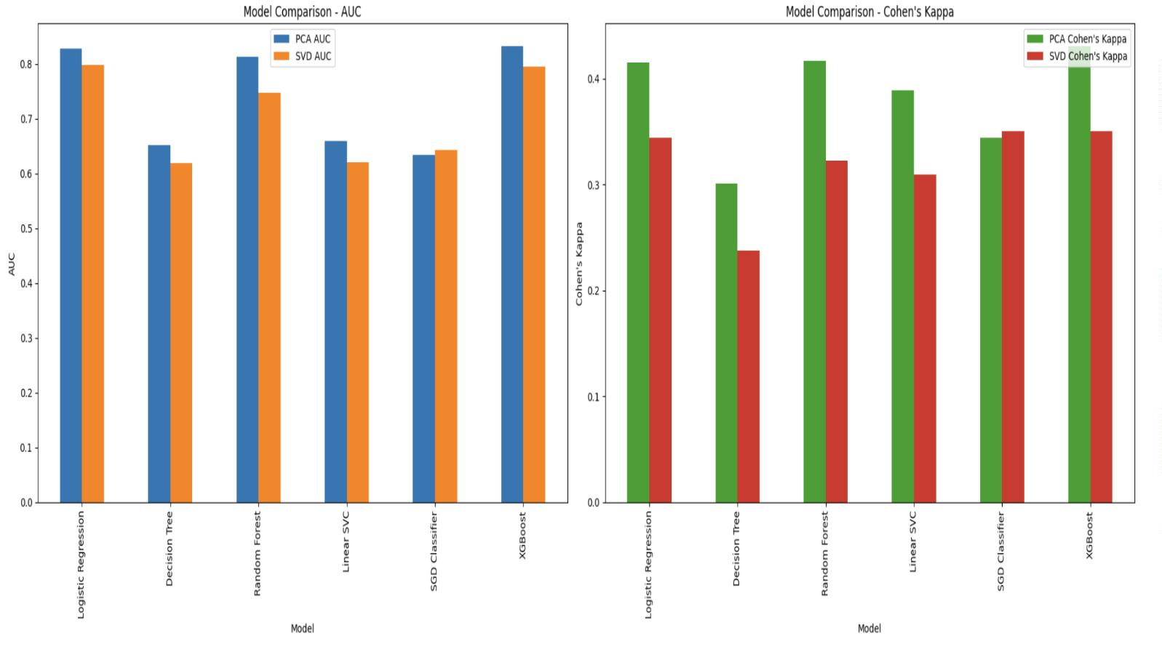
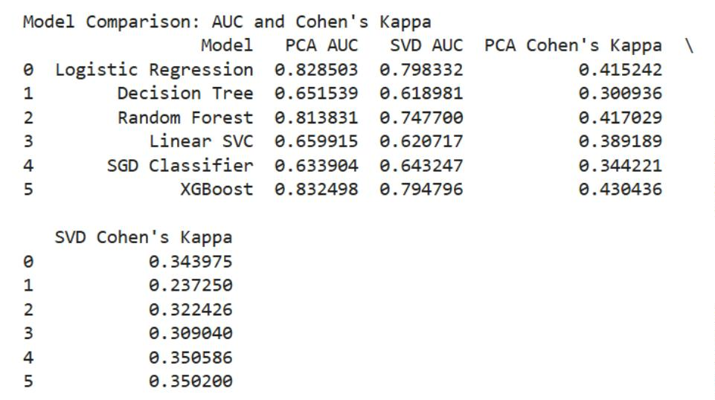

10.7 Regression Analysis
• Linear Regression: Achieved reasonable performance with an MSE of 0.13 and R2 of 0.24.
• Gradient Boosting Regressor: Outperformed Linear Regression with a lower MSE of 0.12 and an
R2 of 0.30.
Figure 26: Linear Regression and Gradient Boosting Regressor for PCA and SVD data
11 Key Observations
• PCA outperformed SVD in dimensionality reduction.
• XGBoost, followed by Logistic Regression emerged as the top-performing models.
• Clustering revealed distinct weather patterns across three clusters.
• Seasonal and interaction-based features signiﬁcantly improved model accuracy.
12 Conclusion
This project demonstrated the eﬃciency of machine learning and dimensionality reduction techniques for
climate data analysis. By reducing the dataset’s dimensionality using PCA and SVD, we managed to
simplify the analysis while retaining critical information, and preserving its variance. Clustering techniques
provided valuable insights into underlying weather patterns, while predictive models showed high accuracy
in forecasting weather conditions. Regression analysis further enhanced our understanding of temperature
trends. Overall, these methods proved to be powerful tools in the realm of climate data analysis and
prediction, oﬀering substantial beneﬁts for future research and practical applications.
References
• Kaggle Weather Dataset: https://www.kaggle.com/datasets
• Scikit-Learn Documentation: https://scikit-learn.org/
• Python Libraries: Numpy, Pandas, Matplotlib, Seaborn, Scikit-learn
19
