Getting Started With Qt (Desktop)

Qt is much more than just a cross-platform SDK - it's a technology strategy that lets you quickly and cost-effectively design, develop, deploy, and maintain software while delivering a seamless user experience across all devices. Let's get started with Qt.

How to setup Qt in Windows?


- Download the open source Qt online installer from here.
- Open the installer and select the package you want to select according to your visual studio edition along with Qt Creator.
- Click next and start the installation.
- After the installation completes, Qt is all setup.

Lets us create a basic “Text Finder” application to understand Qt :

- Select File > New File or Project > Application > Qt Widgets Application > Choose. The Introduction and Project Location dialog opens.

- In the Name field, type TextFinder.

- In the Create in field, enter the path for the project files. For example, C:\Qt\examples, and then click Next (on Windows and Linux). The Kit Selection dialog opens.

- Select build and run kits for your project, and click Next or Continue.
Note: If only one kit is specified in Tools > Options > Build & Run > Kits (on Windows and Linux), this dialog is skipped.
The Class Information dialog opens.

- In the Class name field, type TextFinder as the class name.

- In the Base class list, select Qwidget as the base class type.
Note: The Header file, Source file and Form file fields are automatically updated to match the name of the class.

- Click Next or Continue.
The Project Management dialog opens.

- Review the project settings, and click Finish (on Windows and Linux) .
Note: The project opens in the Edit mode, and these instructions are hidden. To return to these I nstructions, open the Help mode.

The .h and .cpp files come with the necessary boiler plate code. The .pro file is complete.

Filling in the Missing Pieces:
Begin by designing the user interface and then move on to filling in the missing code. Finally, add the find functionality.

Designing the User Interface:

- In the Editor mode, double-click the textfinder.ui file in the Projects view to launch the integrated Qt Designer.
- Drag and drop the following widgets to the form:
  - Label (QLabel)
  - Line Edit (QLineEdit)
  - Push Button (QPushButton)

Note: To easily locate the widgets, use the search box at the top of the Sidebar. For example, to find the Label widget, start typing the word label.

- Double-click the Label widget and enter the text Keyword.

- Double-click the Push Button widget and enter the text Find.

- In the Properties pane, change the objectName to findButton.

- Press Ctrl+A (or Cmd+A) to select the widgets and click Lay out Horizontally (or press Ctrl+H on Linux or Windows) to apply a horizontal layout (QHBoxLayout).

- Drag and drop a Text Edit widget (QTextEdit) to the form.

- Select the screen area and click Lay out Vertically (or press Ctrl+L) to apply a vertical layout (QVBoxLayout).

Applying the horizontal and vertical layouts ensures that the application UI scales to different screen sizes.

- To call a find function when users press the Find button, you use the Qt signals and slots mechanism. A signal is emitted when a particular event occurs and a slot is a function that is called in response to a particular signal. Qt widgets have predefined signals and slots that you can use directly from Qt Designer. To add a slot for the find function:
  - Right-click the Find button to open a context-menu.
  - Select Go to Slot > clicked(), and then select OK.
A private slot, on_findButton_clicked(), is added to the header file, textfinder.h and a private function, TextFinder::on_findButton_clicked(), is added to the source file, textfinder.cpp.

- Press Ctrl+S (or Cmd+S) to save your changes.
For more information about designing forms with Qt Designer, see the Qt Designer Manual.

Completing the Header File:
The textfinder.h file already has the necessary #includes, a constructor, a destructor, and theUiobject. You need to add a private function, loadTextFile(), to read and display the contents of the input text file in the QTextEdit.
- In the Projects pane in the Edit view, double-click the textfinder.h file to open it for editing.

- Add a private function to the private section, after the Ui::TextFinder pointer, as illustrated by the following code snippet:
private slots:
void on_findButton_clicked();

private:
Ui::TextFinder *ui;
void loadTextFile();

Completing the Source File:
Now that the header file is complete, move on to the source file, textfinder.cpp.

- In the Projects pane in the Edit view, double-click the textfinder.cpp file to open it for editing.

- Add code to load a text file using QFile, read it with QTextStream, and then display it on textEdit with QTextEdit::setPlainText(). This is illustrated by the following code snippet:
void TextFinder::loadTextFile()
{
QFile inputFile(":/input.txt");
inputFile.open(QIODevice::ReadOnly);

QTextStream in(&inputFile);
QString line = in.readAll();
inputFile.close();

ui->textEdit->setPlainText(line);
QTextCursor cursor = ui->textEdit->textCursor();
cursor.movePosition(QTextCursor::Start, QTextCursor::MoveAnchor, 1);
}
- To use QFile and QTextStream, add the following #includes to textfinder.cpp:

#include <QFile>
#include <QTextStream>
- For the on_findButton_clicked() slot, add code to extract the search string and use the QTextEdit::find() function to look for the search string within the text file. This is illustrated by the following code snippet:
void TextFinder::on_findButton_clicked()
{
QString searchString = ui->lineEdit->text();
ui->textEdit->find(searchString, QTextDocument::FindWholeWords);
}
- Once both of these functions are complete, add a line to call loadTextFile() in the constructor, as illustrated by the following code snippet:
TextFinder::TextFinder(QWidget *parent)
: QWidget(parent), ui(new Ui::TextFinder)
{
ui->setupUi(this);
loadTextFile();
}
The on_findButton_clicked() slot is called automatically in the uic generated ui_textfinder.h file by this line of code:
QMetaObject::connectSlotsByName(TextFinder);

Creating a Resource File:
You need a resource file (.qrc) within which you embed the input text file. The input file can be any .txt file with a paragraph of text. Create a text file called input.txt and store it in the textfinder folder.
To add a resource file:
- Select File > New File or Project > Qt > Qt Resource File > Choose.

The Choose the Location dialog opens.

- In the Name field, enter textfinder.

- In the Path field, enter C:\Qt\examples\TextFinder, and click Next or Continue.
The Project Management dialog opens.

- In the Add to project field, select TextFinder.pro and click Finish or Done to open the file in the code editor.

- Select Add > Add Prefix.

- In the Prefix field, replace the default prefix with a slash (/).

- Select Add > Add Files, to locate and add input.txt.

Compiling and Running Your Program:
Now that you have all the necessary files, run the qmake utility and then click the button to compile and run your program.
TextFinder is ready to be used.

What is the use of qmake in Qt ?

Qmake is a tool that helps simplify the build process for development project across different platforms. Qmake automates the generation of Makefiles so that only a few lines of information are needed to create each Makefile . Qmake generates a Makefile based on the information in a project file.
In Qt Creator, you just click on run qmake and it automatically generates the required makefiles for your project.

How does user interface files(.ui) work in Qt ?

Qt GUI toolkit has a User Interface Compiler. The uic reads an XML format user interface definition (.ui) file as generated by Qt Designer and creates a corresponding C++ header file. With the Qt's Integrated build tools , uic and qmake , code is generated for the corresponding ui elements.

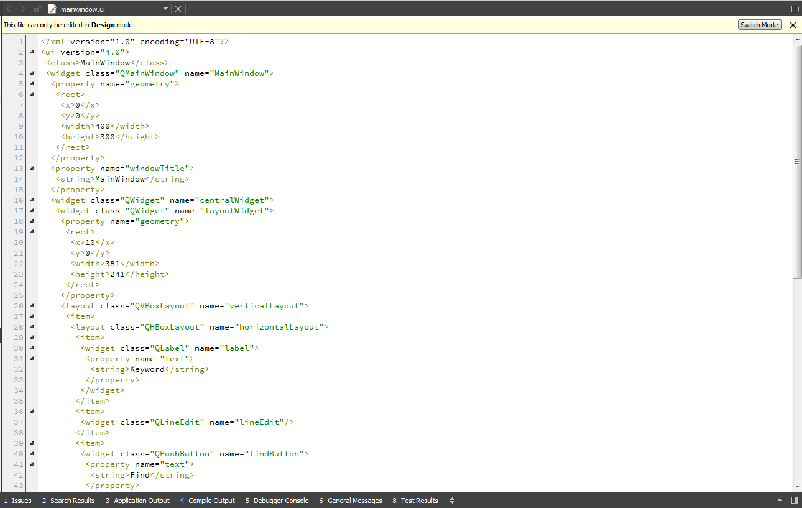

These are the basics to get started with Qt. To know more go to http://doc.qt.io/.

