Member 3: Network Hardening
Configurations
Northbridge Savings & Finance Network Security Upgrade — IE3122 Group Assignment
Student ID: [IT24102763] – Pathiraja P.M.A.R

Overview
This document presents Member 3's two practical network hardening configurations performed on the group's shared Northbridge topology. Configuration 1 is the plan-linked Port Security control for Threat 3.2. Configuration 2 is an Extended ACL used for BYOD network isolation. The originally assigned UplinkFast technique was not implemented because the Packet Tracer 2960 IOS available for this work did not provide the required command, and the assigned topology did not contain a redundant uplink path for a meaningful failover demonstration.

Configuration 1 (Plan-Linked): Port Security

What It Achieves
Port Security restricts an access port to an authorised device MAC address. In this implementation, SW-BR FastEthernet0/2 was limited to one secure MAC address and configured with sticky MAC learning and a shutdown violation action. This prevents an unauthorised device from taking over the branch access port.

Threat Addressed
Threat 3.2 — DHCP Spoofing at Branch Offices. The branch scenario includes weak physical protection and the possibility of unauthorised device insertion. Port Security provides an additional Layer 2 hardening control by restricting which device can use the protected access port. DHCP Snooping is the direct control for rogue DHCP-server protection; Port Security complements it by controlling device insertion.

Configuration Commands
enable
configure terminal
interface fastEthernet 0/2
switchport mode access
switchport port-security
switchport port-security maximum 1
switchport port-security mac-address sticky
switchport port-security violation shutdown
end

Step 1: Verify Port Security Configuration
The configuration was verified before the violation test. The legitimate PC-BR MAC address was learned as a sticky secure MAC on SW-BR Fa0/2.
show port-security interface fastEthernet 0/2
show interfaces status

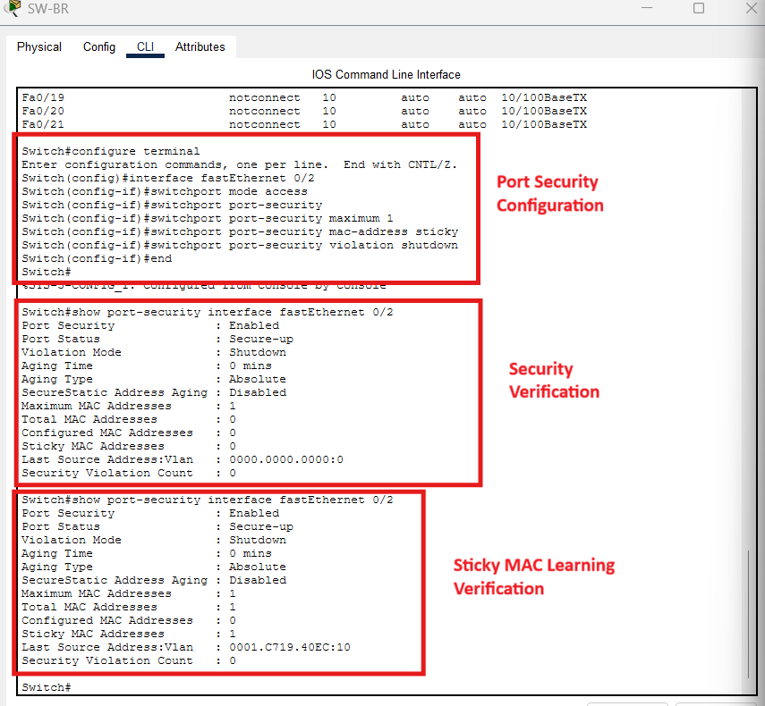

Step 2: Trigger the Port Security Violation
PC-BR was disconnected and a Rogue-PC was connected to the same access port. The rogue device used a different MAC address. After traffic was generated, the switch detected the unauthorised source and placed Fa0/2 into the shutdown/err-disabled state.
show port-security interface fastEthernet 0/2
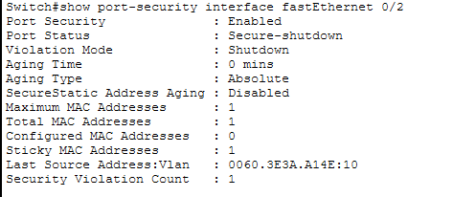
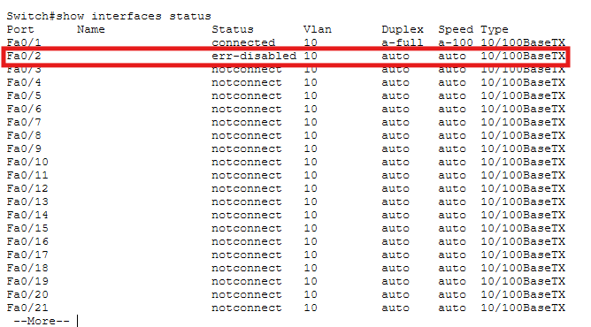
show interfaces status

3: Restore the Port
The rogue device was removed and the access port was manually recovered. The legitimate PC-BR was then reconnected.
enable
configure terminal
interface fastEthernet 0/2
shutdown
no shutdown
end

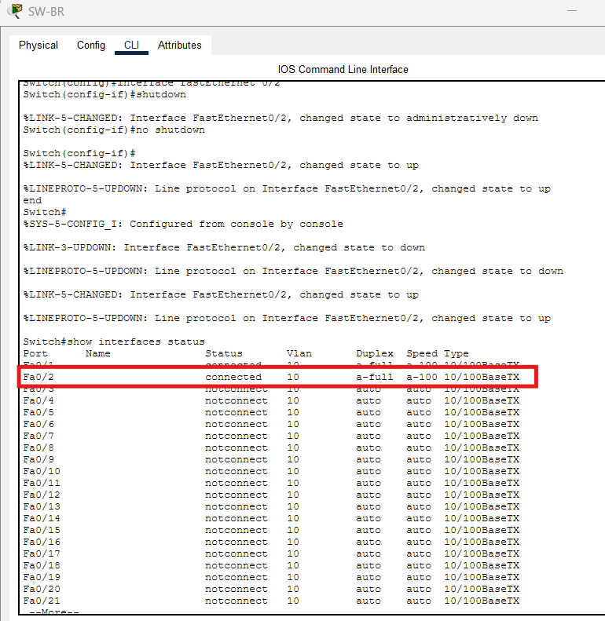

Step 4: Verify Final Connectivity
After reconnecting the legitimate PC-BR, the branch host was able to communicate normally again, confirming that the recovery procedure restored service without removing the Port Security configuration.
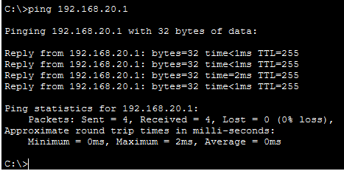

Configuration 2 : Extended ACL — BYOD Network Isolation

What It Achieves
The Extended ACL creates a network-level access-control boundary for a separate BYOD VLAN. Traffic originating from the BYOD network is denied when attempting to reach the internal Head Office network, while other traffic is permitted by the final permit statement. This demonstrates practical segmentation and isolation of unmanaged personal devices.

Threat Addressed
Threat 4.2 — Malware via BYOD / Unmanaged Personal Devices. The ACL does not detect or remove malware. Instead, it reduces exposure by preventing the BYOD segment from directly reaching the internal 192.168.10.0/24 network.

Network and VLAN Setup
A separate BYOD VLAN 50 (BYOD_GUEST) was created on SW-HO and connected to R-HO using router-on-a-stick. The BYOD network used 192.168.50.0/24 with gateway 192.168.50.1, while the protected internal Head Office network remained 192.168.10.0/24.
enable
configure terminal
vlan 50
name BYOD_GUEST
exit
interface fastEthernet 0/4
switchport mode access
switchport access vlan 50
end
On the router, the Fa0/3 switch link was operated as a trunk and Gi0/0.50 was configured for VLAN 50.
configure terminal
interface fastEthernet 0/3
switchport mode trunk
end
interface gigabitEthernet 0/0
no ip address
interface gigabitEthernet 0/0.10
encapsulation dot1Q 10
ip address 192.168.10.1 255.255.255.0
interface gigabitEthernet 0/0.50
encapsulation dot1Q 50
ip address 192.168.50.1 255.255.255.0

Step 1: Verify Connectivity Before ACL
Before the ACL was applied, BYOD-PC at 192.168.50.100 could reach the internal PC-HO at 192.168.10.100, providing the baseline condition for the isolation test.
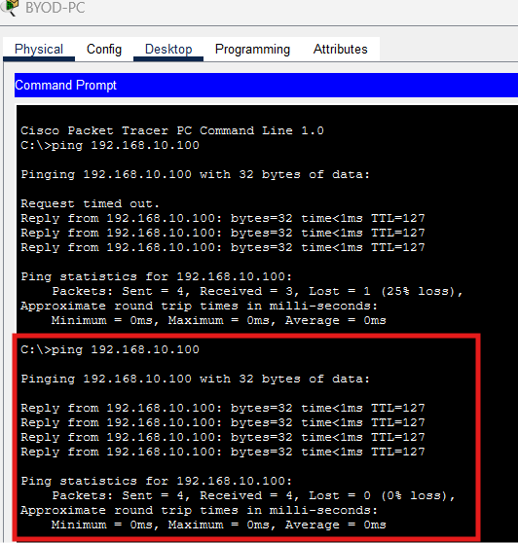

Step 2: Configure and Apply the Extended ACL
The ACL named BYOD-ISOLATION denies traffic from the BYOD subnet to the internal Head Office subnet and then permits other traffic. It is applied inbound on the VLAN 50 router subinterface.
ip access-list extended BYOD-ISOLATION
deny ip 192.168.50.0 0.0.0.255 192.168.10.0 0.0.0.255
permit ip any any
exit
interface gigabitEthernet 0/0.50
ip access-group BYOD-ISOLATION in
end

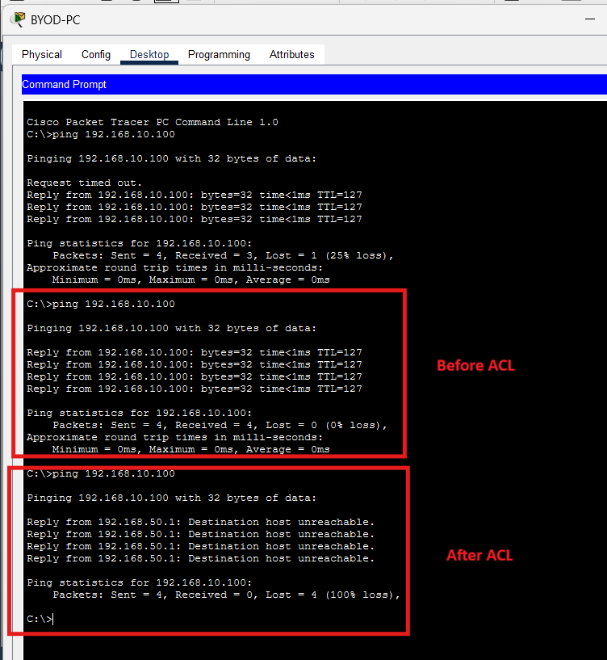

Step 3: Verify ACL Hit Counter
show access-lists BYOD-ISOLATION
The deny entry recorded four matches during the test, confirming that the ACL rule was actively processing and blocking the attempted traffic.
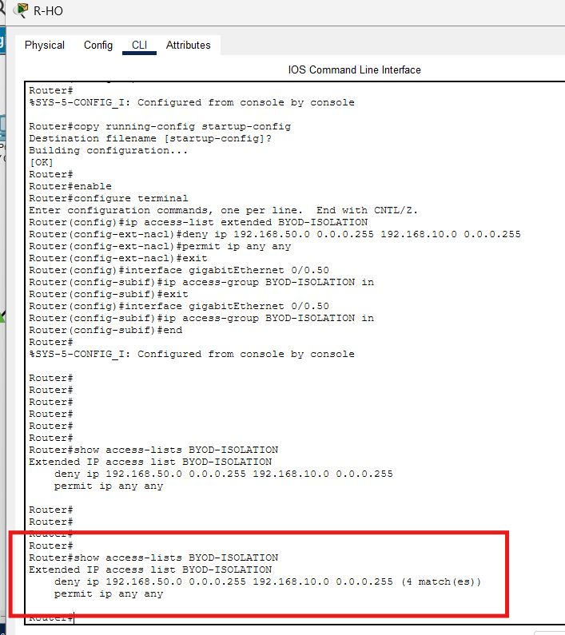

Step 4: Verify ACL Application on the Interface
show ip interface gigabitEthernet 0/0.50
The interface verification confirmed that the inbound access list on Gi0/0.50 was BYOD-ISOLATION.
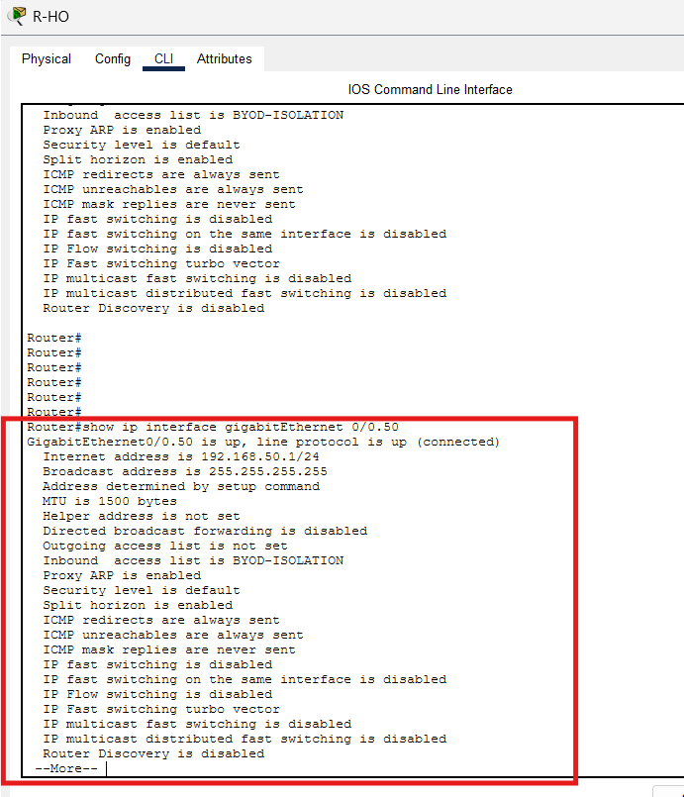

Implementation Note: Originally Assigned UplinkFast
UplinkFast was the original second technique assigned to Member 3. During implementation, the available Cisco 2960 Packet Tracer IOS rejected the spanning-tree uplinkfast command. In addition, the assigned topology contains only one physical uplink on the branch switch, so there was no redundant uplink path on which UplinkFast failover could be demonstrated. The Extended ACL was therefore implemented as the second practical configuration rather than claiming unsupported or non-demonstrable evidence.

Packet Tracer Files
The final practical files were saved separately as:
- Northbridge_Member3_PortSecurity.pkt
- Northbridge_Member3_ExtendedACL.pkt
The accompanying screenshots, command scripts, and detailed practical logs can be kept alongside these files in the final ZIP package.

