**ELECTROMAGNETIC MODELLING USING ARTIFICIAL NEURAL NETWORK**

**S**ubmitted to: **P**rof. **N**avneet **G**upta

**S**ubmitted by: **A**chleshwar **L**uthra

**Abstract** -

In this report, a deep study has been conducted on the design of Microstrip Patch Antenna and the role of Artificial Neural Networks in its modeling. A general design procedure is suggested for microstrip antennas based on rectangular patch geometry using artificial neural networks. Both the topics are first studied separately followed by choosing the best algorithms for antenna modeling. As a part of this project, research has been made on the comparison between results obtained using neural networks and experimental results. It is found that Radial Base Function is quite accurate, sufficiently fast and yields satisfactory results.

**MICROSTRIP PATCH ANTENNA**

Microstrip patch antenna falls under the broad classification of printed antennae. Printed antennae are the ones that are fabricated using standard photolithography techniques. These antennae are inexpensive to fabricate using modern printed circuit technology and are conformable to planar and non-planar surfaces. These can be easily mounted on the surface of satellites, spacecraft, missiles, aircraft, and even handheld mobile devices.

The microstrip patch antenna is one of the most popular examples of printed antennae. These are very simple in construction using conventional fabrication techniques. It consists of a dielectric substrate with a radiating patch on one side and a ground plane on the other as shown in the figure below.

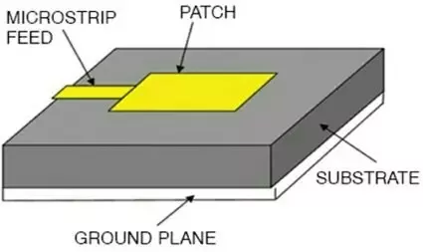

The patch is made up of conducting material such as copper or gold and may take any of the following shapes like circular, rectangular, elliptical or some other common shape. Generally, a thick nonconductor substrate with a low dielectric constant (preferably <6) is desired since it provides larger bandwidth, better radiation, and higher efficiency. However, this ends up in an increase in the size of the antenna.

In order to reduce the size of the microstrip patch antenna, a substrate with a higher dielectric constant (preferably <12) must be used, which results in narrower bandwidth and lesser efficiency. Hence a compromise must be made between antenna dimensions and antenna performance. Excitation guides the electromagnetic energy source to the patch, generating negative charges around the feed point and positive charges on the other part of the patch. This difference in charges creates electric fields in the antenna that are responsible for radiations from the patch antenna.

Three different types of electromagnetic waves are radiated. The primary half is radiated into space, which is ‘useful’ radiation. The secondary half that contributes to the power transmission is diffracted waves, which are reflected back into space between the ground plane and the patch. The last part of the wave, due to total reflection at the air-dielectric separation surface remains trapped in the dielectric substrate and these are generally undesirable.

**RECTANGULAR PATCH GEOMETRY**

The rectangular microstrip antennas are made of a rectangular patch with dimensions width (W) and length (L) over a ground plane with a substrate thickness (h) and dielectric constants εr, εy, as given in the figure. Dielectric constants are usually used in the range of 2.2 ≤ εr ≤ 12. However, the most desirable ones are the dielectric constants at the lower end of this range together with the thick substrates, because they provide better efficiency and larger bandwidth, but at the expense of larger element size.

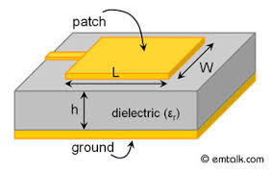

For an anisotropic substrate, the spacing parameter h is replaced by the effective spacing he, and the geometric mean εg is used for the dielectric constant εr:

he = [(εr/ εy)^(0.5)]h

εg = (εr.εy)^(0.5)

The effective dielectric constant of the dielectric material is given in as:

εeff = (εg + 1)/2 + [(εg − 1)/ 2].[1+ 12 (he/W)]^(-½)

For an efficient radiator, a practical width that leads to good radiation efficiencies is :

W = (vo/2fr).( 2/ εg + 1)^(½)

where vo is the free-space velocity of light.

The actual length of the patch:

L = [1/( 2fr .(εeff .µoεo)^(½))] − 2∆L

where ∆L is the extension of the length due to the fringing effects and is given by:

∆L/h = 0.412 [(εeff + 0.3).(W/h + 0.264)]/ [(εeff − 0.258).(W/h + 0.8)]

**ARTIFICIAL NEURAL NETWORK**

Artificial neural networks consist of input and output layers, further a hidden layer consisting of units that remodel the input into one thing that the output layer will use.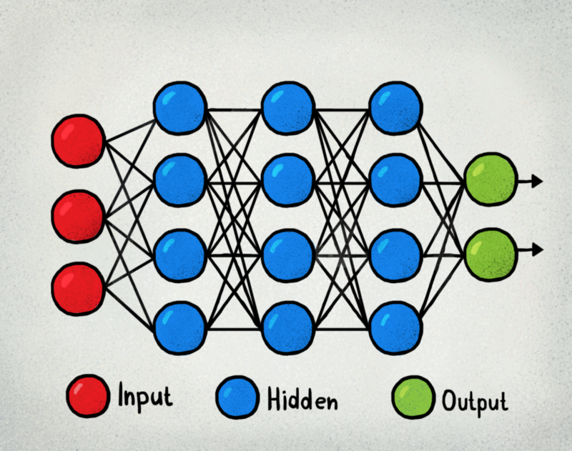

For a basic idea of how a neural network learns, imagine a factory line-up. Once the raw materials (the data set) are input, they are passed down the conveyor, with every subsequent stop or layer extracting a distinct set of high-level features. If the network is meant to identify an object, the primary layer might analyze the brightness of its pixels.

The next layer may then establish any edges within the image, based on lines of comparable pixels. After this, another layer might acknowledge textures and shapes, and so on. By the time the fourth or fifth layer is reached, the deep learning network will have created complicated feature detectors. It will discern that certain image elements (such as a pair of eyes, a nose, and a mouth) are commonly found together.

Once this is done, the engineers who have trained the model can provide labels to the output, and then use backpropagation to correct any mistakes which might have been made. After training, the network can perform its own classification tasks without needing humans to help.

**OPTIMIZING ANTENNA USING NEURAL NETWORK MODEL**

In this study, the Neural Network is functioning as a tool in defining the scale of the proposed microstrip antenna. The NN training procedures are employed in the simulation of results for training the samples. The most widely held algorithm of NN for correcting weights during the training phase is known as backpropagation. Both Radial Basis Function (RBF) and Multilayer Perception (MLP) networks were used in the ANN algorithm.

MLP neural networks are the simplest ANN models, and for that reason most typically used. Further, MLPNNs is trained through the standard backpropagation algorithm. It has three layers, named as, an input layer, a hidden layer, and an output layer. The neurons of the input layer allot the input values xj to the hidden layer(s) neurons. Each neuron of hidden layer j adds up its input values xj after assigning weight to them and thus strengthens the individual connections wij as of the input layer and calculates its output value yi as a mathematical function f of the addition:

yi = f (∑ wijxj) ………………..(1)

where f notation used to represent a hyperbolic or sigmoid tangent function.

In the same way neurons of the output layer are calculated.

Training an ANN involves the adjustment of weights of the network by means of a learning algorithm. Here, the backpropagation learning algorithm is used which is also called the gradient descent algorithm that provides the modification in wij(k) in the form of weighted connection among neurons i and j in this way:

∆wij(k) = α(del)ixj + µ∆ wij(k - 1)……………(2)

where α denotes the learning coefficient, xj is the input value, µ is the momentum coefficient and (del)i belong to a term depending on whether neuron i is a hidden neuron or an output neuron.

In the training of neural network, gradient descent with adaptive learning rate algorithm is used and along with that K-fold cross-validation is used for the test result to be more valuable. This method is used to obtain the best ANN structural design. Eight antenna dimensions with different combinations of length (s1, s2, s3, s4) and width (w1, w2, w3, w4) are used for the patch antenna. These eight dimensions vary from 0.1 to 2 mm. The sampled values are then scaled within the range 1 to -1 and employed as the training data for the network. In neural networks during training process weights are adjusted to minimize the error between the predicted and sampled value. The backpropagation algorithm is used to compute these adjusted values. Mainly three layers are used in algorithm i.e. input layer, hidden layer, and output layer. Out of the data generated, 70% is used for training and the rest is used for testing the trained neural network.

**WORKING MODEL**:

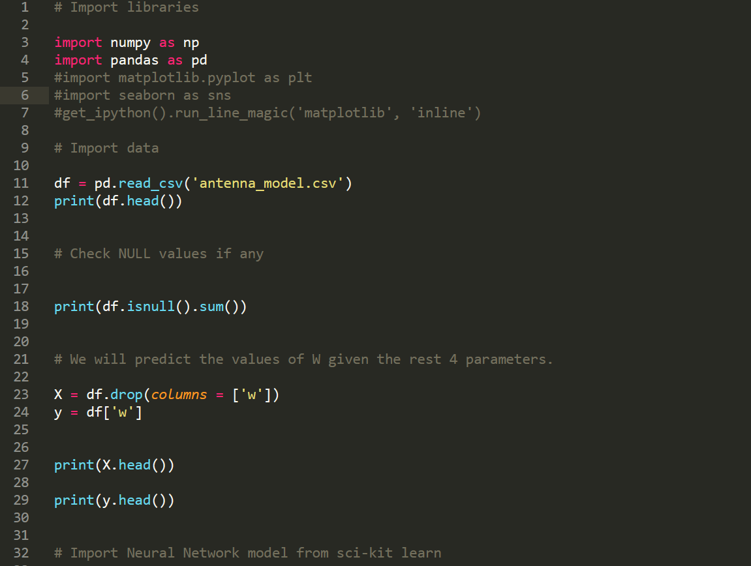

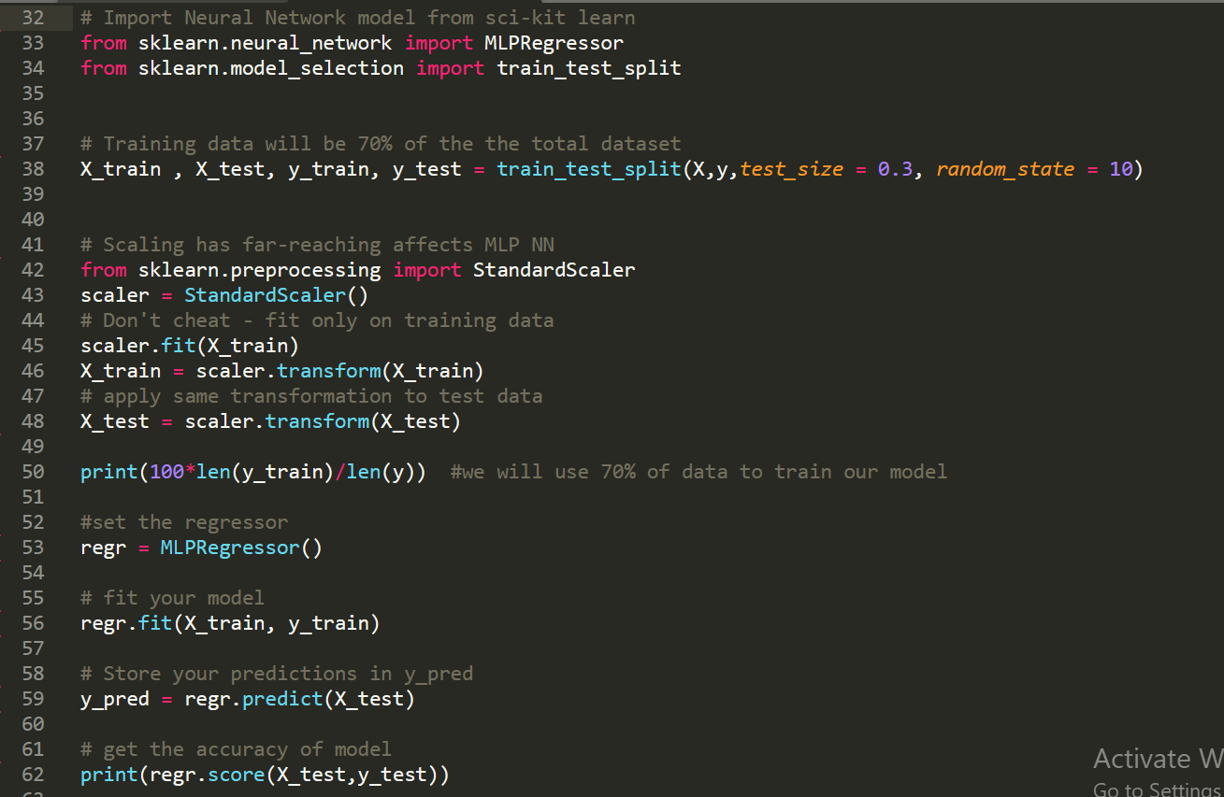

**Note:** This model was able to achieve an accuracy of 99.993% in predict width of the patch (the rest 4 parameters given).

**RESOURCES**:

1. <https://www.electronicsforu.com/technology-trends/microstrip-antenna-applications>
2. [https://pdfs.semanticscholar.org/e080/1f86547816a99848aa034c11f8788c21f265](https://pdfs.semanticscholar.org/e080/1f86547816a99848aa034c11f8788c21f265.pdf)
3. <http://journals.tubitak.gov.tr/elektrik/issues/elk-06-14-3/elk-14-3-7-0606-9.pdf>
4. <https://www.ijitee.org/wp-content/uploads/papers/v8i9S/I10970789S19.pdf>
5. <https://www.digitaltrends.com/cool-tech/what-is-an-artificial-neural-network/>
6. <https://pdfs.semanticscholar.org/6b43/7554e76041f9c42fe929cc74d99b0918eec6.pdf>
7. N. Turker, F. Gunes and T. Yildirim, “Artificial Neural Design of Microstrip Antennas,” Turkish Journal of Electrical Engineering, Vol. 14, No. 3, 2006, pp. 445- 453.