**Database:Normalisasi**

* **ERD normalisai**

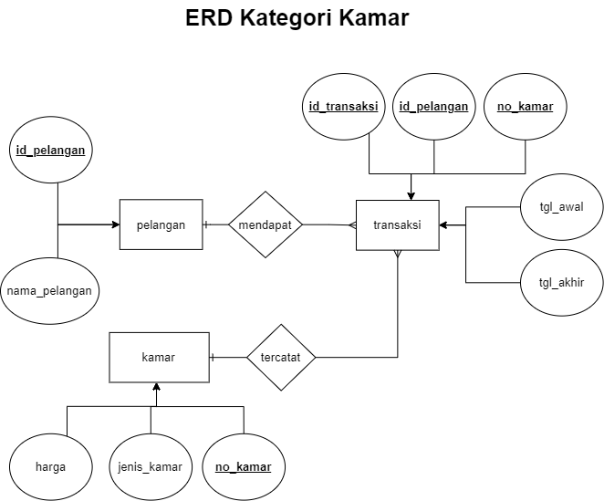

|  |  |  |  |  |  |  |  |  |
| --- | --- | --- | --- | --- | --- | --- | --- | --- |
| Id_pelangan | Nama_pelangan | No_kamar | Jeinis_kamar | harga | Id_transaksi | Tgl_awal | Tgl_akhir | total |
| 0001 | Olifa Amania | 001 | VIP | 10.000.000 | A0001 | 20-05-2000 | 20-06-2021 | 10.000.000 |
| 0002 | Horep Alfiansa | 006 | Keluarga | 5.000.000 | A0002 |  | 20-07-2021 | 10.000.000 |
| 0003 | Karim Abdul | 007 | Keluarga | 5.000.000 | A0003 | 01-06-2000 | 01-07-2021 | 5.000.000 |
| 0004 | Suri alulia | 011 | Standart | 1.000.000 | A0004 |  |  | 1.000.000 |
| 0005 | Yusuf Iwaniya | 012 | Standart | 1.000.000 | A0005 |  | 01-09-2021 | 4.000.000 |

* **Bentuk Normal Pertama (1NF)**

|  |  |  |  |  |  |  |  |  |
| --- | --- | --- | --- | --- | --- | --- | --- | --- |
| Id_pelangan | Nama_pelangan | No_kamar | Jeinis_kamar | harga | Id_transaksi | Tgl_awal | Tgl_akhir | total |
| 0001 | Olifa Amania | 001 | VIP | 10.000.000 | A0001 | 20-05-2000 | 20-06-2021 | 10.000.000 |
| 0002 | Horep Alfiansa | 006 | Keluarga | 5.000.000 | A0002 | 20-05-2000 | 20-07-2021 | 10.000.000 |
| 0003 | Karim Abdul | 007 | Keluarga | 5.000.000 | A0003 | 01-06-2000 | 01-07-2021 | 5.000.000 |
| 0004 | Suri alulia | 011 | Standart | 1.000.000 | A0004 | 01-06-2000 | 01-07-2021 | 1.000.000 |
| 0005 | Yusuf Iwaniya | 012 | Standart | 1.000.000 | A0005 | 01-06-2000 | 01-09-2021 | 4.000.000 |

* **Bentuk Normal Kedua (2NF)**

|  |  |  |
| --- | --- | --- |
| Id_pelangan | Id_transaksi | total |
| 0001 | A0001 | 10.000.000 |
| 0002 | A0002 | 10.000.000 |
| 0003 | A0003 | 5.000.000 |
| 0004 | A0004 | 1.000.000 |
| 0005 | A0005 | 4.000.000 |

|  |  |
| --- | --- |
| Id_pelangan | Nama_pelangan |
| 0001 | Olifa Amania |
| 0002 | Horep Alfiansa |
| 0003 | Karim Abdul |
| 0004 | Suri alulia |
| 0005 | Yusuf Iwaniya |

|  |  |  |  |  |  |
| --- | --- | --- | --- | --- | --- |
| Id_transaksi | Tgl_awal | Tgl_akhir | No_kamar | Jeinis_kamar | harga |
| A0001 | 20-05-2000 | 20-06-2021 | 001 | VIP | 10.000.000 |
| A0002 | 20-05-2000 | 20-07-2021 | 006 | Keluarga | 5.000.000 |
| A0003 | 01-06-2000 | 01-07-2021 | 007 | Keluarga | 5.000.000 |
| A0004 | 01-06-2000 | 01-07-2021 | 011 | Standart | 1.000.000 |
| A0005 | 01-06-2000 | 01-09-2021 | 012 | Standart | 1.000.000 |

* **Diagram Ketergantungan Fungsional**

total

Id_transaksi

No_kamar

Jenis_kamar

Tgl_awal

harga

Tgl_akhir

Id_pelangan

Nama_pelangan

* **Bentuk Normal Ketiga (3NF)**

|  |  |  |
| --- | --- | --- |
| Id_pelangan | Id_transaksi | total |
| 0001 | A0001 | 10.000.000 |
| 0002 | A0002 | 10.000.000 |
| 0003 | A0003 | 5.000.000 |
| 0004 | A0004 | 1.000.000 |
| 0005 | A0005 | 4.000.000 |

|  |  |
| --- | --- |
| Id_pelangan | Nama_pelangan |
| 0001 | Olifa Amania |
| 0002 | Horep Alfiansa |
| 0003 | Karim Abdul |
| 0004 | Suri alulia |
| 0005 | Yusuf Iwaniya |

|  |  |  |
| --- | --- | --- |
| Id_transaksi | Tgl_awal | Tgl_akhir |
| A0001 | 20-05-2000 | 20-06-2021 |
| A0002 | 20-05-2000 | 20-07-2021 |
| A0003 | 01-06-2000 | 01-07-2021 |
| A0004 | 01-06-2000 | 01-07-2021 |
| A0005 | 01-06-2000 | 01-09-2021 |

|  |  |  |
| --- | --- | --- |
| No_kamar | Jeinis_kamar | harga |
| 001 | VIP | 10.000.000 |
| 006 | Keluarga | 5.000.000 |
| 007 | Keluarga | 5.000.000 |
| 011 | Standart | 1.000.000 |
| 012 | Standart | 1.000.000 |

* **Diagram Ketergantungan Fungsional**

Id_transaksi

No_kamar

Jenis_kamar

Tgl_awal

harga

Tgl_akhir

Id_pelangan

Nama_pelangan

total