**Advanced Institute of Manufacturing with High-Tech Innovations**

**National Chung Cheng University**

**Report of 2017 AIM-HI Academic Research Program**

|  |  |  |  |  |
| --- | --- | --- | --- | --- |
| Student | **Swapnil Bembde** | | Faculty Mentor | **Prof. Chang, Sheng-Fuh** |
| Department (where the research took place) | | | **Electrical Engineering** | |
| Research Period  2017-05-11 to 2017- 07-11 | | | Date of Report Submission  2017-07-12 | |
| Report Title | Heart Beat Detection | | | |
| Highlights of Report | * Detecting a person’s heartbeats which is relied on wireless technology * Lots of advantages for medical applications over wired alternatives * Applied methods of Statistics i.e. Joint optimization problem * Used numerical methods for calculation of second order derivative * Employed Cubic Spline interpolation * Includes an algorithm to detect period of CW Radar successfully. * Detailed process for detecting heartbeats. * Includes an algorithm to determine IBI (inter-beat-interval) | | | |
| Signature of Student |  | Date | | 12th July, 2017 |
| Mentor Review Comment | * Excellent □ Good □ Average □ Poor | | | |
| Signature of Mentor |  | | Date |  |

* This report will be available on-line to the public; please do not include any proprietary data.

* Please have your faculty mentor verify this report and submit the report to AIM-HI Office on the last day of your short-term academic research.

Advanced Institute of Manufacturing with High-tech Innovations

National Chung Cheng University

HEART BEAT DETECTION

Swapnil Babruwan Bembde

Prof. Chang, Sheng-Fuh

July 12th, 2017

**Heart Beat Detection**

Swapnil Bembde

Electrical Engineering

Advanced Institute of Manufacturing with HI-tech Innovations

National Chung Cheng University, Chia-Yi 621, Taiwan, R.O.C.

**Abstract**

This project explains and demonstrates an afresh technique that can determine inter-beat-interval (IBI) of heartbeats and time interval of each breathing cycle caused by a human body. An aim of the project is same as ECG with some advantages like being wireless and more convenient. This extracted data can be used to predict vital signs of humans. For extraction of the heartbeats from acquired raw data an algorithm is developed and implemented in Python_2.7.

**1. Introduction**

Radar (RAdio Direction And Ranging) based remote sensing techniques are being employed to find the velocities and positions of the targets such as aircraft, ships, and moving vehicles. This versatile technique can be used for biomedical applications because this is compact, accurate, reliable, and inexpensive are currently commercially available. And hence over the past few years, there have been increasing attempts to apply such techniques to biomedical measurements. There are a lot of advantages of wireless systems for medical applications over wired alternatives i.e. an ease of use, reduced risk of failure, reduce patient discomfort, reduced risk of infection, enhance mobility and low cost of care delivery, and these systems bring forth exciting possibilities for new applications in the medical division. Hence more of the biomedical researchers want to use wireless mediums to achieve the better results.

For determination of different physiological signals we can use RF (Radio Frequency) signals. If RF signal is projected towards a human then the body will reflect the signal with some variation in the original RF signal. Recent research has shown that RF reflections can be used to detect human breathing and average heart rate without body contact [9, 10]. Using few techniques and further processing we can get the signal caused by the breathing motion and heartbeats only. Reflections from other objects can be neglected. FMCW is the very robust technique to determine the displacement and velocity of a moving object [2, 6]. However, periodicity of the heartbeats has little relevance with emotion recognition. Hence, results of this project can be employed to achieve one of the complicated objectives such as predicting human behavior [8].

An algorithm for extracting heartbeats from the acquired raw data from RADAR is completely depends upon some statistical and numerical analytical methods and results. Extracting individual heartbeats incurs lots of challenges, to tackle these challenges, we have to identify the challenge and use statistical methods. Since inter-beat-interval (IBI) [7] has the most significance in biomedical applications; we need to ensure that IBI has least time error.

**2. Methodology**

Overall project can be divided into mainly three components:-

1. Hardware configuration – Radar system is made my lab mates. More information regarding hardware is included in Appendix.
2. Data Acquisition – Hardware – software interface.
3. Data Processing – Using the algorithm, the acquired raw data is processed.

**2.1 Hardware Configuration**

The down-converted signals is fed into ADC and Arduino is used as ADC (Analog to digital converter). Rx and Tx are two antennas which are shown in the figure.

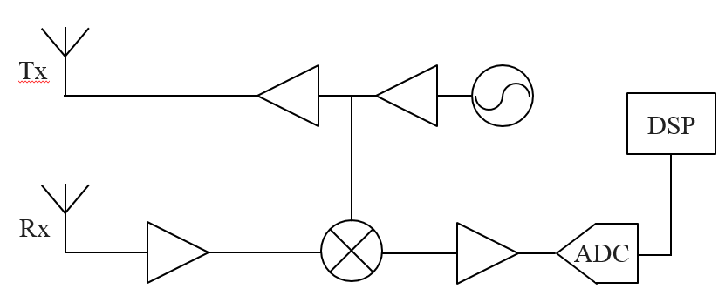

Figure-1

Block diagram of Hardware architecture- consists of

Antenna, VCO, buffer, power amplifier, and operational amplifier.

**2.2 Data Acquisition**

For data acquisition Labview software is used. Labview is a software which is combined with a graphical programming syntax that reduces programming time. Using this software data of phase of the signal extracted.

**2.3 Data Processing**

This is the area on which I have been working during my internship. For data processing I have used Python as a coding language. Python is employed because of it is faster than MATLAB and more efficient than C++. For programming I use Ubuntu14.04 as OS. Everything is run on compiler which comes inbuilt in Ubuntu. Results in windows compiler may slightly differ from Ubuntu’s. As mentioned introduction, to tackle the problems different methods are used.

**2.3.1 Mitigation of Impact caused by Breathing**

To extract the heartbeat signal we have preprocess the RF phase data. Just simply by applying second derivative to the RF phase signal we get the heartbeat signal. To smoothen the signal I have used Butterworth Low pass filter and specifications are discussed in discussion. I have used following numerical method to calculate second order derivative. [3]

 (1)

Where f0′′ refers to the second derivative at a particular sample, fi refers to the value of the time series i samples away, and h is the time interval between consecutive samples.

**2.3.2 Heartbeat Segmentation**

For segmentation we do not the morphology for heartbeats. To address this challenge, using joint optimization we can get morphology as well as segmentation. Depending upon different human, different health conditions length of each heartbeat may vary. Hence, if we view this problem as joint optimization problem, then it can be solved. Through each iteration, updating segmentation and updating template, both can achieve their global optimal [8, 10]. Updating both we can minimize the cost function (Variance of segments).

(2)

This Var(S) is the cost function, we want to minimize it.

Si is each segmentation,

w(morph, |Si|) is linear warping morph into length of each Si. [4, 5]

So, update each Si+1 and morph such that Var(S) is minimum.

This algorithm has linear complexity of O(kn), where k is number of iterations and n is total number of samples in the heartbeat signal.[8]

Pseudo code for the implemented algorithm is –

Input: Sequence inp of n points, heart rate range B.  
Output: Segments S, template µ of length m.

Initialize µ0 as zero vector  
 l ← 0 ⊲ number of iterations  
 REPEAT  
 Sl+1 ← UpdateSegmentation(inp, µl)  
 µl+1 ← UpdateTemplate(inp, Sl+1)  
 l ← l + 1  
 UNTIL convergence  
 return Sl and µl  
 PROCEDURE UpdateSegmentation(inp, µ)  
 S0 ← 0  
 D0 ← 0

FOR t ← 1 to n DO  
 τ∗ ← arg minτ∈τt,B {Dτ + ||inpτ+1:t - ω(µ, t - τ)||2}  
 Dt ← Dτ∗ + ||inpτ∗+1:t - ω(µ, t – τ)||2  
 St ← Sτ ∗ ∪ {inpτ∗+1:t}  
 return Sn  
 PROCEDURE UpdateTemplate(x, S)  
 µ ← 1/n Σsi∈S |si|ω(si, m)  
 return µ

Where µ is morph, m is the necessary length of morph. For this algorithm we need to put limits on each segmentation, I have put limits as (0.6 secs, 1 secs) [12].

**3. Results**

Experimentation is done in two setups –

* 1. **Finding a frequency of a moving metal plate**

Collected 1000 samples of frequency from CW (Continuous Wave) RADAR [1]. After analyzing the signal (set of samples), frequency of the plate is determined.

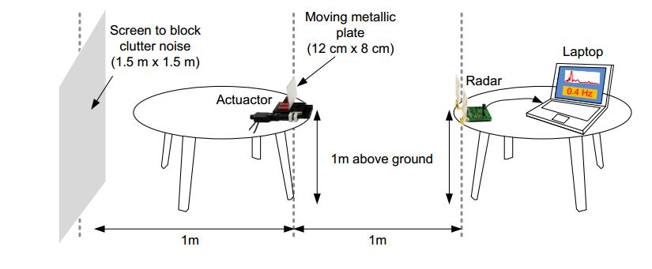

Figure 2

Setup of the experiment 1

Metal plate is having 5mm displacement in to and fro direction. After collecting data from Labview these results as follows –

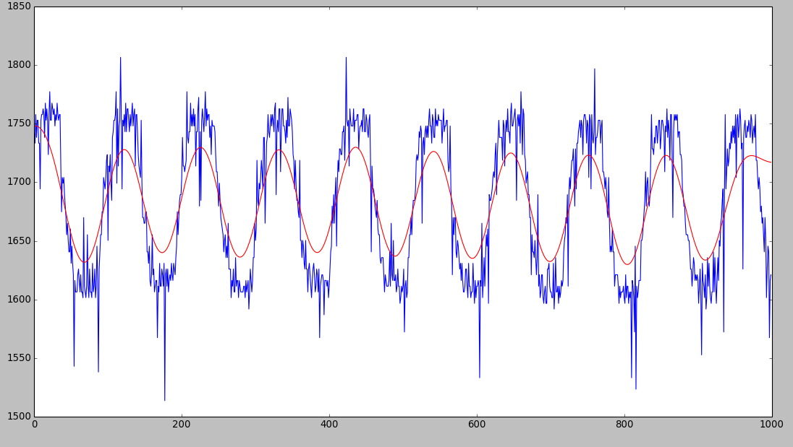

Figure 3

After applying filter on the frequency wave

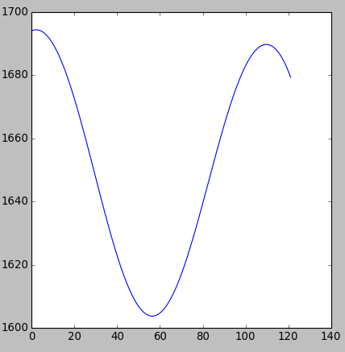

Figure 4

An ideal template of segment for 0.9Hz of frequency of metal

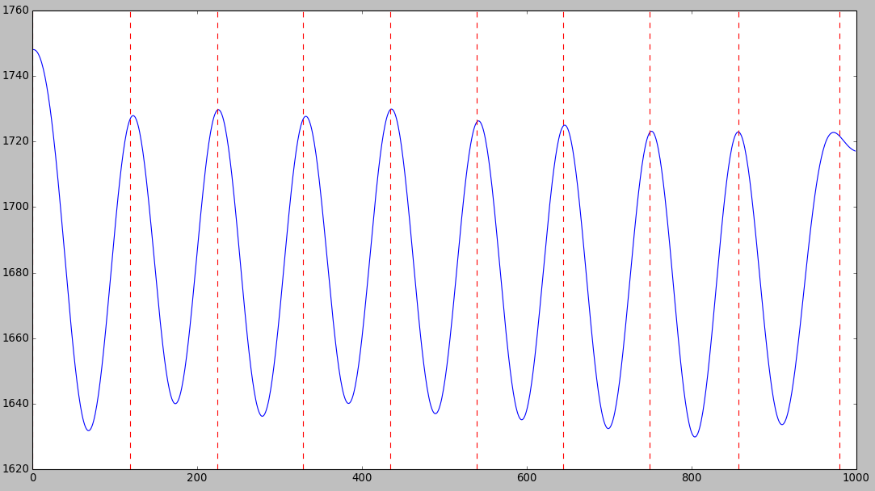

Figure 5

Segmentation is done by the algorithm

Results from algorithm looks promising because we know, what was the frequency of the moving metal plate.

There was also a faulty case can happen, segmentation and template may the variance to follow a loop. This effect successfully removed from the algorithm. Here is a screenshot of this case.

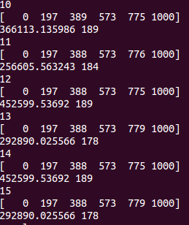

Figure 6

For knowing frequency of metal plate, algorithm stuck in the loop

Given number of iteration, segmentation and cost values

* 1. **Detection of heartbeats**

The RADAR is placed in front of chest at the distance of 20 cm. Reflected signal is modulated by chest movement is acquired via Labview [13]. Then Phase of the signal is calculated using Labview software. Extracted RF phase signal is fed to the above stated algorithm.

We took two different kind of measurements, one with holding our breath and another one is normal one. I and my friend, Nhan, are the test subjects for these measurements. Some test results are show in the following figures. For each following result sample rate =100, t_min =60 and t_max =100, but filter specifications are different for these two kind of measurements. The number of heartbeats were confirmed by checking subjects pulse at the wrist. For Nhan without breathing, 12 heartbeats occurred in 11 secs.

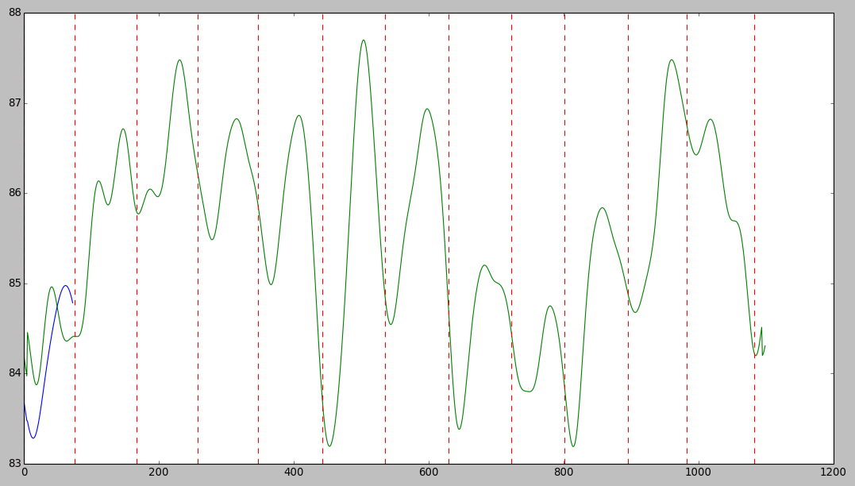

Figure 3

After filtering and segmentation, Green signal is without breath (detection of heartbeats) and blue segment is ideal template (of a heartbeat)

Test signal of with breath of me-

By checking the pulse at my wrist, I detected number of beats as 12 in 10 secs. By using our algorithm we could find the same result.

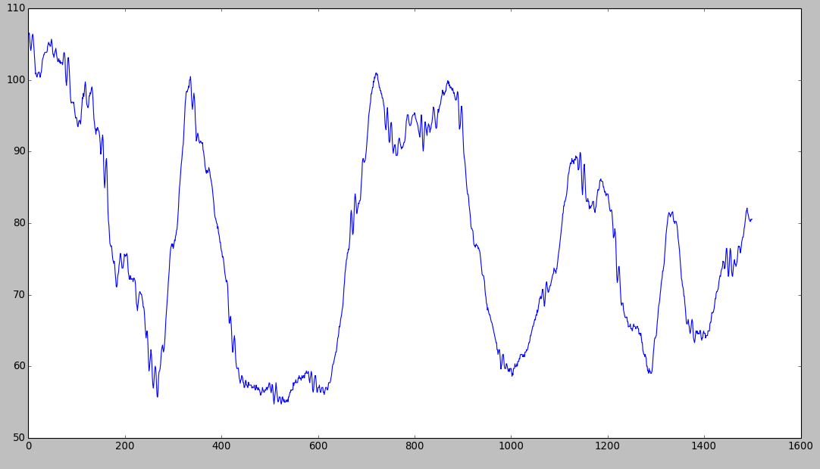

Figure 4

RF phase signal due to chest movements.

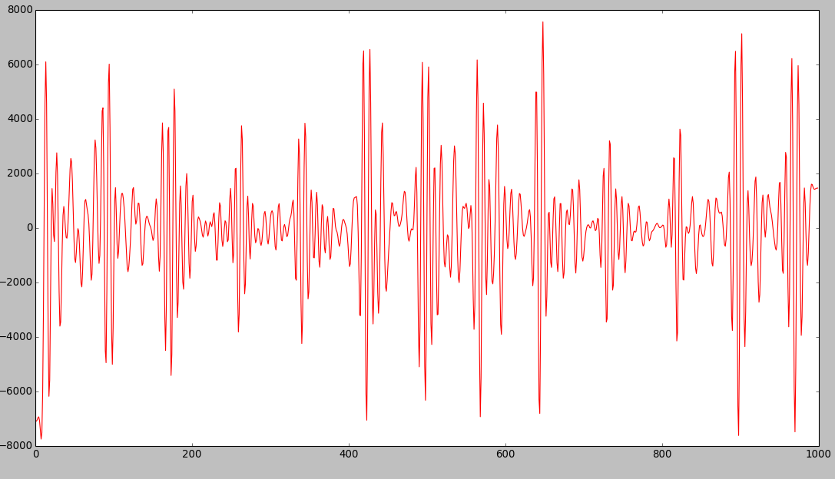

Figure 5

Extracted heartbeat signal from the signal (from figure 4)

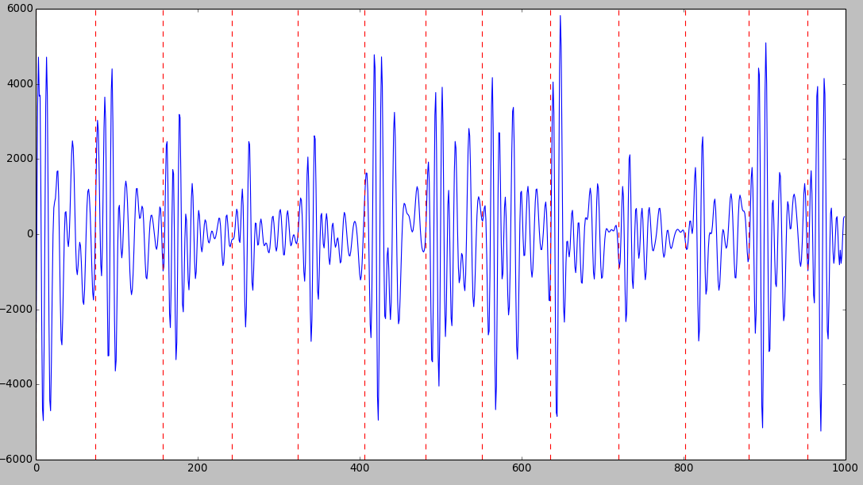

Figure 6

Heartbeat segmentation after applying algorithm

**4. Discussion**

In this section walkthrough of the code is being discussed.

//Numerical method to calculate 2nd order derivative

def der(inp):

d_plus1 = np.roll(inp,-1)

d_plus2 = np.roll(inp,-2)

d_plus3 = np.roll(inp,-3)

d_minus1 = np.roll(inp,1)

d_minus2 = np.roll(inp,2)

d_minus3 = np.roll(inp,3)

dd_inp =4*inp

dd_inp = (dd_inp+d_plus1+d_minus1-2*(d_plus2+d_minus2)-(d_plus3+d_minus3))/(16*t_s/samples*t_s/samples)

return dd_inp

This is calculated using equation (1).

//Linear Warping by cubic spline interpolation

def warp(u,index):

x =np.arange(len(u))

tck = interpolate.splrep(x, u)

x1 =np.arange(index)

return interpolate.splev(x1, tck)

To use this interpolation we need to include this package

from scipy import interpolate

//Using var_seg function we can calculate variance of each segmentation with given template.

def var_seg(seg,morph):

warped = warp(morph,len(seg))

var1 =np.subtract(seg,warped)

return (np.linalg.norm(var1)*np.linalg.norm(var1))

For this we need to include this package in our python file

import numpy as np

//Calculating the variance of segmentations

def cost_fn(inp,u,s):

sums=0

for i in range(1,len(s)):

sums=sums+var_seg(inp[s[i-1]:s[i]-1],u)

return sums

We can have recursive function rather than iterative function for the variance calculation.

// Butterworth 3rd order filter approximation with normalized cutting frequency as 0.1. normalized

def filt(inp):

b,a =signal.butter(3,0.05,output='ba')

inp = signal.filtfilt(b,a,inp)

return inp

//For updating segmentation

def segment(inp,u):

s=[[0]*1]*(len(inp)+1)

d=np.zeros(len(inp)+1)

for i in range(1,len(inp)+1):

temp=np.full(t_max-t_min+1,1e20)

temp_itr=np.full(25,1e20)

temp_itr_arg=np.full(25,0)

if t_min<=i<=t_max:

d[i] = d[0]+var_seg(inp[0:i-1],u)

for itr in range(2,25):

if itr*t_min<= i <=itr*t_max:

for tau in range(t_min,t_max+1):

if (itr-1)*t_min<=i-tau<=(itr-1)*t_max:

temp[tau-t_min]= d[i-tau] + var_seg(inp[i-tau:i-1],u)

temp_itr[itr] =np.amin(temp)

temp_itr_arg[itr] = int(i-(np.argmin(temp)+t_min))

temp=np.full(t_max-t_min+1,1e20)

if i>t_max:

d[i]=np.amin(temp_itr)

s[i]=np.append(s[int(temp_itr_arg[np.argmin(temp_itr)])],int(temp_itr_arg[np.argmin(temp_itr)]))

s[len(inp)] = np.append(s[len(inp)],len(inp))

return s[len(inp)]

Where d[i] stores cost value corresponding to each ith sample and s[i] is segmentation corresponding to each ith sample. t_min and t_max are given limits of an each segment.

// For updating template

def template(inp,seg):

prev_cost = 1e20

cost = 0

morph=[]

for m in range(t_min,t_max+1):

sums =np.zeros(m)

for i in range(1,len(seg)):

sums=sums+abs(seg[i]-seg[i-1])*warp(inp[seg[i-1]:seg[i]-1],m)

sums=sums/len(inp)

cost = cost_fn(inp,sums,seg)

if cost<prev_cost:

prev_cost =cost

morph = sums

return morph

value of m can vary from t_min to t_max.

Using these functions I have implemented main function which is nothing but causes iterations of UpdateSegmentation and UpdateTemplate. And also tries to remove some error cases, such as bouncing between two segmentations. This case included in results section.

**5. Conclusion**

This project represents a way of detecting a person’s heartbeats which is relied on wireless technology. Depending upon different hardware results can be different. Depending hardware, software part can be made compatible. We may need to change type of filters or type of numerical methods for second derivative. We can also use different method instead of 2nd order derivative such as moving average filter. I think algorithm is very efficient as per accuracy but it takes more time. Since we globally optimize the segmentation and template this might not give best possible solution. I think for IBI determination it is very efficient method. This algorithm can be employed to any kind of data which possesses periodicity.

**Acknowledgements**

First of all, I want to thank my professor giving me this splendid opportunity and guiding throughout the project. I also want to thank AIM-HI department for supporting me in every possible way to make my stay pleasant and delightful. I would also like to express my thanks to the Ministry of Education, Taiwan, Republic of China supporting me financially throughout the internship. I also want to thank my lab mates, student-host Mr. Po-Cheng Hsu and specially Mr. Po-Tsung Chen and Ms. Pei-Yu Lyu.

**Appendix**

**RADAR System –**

Frequency = 24.188GHz

Powerdc = 561mW

Gain = -25.36 dBm

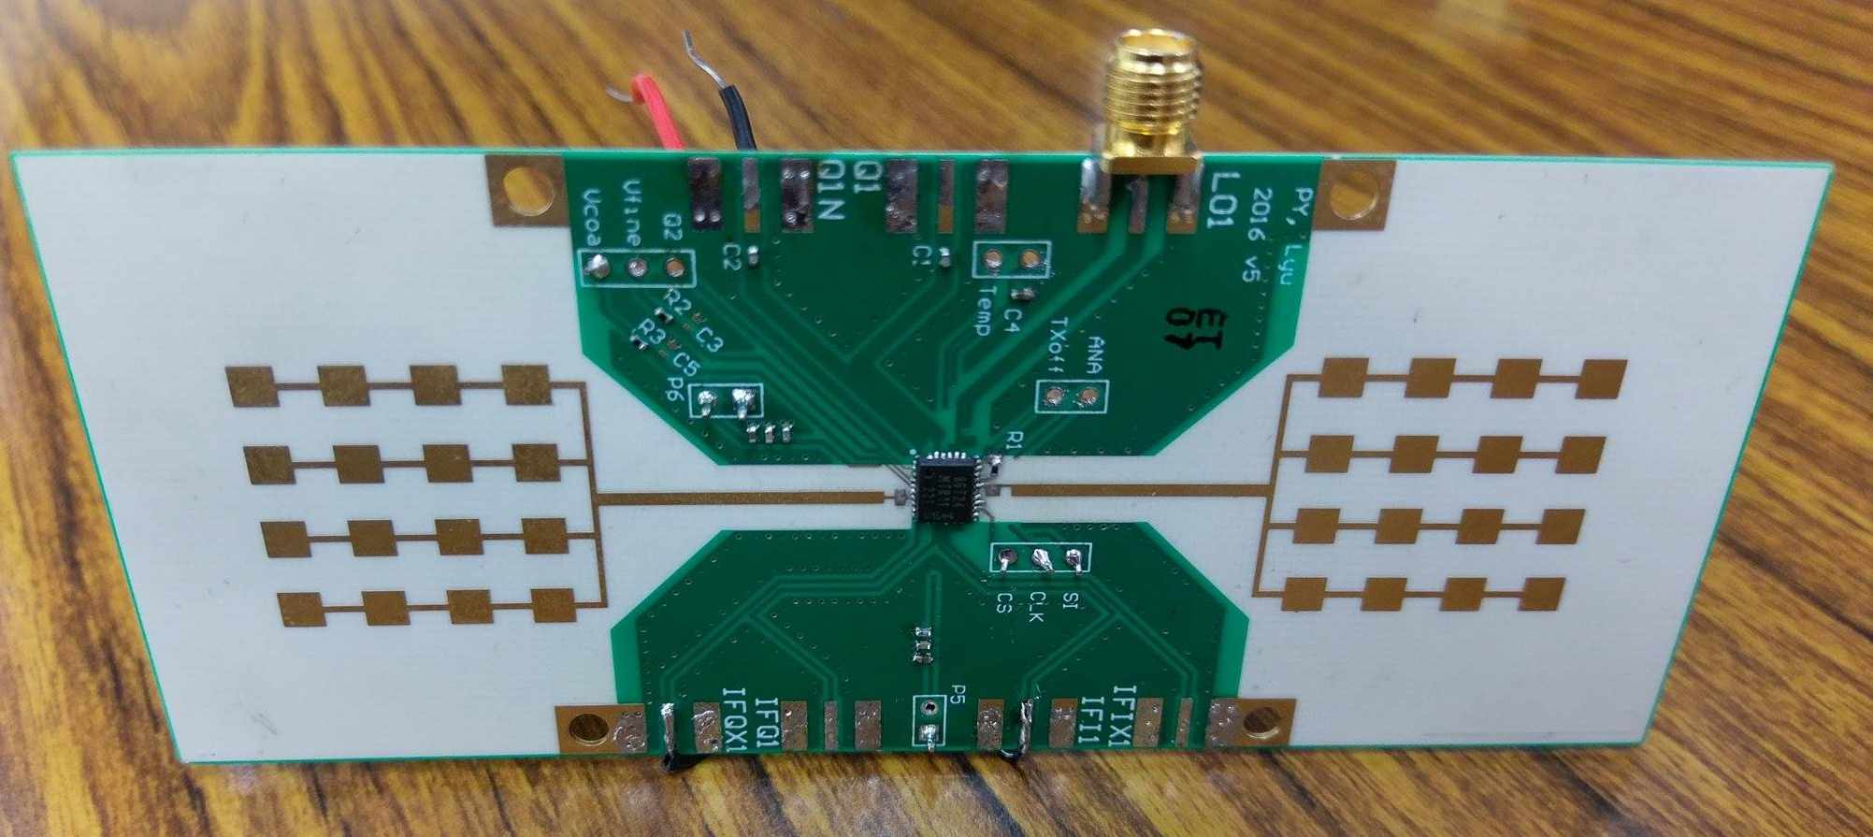

Fig.1 Front view of RADAR system

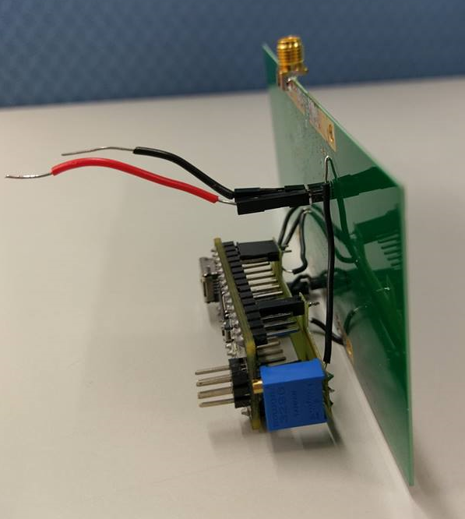

Fig. 2 Side view of RADAR system

**References**

1. <https://en.wikipedia.org/wiki/Continuous-wave_radar>
2. Carr, A.E., Cuthbert L.G.; Olver A.D. "Digital signal processing for target detection FMCW radar," Communications, Radar and Signal Processing, IEE Proceedings, vol.128, no.5, pp.331-336, October 1981
3. Noise robust differentiation for 2nd order derivative estimation. http://www.holoborodko.com/pavel/ downloads/NoiseRobustSecondDerivative
4. S. McKinley and M. Levine. Cubic spline interpolation. College of the Redwoods, 45(1):1049–1060, 1998
5. <https://mse.redwoods.edu/darnold/math45/laproj/Fall98/SkyMeg/splinepres/sld001.htm>
6. <https://ocw.mit.edu/resources/res-ll-003-build-a-small-radar-system-capable-of-sensing-range-doppler-and-synthetic-aperture-radar-imaging-january-iap-2011/projects/>
7. <https://hrvcourse.com/heart-rate-variability-vs-heart-rate/>
8. Mingmin Zhao, Fadel Adib, Dina Katabi. “Emotion Recognition using Wireless Signals”
9. A. D. Droitcour, O. Boric-Lubecke, and G. T. Kovacs. Signal-to-noise ratio in doppler radar system for heart and respiratory rate measurements.
10. F. Adib and D. Katabi. See through walls with wifi! In Proceedings of the ACM SIGCOMM 2013, pages 75–86, New York, NY, USA, 2013. ACM.
11. F. Adib, H. Mao, Z. Kabelac, D. Katabi, and R. C. Miller. Smart homes that monitor breathing and heart rate. ACM, 2015
12. <https://www.ncbi.nlm.nih.gov/pmc/articles/PMC4035586/>
13. http://www.ni.com/zh-tw/shop/labview.html
14. https://www.scipy.org/