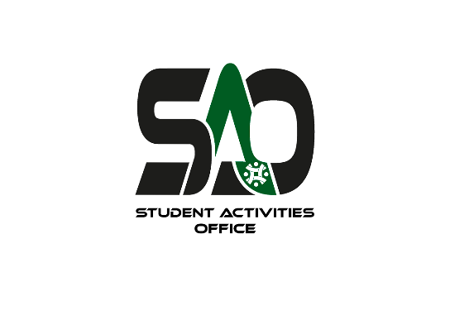

***GUEST AUTHORIZATION REQUEST***

**Event Date:**  **Club Name:**

**Person in charge of the event:** **Contact Number:**

**AUI Faculty Moderating: …………………………………………………**

**Purpose Of Guest Visit:**

**………………………………………………………………………………………………………………………………………………………………………………………………………………………………………………………………………………………………………………………………………………**

**Guest(s) Name and CIN or Passport:**

**………………………………………………………………………………………………………………………………………………………………………………………………………………………………………………………………………………………………………………………………………………**

**Small Description / Background check of the guest (s):**

**………………………………………………………………………………………………………………………………………………………………………………………………………………………………………………………………………………………………………………………………………………………………………………………………………………………………………………………………………………………………………………………………………………………………………………………………………………………………………………………………………………………………………………………………………………………………………………………………………………………………………………………………………………………………………………………………**

*Club President*

_____________________

*Signature*

**Approval: This part is for the administration ONLY**

*SAO Dr. M. Chraibi ADSSE Mr. Yassir Touhami, COO*

_____________________ _____________________ _____________________

*Signature Signature Signature*

SAO approval Only DSA Office approval Only

*Dr. Amine Bensaid, President*

_____________________

*Signature*