**Assignment 1. Quality assessment for Smartphone Cameras**

Smartphone has been one of the most popular digital devices in the past decades, with more than 300 million smartphones sold every quarter in the worldwide. Most of the smartphone vendors, such as Apple, Huawei, Samsung, launch their new flagship smartphones every year. People use smartphone cameras to shoot selfie photos, film scenery or events, and record videos of family and friends. The specifications of smartphone cameras and the quality of taken pictures are major criteria for consumers to select and buy smartphones. Many smartphone manufacturers also introduce and advertise their smartphones by introducing the strengths and advantages of their smartphone cameras. However, how to evaluate the quality of smartphone cameras and the taken pictures remains a problem for both smartphone manufacturers and consumers. Currently in the market, there are several teams and companies who evaluate the quality of smartphone cameras and announce the ranking and scores of the quality of smartphone cameras, and the scores of smartphone cameras are subjectively graded by several photographers and experts from different aspects, such as exposure, color, noise, and texture. However, subjective assessment is not easy to reproduce, and it is not easy to deploy in practical image processing systems.

In the last two decades, objective image quality assessment (IQA) has been widely researched, and a large amount of objective IQA algorithms have been designed to automatically and accurately estimate the quality of images. However, most objective IQA methods are designed to assess the overall perceived quality of the image degraded by various simulated distortions, which rarely exist in pictures taken by modern smartphone cameras. Thus these methods are not suitable for the task of smartphone camera quality assessment, while objective evaluation methods specifically designed for the purpose of smartphone camera quality assessment are relatively rare.

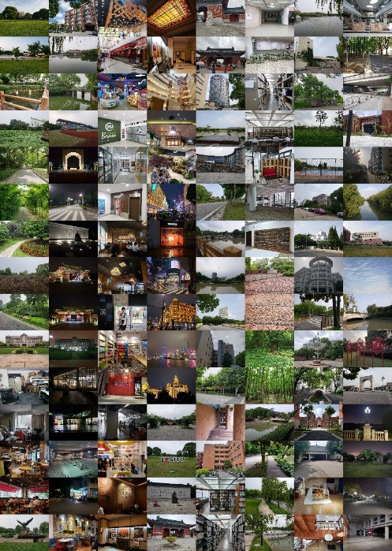

**Fig. 1 Example images in the ICME Grand Challenge database.**

In this assignment, you should:

1. **Design an objective IQA model to provide quality rankings or scores in terms of four different aspects, including exposure, color, noise and texture, by using the datasets released by the ICME Grand Challenge.**
2. **Write a report in IEEE Journal format. The report should include title, abstract, the implementation details of your models, the experimental setup and the experimental results, and some analyses, etc.**
3. **Validate the proposed model on the test dataset.**

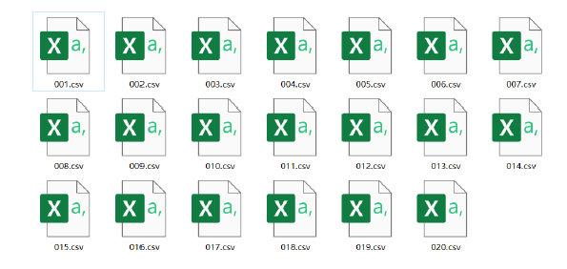

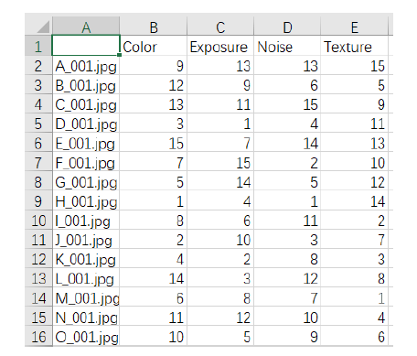

**Fig. 1 The format of the submitted results on test dataset**

Finally, you should send the report, the model (including the readme file), and the results on the test dataset to sunguwei@sjtu.edu.cn. The email title should be written as: Assignment1 + Name1 + StudentNumber1 + Name2 + StudentNumber2 ……

The link to the ICME Grand Challenge database:

1. <https://jbox.sjtu.edu.cn/l/NHw1Ij> or

2. 链接：<https://pan.baidu.com/s/17UkJ_kpa32yo2fod6pb2dQ> 提取码：776j

The link to the codes of the teams participating in the ICME Grand Challenge:

1. <https://jbox.sjtu.edu.cn/l/j5EbVP> or

2. 链接: https://pan.baidu.com/s/11pbNeS_pzOHY9XS_JxcsRA 密码: gpyd

Some useful links to this assignment:

1. <https://engine.scichina.com/publisher/scp/journal/SCIS/63/11/10.1007/s11432-019-2757-1?slug=fulltext>
2. <https://github.com/HuiZeng/BIQA_Toolbox>
3. <https://ieeexplore.ieee.org/abstract/document/9106040/>
4. <https://ieeexplore.ieee.org/document/9106047>
5. <https://ieeexplore.ieee.org/document/9106034>
6. <https://ieeexplore.ieee.org/document/9106048>
7. <https://ieeexplore.ieee.org/document/9105971>
8. <https://ieeexplore.ieee.org/document/9190832>
9. <https://ieeexplore.ieee.org/document/9191104>