**Assignment 3. Saliency4ASD: Visual attention modeling for Autism Spectrum Disorder**

Visual attention (VA) modeling has been the focus of many research efforts in the past years. Historically, the topic was mostly addressed in vision science community but it is amazing to observe how it has bloomed in both multimedia processing and the computer vision communities during the last decade. This has led to the explosion of a variety of visual attention models: bottom-up vs top-down saliency modeling, object of perceived interest modeling, saccadic scan-path based models. This trend in both communities is mostly driven by applications of visual attention computational models in many fields where image/video is used. Several domains have been benefitted by the introduction of human visual system properties.

The purpose of this Grand Challenge is to drive efforts of Visual attention modelling community towards a healthcare societal challenge in. Gaze features related to saccades and fixations have demonstrated their usefulness in the identification of mental states, cognitive processes and neuropathologies (Tseng, Cameron, et al., 2013; Itti, 2015), notably for people with ASD (Autism Spectrum Disorder).

With this Grand challenge, it is expected, from datasets released by the organizers: track 1) to develop models (saliency prediction or saccadic models that fits gaze behavior of people with ASD; track 2) to propose models able to classify level of ASD from gaze data.

The first goal is particularly useful to develop ad hoc CHIs (Computer Human Interfaces) that are adapted for people with ASD. In addition to early stage detection of ASD, the second goal could be relevant to monitor the efficiency of any remediation protocol.

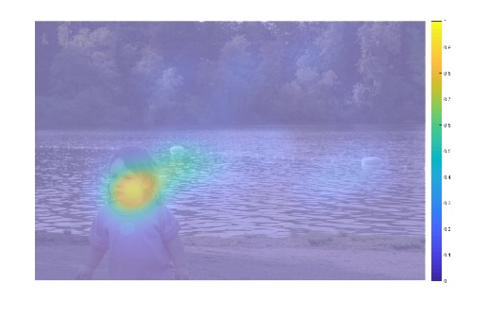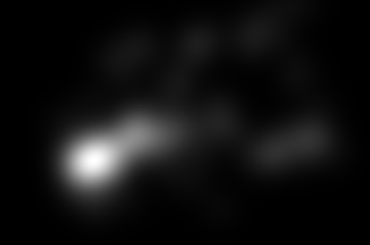Participants are free to submit computational models in the both categories (Each of the submissions will be evaluated with the respective collected ground-truth by the organizers).

**Fig 1. The format of the submitted results on test dataset (from left to right: raw image, saliency map, heat map)**

In this assignment, you should:

1. **Design a saliency prediction model that fits gaze behavior of people with ASD, by using the datasets released by the ICME Grand Challenge.**
2. **Write a report in IEEE Journal format. The report should include title, abstract, the implementation details of your models, the experimental setup and the experimental results, and some analyses, etc.**
3. **Validate the proposed model on the test dataset (report AUC, sAUC, CC, NSS). (The test dataset will be released later.)**
4. **(Additional task: if you are interested in the second track, you can also try to classify the ASD individuals and TD people from gaze data.)**

Finally, you should send the report, the model (including the readme file), and the results on the test dataset to sunguwei@sjtu.edu.cn. The email title should be written as: Assignment1 + Name1 + StudentNumber1 + Name2 + StudentNumber2 ……

The link to the ICME Grand Challenge database:

<https://zenodo.org/record/2647418#.X79BLc0zaUk>

The link to the codes of the teams participating in the ICME Grand Challenge:

<https://pan.baidu.com/s/1mHohx6vfRWYvdbsF6vtUbA>

password: losc

Some useful links to this assignment:

<https://saliency.tuebingen.ai/>

Reference:

1. Huiyu Duan, Guangtao Zhai, Xiongkuo Min, Zhaohui Che, Yi Fang, Xiaokang Yang, Jesus Gutierrez, and Patrick Le Callet, “A Dataset of Eye Movements for the Children with Autism Spectrum Disorder,” in Proceedings of ACM Multimedia Systems Conference (ACM MMSys), 2019.

2. Huiyu Duan, Guangtao Zhai, Xiongkuo Min, Yi Fang, Zhaohui Che, Xiaokang Yang, and Ning Liu, “Learning to Predict where the Children with ASD Look,” in Proceedings of IEEE International Conference on Image Processing (ICIP), 2018.