DAWN

Software Design Model

Version 1.0

**By:**

Dawn Group

2019-04

**Group Member:**

Zihan Xu

Yi Kuang

Chenyu Yang

Yuting Lan

Jianzhen Cao

**Document Language:**

English

Revision History

|  |  |  |  |
| --- | --- | --- | --- |
| **Date** | **Version** | **Description** | **Author** |
| 2019-4-16 | 1.0 | Finish the 1st edition of Software Design Model | Zihan Xu, Yi Kuang, Chenyu Yang, Yuting Lan, Jianzhen Cao |
|  |  |  |  |
|  |  |  |  |
|  |  |  |  |
|  |  |  |  |

1 Introduction 1

1.1 Purpose 1

1.2适用范围 Domain 1

1.3定义 Definition 1

1.4参考资料Reference 1

1.5概述 cjz Overview 1

2． 用例视图Use Case View 2

3. 逻辑视图Logical View 2

3.1 系统结构System structure 2

3.2 用例视图Use Case View 5

3.3 设计视图Design View 10

3.4 其他图(NULL) 13

4. 实现视图Implementation View 13

5. 进程视图 Process View 19

6. 部署视图 Deployment View 20

Software design patten

# 1 Introduction

## Purpose

The purpose of this software design model document is to organize various design models of our game. Based on the previous requirements specification and system analysis, the structure of the system is displayed in detail, laying the foundation for the subsequent software implementation. We will construct logical views, implementation views, process views and deployment views. We will be able to develop the whole project based on it.

## 1.2 Domain

The Dawn game system. The characteristics, subsystems and models that related to the system meet the content of this document

## 1.3 Definition

See more details in glossary document.

## 1.4 Reference

<<Object-Oriented Software Engineering Practice Guide-2>> Shanghai Jiao Tong University Press, 2016

<<Object-Oriented Software Engineering - Using UML, Patterns, and Java>> (3rd edition), Tsinghua University Press, 2011

## 1.5 Overview

This document includes introduction, Use-case Diagram, Logic Diagram, Implementation Diagram, Process View and Deployment View. The Use-case Diagram displays functions provided by our app. Logical View talks about classes of each subsystem and Implementation Diagram displays how the functions are realized with some components. Process View lists each thread of the process. Deployment View shows an arrangement in physical level.

# 2． Use Case View

The complete use case model:

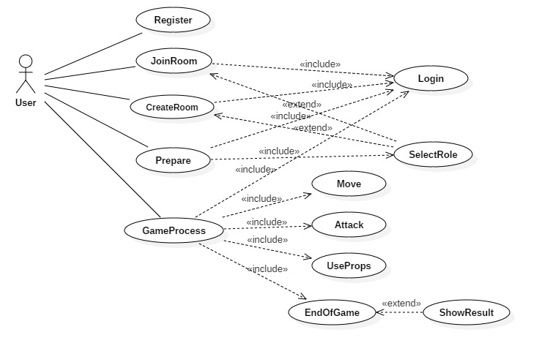

# 3. Logical View

## 3.1 System structure

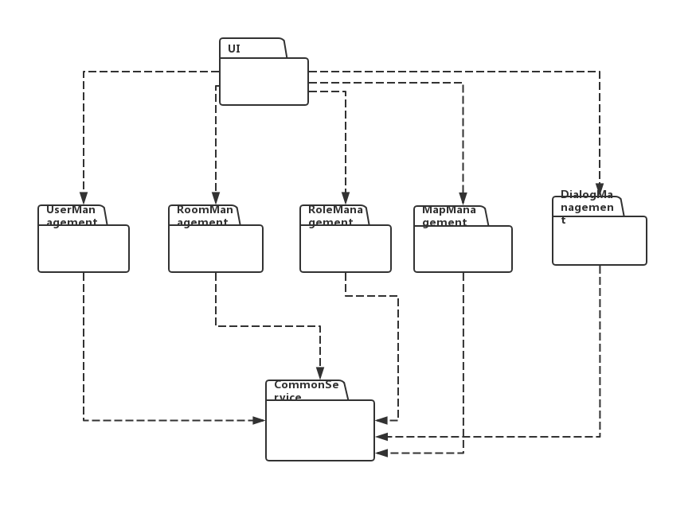

1. User-Interface Subsystem

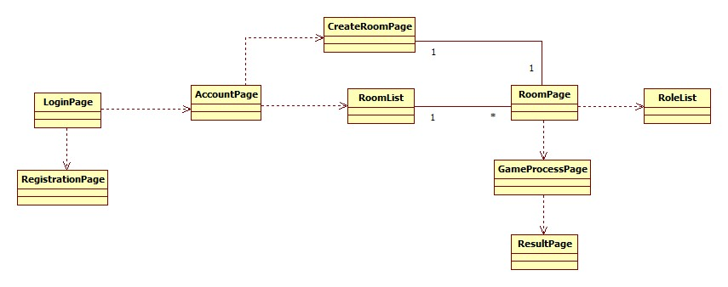

1. User-management Subsystem

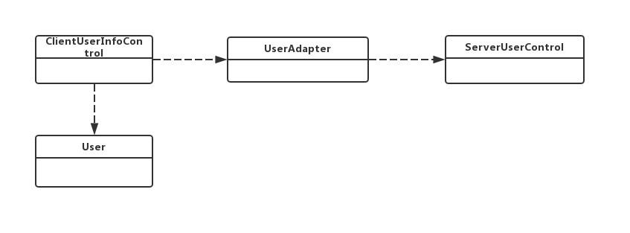

1. Role-management Subsystem

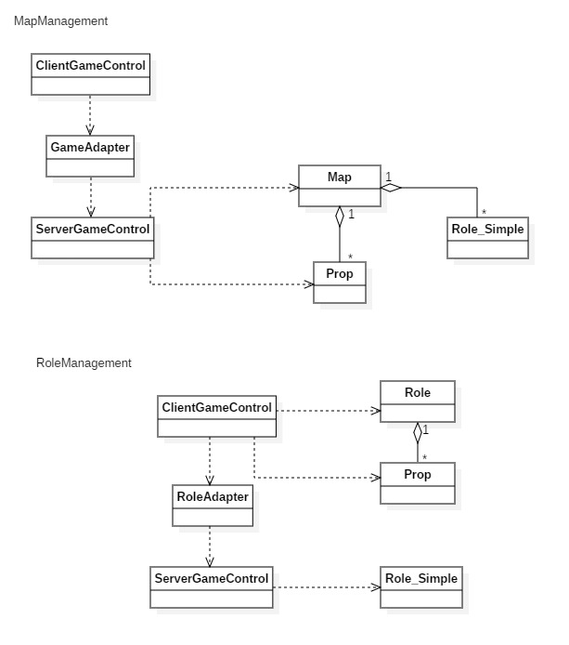

1. Map-management Subsystem

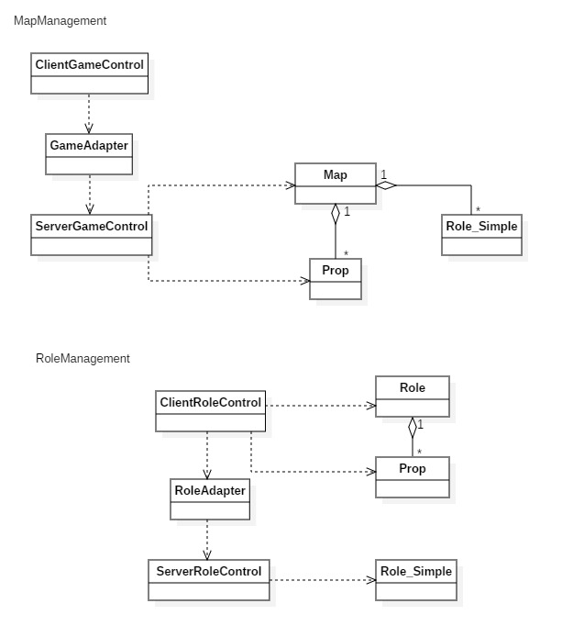

1. Room-management Subsystem

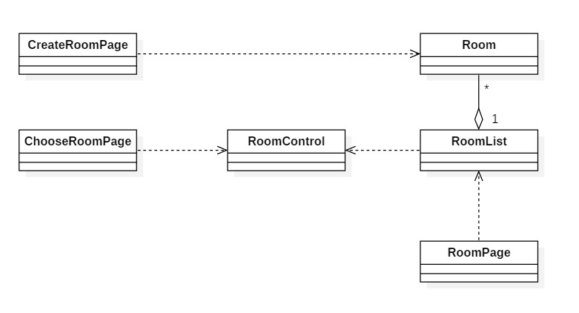

1. Common-service Subsystem

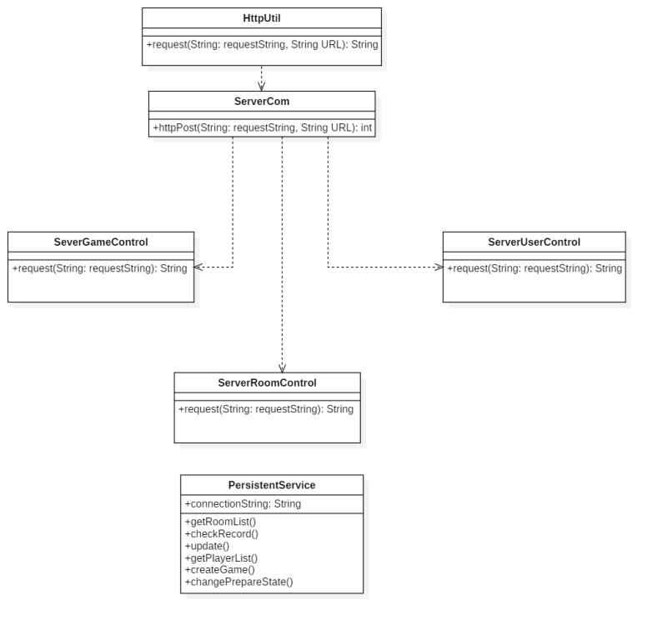

## 3.2 Use Case View

1. <Register> Implementation

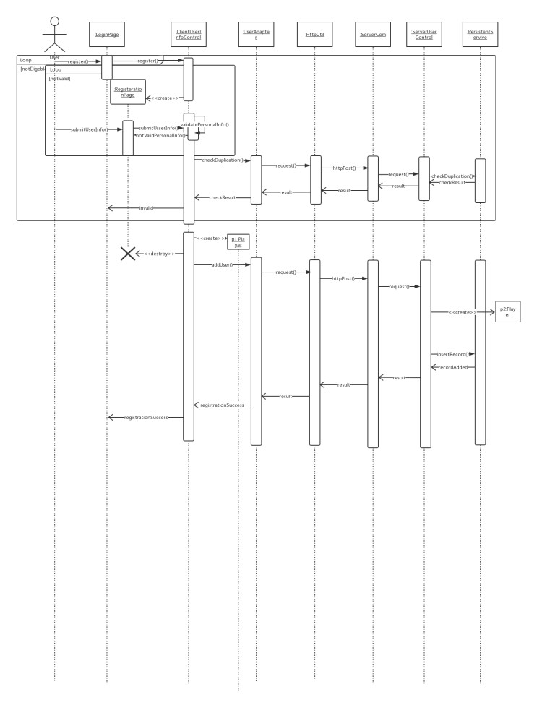

1. <Login> Implementation

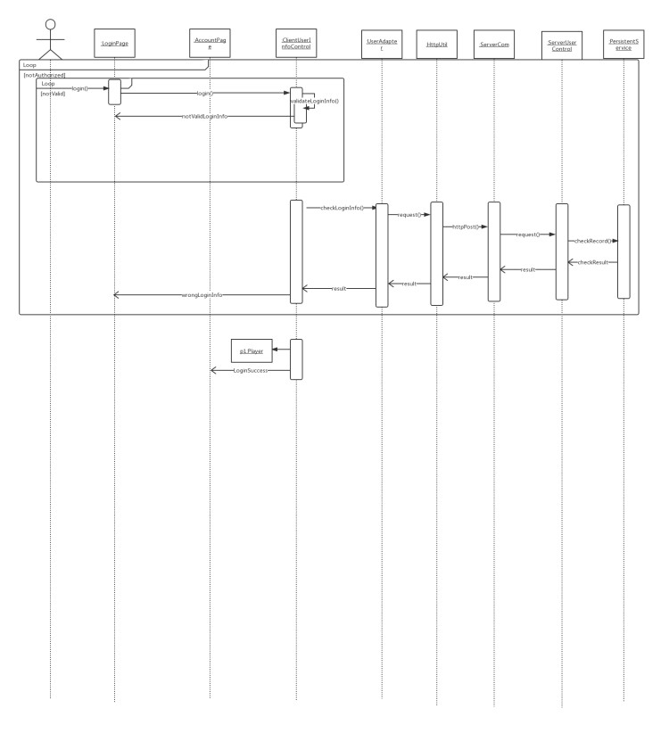

(3) <CreateRoom> Implementation

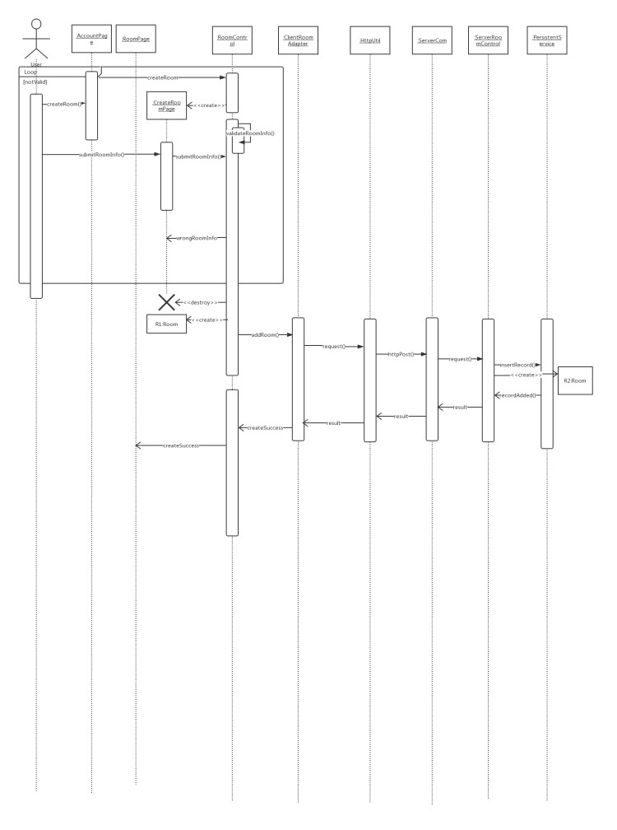

(4) <JoinRoom> Implementation

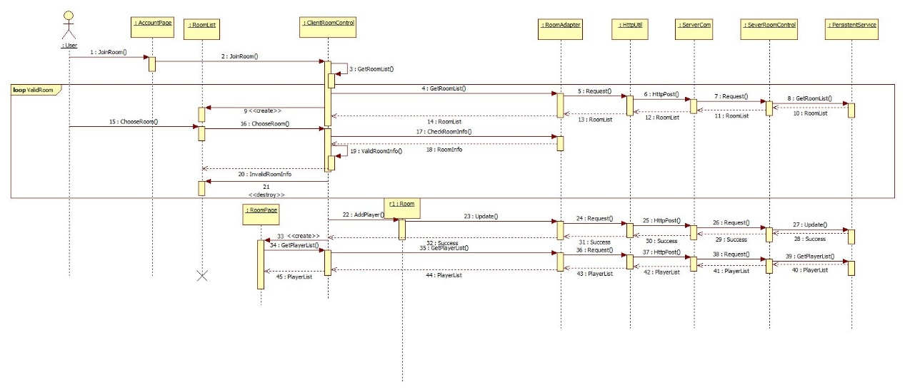

(5) <SelectRole> Implementation

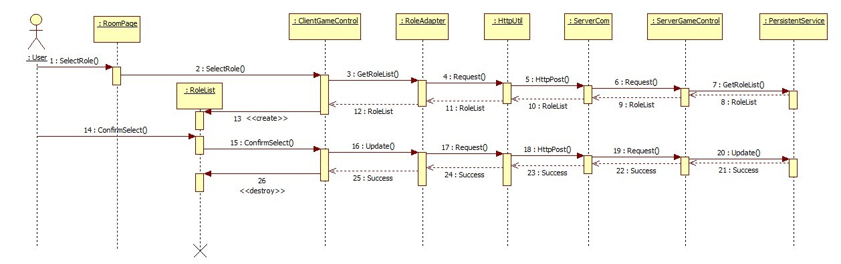

(6) <Prepare> Implementation

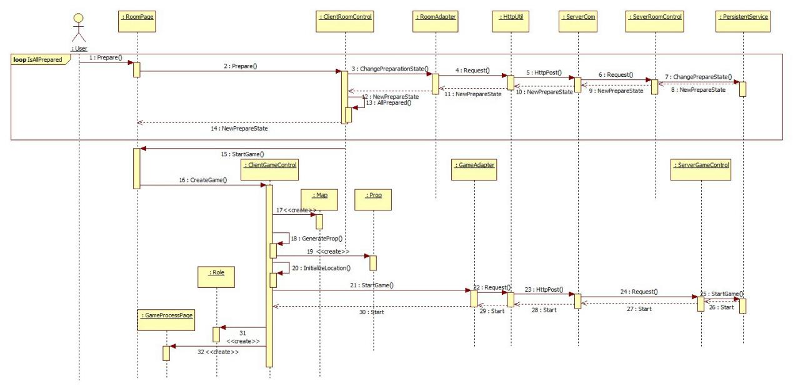

(7) <GameProcess> Implementation

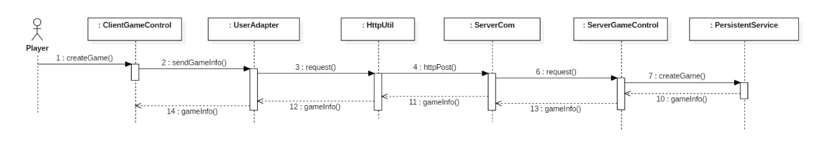

(8) <Move> Implementation

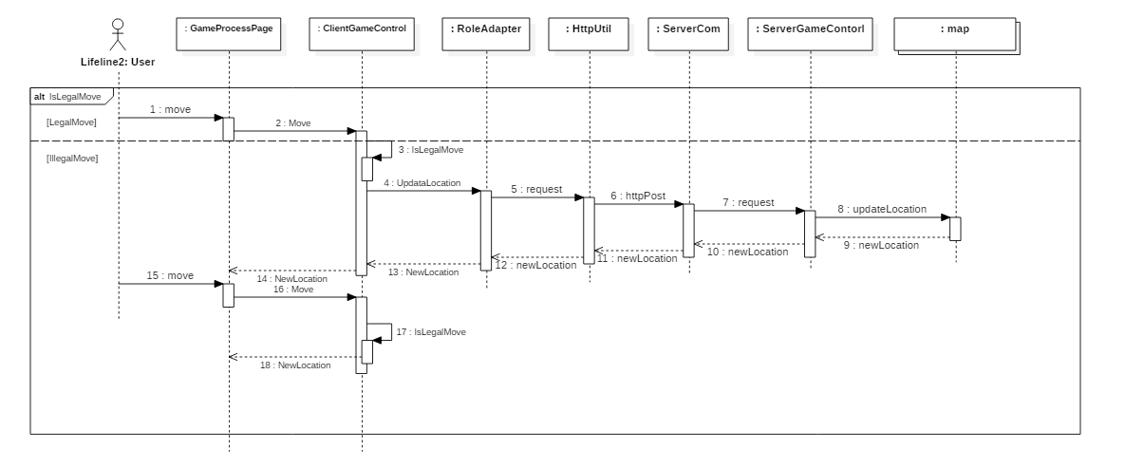

(9) <Attack> Implementation

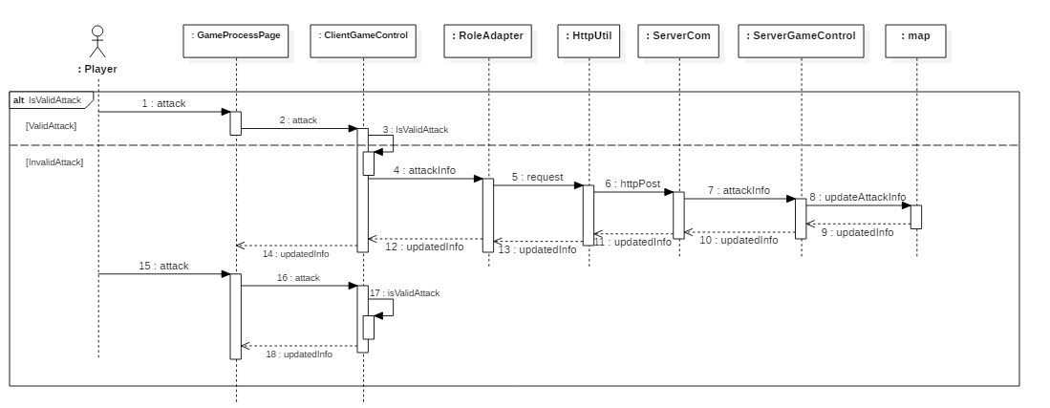

(10) <Use> Implementation

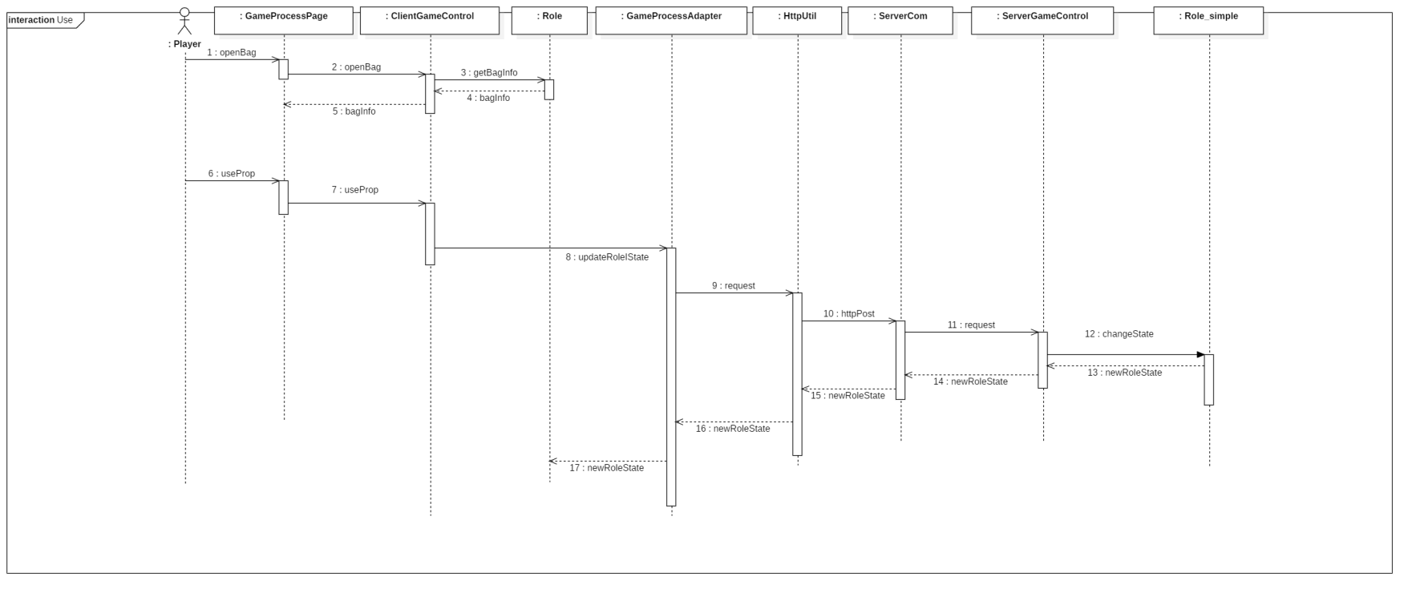

(11) <End&Result> Implementation

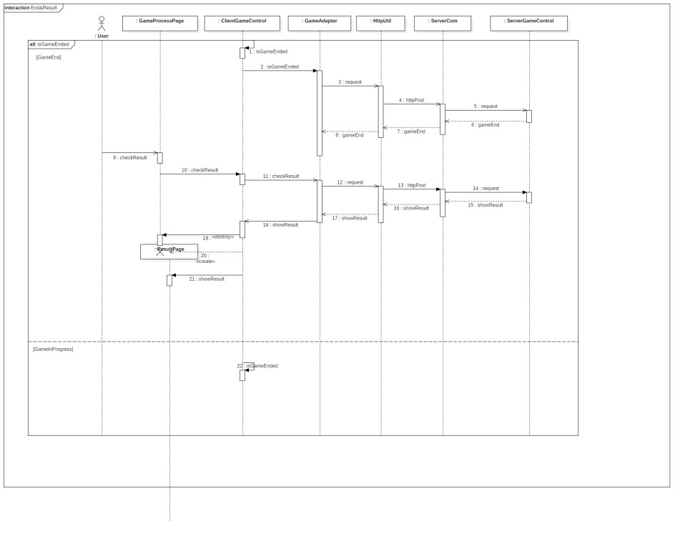

## 3.3 Design View

Since there are lots of classes, we decided to create a Package Diagram and then draw Class Diagrams on the basis of subsystems.



1. User-Interface Subsystem

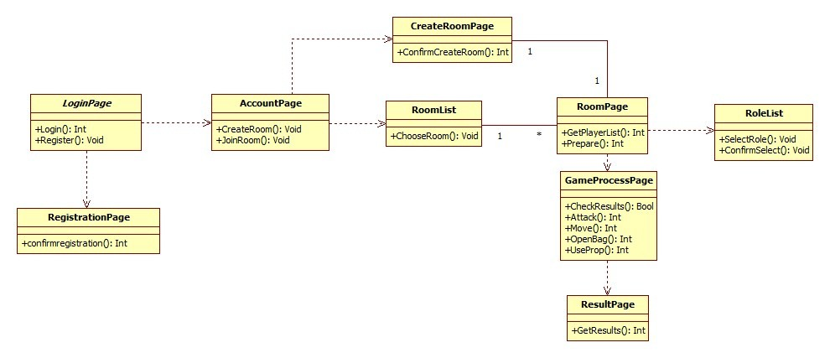

1. User-management Subsystem

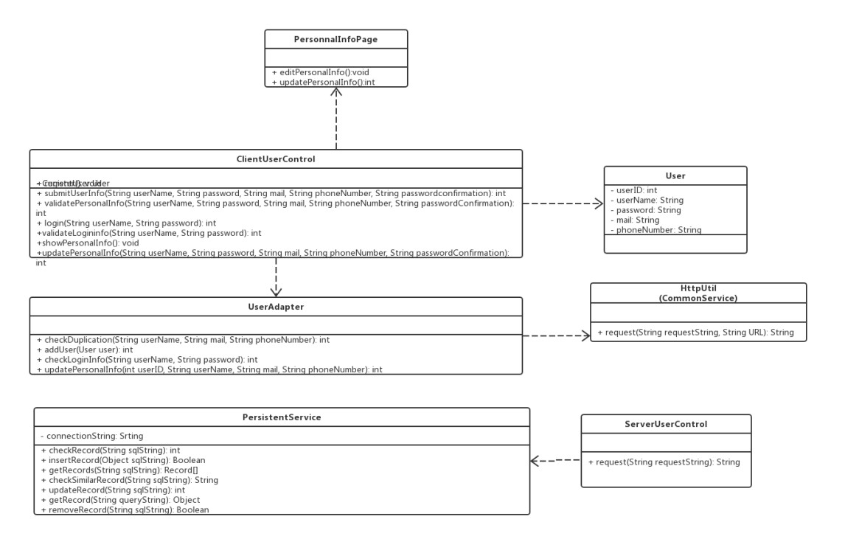

1. Role-management Subsystem

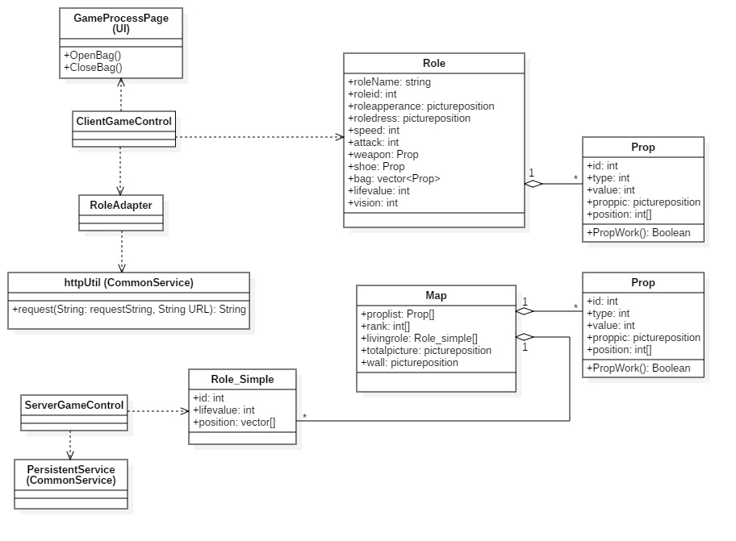

1. Map-management Subsystem

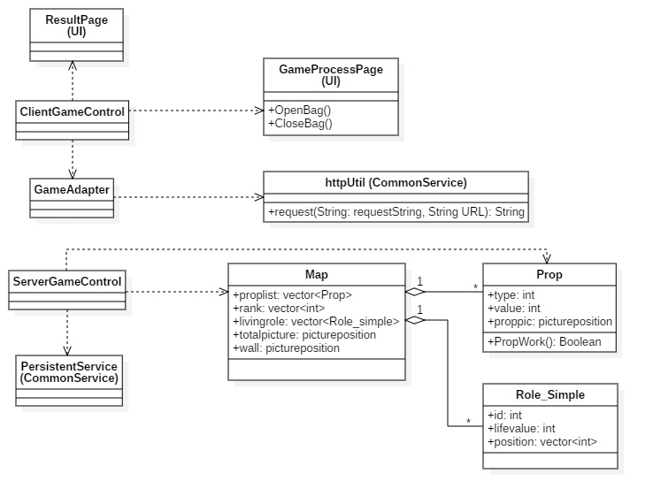

1. Room Management Subsystem

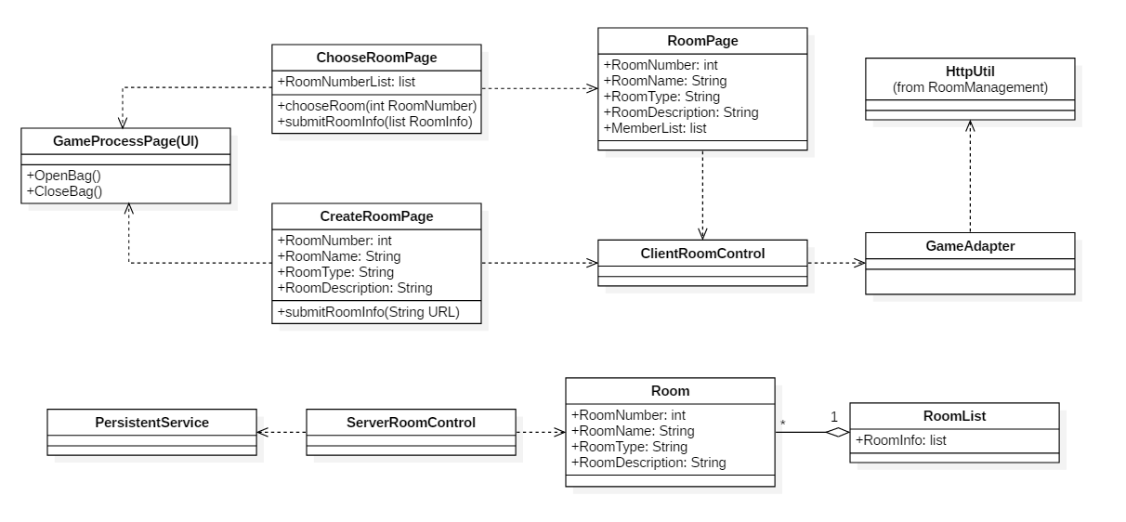

1. Common-service Subsystem



# 4. Implementation View

1. Development Model Composition
   1. User-Interface Subsystem

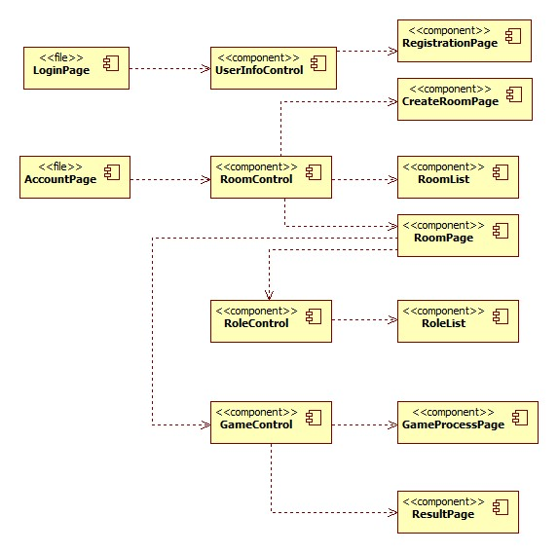

* 1. User-management Subsystem

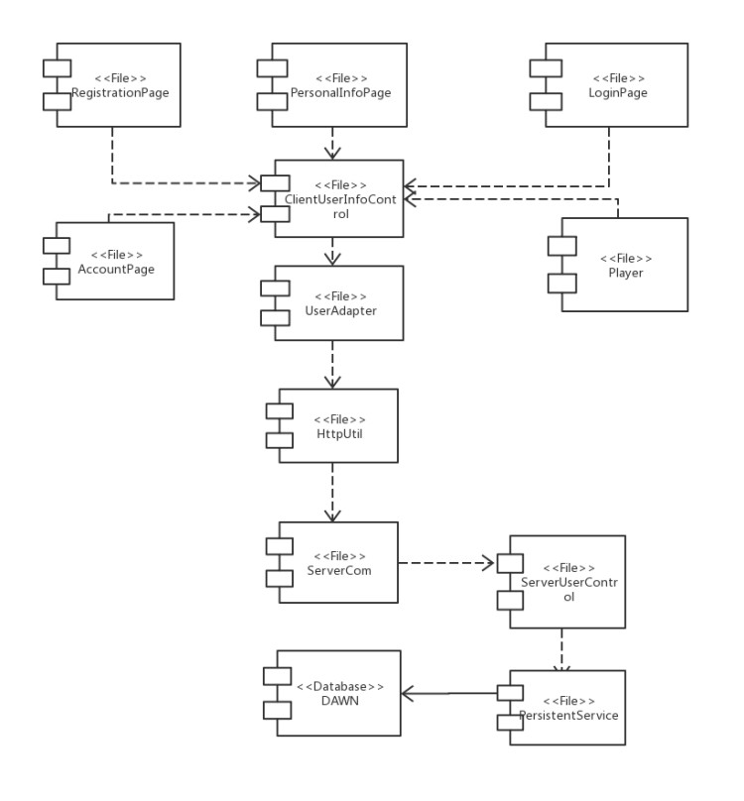

* 1. Role-management Subsystem

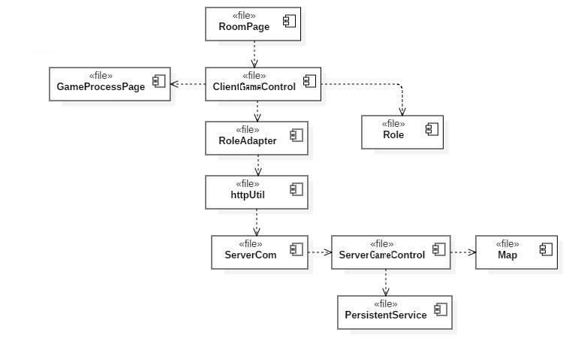

* 1. Map-management Subsystem

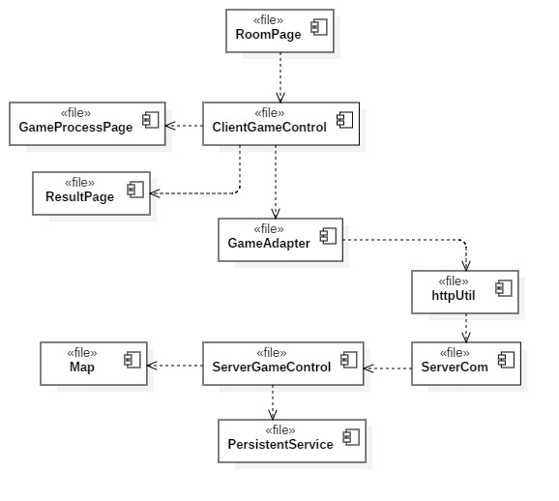

* 1. Room-management Subsystem

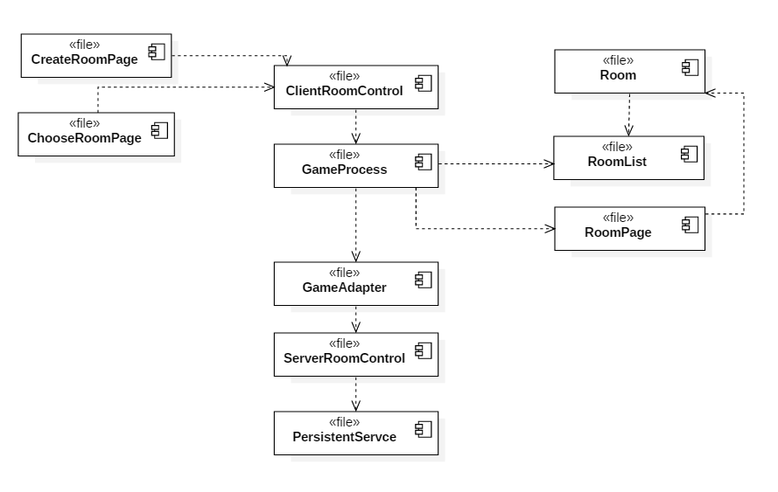

* 1. Common-service Subsystem

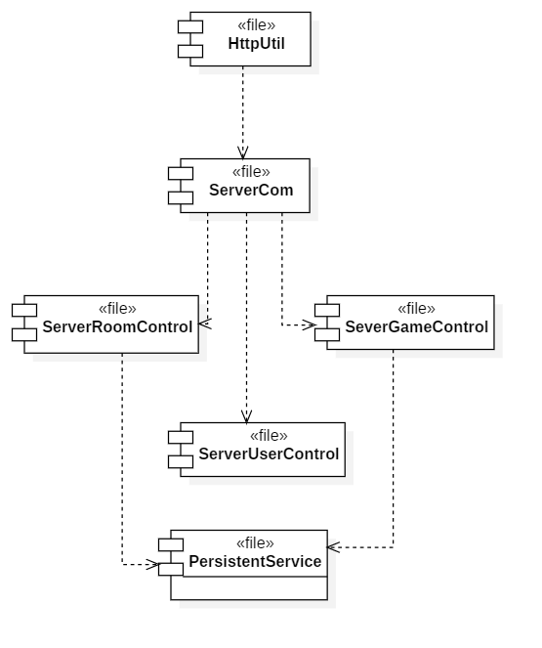

1. Post-compilation

Since each one of the .java file will be compiled to generate a corresponding .class file, the compiled component map should be identical to the development model composition.

# 5. 进程视图 Process View

通过类图或者组件图的形式表示进程类、线程类及其相互关系，通过类图表示进程、线程中包含的类。

1. Client Process View

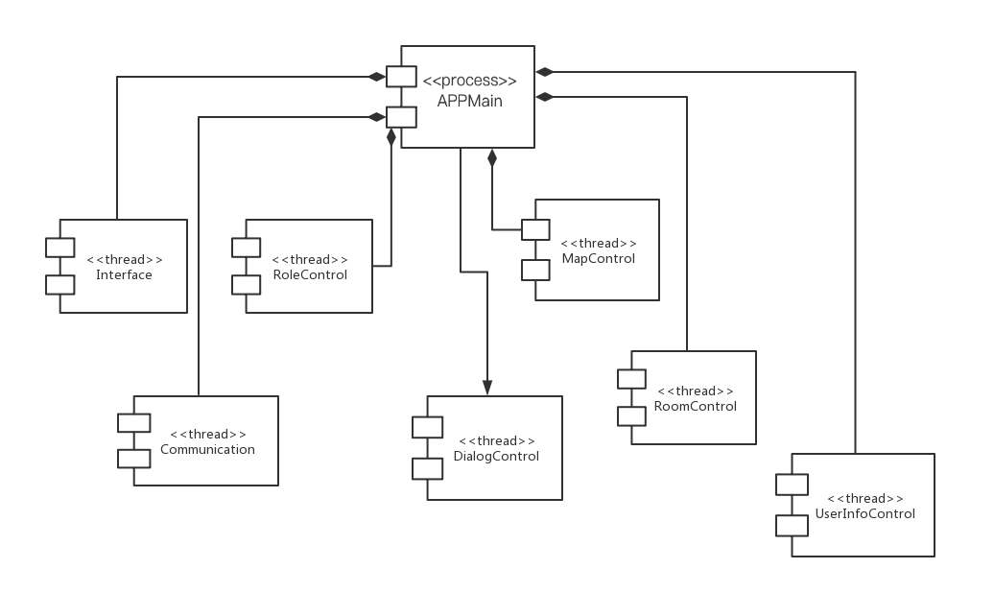

1. Server Process View

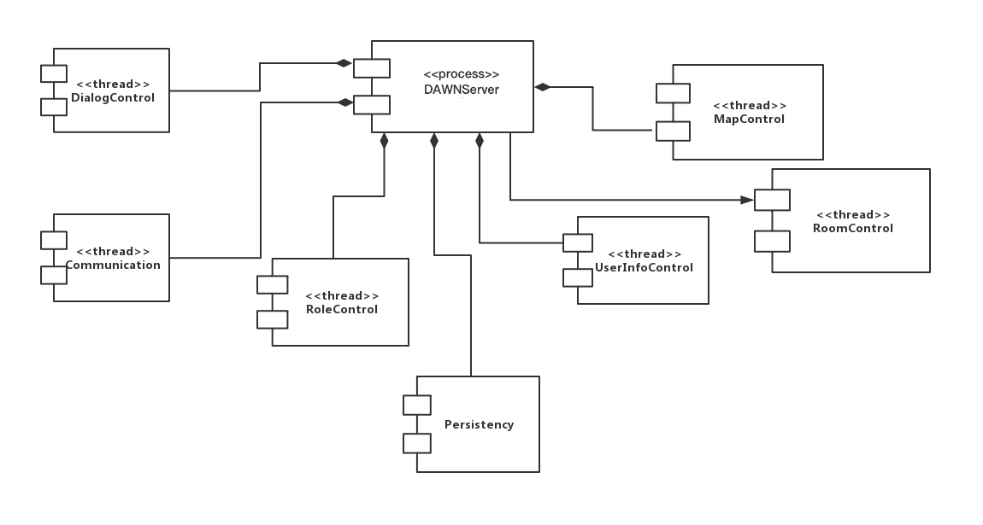

# 6. 部署视图 Deployment View

画出系统的物理部署图。

