**BIG DATA ANALYTICS(SWE2011)**

**Name :** Akshaya vardhini

**Reg. no :** 22MIS1098

**Aim:**

To obtain a dataset (covertype.csv) and implement the SOM Neural network model and visualize the output.

**Tools Used:**

Jupyter notebook

**Outputs:**

1.

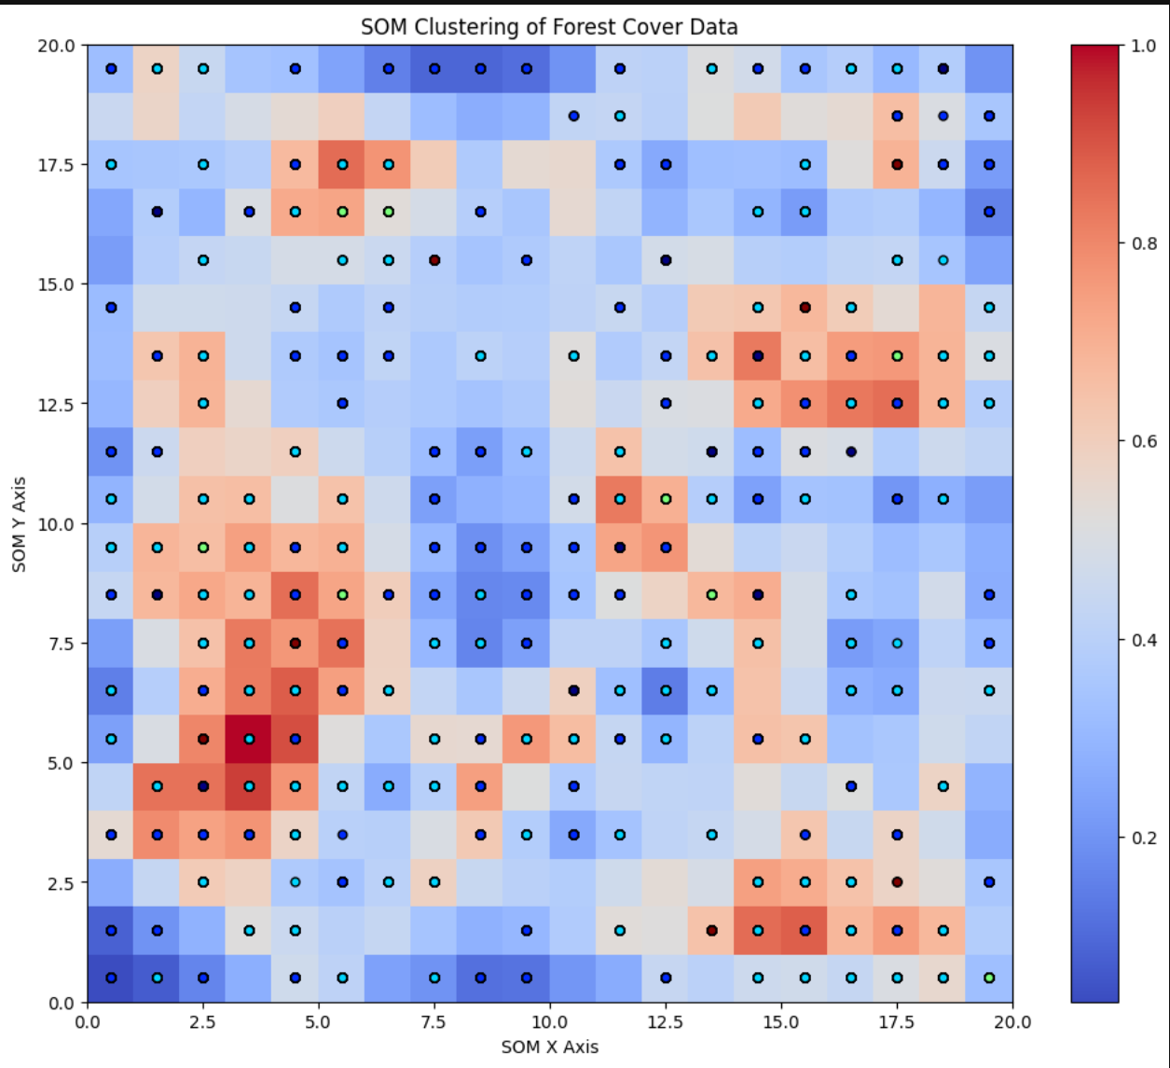

In the background, red areas indicate regions where neurons are **far** from each other (indicating sparsely populated clusters or outliers)while theblue areas indicate regions where neurons are **close** to each other (indicating dense clusters of similar data points).The different colored points represent different forest cover types. Each colour corresponds to a specific **Cover_Type** from the dataset.

2.

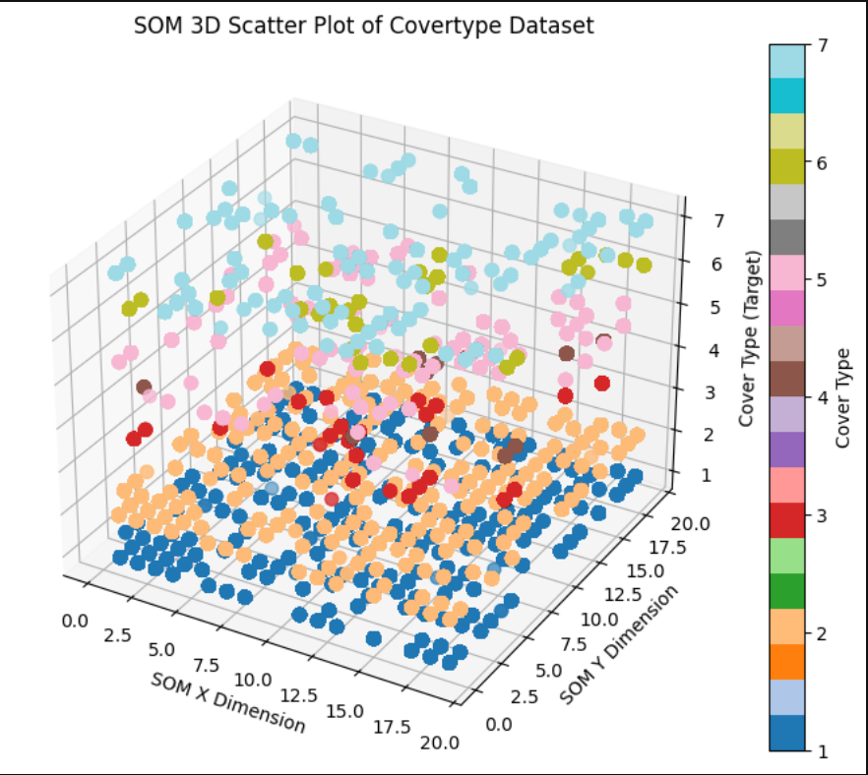

The X and Y dimensions represent the **SOM grid coordinates** where each data point has been mapped. Each input feature vector is associated with a specific neuron in the SOM. The Z-axis represents the **Cover Type**, which is the target variable from the dataset. Each unique forest cover type is represented by a different colour in the plot.

3.

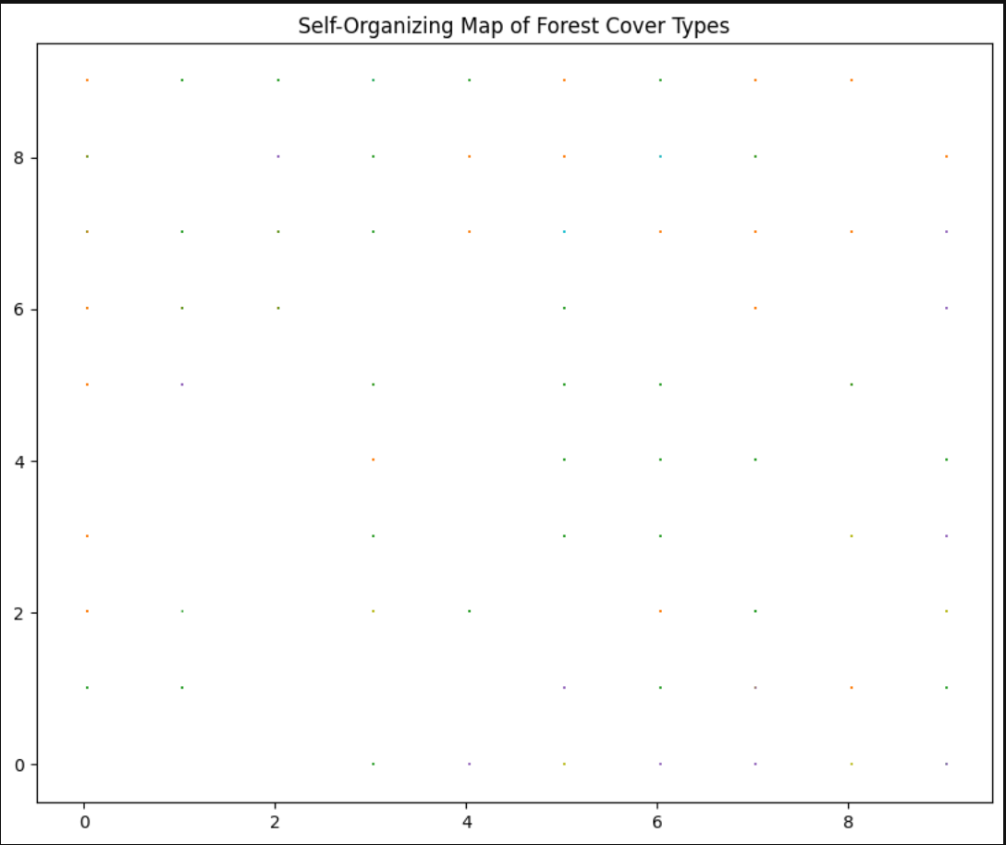

The plot is a grid where each point (dot) represents a **data point** from the dataset, and its position is determined by the neuron in the SOM that best matches the data point's feature vector. The colour of each dot corresponds to the **forest cover type (y),** which is categorized into 7 types. Different types of forest cover are visualized in distinct colours.