

Project Plan and First Increment

Fall 2016

TEAM -2

* Sujitha, Puthana (44)
* Achyuth Reddy, Nalamadgu (33)
* Anusha, Malineni (27)
* Sri Sai Narayana Ram Gopal, Mangena (29)

**TABLE OF CONTENT**

1. Introduction 3

2. Project Goals & Objectives 4

3. Project Plan 5

4. First Increment Report 7

5. Implementation 12

6. Project Management 17

7. Bibliography…………………………………………..18

1. **Introduction**

**One Stop for CS**

1. **Project Goal and Objectives (revised)**
   1. **Overall goal:**

Main goal of this application is to provide all the available sources like presentations, videos, research papers and online courses to learn any technology in the field of computer science.

* 1. **Specific objectives (problem statement)**

2.2.1 To create a unique platform where the users can get all the available resources related to any course in the field of computer science.

2.2.2 By searching for a specific course, this application will retrieve available resources in the form of videos, presentations, research papers and online courses.

2.2.3 Notifying the users about current trends in the field of computer science.

* 1. **Specific features**
     1. **Search for presentations:** This feature enables the user to search for top presentations related to a particular course.
     2. **Search for videos:** This feature enables the user to search for top videos related to a particular course.
     3. **Search for research papers:** This feature enables the user to search for research papers related to a particular course.
     4. **Search for online courses:** This feature enables the user to search for available online courses related to a particular course.
     5. **Latest technologies:** User can see the latest trending technologies in the field of computer science.
     6. **Accepts Suggestions:** User can suggest new resources in the form of videos, presentations, research papers and online courses for any particular course.
     7. **Bookmarking facility:** A RegisteredUser can bookmark a particular video, presentation, research paper or an online course website. By bookmarking resources, user can find them under bookmarks section.

**2.4 Significance**

The application provides the wide range of source file PPT’s, videos, research paper as a single point.

**3.Project Plan**

1. **Zen- Hub Screen Shot**

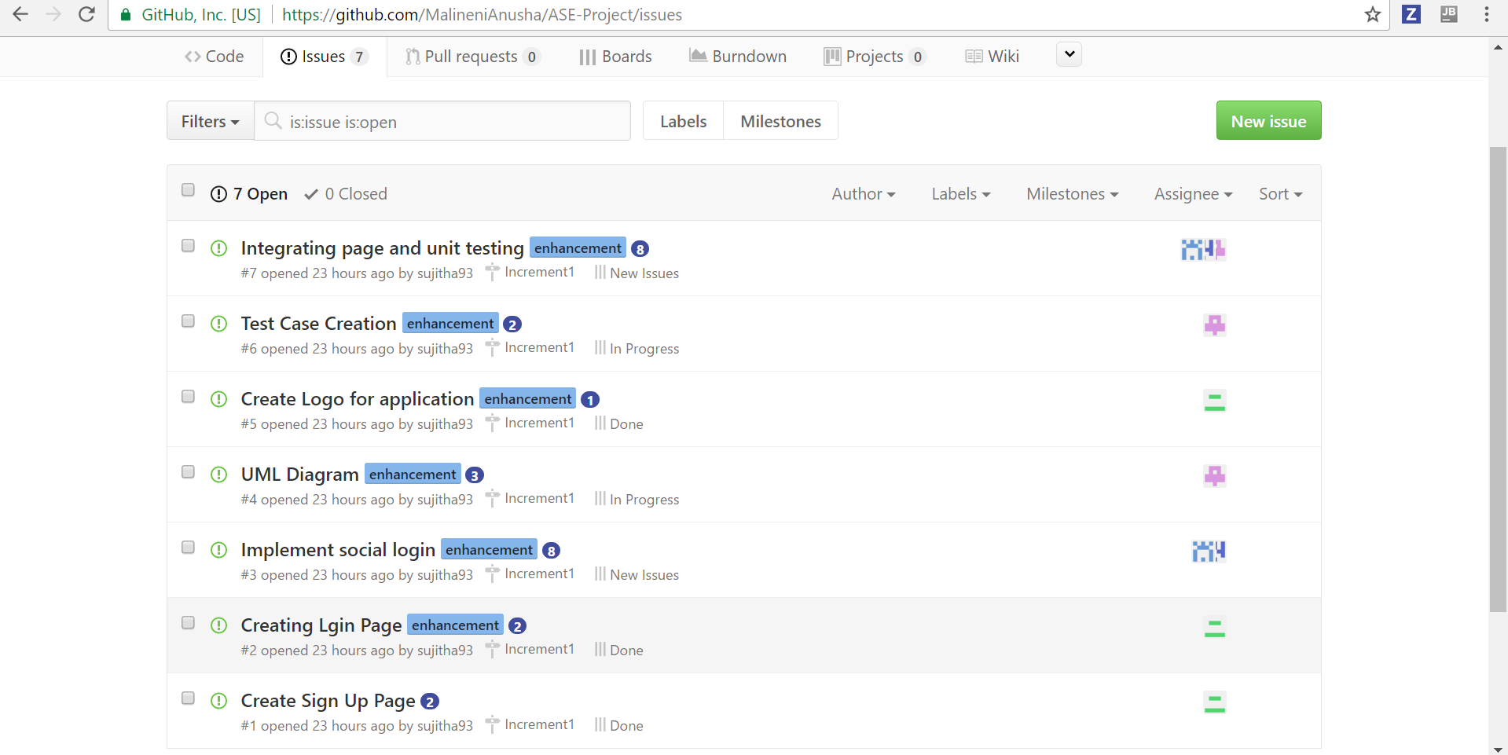

1. **Project Timeline, Members, Task Responsibility**

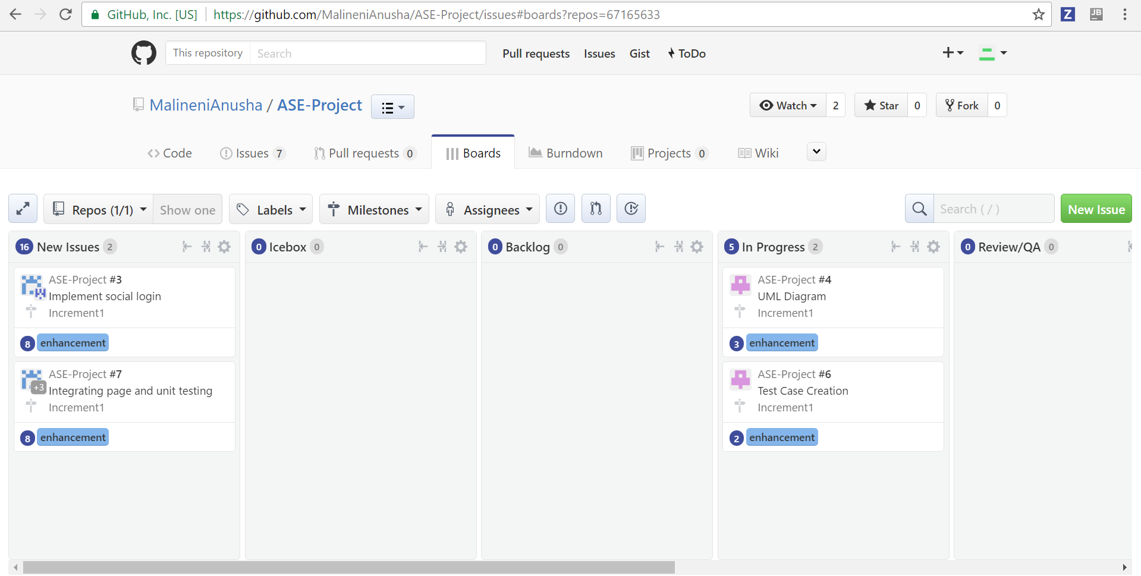

1. **Burn- Down chart**

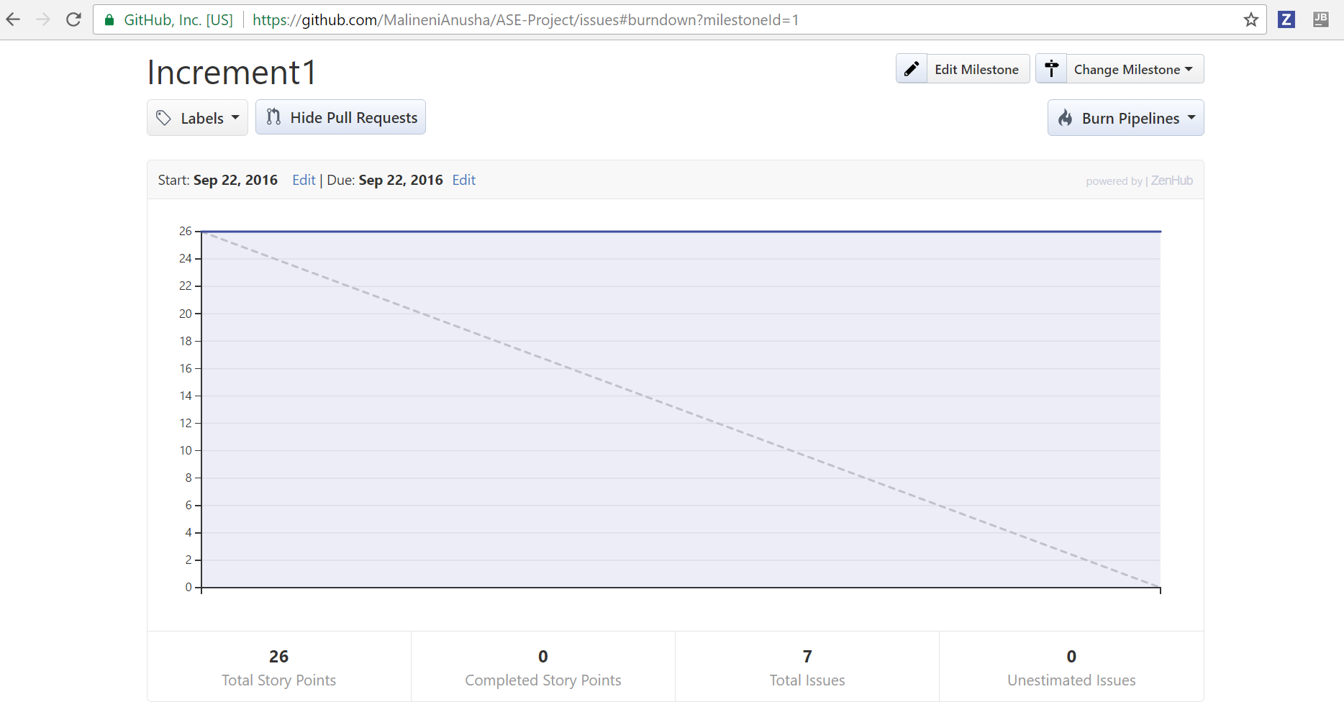

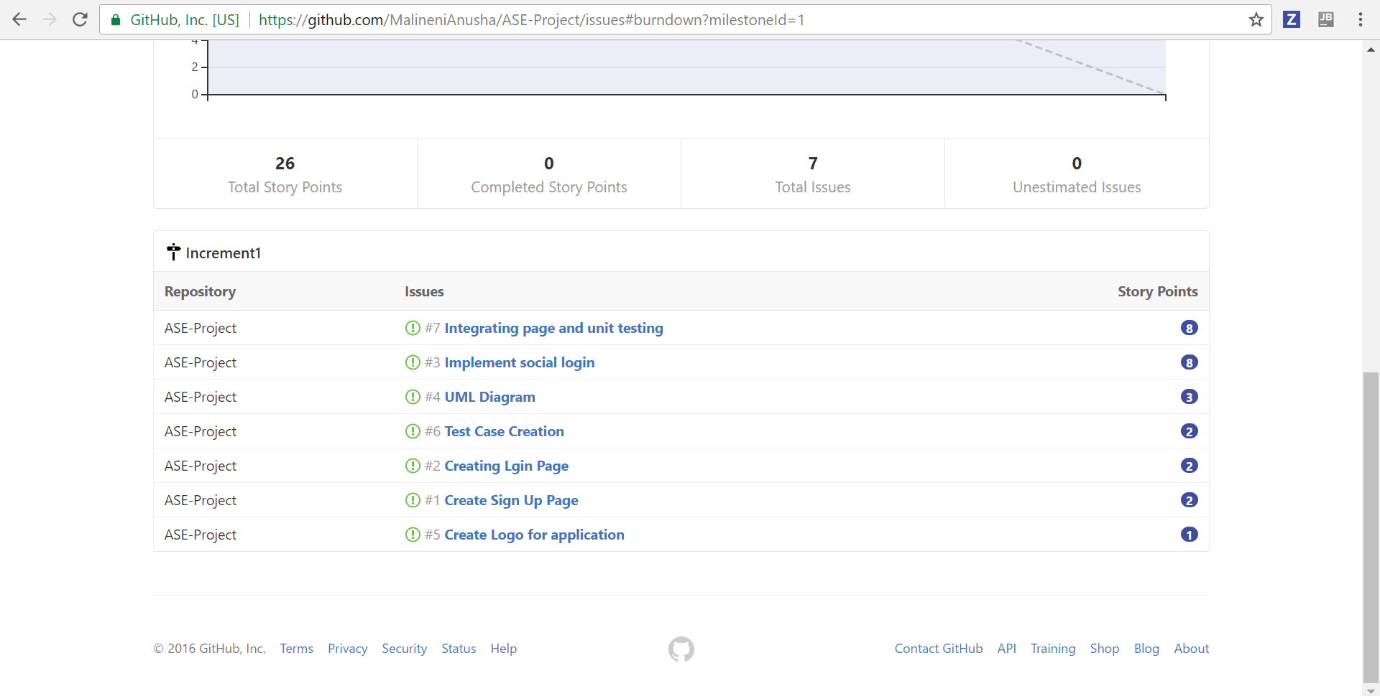

1. **First Increment Report**
   1. **Detail Design of Features:**

**4.1.1. Wireframes**

* **Login Page**

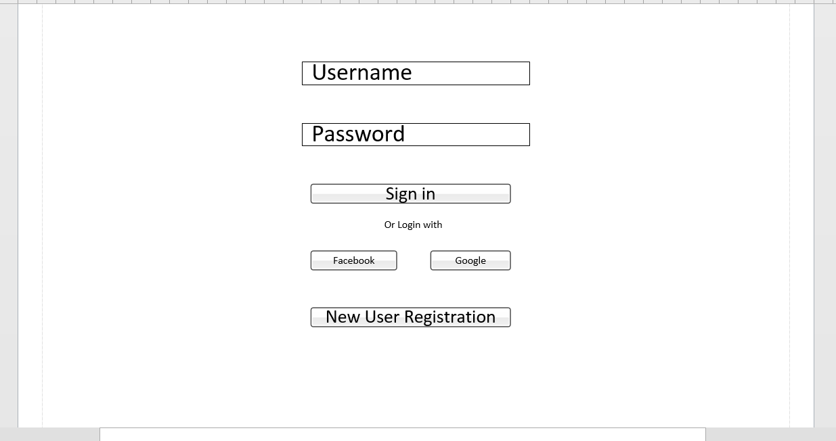

* **Registration Page**

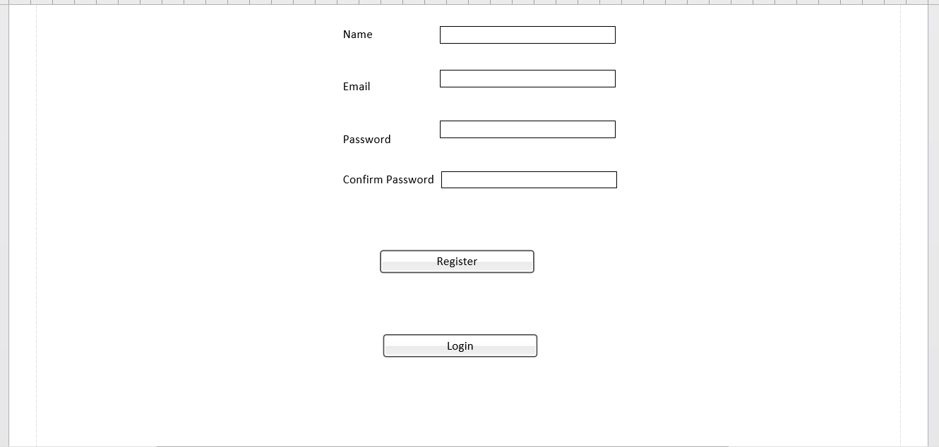

* **Home Page**

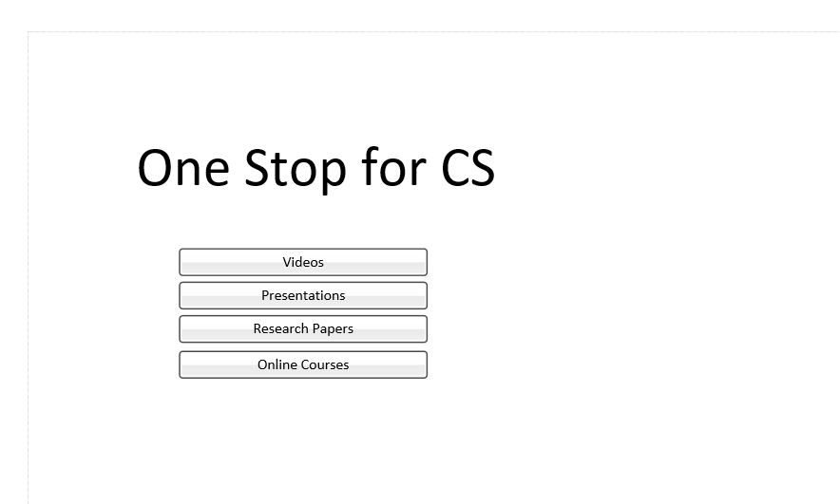

* + 1. **Class Diagram:**

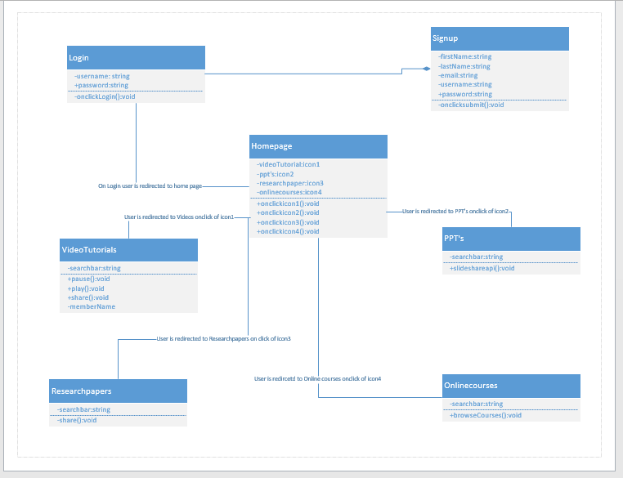

* + 1. **Use Case Diagram:**

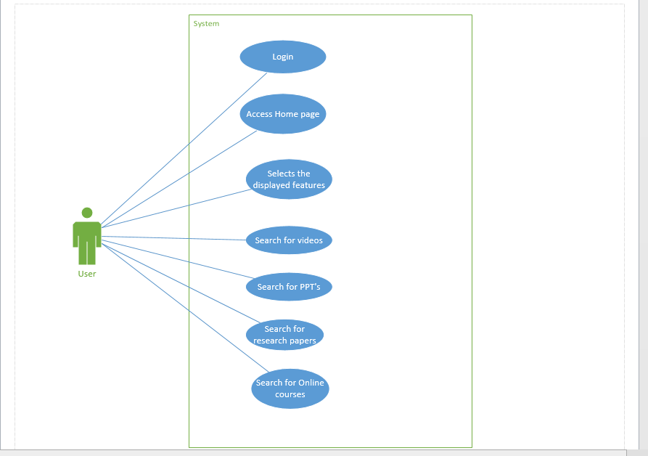

* + 1. **Sequence Diagram**

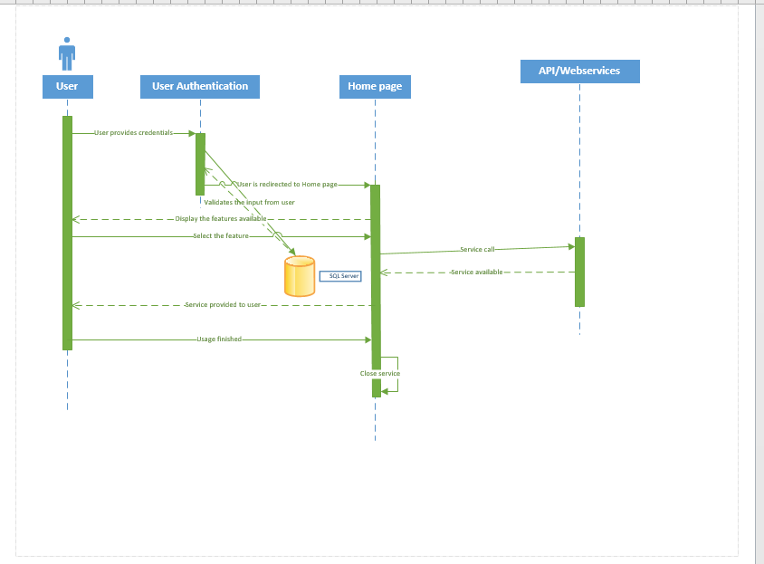

* + 1. **Architecture Diagram**

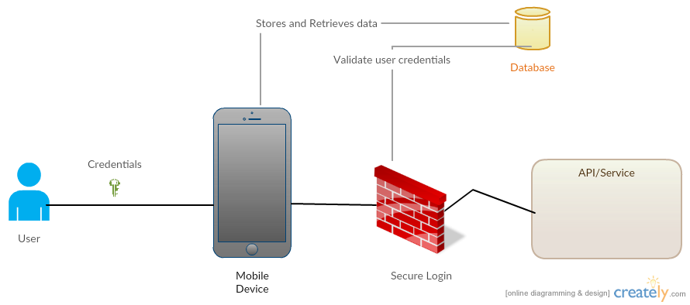

1. **Implementation**

**Unit Testing**

* **Test Cases for Login and Signup page:**

|  |  |  |  |
| --- | --- | --- | --- |
| **Case** | **Test case Description** | **Expected Result** | **Actual Result** |
| Login | Enter invalid username and password | Error message should pop up saying invalid credentials. | PASS |
| Login | Enter invalid username and valid password | Error message should pop up saying invalid credentials. | PASS |
| Login | Enter valid username and invalid password | Error message should pop up saying invalid credentials. | PASS |
| Login | Enter valid username and password | Page should redirect to Home page | PASS |
| Signup | Email id format should end with @mail.com | Give error message incorrect email id format | PASS |
| Signup | Password of length 8 characters | Gives error message password is weak | PASS |
| Signup | Password and confirm password should match | If this succeeds it redirects to login page | PASS |

1. **Project Management**

### Implementation status report

**Technology Used:** Android SDK, HTML, CSS, JS, Angular JS, J2EE.

**Work Completed**

* Design and Architecture of the Application
* Login and Registration using Android
* Collecting the API useful for the application

**Work to be Completed**

* Integrating the API with the application.
* Navigating the application in ionic.
* Improving the User Interface of the application.

**Contributors:**

* Sujitha, Puthana – 25 %
* Achyuth Reddy, Nalamadgu – 25%
* Anusha, Malineni – 25%
* Sri Sai Narayana Ram Gopal, Mangena – 25%

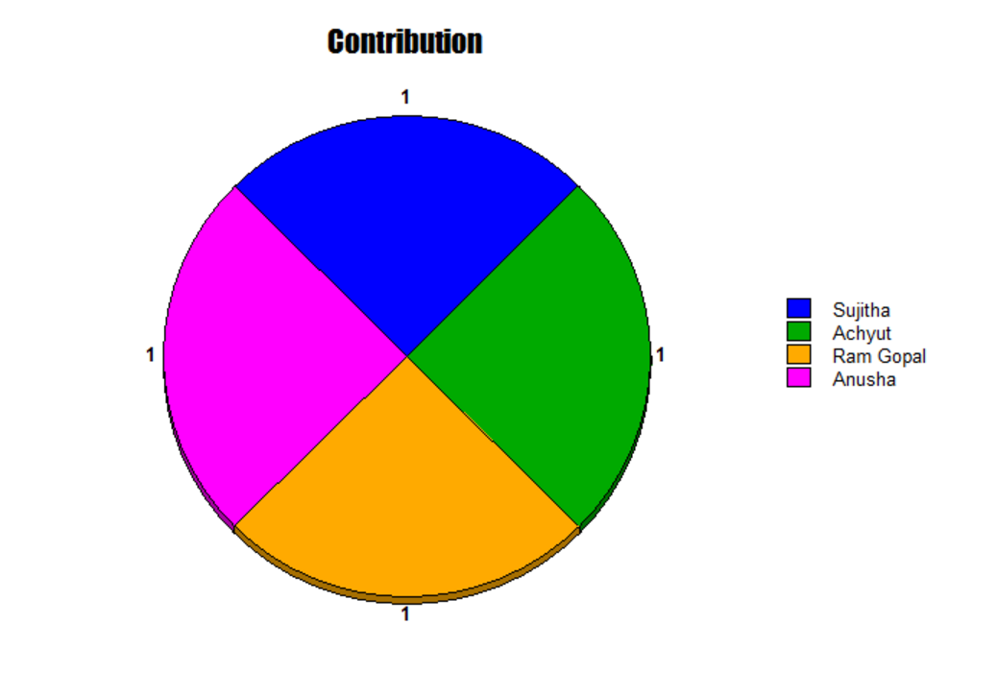

1. **Bibliography**

<http://creately.com/>