**Exercise 1: Implementing the Singleton Pattern**

CODE:

import java.util.*;

public class Logger {

private static Logger *instance*;

private Logger() {

System.*out*.println("Logger created");

}

public static Logger getInstance() {

if (*instance* == null) {

*instance* = new Logger();

}

return *instance*;

}

public static void main(String[] args) {

Logger logger1 = Logger.*getInstance*();

Logger logger2 = Logger.*getInstance*();

if (logger1 == logger2) {

System.*out*.println(logger1);

System.*out*.println(logger2);

System.*out*.println("Both logger instances are the same.");

} else {

System.*out*.println("Different logger instances.");

}

}

}

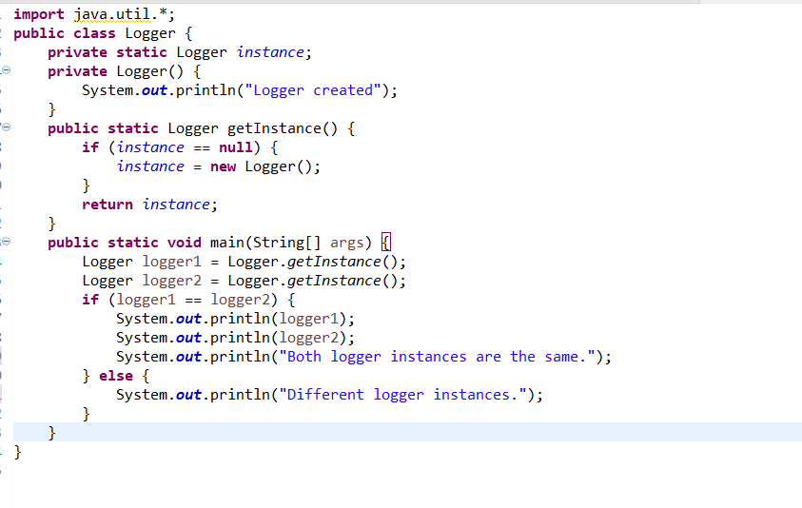

OUTPUT:

