PL/SQL:

**Exercise 2: Error Handling**

**Scenario 1:** Handle exceptions during fund transfers between accounts.

* + **Question:** Write a stored procedure **SafeTransferFunds** that transfers funds between two accounts. Ensure that if any error occurs (e.g., insufficient funds), an appropriate error message is logged and the transaction is rolled back.

CODE:

CREATE OR REPLACE PROCEDURE SafeTransferFunds (

p_from_account_id IN NUMBER,

p_to_account_id IN NUMBER,

p_amount IN NUMBER

) IS

v_from_balance NUMBER;

BEGIN

-- Get current balance of from_account

SELECT Balance INTO v_from_balance

FROM Accounts

WHERE AccountID = p_from_account_id

FOR UPDATE;

IF v_from_balance < p_amount THEN

RAISE_APPLICATION_ERROR(-20001, 'Insufficient funds for transfer.');

END IF;

-- Deduct from sender

UPDATE Accounts

SET Balance = Balance - p_amount,

LastModified = SYSDATE

WHERE AccountID = p_from_account_id;

-- Add to receiver

UPDATE Accounts

SET Balance = Balance + p_amount,

LastModified = SYSDATE

WHERE AccountID = p_to_account_id;

COMMIT;

DBMS_OUTPUT.PUT_LINE('Transfer of ' || p_amount || ' successful from Account ' || p_from_account_id || ' to Account ' || p_to_account_id);

EXCEPTION

WHEN OTHERS THEN

ROLLBACK;

DBMS_OUTPUT.PUT_LINE('Transfer failed: ' || SQLERRM);

END;

/

OUTPUT:

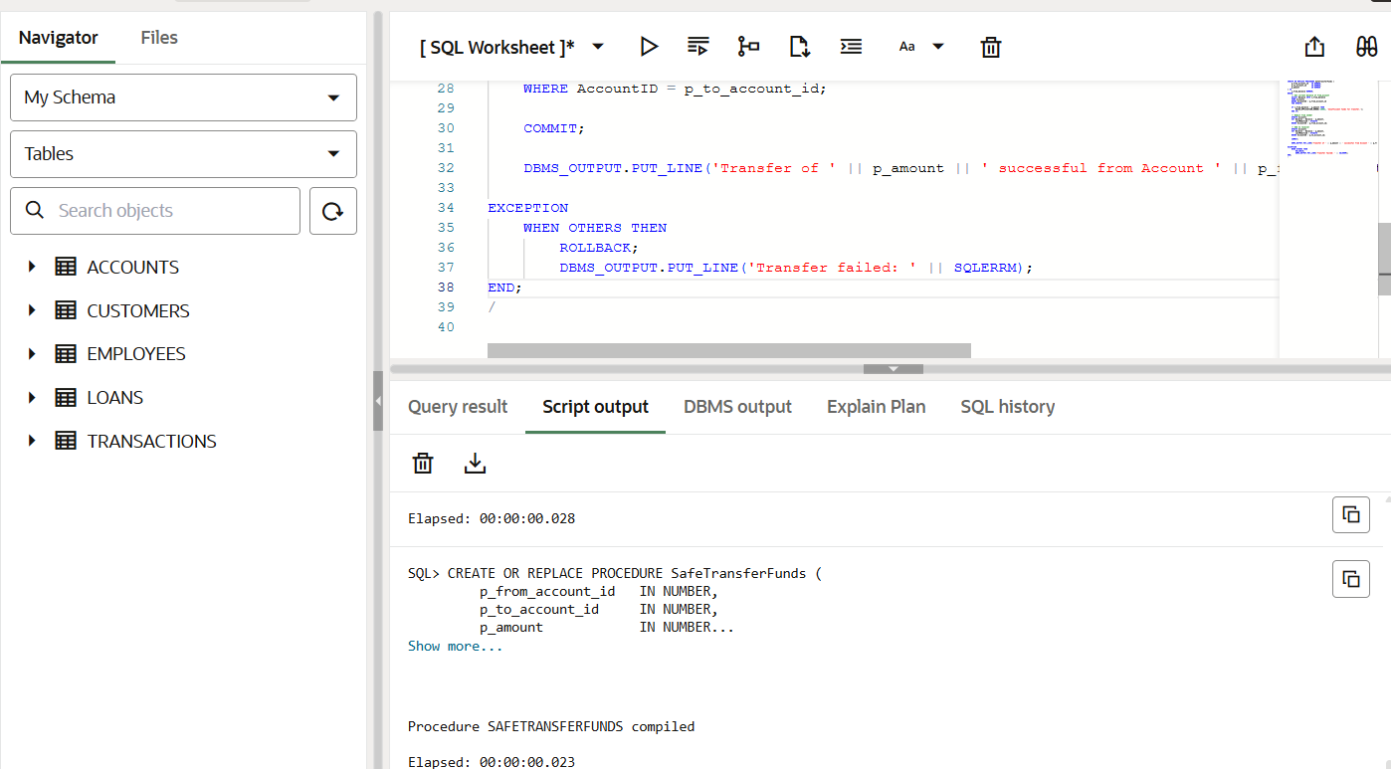

**Scenario 2:** Manage errors when updating employee salaries.

* + **Question:** Write a stored procedure **UpdateSalary** that increases the salary of an employee by a given percentage. If the employee ID does not exist, handle the exception and log an error message.

CODE:

CREATE OR REPLACE PROCEDURE UpdateSalary (

p_employee_id IN NUMBER,

p_percent IN NUMBER

) IS

BEGIN

UPDATE Employees

SET Salary = Salary + (Salary * p_percent / 100),

HireDate = HireDate -- Dummy assignment to ensure update triggers

WHERE EmployeeID = p_employee_id;

IF SQL%ROWCOUNT = 0 THEN

RAISE_APPLICATION_ERROR(-20002, 'Employee not found with ID: ' || p_employee_id);

END IF;

COMMIT;

DBMS_OUTPUT.PUT_LINE('Salary updated for EmployeeID: ' || p_employee_id);

EXCEPTION

WHEN OTHERS THEN

ROLLBACK;

DBMS_OUTPUT.PUT_LINE('Salary update failed: ' || SQLERRM);

END;

/

OUTPUT:

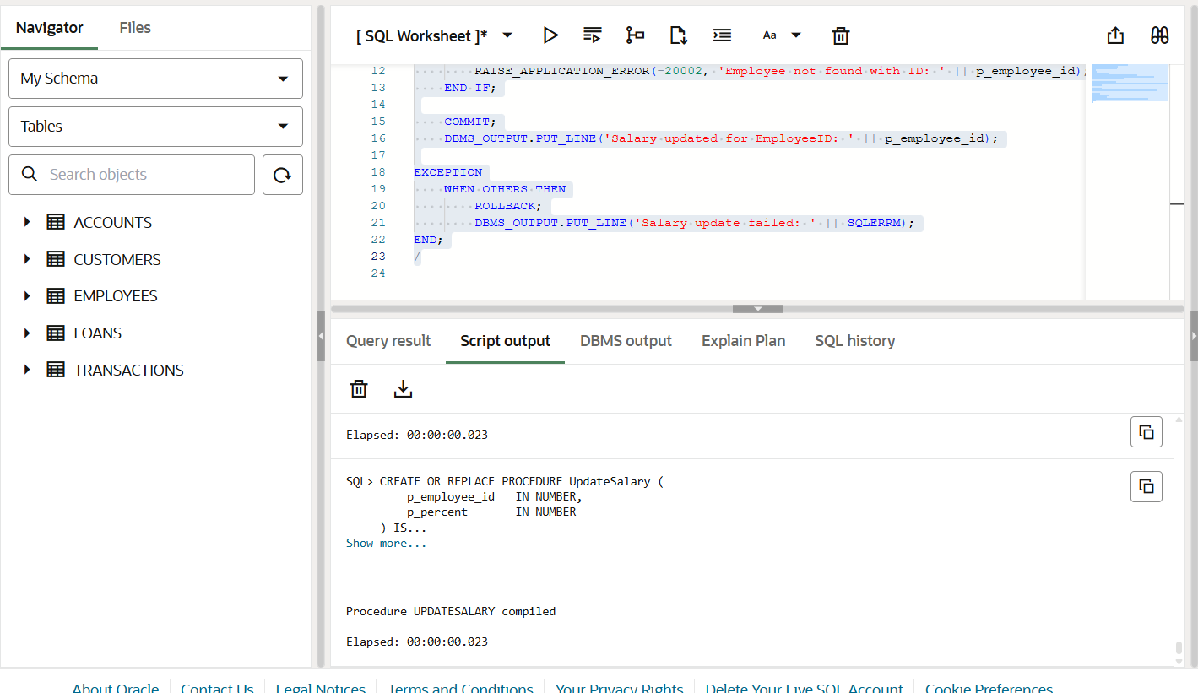

**Scenario 3:** Ensure data integrity when adding a new customer.

* + **Question:** Write a stored procedure **AddNewCustomer** that inserts a new customer into the Customers table. If a customer with the same ID already exists, handle the exception by logging an error and preventing the insertion.

CODE:

CREATE OR REPLACE PROCEDURE AddNewCustomer (

p_customer_id IN NUMBER,

p_name IN VARCHAR2,

p_dob IN DATE,

p_balance IN NUMBER

) IS

BEGIN

INSERT INTO Customers (CustomerID, Name, DOB, Balance, LastModified)

VALUES (p_customer_id, p_name, p_dob, p_balance, SYSDATE);

COMMIT;

DBMS_OUTPUT.PUT_LINE('Customer added successfully: ' || p_name);

EXCEPTION

WHEN DUP_VAL_ON_INDEX THEN

DBMS_OUTPUT.PUT_LINE('Insert failed: Customer with ID ' || p_customer_id || ' already exists.');

WHEN OTHERS THEN

DBMS_OUTPUT.PUT_LINE('Insert failed: ' || SQLERRM);

END;

/

OUTPUT:

