SPRING REST USING SPRINGBOOT:

1.spring-learn:

Hands-on-1:

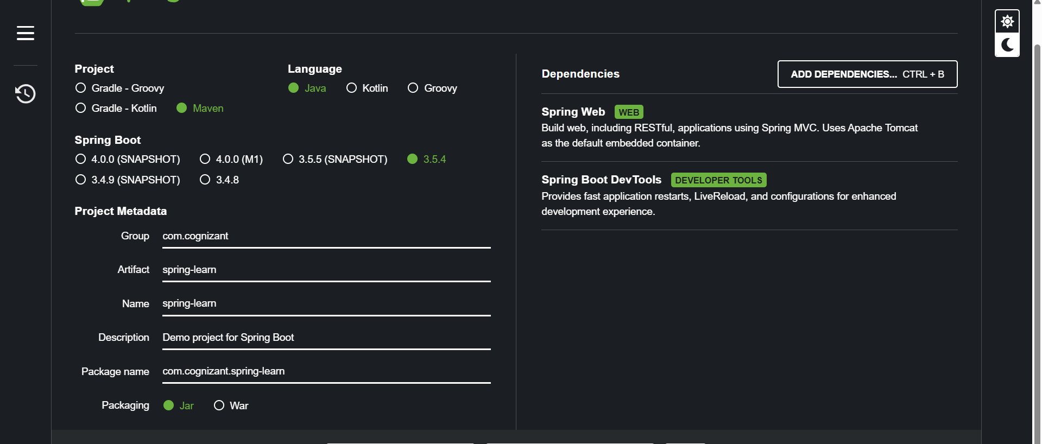

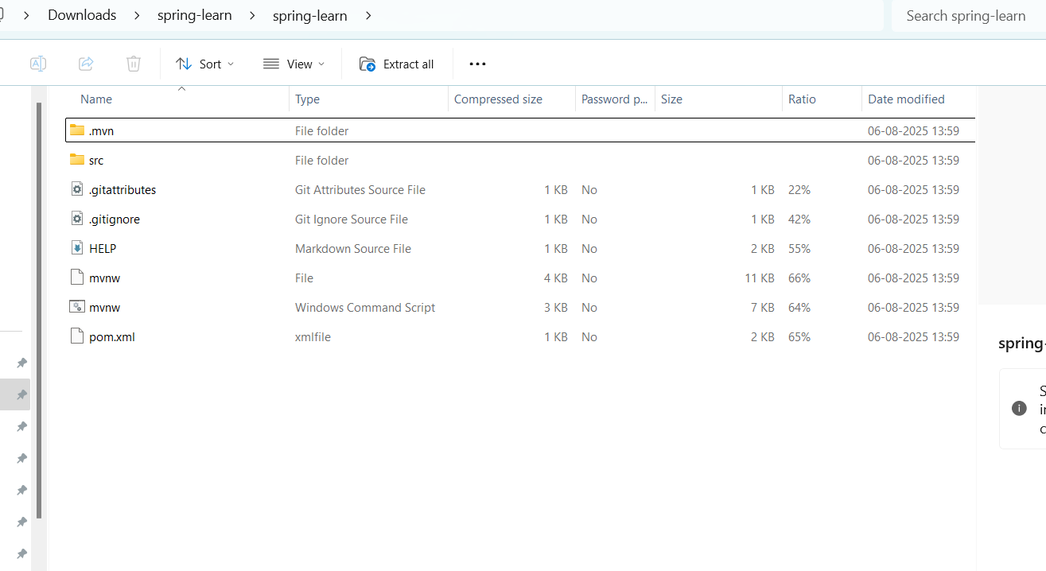

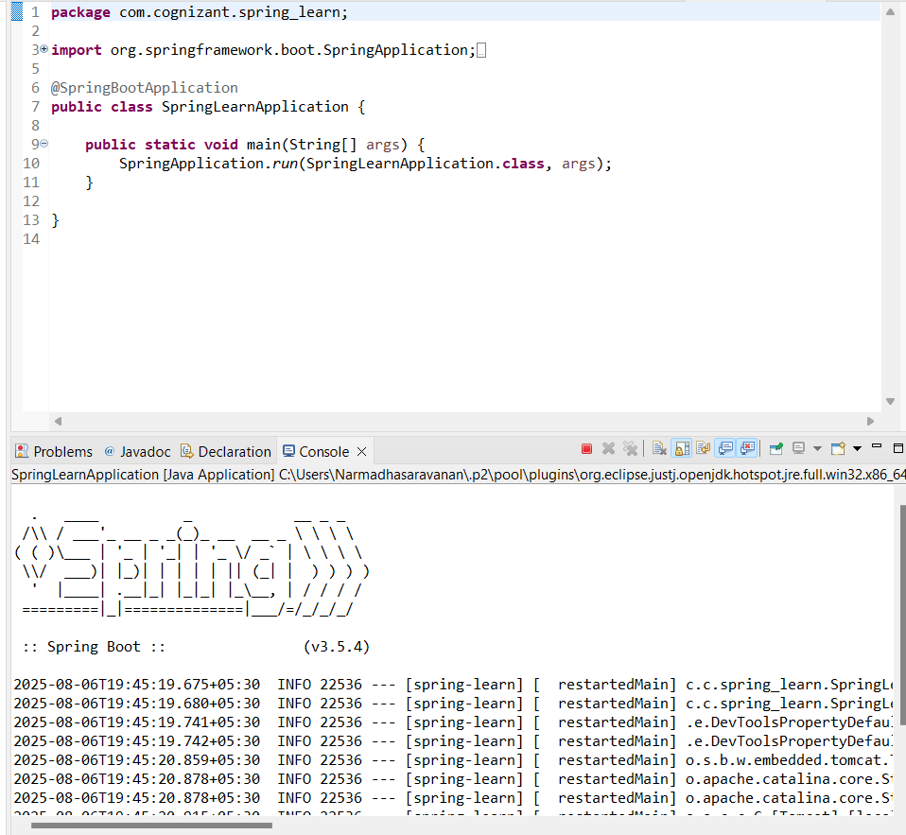

package com.cognizant.spring_learn;

import org.springframework.boot.SpringApplication;

import org.springframework.boot.autoconfigure.SpringBootApplication;

@SpringBootApplication

public class SpringLearnApplication {

public static void main(String[] args) {

SpringApplication.run(SpringLearnApplication.class, args);

}

}

Hands-on-2:

package com.cognizant.spring_learn;

import org.springframework.boot.SpringApplication;

import org.springframework.boot.autoconfigure.SpringBootApplication;

import org.springframework.context.ApplicationContext;

import org.springframework.context.support.ClassPathXmlApplicationContext;

import java.text.SimpleDateFormat;

import java.util.Date;

@SpringBootApplication

public class SpringLearnApplication {

public void displayDate() throws Exception {

ApplicationContext context = new ClassPathXmlApplicationContext("date-format.xml");

SimpleDateFormat format = context.getBean("dateFormat", SimpleDateFormat.class);

Date date = format.parse("31/12/2018");

System.*out*.println(date);

}

public static void main(String[] args) throws Exception {

SpringApplication.*run*(SpringLearnApplication.class, args);

SpringLearnApplication app = new SpringLearnApplication();

app.displayDate();

}

}

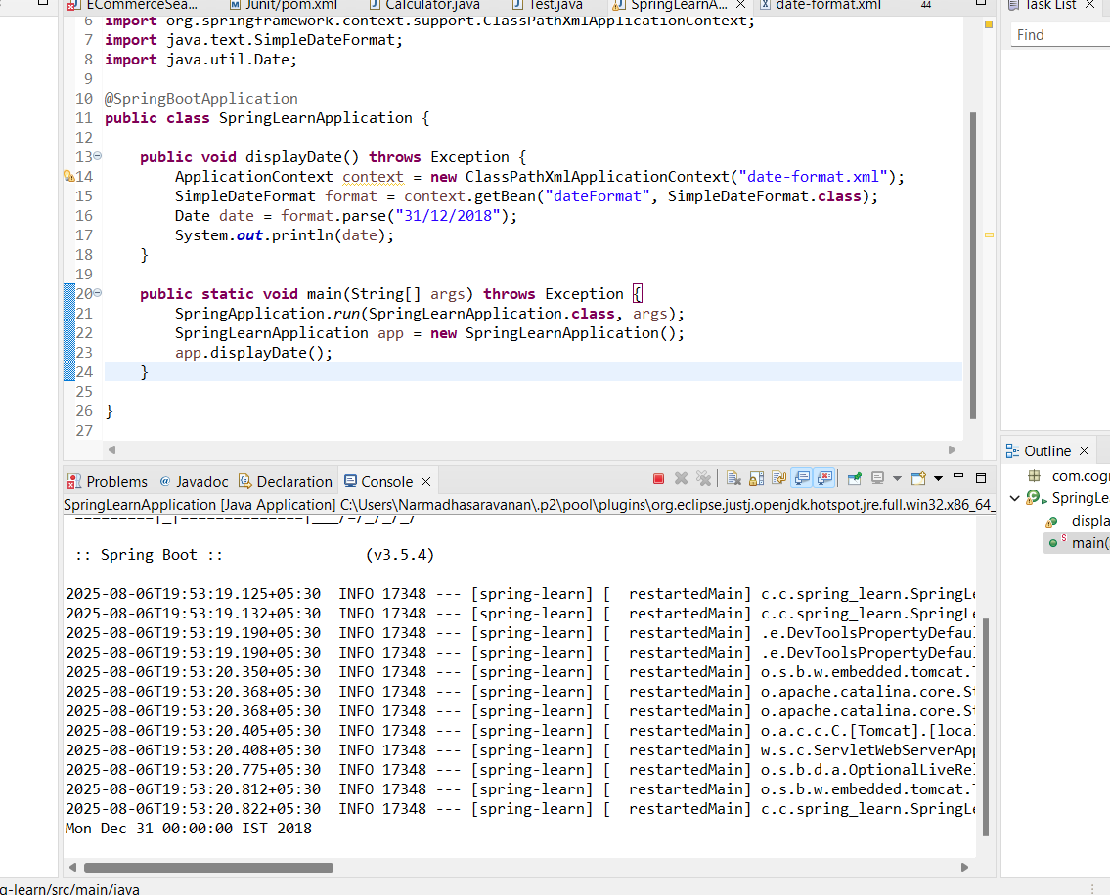

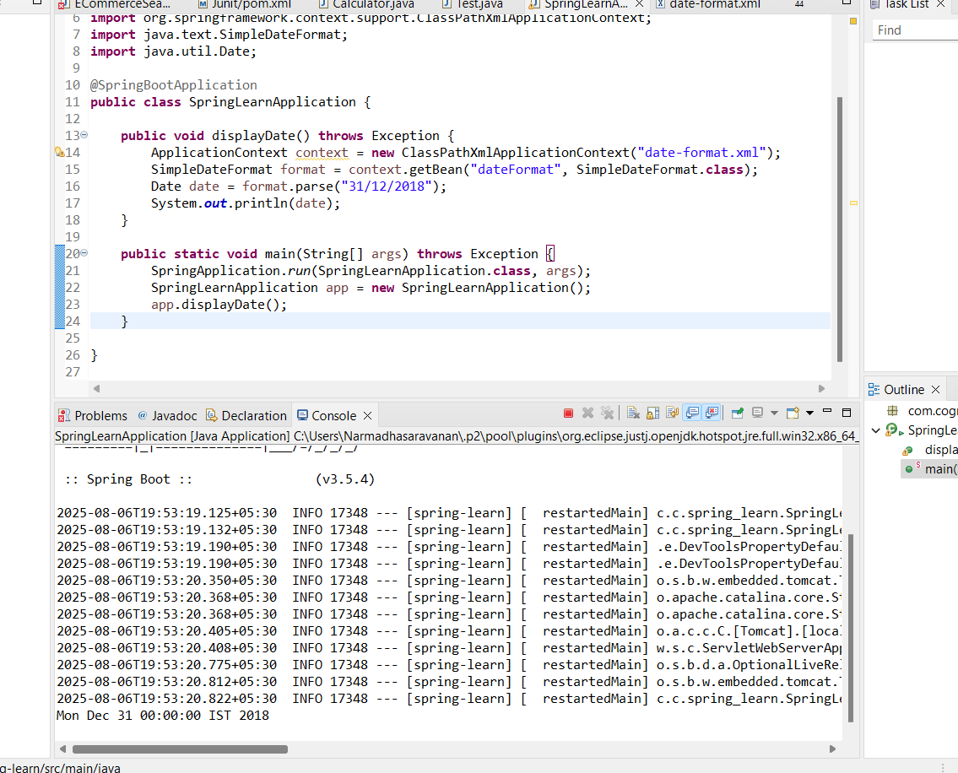

Hands-on-3:

package com.cognizant.spring_learn;

import org.springframework.boot.SpringApplication;

import org.springframework.boot.autoconfigure.SpringBootApplication;

import org.springframework.context.ApplicationContext;

import org.springframework.context.support.ClassPathXmlApplicationContext;

import java.text.SimpleDateFormat;

import java.util.Date;

import org.slf4j.Logger;

import org.slf4j.LoggerFactory;

@SpringBootApplication

public class SpringLearnApplication {

private static final Logger *LOGGER* = LoggerFactory.*getLogger*(SpringLearnApplication.class);

public void displayDate() throws Exception {

*LOGGER*.info("START");

ApplicationContext context = new ClassPathXmlApplicationContext("date-format.xml");

SimpleDateFormat format = context.getBean("dateFormat", SimpleDateFormat.class);

Date date = format.parse("31/12/2018");

*LOGGER*.debug("Date : {}", date);

*LOGGER*.info("END");

}

public static void main(String[] args) throws Exception {

SpringApplication.*run*(SpringLearnApplication.class, args);

SpringLearnApplication app = new SpringLearnApplication();

app.displayDate();

}

}

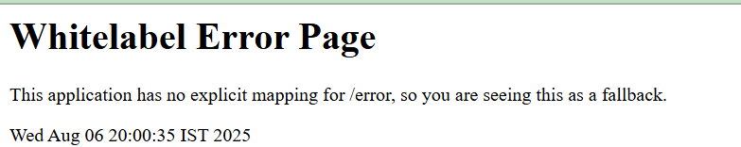

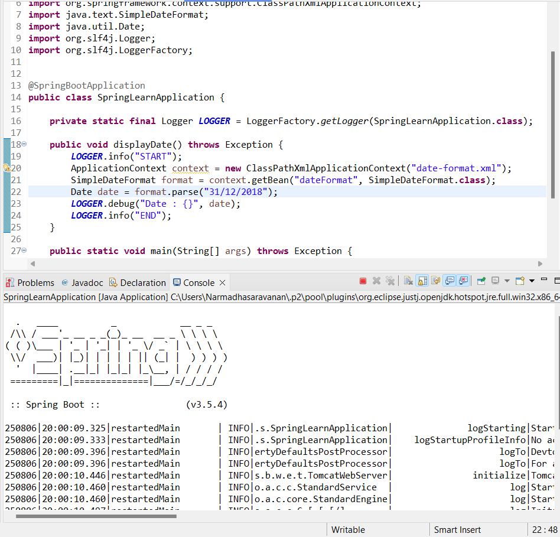

Hands-on -4:

package com.cognizant.spring_learn;

import org.springframework.boot.SpringApplication;

import org.springframework.boot.autoconfigure.SpringBootApplication;

import org.springframework.context.ApplicationContext;

import org.springframework.context.support.ClassPathXmlApplicationContext;

import java.text.SimpleDateFormat;

import java.util.Date;

import org.slf4j.Logger;

import org.slf4j.LoggerFactory;

@SpringBootApplication

public class SpringLearnApplication {

private static final Logger *LOGGER* = LoggerFactory.*getLogger*(SpringLearnApplication.class);

public void displayDate() throws Exception {

*LOGGER*.info("START");

ApplicationContext context = new ClassPathXmlApplicationContext("date-format.xml");

SimpleDateFormat format = context.getBean("dateFormat", SimpleDateFormat.class);

Date date = format.parse("31/12/2018");

*LOGGER*.debug("Date : {}", date);

*LOGGER*.info("END");

}

public void displayCountry() {

*LOGGER*.info("START");

ApplicationContext context = new ClassPathXmlApplicationContext("country.xml");

Country country = (Country) context.getBean("country", Country.class);

*LOGGER*.debug("Country : {}", country.toString());

*LOGGER*.info("END");

}

public static void main(String[] args) throws Exception {

SpringApplication.*run*(SpringLearnApplication.class, args);

SpringLearnApplication app = new SpringLearnApplication();

app.displayDate();

app.displayCountry();

}

}

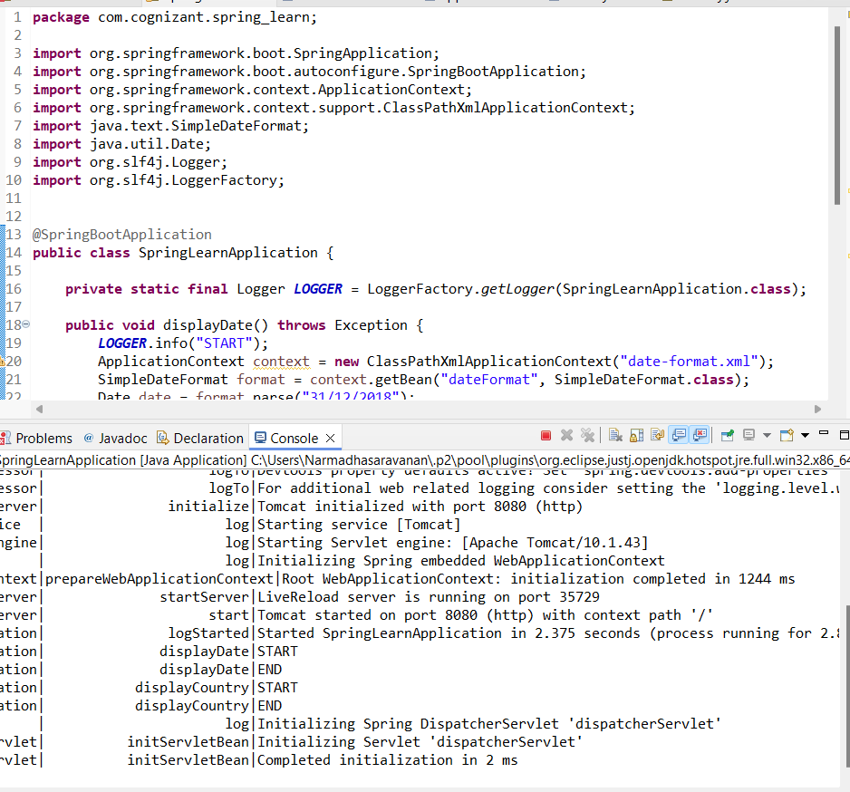

Hands-on-5:

package com.cognizant.spring_learn;

import org.springframework.boot.SpringApplication;

import org.springframework.boot.autoconfigure.SpringBootApplication;

import org.springframework.context.ApplicationContext;

import org.springframework.context.support.ClassPathXmlApplicationContext;

import java.text.SimpleDateFormat;

import java.util.Date;

import org.slf4j.Logger;

import org.slf4j.LoggerFactory;

@SpringBootApplication

public class SpringLearnApplication {

private static final Logger *LOGGER* = LoggerFactory.*getLogger*(SpringLearnApplication.class);

public void displayDate() throws Exception {

*LOGGER*.info("START");

ApplicationContext context = new ClassPathXmlApplicationContext("date-format.xml");

SimpleDateFormat format = context.getBean("dateFormat", SimpleDateFormat.class);

Date date = format.parse("31/12/2018");

*LOGGER*.debug("Date : {}", date);

*LOGGER*.info("END");

}

public void displayCountry() {

*LOGGER*.info("START");

ApplicationContext context = new ClassPathXmlApplicationContext("country.xml");

Country country1 = context.getBean("country", Country.class);

*LOGGER*.debug("Country 1 : {}", country1.toString());

Country country2 = context.getBean("country", Country.class);

*LOGGER*.debug("Country 2 : {}", country2.toString());

*LOGGER*.info("END");

}

public static void main(String[] args) throws Exception {

SpringApplication.*run*(SpringLearnApplication.class, args);

SpringLearnApplication app = new SpringLearnApplication();

app.displayDate();

app.displayCountry();

}

}

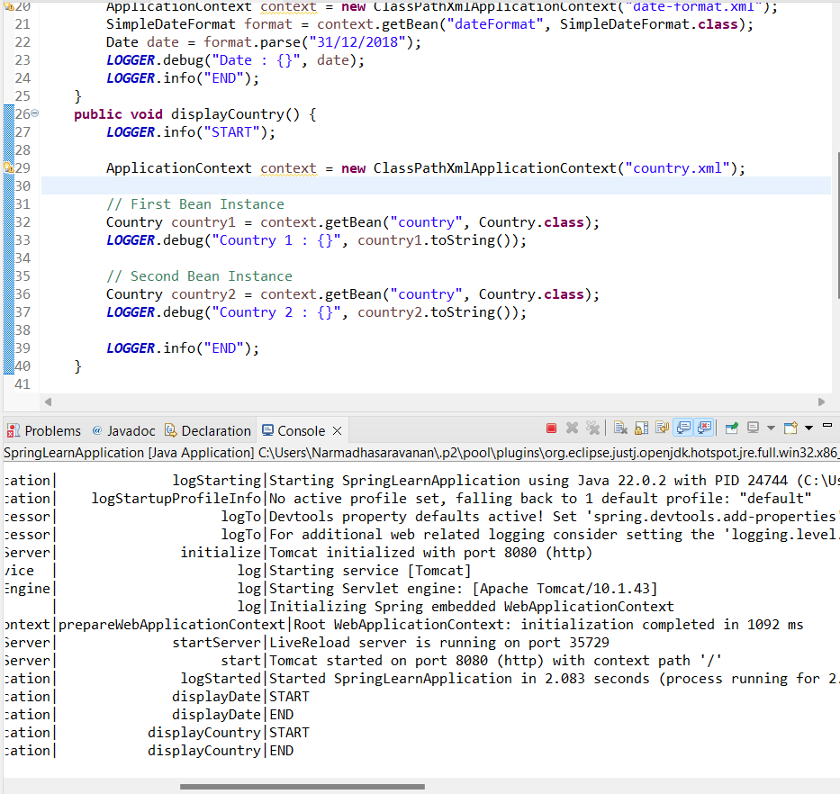

Hands-on-6:

package com.cognizant.spring_learn;

import java.util.*;

import org.springframework.boot.SpringApplication;

import org.springframework.boot.autoconfigure.SpringBootApplication;

import org.springframework.context.ApplicationContext;

import org.springframework.context.support.ClassPathXmlApplicationContext;

import java.text.SimpleDateFormat;

import java.util.Date;

import org.slf4j.Logger;

import org.slf4j.LoggerFactory;

@SpringBootApplication

public class SpringLearnApplication {

private static final Logger *LOGGER* = LoggerFactory.*getLogger*(SpringLearnApplication.class);

public void displayDate() throws Exception {

*LOGGER*.info("START");

ApplicationContext context = new ClassPathXmlApplicationContext("date-format.xml");

SimpleDateFormat format = context.getBean("dateFormat", SimpleDateFormat.class);

Date date = format.parse("31/12/2018");

*LOGGER*.debug("Date : {}", date);

*LOGGER*.info("END");

}

public void displayCountries() {

*LOGGER*.info("START");

ApplicationContext context = new ClassPathXmlApplicationContext("country.xml");

List<Country> countryList = context.getBean("countryList", List.class);

*LOGGER*.debug("CountryList : {}", countryList);

*LOGGER*.info("END");

}

public static void main(String[] args) throws Exception {

SpringApplication.*run*(SpringLearnApplication.class, args);

SpringLearnApplication app = new SpringLearnApplication();

app.displayDate();

app.displayCountries();

}

}

