Initial Prototype Url: <https://recipeswe632.netlify.app/>

New URL:

Synopsis

|  |  |  |
| --- | --- | --- |
| Content | Count | Owner |
| Problem 1- Customize your bowl | 1 | Achudan |
| Can submit empty bowl | 1 | Achudan |
| categorize the menu on left side | 2 | Achudan |
| help and documentation | 3 |  |
| Title of the application | 1 | Achudan |
| lower case | 1 |  |

Fixes:

**Problem 1:**

Heuristic 6: Recognition rather than recall

Issue: In the app, the user has the ability to create a custom recipe separate from the default ones given on the main page. However, this option is hard to see when the page is first loaded up. A user would either have to scroll all the way down to see the option, or click on the “Custom” button on the top right of the header. This button is not immediately apparent or visible to the user, and the name is too vague to give any context that it’s specifically for customizing recipes. As such, this would violate Heuristic 6, as the focus is to make everything clearly visible and easy to access.

Old Screenshot:

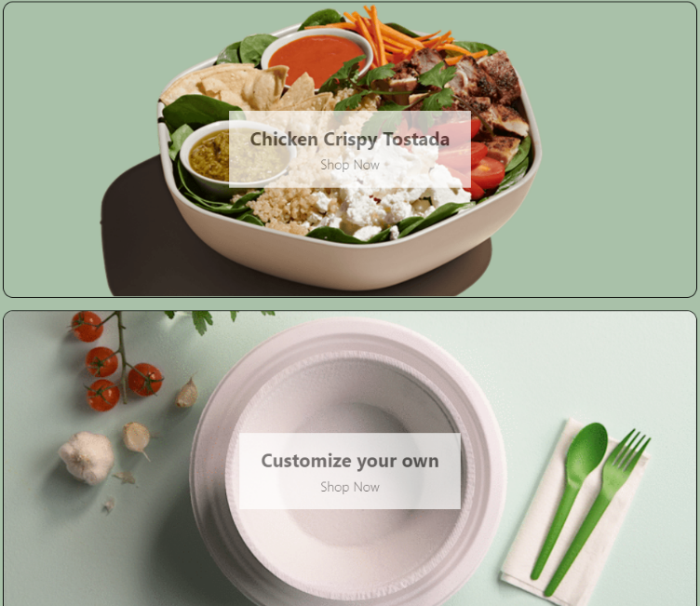

Fixes: The Navbar menu ‘Custom’ changed to ‘Build your own recipe’ for a better heuristic. The custom card is placed to the top of the menu item for easy recognition.

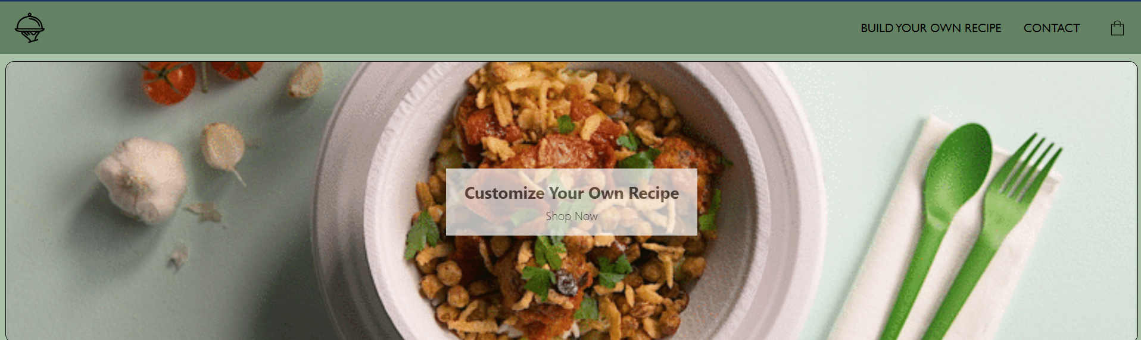

**Problem 2:**

Heuristic 3 and 5: User Control and Error prevention

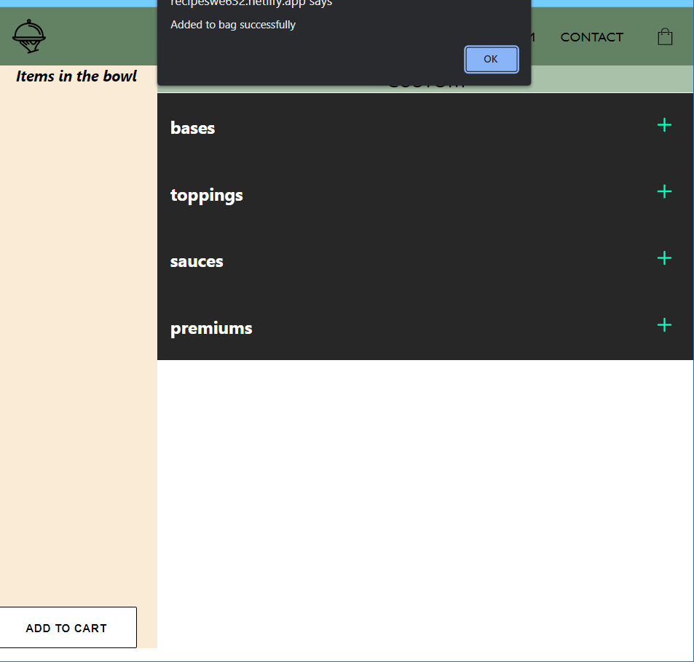

**Use Case 4 :** In the app, a user can select customize, then submit an empty recipe into the cart (no items). This should not happen, as users should not be able to submit an empty recipe. This action may confuse users, as submitting an empty recipe could show up in the cart.

Fix: A pop up is displayed to prevent user from adding an empty bowl to the cart.

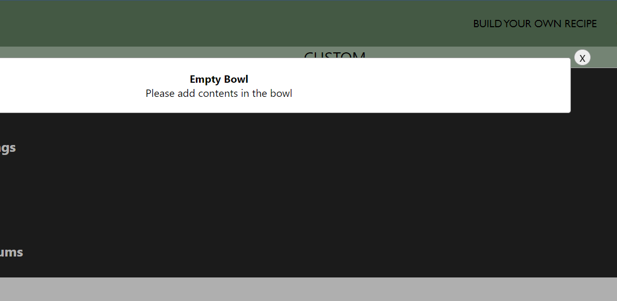

**Problem 3:**

Heuristic 7: Flexibility and Efficiency of Use

**Use case 3:** Similar to Problem 3, the same can be said for the list of added items on the left side of the screen (See screenshot below). Currently the list only sorts by first in first out selection, which although makes some sense is not efficient for the user to clearly identify what selections they’ve picked. Similar to the above suggestion, I would suggest sorting this list by submenus.

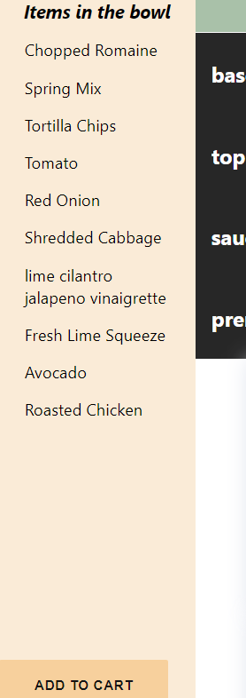

Fix: A sub category of menu is displayed in the left pane view.

