1. The First Request will Pull out the Response to Prompt the User to provide the Numbers.

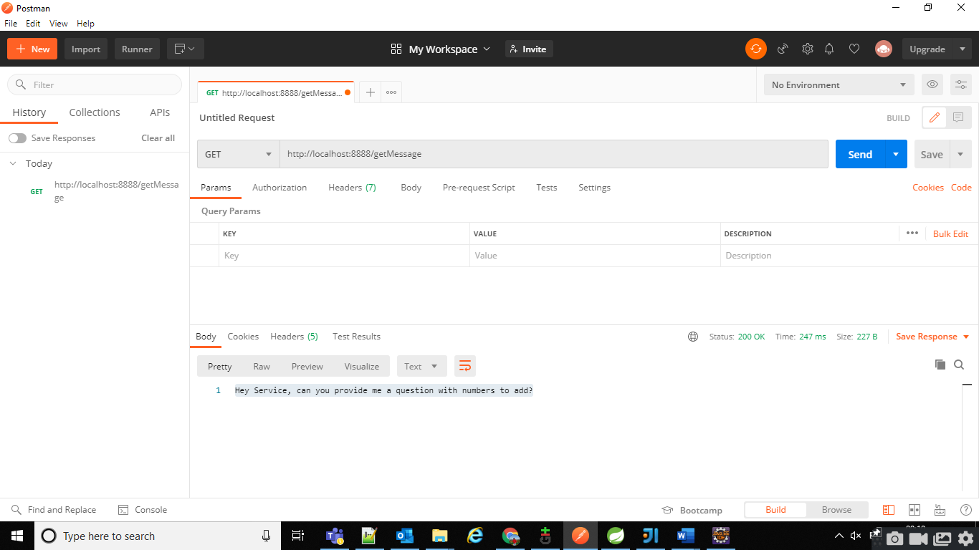

1. The Second Request will Create the Random Number Dynamically and send it back to the User.

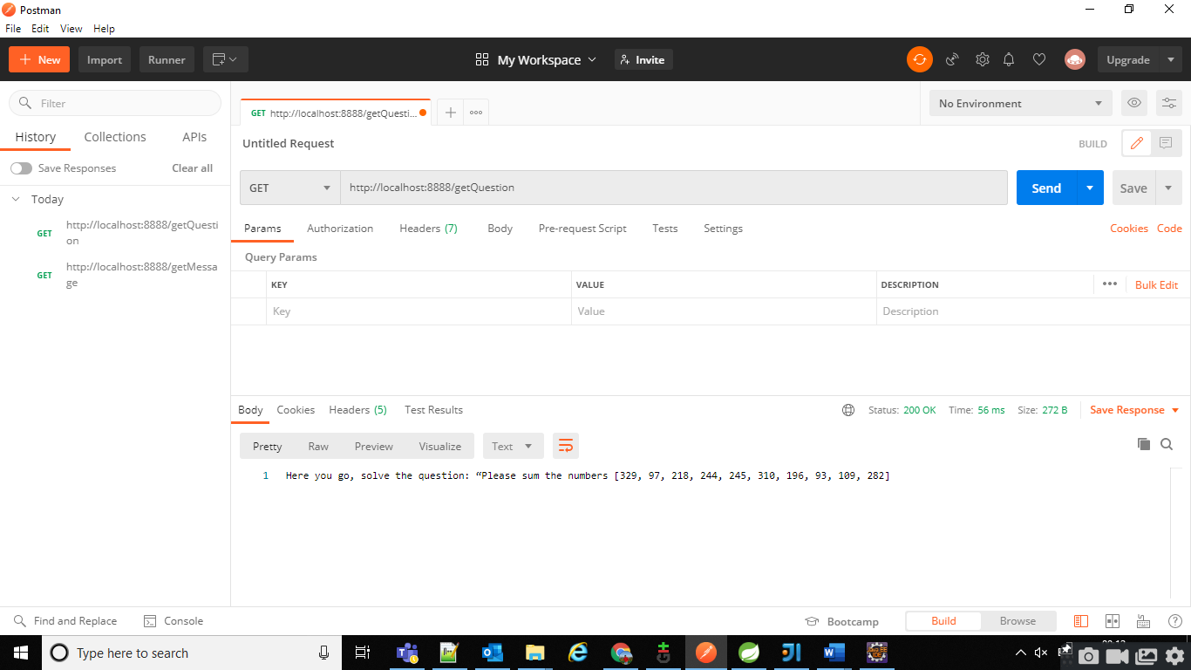

1. The Final Request will Push the values and the sum which user is going to provide :
2. First Case Providing the Wrong Sum Value which will give the Bad Response and not Valid.

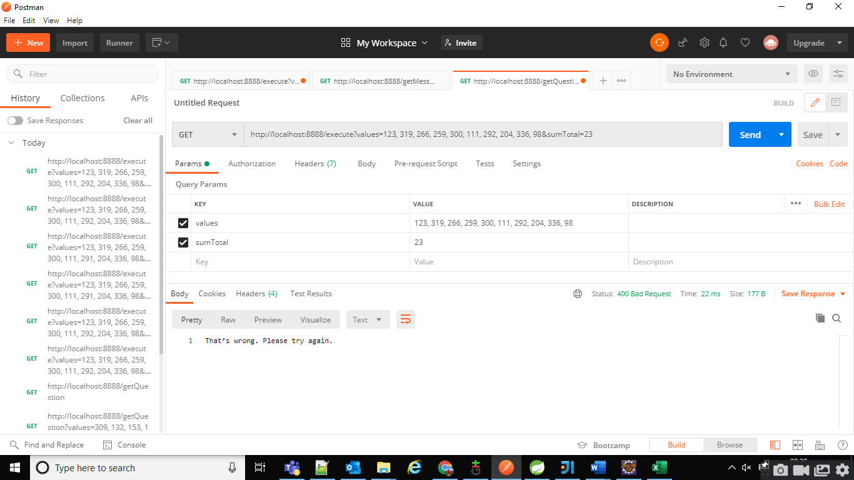

1. Second one is the Actual Correct Value which will validate and give the Success Response to the User.

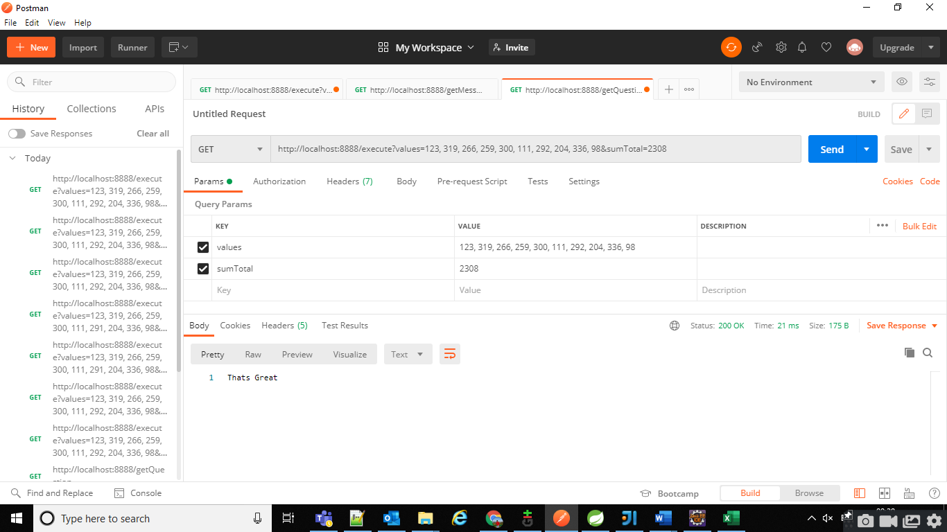

Iii) SafeGuard Against Cheating like change the values to some malicious values.

