Logically Inconsistent Records & Their Impact on ML Model Performance

Here is a Bar plot representing Missing values count in the entire raw data (93,621)

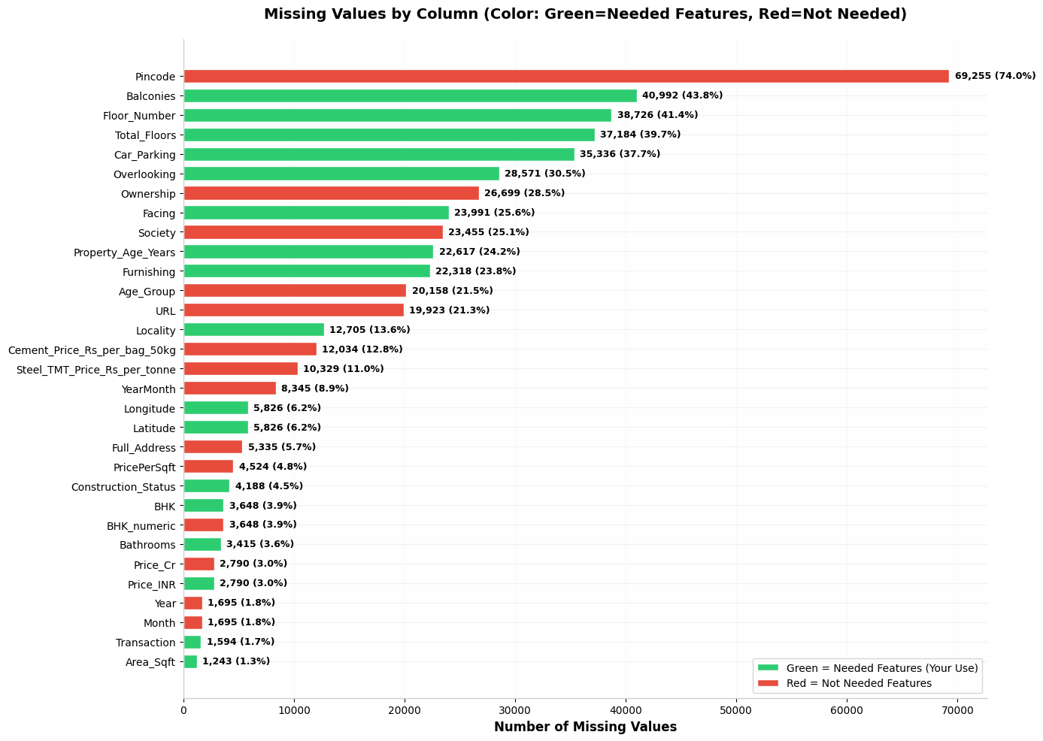

Note:- On this raw data, removed all missing values from the required columns/features and final dataset size is 20K records. And this report is on 20,612 records.

What Are Logically Inconsistent Records?
These are listings where every individual field looks plausible on its own, but the fields contradict each other once read together as a real property. A real-estate expert reviewing the record end-to-end would immediately spot the mismatch — even though no single value is "out of range." Examples found in this dataset:
- A 1BHK apartment listed with ~4,000 sq ft of area (a 1BHK should realistically be 400–900 sq ft).
- A unit's Floor_Number exceeding the building's Total_Floors (e.g. "Floor 12" in a 5-floor building) — physically impossible.
- A property tagged "New Launch" or "Under Construction" that already shows 10+ years of Property_Age_Years.
- Bathroom, balcony, or car-parking counts wildly disproportionate to the BHK size (e.g. a 1BHK with 6 bathrooms).

Scale in This Dataset
Inconsistency type | Records affected | % of dataset
BHK size doesn't match Area_Sqft | 4,381 | 21.3%
"New Launch"/"Under Construction" but Age > 2 yrs | 6,718 | 32.6%
Floor_Number > Total_Floors | 420 | 2.0%
Bathrooms/Balconies/Parking disproportionate to BHK | 650 | 3.2%

How This Affects ML Model Performance
If a model is trained on these records without cleaning, the damage isn't random noise — it's structured, misleading signal:
- Corrupted feature–target relationships: the model learns false patterns, such as "1BHKs can be priced like 4,000 sq ft units," which distorts the learned relationship between area, BHK, and price for every prediction — not just the bad rows.
- Inflated or deflated price-per-sqft learning since price per sqft is a core driver of valuation, inconsistent area/BHK combinations directly bias the model's understanding of fair market rate by locality and unit type.
- Impossible values act as leverage points: extreme mismatches (e.g. floor > total floors, 10-year-old "new launch") have outsized influence on tree-based and linear models alike, pulling decision boundaries or coefficients away from genuine market behavior.
- Degraded generalization: a model tuned to noisy, self-contradictory training data will perform worse on real, clean listings at inference time — validation metrics computed on an equally dirty test split can look deceptively acceptable while real-world accuracy suffers.
- Downstream trust and business risk: valuation errors compound into mispriced listings, unreliable investment recommendations, or flawed locality-level market insights, which is especially costly in real estate given high per-unit transaction values.

