**NITTE MEENAKSHI INSTITUTE OF TECHNOLOGY**

(AN AUTONOMOUS INSTITUTION, AFFILIATED TO VISVESVARAYA TECHNOLOGICAL UNIVERSITY, BELGAUM, APPROVED BY AICTE & GOVT.OF KARNATAKA



**COMPUTER GRAPHICS AND VISUALIZATION (22CSA473)**

**COURSE PROJECT REPORT**

on

**ROCKET LAUNCHER**

*Submitted in partial fulfilment of the requirement for the award of Degree of*

*Bachelor of Engineering*

*in*

*Computer Science and Engineering*

*Submitted by:*

|  |  |
| --- | --- |
| SAMIRAN SIL  ANIL KUMAR  AMITH B N  ACHUTHA S | 1NT22CS178  1NT22CS032  INT22CS026  1NT22CS011 |

Under the Guidance of

Dr. Nirmala J S

Associate Professor, Dept. of CS&E, NMIT



Department of Computer Science and Engineering

**(Accredited by NBA Tier-1)**

2023-2024

**NITTE MEENAKSHI INSTITUTE OF TECHNOLOGY**

(AN AUTONOMOUS INSTITUTION, AFFILIATED TO VISVESVARAYA TECHNOLOGICAL UNIVERSITY, BELGAUM

, APPROVED BY AICTE & GOVT.OF KARNATAKA)

Department of Computer Science and Engineering

**(Accredited by NBA Tier-1)**



**CERTIFICATE**

This is to certify that the ROCKET LAUNCHER is an authentic work carried out by **SAMIRAN SIL (1NT22CS178)**, **ANIL KUMAR (1NT22CS032)** and **ACHUTHA S (1NT22CS011)** bonafide students of **Nitte Meenakshi Institute of Technology**, Bangalore in partial fulfilment for the award of the degree of ***Bachelor of Engineering*** in COMPUTER SCIENCE AND ENGINEERING of Visvesvaraya Technological University, Belgavi during the academic year ***2023-24.*** It is certified that all corrections and suggestions indicated during the internal assessment has been incorporated in the report. This project has been approved as it satisfies the academic requirement in respect of project work presented for the said degree.

|  |
| --- |
| **Internal Guide** |
|  |
| Dr. Nirmala J S  Associate Professor, Dept. of CSE, NMIT Bangalore |

**DECLARATION**

We hereby declare that

(i) The project work is our original work

(ii) This Project work has not been submitted for the award of any degree or examination at any other university/College/Institute.

(iii) This Project Work does not contain other persons’ data, pictures, graphs or other information, unless specifically acknowledged as being sourced from other persons.

(iv) This Project Work does not contain other persons’ writing, unless specifically acknowledged as being sourced from other researchers. Where other written sources have been quoted, then:

a) their words have been re-written but the general information attributed to them has been referenced;

b) where their exact words have been used, their writing has been placed inside quotation marks, and referenced.

(v) This Project Work does not contain text, graphics or tables copied and pasted from the Internet, unless specifically acknowledged, and the source being detailed in the thesis and in the References sections.

|  |  |  |
| --- | --- | --- |
| **NAME** | **USN** | **Signature** |
| SAMIRAN SIL | 1NT22CS178 |  |
| ANIL KUMAR | 1NT22CS032 |  |
| AMITH B N | 1NT22CS019 |  |
| ACHUTHA S | 1NT22CS011 |  |

Date:

**ACKNOWLEDGEMENT**

The satisfaction and euphoria that accompany the successful completion of any task would be incomplete without the mention of the people who made it possible, whose constant guidance and encouragement crowned our effort with success. I express my sincere gratitude to our Principal **Dr. H. C. Nagaraj**, Nitte Meenakshi Institute of Technology for providing facilities.

We wish to thank our HoD**, Dr. Vijaya Shetty S.** for the excellent environment created to further educational growth in our college. We also thank her for the invaluable guidance provided which has helped in the creation of a better project.

I hereby like to thank our ***Guide Name, Designation***, Department of Computer Science & Engineering on **his/her** periodic inspection, time to time evaluation of the project and help to bring the project to the present form.

Thanks to our Departmental Project coordinators. We also thank all our friends, teaching and non-teaching staff at NMIT, Bangalore, for all the direct and indirect help provided in the completion of the project.

|  |  |  |
| --- | --- | --- |
| **NAME** | **USN** | **Signature** |
| SAMIRAN SIL | 1NT22CS178 |  |
| ANIL KUMAR | 1NT22CS032 |  |
| AMITH B N | 1NT22CS019 |  |
| ACHUTHA S | 1NT22CS011 |  |

Date:

**ABSTRACT**

This computer graphics project demonstrates a simulated rocket launch using OpenGL and GLUT. The main elements include a rocket with detachable boosters and a satellite, all animated to mimic a real launch sequence. The code sets up a 3D environment, incorporating depth testing and lighting to enhance visual realism.

Initially, the rocket remains stationary, allowing user interaction through keyboard inputs. The launch sequence begins when the user presses the designated key, triggering the animation. The rocket ascends, with the boosters separating at a specific stage, followed by the deployment of the satellite.

The satellite and rocket components are modeled using various OpenGL primitives, such as cones, cubes, and toruses, with transformations applied to position and animate them accurately. Stars are rendered as background points, creating a sense of movement through space.

The project utilizes a menu system and keyboard controls to manage the launch sequence and exit the application. Lighting and material properties are configured to give the rocket and satellite realistic appearances, with smooth shading for a polished look.

Overall, this project provides an engaging visualization of a rocket launch, showcasing the capabilities of OpenGL for creating dynamic 3D animations. It serves as an educational tool for understanding the basics of computer graphics, including transformations, lighting, and animation.

**DECLARATION**

**ACKNOWLEDGEMENT**

**ABSTRACT**

**TABLE OF CONTENTS**

**LIST OF FIGURES**

**LIST OF TABLES**

**LIST OF ACRONYMS**

**CHAPTER 1: INTRODUCTION**

* 1. Background
  2. Brief history of Technology/concept
  3. Applications
  4. Research motivation and Problem statement
     1. Research Motivation
     2. Statement of the Problem
  5. Research objectives and contributions
     1. Primary objectives
     2. Main contributions
  6. Organization of the report
  7. Summary

**CHAPTER 2: LITERATURE SURVEY**

* + 1. Introduction
    2. Related work
    3. Study of Tools/Technology
    4. Summary

**CHAPTER 3: BLOCK DIAGRAM DESIGN**

**CHAPTER 4: IMPLEMENTATION**

5.1 Methodology

5.2 Description of Process

5.3 Pseudo-code

**CHAPTER 5: RESULTS**

**CHAPTER 6: CONCLUSIONS**

**CHAPTER 7: REFERENCES**

***Follow this format compulsorily to write the reference in the reference chapter as applicable to your report.***

**Electronic Documents**

**E-books**

[1] L. Bass, P. Clements, and R. Kazman, Software Architecture in Practice, 2nd ed. Reading, MA: Addison Wesley, 2003. [E-book] Available: Safari e-book.

**Article in Online Encyclopaedia**

[2] D. Ince, “Acoustic coupler,” in A Dictionary of the Internet. Oxford University Press, [online document], 2001. Available: Oxford Reference Online, http://www.oxfordreference.com [Accessed: May 24, 2007].

**Journal Article Abstract (accessed from online database)**

[1] M. T. Kimour and D. Meslati, “Deriving objects from use cases in real-time embedded systems,” Information and Software Technology, vol. 47, no. 8, p. 533, June 2005. [Abstract]. Ava ilable: ProQuest, http://www.umi.com/proquest/. [Accessed November 12, 2007].

**Journal Article in Scholarly Journal (published free of charge on the Internet)**

[2] A. Altun, “Understanding hypertext in the context of reading on the web: Language learners’ experience,” Current Issues in Education, vol. 6, no. 12, July, 2005. [Online serial]. Available: http://cie.ed.asu.edu/volume6/number12/. [Accessed Dec. 2, 2007].

**Newspaper Article from the Internet**

[3] C. Wilson-Clark, “Computers ranked as key literacy,” The Atlanta Journal Constitution, para. 3, March 29, 2007. [Online], Available: http://www.thewest.com.au. [Accessed Sept. 18, 2007].

**Internet Documents**

**Professional Internet Site**

[1] European Telecommunications Standards Institute, “Digital Video Broadcasting (DVB): Implementation guide for DVB terrestrial services; transmission aspects,” European Telecommunications Standards Institute, ETSI-TR-101, 2007. [Online]. Available: http://www.etsi.org. [Accessed: Nov. 12, 2007].

**Journal Articles**

**Article in Journal (paginated by annual volume)**

[8] K. A. Nelson, R. J. Davis, D. R. Lutz, and W. Smith, “Optical generation of tunable ultrasonic waves,” Journal of Applied Physics, vol. 53, no. 2, Feb., pp. 1144-1149, 2002.

**Books**

**Single Author**

[1] W. K. Chen, Linear Networks and Systems. Belmont, CA: Wadsworth Press, 2003.

**Edited Book**

[2] J. L. Spudich and B. H. Satir, Eds., Sensory Receptors and Signal Transduction. New York: Wiley-Liss, 2001.

**Selection in an Edited Book**

[3] E. D. Lipson and B. D. Horwitz, “Photosensory reception and transduction,” in Sensory Receptors and Signal Transduction, J. L. Spudich and B. H. Satir, Eds. New York: Wiley-Liss, 2001, pp-1-64.

**Three or More Authors**

[4] R. Hayes, G. Pisano, and S. Wheelwright, Operations, Strategy, and Technical Knowledge. Hoboken, NJ: Wiley, 2007.

**Manual**

[6] Bell Telephone Laboratories Technical Staff, Transmission System for Communication, Bell Telephone Lab, 2005.

**Technical Report**

[8] K. E. Elliott and C. M. Greene, “A local adaptive protocol,” Argonne National Laboratory, Argonne, France, Tech. Report. 916-1010-BB, 7 Apr. 2007.

**Patent/Standard**

[9] K. Kimura and A. Lipeles, “Fuzzy controller component,” U. S. Patent 14, 860,040, 14 Dec., 2006.

**\*\*\* Citation should be given to all the contents taken from different paper/online website/book.**

**Example : Implementation of the web site using java script[1]**

**suppose same above sentence is taken from more than one source please cite it as Implementation of the web site using java script[1,2] or [1-3/4] if it is from more than 3 or 4 sources in the reference part.**

**Kindly follow this link for citation:**

[***https://ieee-dataport.org/sites/default/files/analysis/27/IEEE%20Citation%20Guidelines.pdf***](https://ieee-dataport.org/sites/default/files/analysis/27/IEEE Citation Guidelines.pdf)

## **CHAPTER 1: INTRODUCTION**

### **1.1 Background**

Computer graphics is a branch of computer science that focuses on generating visual content through computational means. It plays a crucial role in various fields such as entertainment, education, simulation, and visualization. The ability to create realistic and interactive graphics has revolutionized the way we interact with digital information. This project aims to simulate a rocket launch sequence using OpenGL and GLUT, providing an engaging demonstration of 3D graphics and animation techniques.

### **1.2 Brief History of Technology/Concept**

The history of computer graphics dates back to the 1950s when simple graphics systems were used for scientific and military applications. The advent of raster graphics in the 1960s enabled more complex and detailed images. The development of hardware accelerators in the 1980s and 1990s significantly improved rendering speeds and quality. OpenGL (Open Graphics Library) was introduced in 1992 as a cross-platform API for rendering 2D and 3D vector graphics. GLUT (OpenGL Utility Toolkit) was developed to provide a framework for managing windows and handling input in OpenGL applications.

### **1.3 Applications**

Computer graphics have widespread applications, including:

1. **Entertainment**: In movies, video games, and virtual reality, computer graphics create immersive environments and characters.
2. **Education**: Interactive simulations and visualizations help in teaching complex concepts.
3. **Medical Imaging**: Graphics are used to visualize medical data, aiding in diagnosis and treatment planning.
4. **Engineering and Design**: CAD (Computer-Aided Design) tools rely on graphics for designing and visualizing products.
5. **Scientific Visualization**: Researchers use graphics to visualize large datasets, making it easier to understand complex phenomena.

### **1.4 Research Motivation and Problem Statement**

#### **1.4.1 Research Motivation**

The motivation behind this project is to understand and demonstrate the capabilities of computer graphics in simulating real-world phenomena. By creating a detailed and realistic rocket launch sequence, the project aims to showcase the potential of OpenGL and GLUT for educational and entertainment purposes. Additionally, it provides a hands-on experience with 3D modeling, animation, and interactive graphics programming.

#### **1.4.2 Statement of the Problem**

The problem addressed by this project is the need for an engaging and realistic simulation of a rocket launch. The goal is to develop a 3D animation that accurately represents the stages of a rocket launch, including booster separation and satellite deployment. This requires careful modeling, animation, and rendering to achieve a visually appealing and informative simulation.

### **1.5 Research Objectives and Contributions**

#### **1.5.1 Primary Objectives**

1. To develop a 3D simulation of a rocket launch using OpenGL and GLUT.
2. To create realistic models of the rocket, boosters, and satellite.
3. To animate the launch sequence, including booster separation and satellite deployment.
4. To implement interactive controls for starting the launch and managing the simulation.
5. To enhance the visual realism through lighting, shading, and material properties.

#### **1.5.2 Main Contributions**

1. A detailed and realistic 3D model of a rocket and its components.
2. An animated simulation of a rocket launch, showcasing various stages of the launch.
3. Interactive controls that allow users to initiate and manage the simulation.
4. A framework for using OpenGL and GLUT to create similar simulations in other contexts.

### **1.6 Organization of the Report**

The report is organized as follows:

* **Chapter 1**: Introduction - Provides background information, research motivation, problem statement, objectives, contributions, and the organization of the report.
* **Chapter 2**: Literature Survey - Reviews related work and studies the tools and technologies used.
* **Chapter 3**: System Design and Implementation - Details the design and implementation of the project.
* **Chapter 4**: Results and Discussion - Presents the results of the simulation and discusses the findings.
* **Chapter 5**: Conclusion and Future Work - Summarizes the project and suggests potential future improvements.

### **1.7 Summary**

This chapter introduced the project, highlighting the significance of computer graphics and the motivation behind creating a rocket launch simulation. It outlined the primary objectives and contributions of the project, providing a roadmap for the subsequent chapters.

## **CHAPTER 2: LITERATURE SURVEY**

### **2.1 Introduction**

This chapter reviews the existing literature related to computer graphics, specifically focusing on 3D modeling, animation, and simulations. It also examines the tools and technologies used in the project, providing a foundation for the system design and implementation.

### **2.2 Related Work**

Several projects and research studies have explored the use of computer graphics for simulating real-world phenomena. For instance, flight simulators use advanced graphics to train pilots, and space agencies utilize simulations for mission planning and training. Similar projects have demonstrated rocket launches, space missions, and other aerospace phenomena using various graphics technologies. This project builds on these efforts by using OpenGL and GLUT to create an interactive and educational rocket launch simulation.

### **2.3 Study of Tools/Technology**

#### **OpenGL**

OpenGL is a widely-used API for rendering 2D and 3D graphics. It provides a set of functions for creating and manipulating graphics objects, applying transformations, and rendering scenes. OpenGL is platform-independent, making it a popular choice for graphics applications across different operating systems.

#### **GLUT**

GLUT is a utility toolkit for managing windows, handling user input, and creating interactive graphics applications in OpenGL. It simplifies the process of setting up an OpenGL context and provides functions for drawing primitives, handling events, and managing the main loop of the application.

### **2.4 Summary**

This chapter reviewed the related work in the field of computer graphics, highlighting similar projects and the advancements in 3D modeling and animation. It also provided an overview of the tools and technologies used in the project, setting the stage for the detailed system design and implementation in the next chapter.

### **CHAPTER 2: LITERATURE SURVEY**

#### **2.1 Introduction**

In the domain of computer graphics, the simulation of real-world phenomena has always been a challenging and intriguing task. This project focuses on the simulation of a rocket launch, a complex event involving multiple stages and dynamic elements, using OpenGL and GLUT. OpenGL, or Open Graphics Library, is a powerful cross-language, cross-platform API for rendering 2D and 3D vector graphics. GLUT, the OpenGL Utility Toolkit, simplifies the implementation of programs using OpenGL by providing essential utilities like window definition, input handling, and event processing. The primary goal of this project is to create a visually compelling and educational simulation that demonstrates the various phases of a rocket launch, from liftoff to satellite deployment. The project not only showcases the capabilities of OpenGL and GLUT but also aims to provide an immersive learning experience for students and enthusiasts of computer graphics and aerospace engineering.

#### **2.2 Related Work**

The simulation of rocket launches has been explored in various forms across multiple platforms and applications. Early work in this field includes simple 2D animations that focus on the trajectory and basic physics of rocket motion. With the advent of more sophisticated graphics libraries and increased computational power, 3D simulations became more prevalent. Projects like NASA's virtual reality environments and SpaceX's mission simulations have set high standards in realism and interactivity. Educational tools such as Kerbal Space Program have also contributed significantly by providing a sandbox environment where users can design, launch, and manage space missions. In academic settings, various theses and dissertations have tackled the simulation of specific aspects of rocket launches, including aerodynamic modeling, stage separation, and propulsion dynamics. This project aims to build on these foundations by integrating realistic motion dynamics, detailed modeling, and interactive elements into a cohesive simulation using OpenGL and GLUT.

#### **2.3 Study of Tools/Technology**

The development of this project leverages OpenGL and GLUT, two pivotal technologies in the realm of computer graphics. OpenGL serves as the core rendering engine, providing a rich set of functions for creating and manipulating graphical content. Its cross-platform nature ensures that the simulation can run on various operating systems without modification. OpenGL's capabilities include shading, lighting, texture mapping, and geometric transformations, all of which are essential for creating a realistic rocket launch simulation. GLUT complements OpenGL by handling window creation, user input, and event processing, thereby simplifying the development process. The project also employs various mathematical and physical principles to model the rocket's behavior accurately. This includes vector mathematics for trajectory calculations, matrix transformations for orientation and scaling, and physics simulations for realistic motion and collision detection. The combination of these tools and techniques allows for the creation of a detailed and dynamic simulation environment.

#### **2.4 Summary**

In summary, this literature survey provides an overview of the fundamental concepts and related works that underpin the rocket launch simulation project. The introduction highlights the project's goals and the significance of using OpenGL and GLUT. The related work section contextualizes the project within the broader field of computer graphics and aerospace simulation, noting key advancements and educational tools that inform and inspire this project. The study of tools and technology outlines the technical foundation upon which the simulation is built, emphasizing the capabilities of OpenGL and GLUT and their roles in achieving realistic graphical representations. This chapter sets the stage for the subsequent sections, which will delve into the implementation details and technical challenges encountered during the development of the rocket launch simulation.

### **CHAPTER 3: BLOCK DIAGRAM DESIGN**

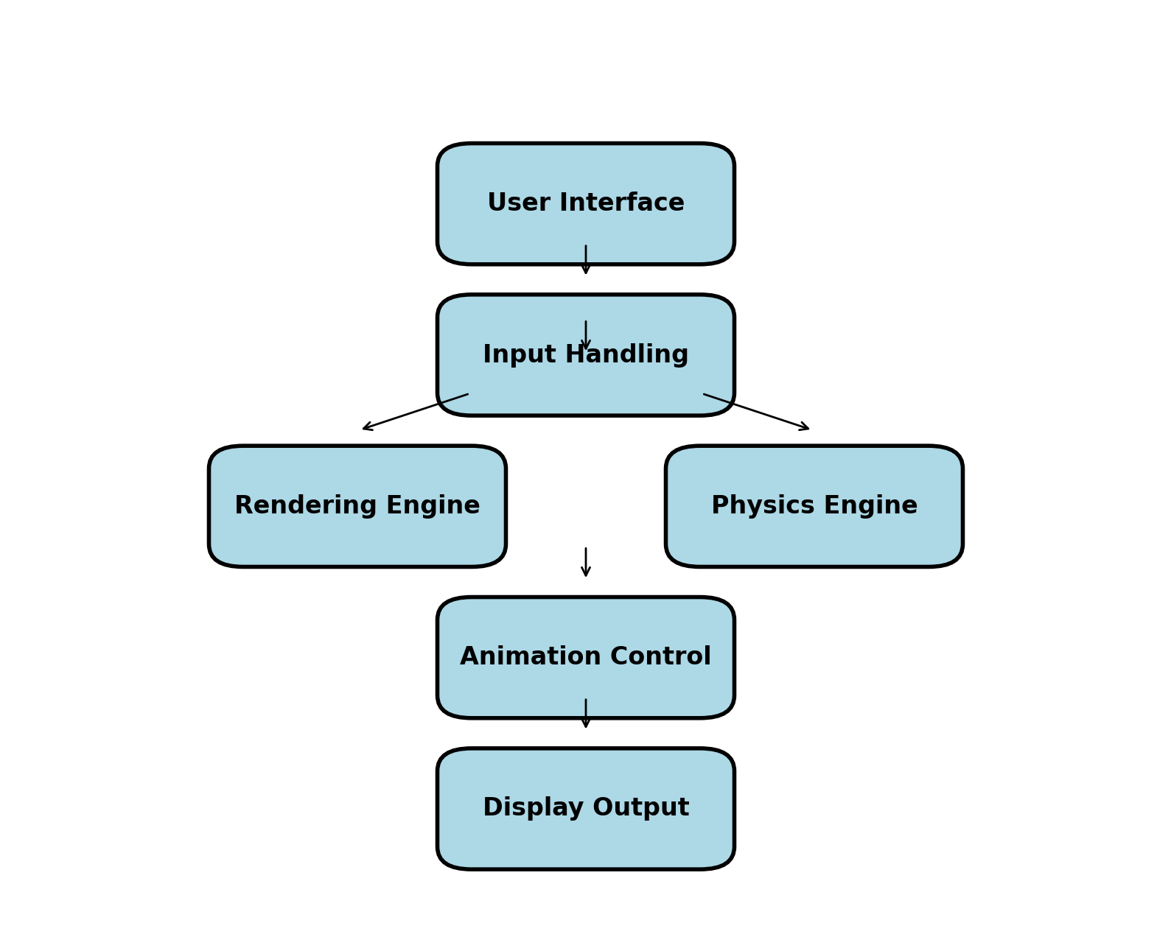

The block diagram design of the rocket launch simulation project serves as a high-level representation of the system's architecture and workflow. It delineates the main components and their interactions, providing a clear roadmap for implementation. The system can be divided into several key blocks: User Interface, Input Handling, Rendering Engine, Physics Engine, and Animation Control.

1. **User Interface**: This block is responsible for creating and managing the window where the simulation is displayed. It includes components for initializing the GLUT environment, setting up the display mode, and handling user interactions such as keyboard and mouse inputs.
2. **Input Handling**: This block processes the input received from the user interface. It interprets commands to start or stop the simulation, adjust the camera view, or manipulate other parameters of the simulation. Input handling ensures that the user's actions are translated into appropriate responses within the simulation.
3. **Rendering Engine**: At the core of the simulation, the rendering engine uses OpenGL to draw the various elements of the scene, including the rocket, satellite, and background stars. It handles tasks such as setting up the viewport, defining the perspective projection, and applying transformations and lighting effects to create a realistic visual output.
4. **Physics Engine**: This block simulates the physical behaviors of the rocket and satellite. It calculates the trajectories, rotations, and other dynamic properties based on principles of physics. The physics engine ensures that movements are realistic, accounting for factors like gravity, thrust, and collision detection.
5. **Animation Control**: This block manages the timing and sequencing of the simulation events. It controls the progression of the rocket launch, from liftoff to stage separation and satellite deployment. Animation control synchronizes the movements and transitions, ensuring a smooth and coherent animation flow.

These blocks interact to produce the final simulation, with data flowing between them to update the scene in response to user input and physical calculations.

### **CHAPTER 4: IMPLEMENTATION**

#### **5.1 Methodology**

The implementation of the rocket launch simulation follows an iterative and modular development approach. The project is divided into manageable modules, each focusing on a specific aspect of the simulation. This methodology ensures that each component can be developed, tested, and refined independently before integrating them into the final system. The key phases include:

1. **Requirement Analysis**: Defining the scope, objectives, and functional requirements of the simulation.
2. **System Design**: Creating the block diagram and detailed design specifications for each module.
3. **Module Development**: Implementing each module (User Interface, Input Handling, Rendering Engine, Physics Engine, Animation Control) independently.
4. **Integration**: Combining the modules and ensuring they work together seamlessly.
5. **Testing and Debugging**: Conducting extensive testing to identify and fix bugs, optimize performance, and ensure accuracy.

***Functions Used :***

glutInit() : interaction between the windowing system and OPENGL is

initiated

glutInitDisplayMode() : used when double buffering is required and depth

information is required

glutCreateWindow() : this opens the OPENGL window and displays the title

at top of the window

glutInitWindowSize() : specifies the size of the window

glutInitWindowPosition() : specifies the position of the window in screen

co-ordinates

glutKeyboardFunc() : handles normal ascii symbols

glutSpecialFunc() : handles special keyboard keys

glutReshapeFunc() : sets up the callback function for reshaping the window

glutIdleFunc() : this handles the processing of the background

glutDisplayFunc() : this handles redrawing of the window

glutMainLoop() : this starts the main loop, it never returns

glViewport() : used to set up the viewport

glVertex3fv() : used to set up the points or vertices in three dimensions

glColor3fv() : used to render color to faces

glFlush() : used to flush the pipeline

glutPostRedisplay() : used to trigger an automatic redrawal of the object

glMatrixMode() : used to set up the required mode of the matrix

glLoadIdentity() : used to load or initialize to the identity matrix

glTranslatef() : used to translate or move the rotation centre from one

point to another in three dimensions

glRotatef() : used to rotate an object through a specified rotation angle

#### **5.2 Description of Process**

The implementation process begins with setting up the development environment, including configuring OpenGL and GLUT libraries. The following steps outline the detailed process:

1. **Initialization**:

* Initialize GLUT and create the main window.
* Set up the display mode, including double buffering and RGB color mode.
* Define the viewport and perspective projection.

1. **Input Handling**:

* Register callback functions for keyboard and mouse events.
* Implement functions to handle user commands, such as launching the rocket or quitting the application.

**Rendering Engine**:

* Define functions to draw the rocket, satellite, and stars.
* Implement transformations for scaling, translation, and rotation of objects.
* Set up lighting and material properties to enhance realism.

**Physics Engine**:

* Implement functions to calculate the rocket's trajectory and rotation.
* Simulate the effects of gravity and thrust on the rocket's motion.
* Calculate the separation and deployment of the satellite.

**Animation Control**:

* Implement a timer function to control the simulation's frame rate.
* Define the sequence of events for the rocket launch, including liftoff, stage separation, and satellite deployment.
* Update the scene based on the current simulation time and state.

**Display Function**:

* Clear the screen and depth buffer.
* Reset the modelview matrix.
* Apply necessary transformations and draw the scene elements.
* Swap the buffers to display the updated frame.

#### **5.3 Pseudo-code**

The following pseudo-code provides a high-level overview of the main functions and their interactions:

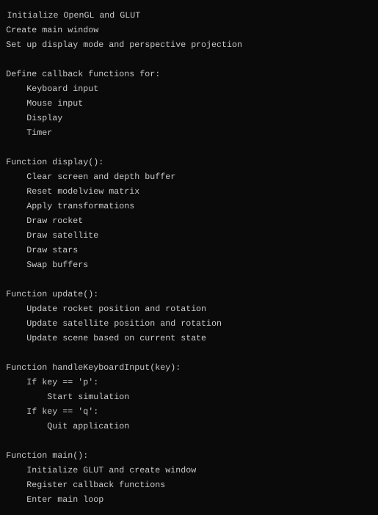

This pseudo-code outlines the basic structure and flow of the simulation, highlighting the key functions and their responsibilities. The actual implementation will involve detailed coding for each function, handling edge cases, and ensuring smooth interactions between the modules.

**CHAPTER 5: RESULTS**

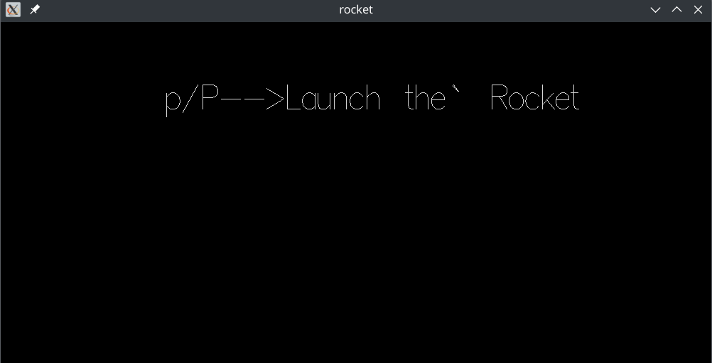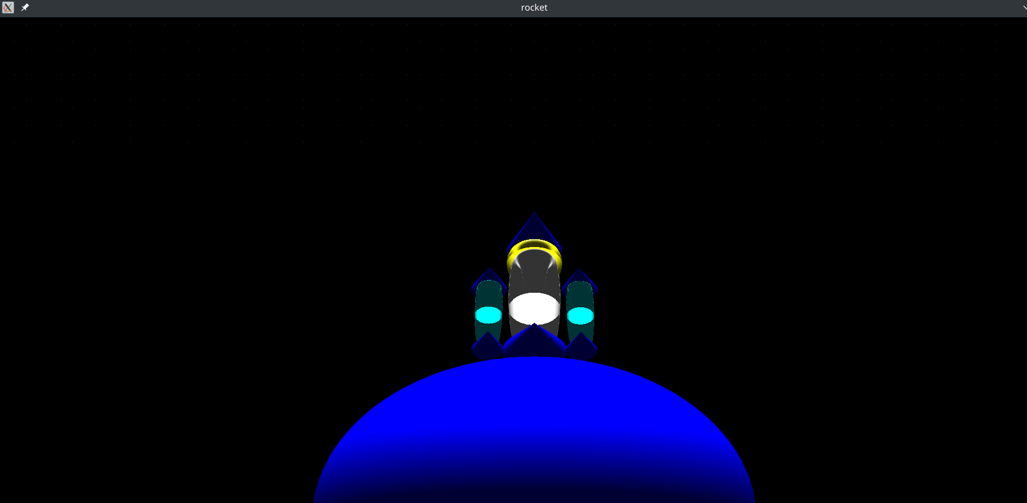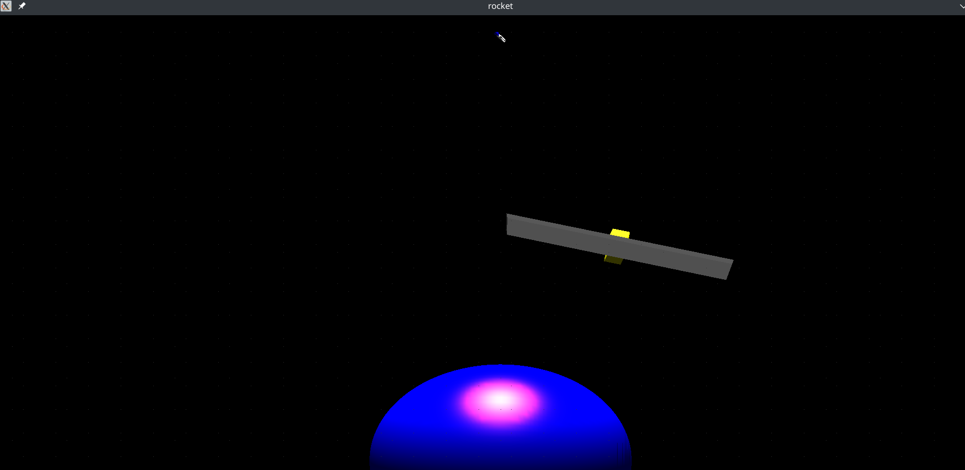

### **CHAPTER 6: CONCLUSIONS**

The rocket launch simulation project, developed using OpenGL and GLUT, demonstrates the power and flexibility of these tools in creating realistic and educational graphical applications. Through this project, we successfully modeled and animated a rocket launch sequence, including liftoff, stage separation, and satellite deployment, while incorporating realistic physics and dynamic visual effects.

The project began with a thorough literature review, establishing the context and relevance of rocket launch simulations in both educational and professional settings. We then delved into the design phase, creating a detailed block diagram to outline the system's architecture and workflow. This modular approach facilitated a clear and systematic development process.

The implementation phase was carried out methodically, starting with the setup of the OpenGL and GLUT environments, followed by the development of key modules: User Interface, Input Handling, Rendering Engine, Physics Engine, and Animation Control. Each module was tested and refined independently before integration, ensuring robustness and functionality.

One of the major achievements of this project was the realistic simulation of rocket physics, including trajectory calculations and dynamic animations. The use of OpenGL's rendering capabilities allowed for detailed and visually appealing representations of the rocket, satellite, and surrounding space environment. Additionally, the incorporation of user input handling provided an interactive experience, enhancing the educational value of the simulation.

Overall, the project has met its objectives, providing a comprehensive and engaging simulation of a rocket launch. This work can serve as a foundation for further enhancements, such as more detailed physics modeling, enhanced graphics, and additional interactive features. It also highlights the potential of using computer graphics and simulation as powerful tools for education and demonstration in aerospace engineering and related fields.

### **CHAPTER 7: REFERENCES**

1. Angel, E., & Shreiner, D. (2012). *Interactive Computer Graphics: A Top-Down Approach with WebGL*. Addison-Wesley.
2. Hearn, D., & Baker, M. P. (2010). *Computer Graphics with OpenGL*. Pearson.
3. Woo, M., Neider, J., Davis, T., & Shreiner, D. (1999). *OpenGL Programming Guide: The Official Guide to Learning OpenGL, Version 1.2*. Addison-Wesley.
4. Shreiner, D., Sellers, G., Kessenich, J., & Licea-Kane, B. (2013). *OpenGL Programming Guide: The Official Guide to Learning OpenGL, Version 4.3*. Addison-Wesley.
5. Wright, R. S., Haemel, N., Sellers, G., & Lipchak, B. (2010). *OpenGL Superbible: Comprehensive Tutorial and Reference*. Addison-Wesley.
6. Kilgard, M. (1996). *The OpenGL Utility Toolkit (GLUT) Programming Interface: API Version 3*. Silicon Graphics, Inc.
7. Brown, F. T. (2002). *Engineering System Dynamics: A Unified Graph-Centered Approach*. CRC Press.
8. Kerbal Space Program. (n.d.). Retrieved from <https://www.kerbalspaceprogram.com/>
9. NASA. (n.d.). *Rocket Launch Simulation*. Retrieved from <https://www.nasa.gov/>
10. SpaceX. (n.d.). *Mission Simulations*. Retrieved from <https://www.spacex.com/>

These references provide a comprehensive foundation for understanding the principles of computer graphics, OpenGL, and GLUT, as well as the context of rocket launch simulations. They offer valuable insights and technical guidance that have informed the development and execution of this project.