**Individual Tech Project - Create Dynamic Notifications System**

**About the project:**

This system is used to create notification templates and use them to send personalized notifications to a group of users. Details abouts the users like username, firstname, lastname, email etc. can be used in the notification content for personalization. SUPERADMIN, ADMIN and USER are the roles available. Users can only access their notifications. Authentication and authorization are done using jwt tokens.

**Details about the microservices:**

* gateway - Microservice that acts as an API gateway and routes requests to other microservices using their names
* service-discovery - Eureka server to discover and monitor other microservices
* auth-service - Authenticates users and issues jwt tokens
* admin-service - Microservice that provides APIs for admins to send notifications to users
* user-service - Microservice that provides APIs for users to view and manage their notifications

**Demo:**

1. Log in with admin credentials.

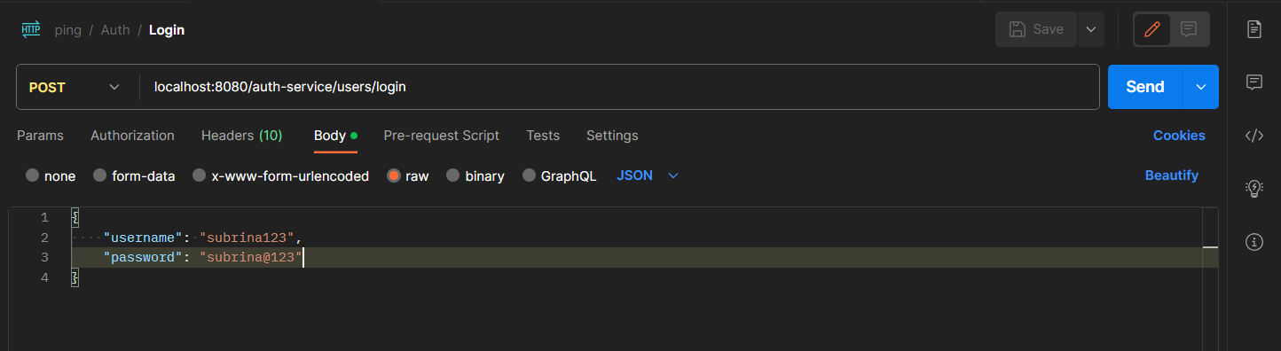

1. We get the admin details as the response. Copy the access token.

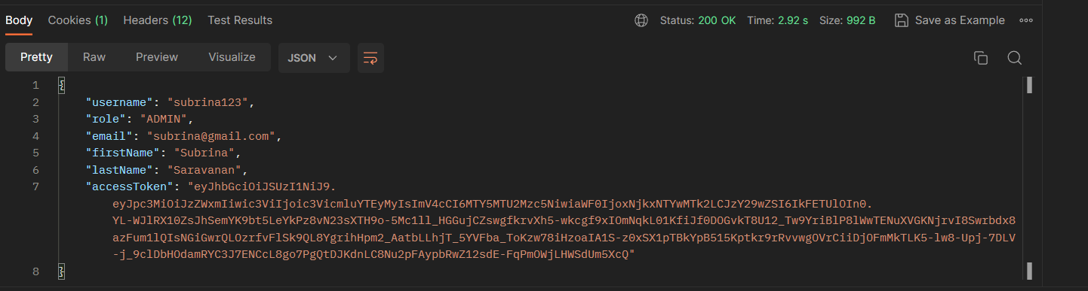

1. Paste the token in any API that can only be accessed by an admin. We are going to get all the notification templates available.

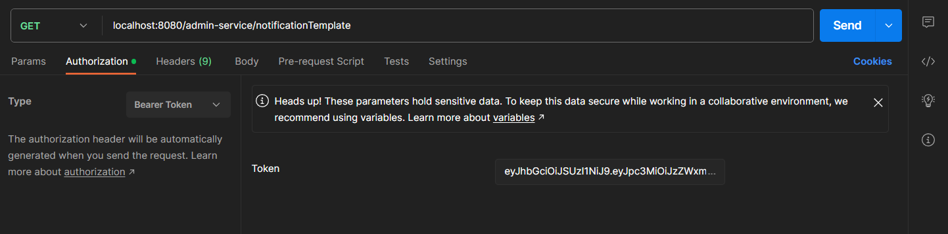

1. We can see a template here with id 1.

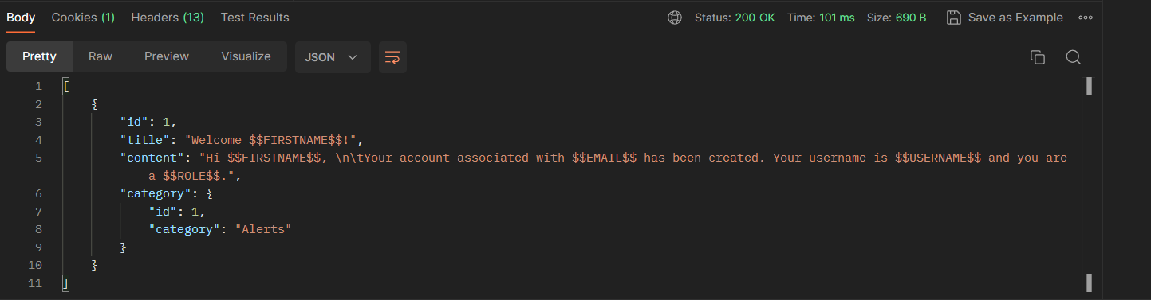

1. Now, let us post notifications to multiple users with the given template.

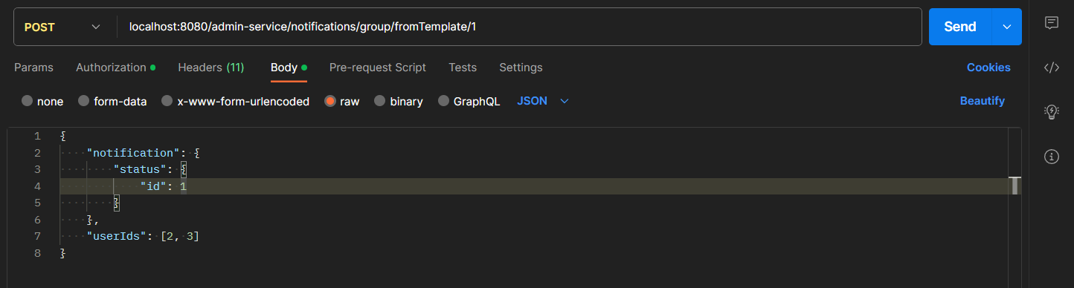

1. We can see that the template is personalized for the user and posted to them.

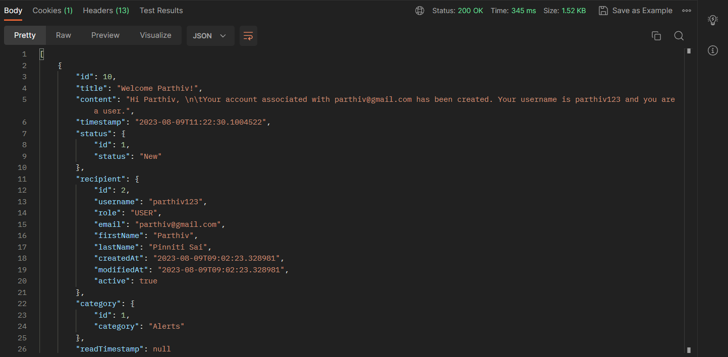

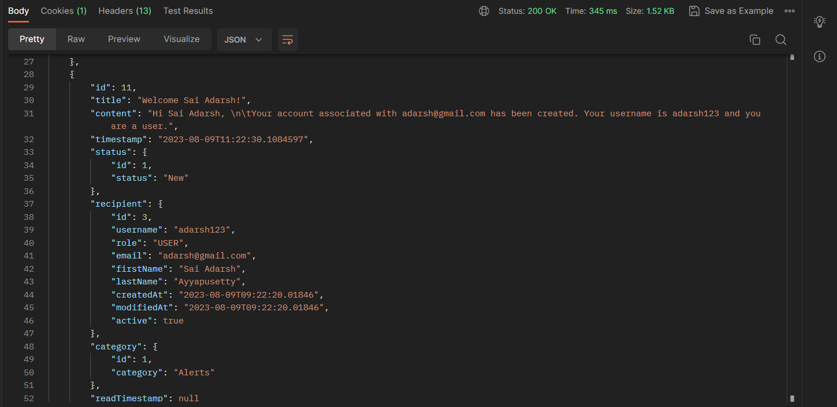

1. Let us log in as Parthiv now.

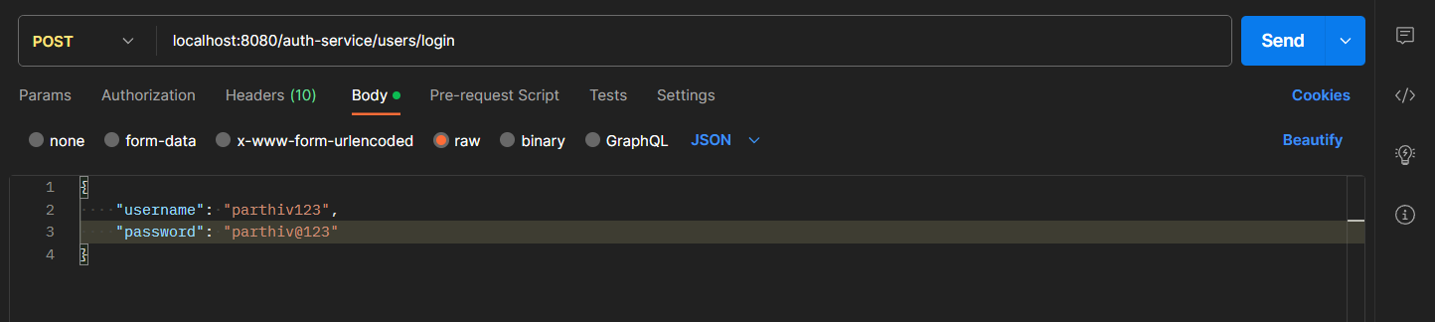

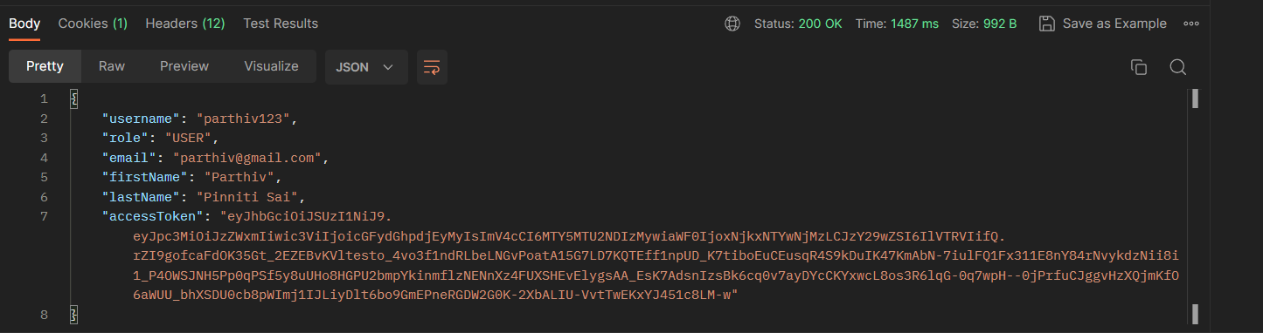

1. The notification we created just now using the admin account can be seen here.

