**A Report On**

**Hedging a Portfolio of Stocks – Comparing Stock and Index Futures**

On

CGPOWER, ZOMATO, ADANIPOWER, VARROC

For the Course **ECON F354 : Derivatives & Risk Management**

**Time of Submission : 15th November 2024 @ 11:30 am**  BY GROUP - 18

|  |  |  |
| --- | --- | --- |
| **ID** | **NAME** | **Contributed (Yes/ No)** |
| 2021A7PS2807H | ACHYUT HARESHKUMAR DEDANIA | Yes |



**BIRLA INSTITUTE OF TECHNOLOGY & SCIENCE, PILANI**

**Semester - 1 | 2024-2025**

# Portfolio construction, descriptive statistics, returns

|  |  |  |  |  |  |
| --- | --- | --- | --- | --- | --- |
| **Company** | **Sector** | **Market Cap. (₹ Cr.)** | **Quantity** | **Portfolio Value (₹)** | **Weight (%)** |
| CGPOWER | Capital Goods | 1,07,386.56 | 30,000 | 2,12,40,000.00 | 24.58 |
| ZOMATO | Consumer services | 1,76,492.80 | 1,20,000 | 2,39,65,200.00 | 27.74 |
| ADANIPOWER | Power | 2,91,623.81 | 30,000 | 2,15,10,000.00 | 24.90 |
| VARROC | Automobile and  Auto Components | 9,945.63 | 30,000 | 1,96,80,000.00 | 22.78 |
| **Total** |  |  |  | ₹8,63,95,200.00 | 100 |

Table 1: Defining Portfolio Snapshot as on 1st July 2024.

This portfolio comprises four stocks from diverse sectors, providing exposure to capital goods, consumer services, power, and the automobile and auto components industries. CGPOWER, a leader in capital goods, represents 24.58% of the portfolio, with an investment of ₹2.12 crore. ZOMATO, a prominent player in consumer services, holds the largest share at 27.74%, with a value of ₹2.39 crore, offering potential growth in India’s food delivery sector. ADANIPOWER, accounting for 24.9% of the portfolio, strengthens exposure to the power sector, aligning with India’s expanding energy infrastructure. VARROC, an automotive component manufacturer, constitutes 22.78% of the portfolio with ₹1.96 crore invested, providing potential in the growing automobile sector. With a total portfolio value of ₹8.63 crore, this balanced allocation across high-growth and essential industries seeks stability and potential growth, mitigating risks through diversification while aiming for long-term returns.

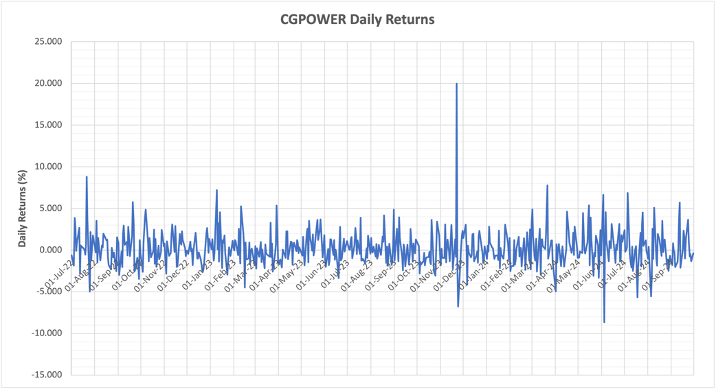 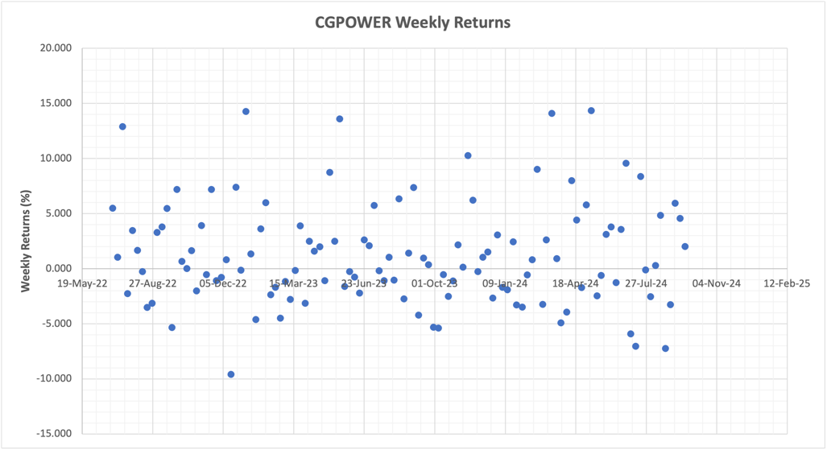

Graph 1: CGPOWER Daily Returns Graph 2: CGPOWER Weekly Returns

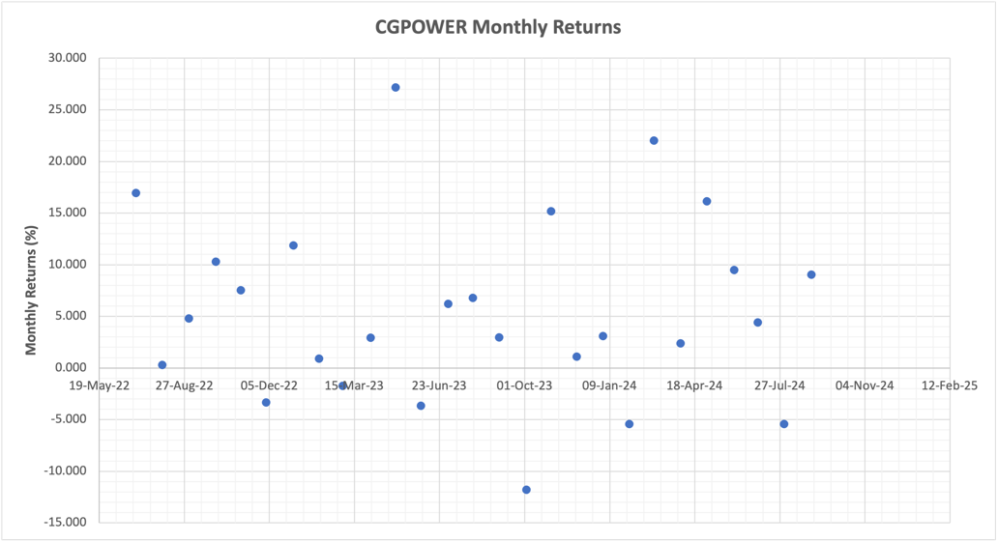 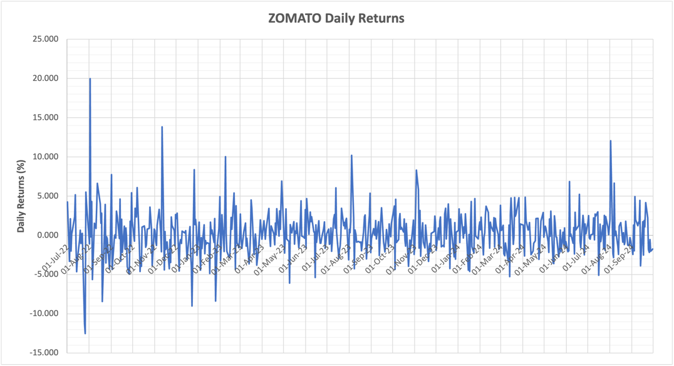

Graph 3: CGPOWER Monthly Returns Graph 4: ZOMATO Daily Returns

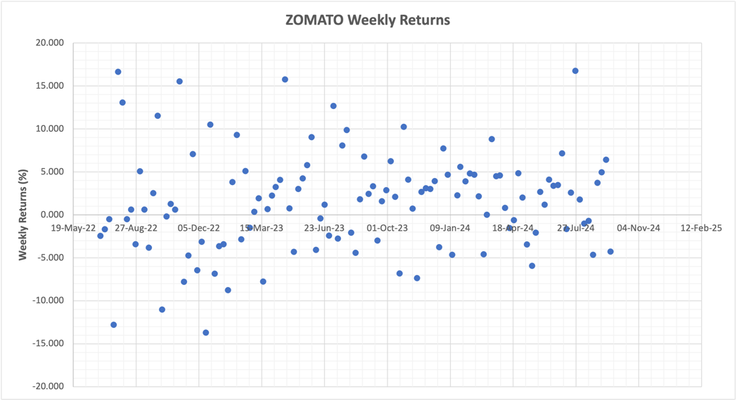 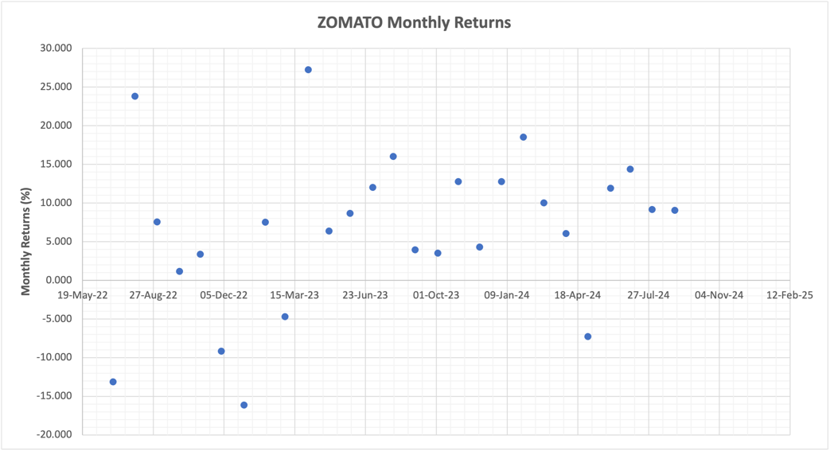

Graph 5: ZOMATO Weekly Returns Graph 6: ZOMATO Monthly Returns

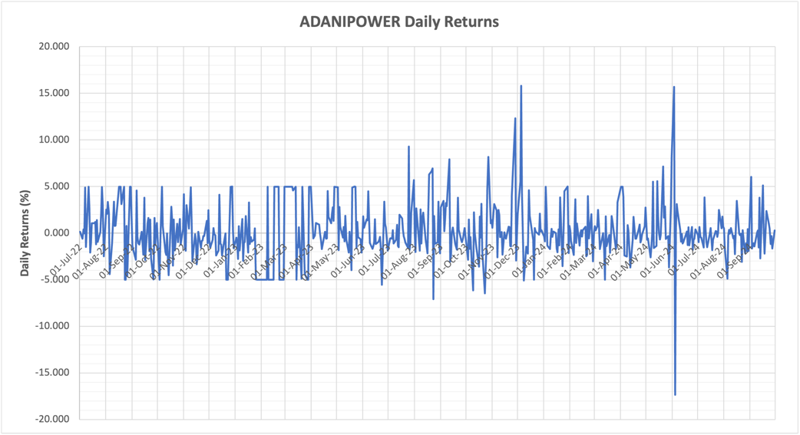 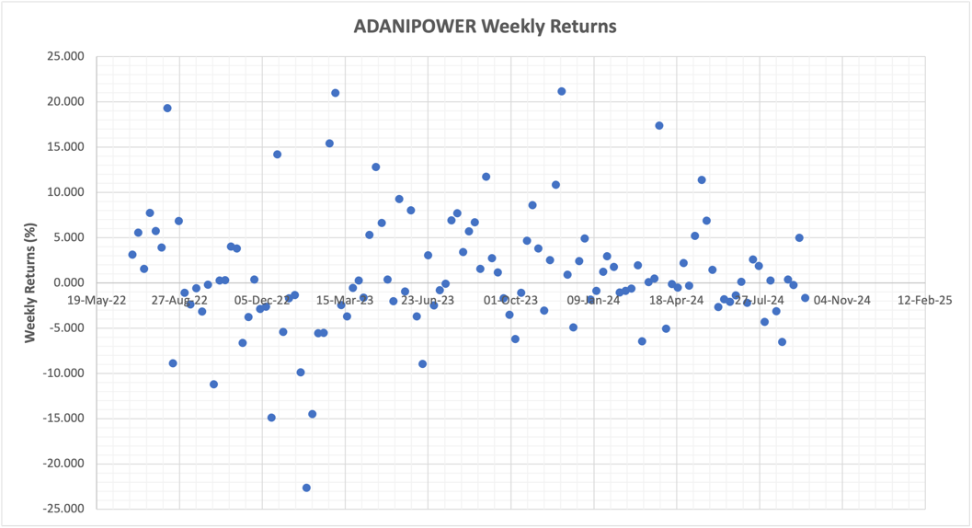

Graph 7: ADANIPOER Daily Returns Graph 8: ADANIPOWER Weekly Returns

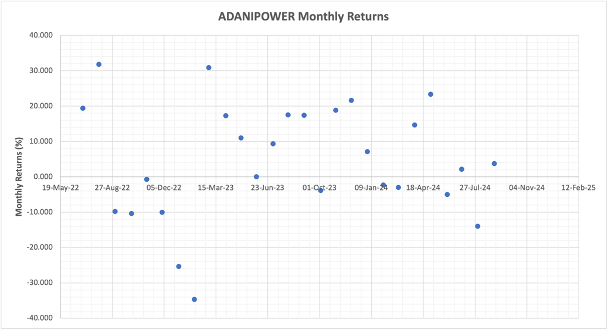 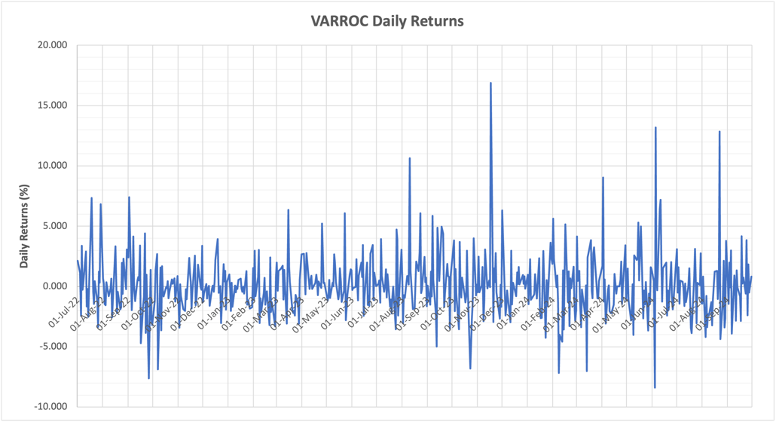

Graph 9: ADANIPOWER Monthly Returns Graph 10: VARROC Daily Returns

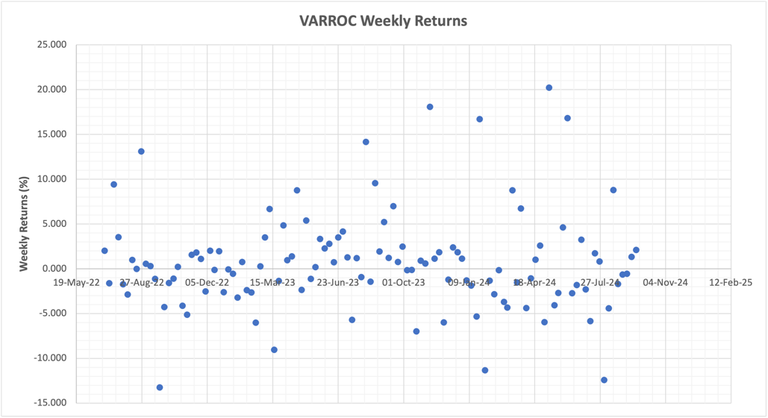 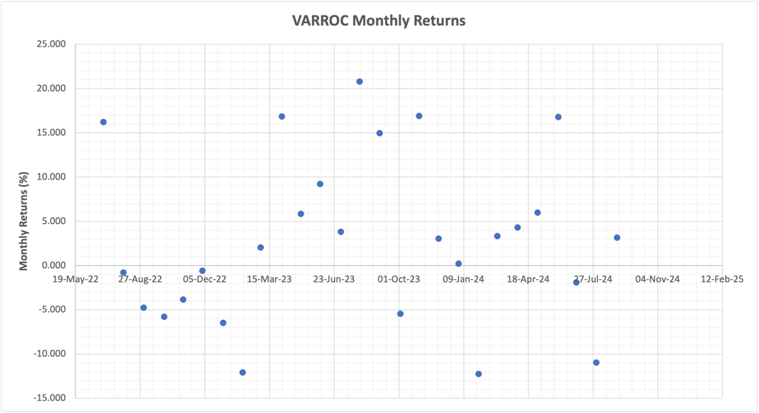

Graph 11: VARROC Weekly Returns Graph 12: VARROC Monthly Returns

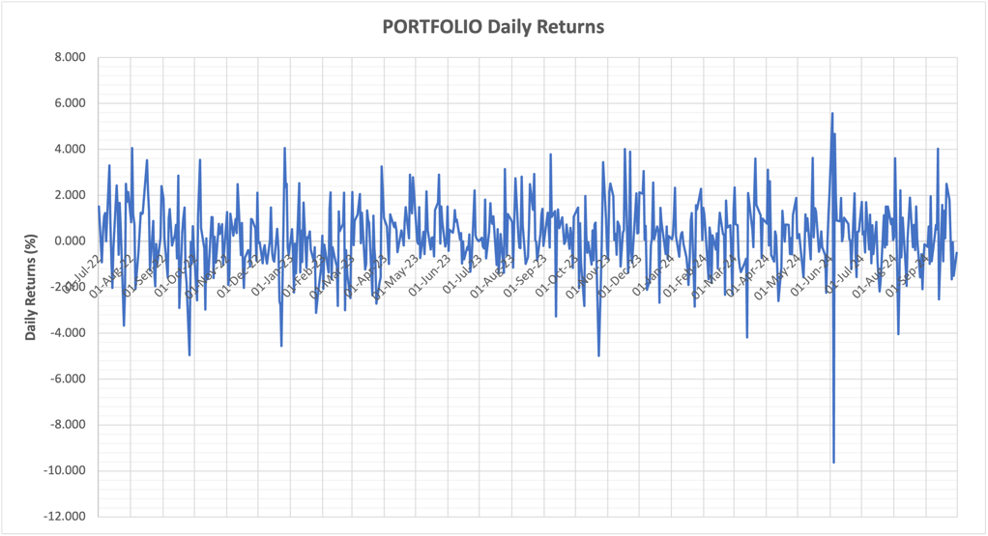 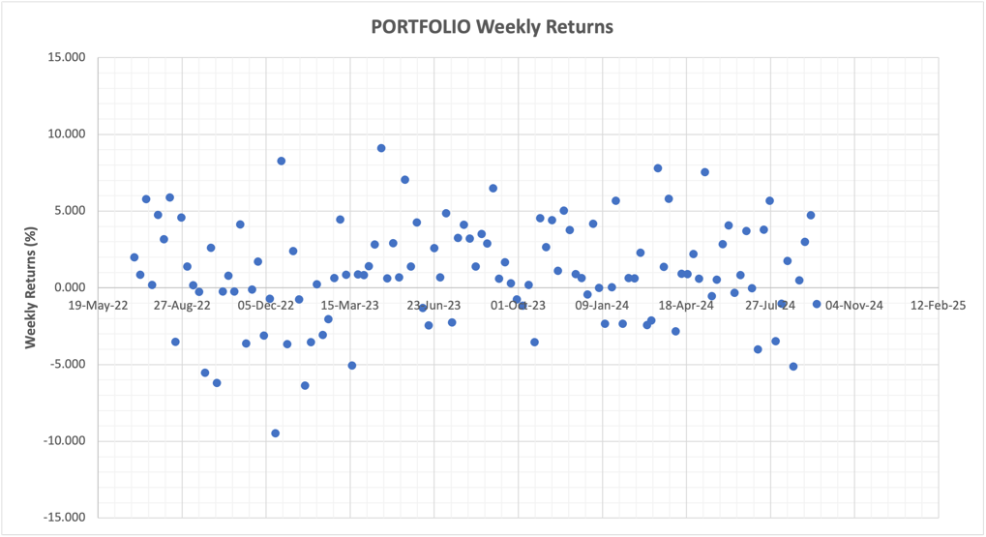

Graph 13: PORTFOLIO Daily Returns Graph 14: PORTFOLIO Weekly Returns

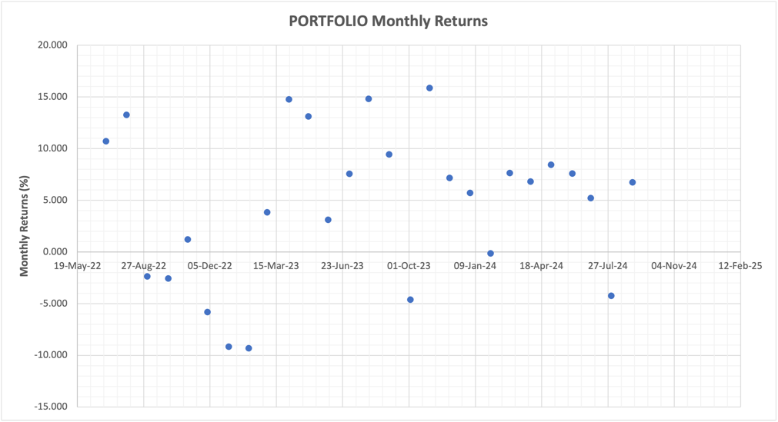 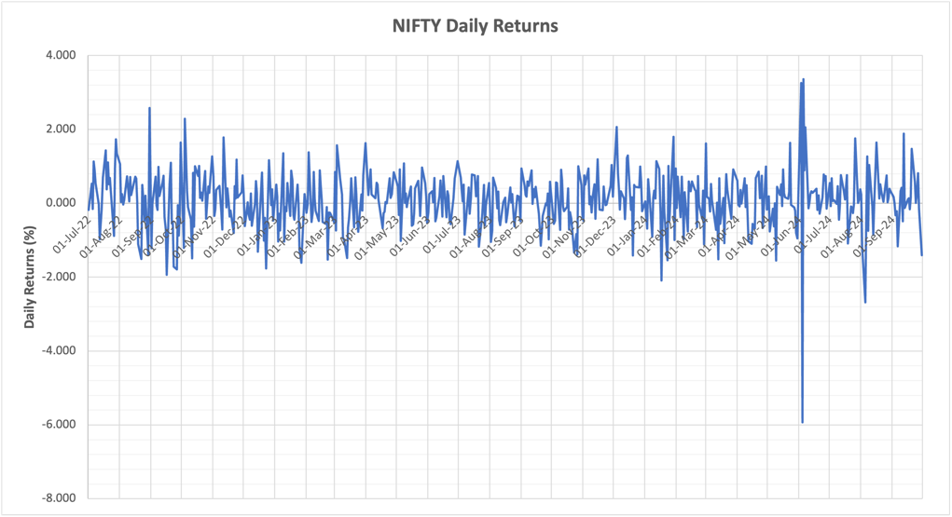

Graph 15: PORTFOLIO Monthly Returns Graph 16: NIFTY Daily Returns

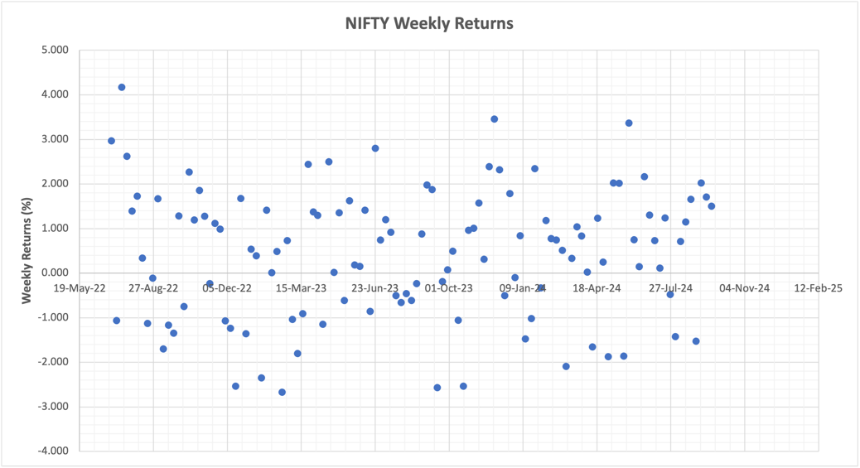 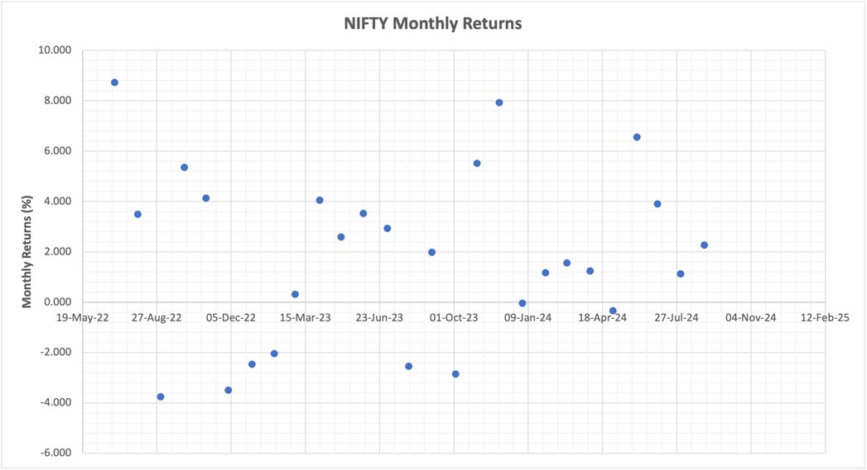

Graph 17: NIFTY Weekly Returns Graph 18: NIFTY Monthly Returns

|  |  |  |  |  |  |
| --- | --- | --- | --- | --- | --- |
|  | **CGPOWER** | **ZOMATO** | **ADANIPOWER** | **VARROC** | **PORTFOLIO** |
| Daily Returns Correlation | 0.27919563 | 0.29918068 | 0.373443142 | 0.29970306 | 0.54514122 |
| Weekly Returns Correlation | 0.30159456 | 0.23150915 | 0.285238852 | 0.2937291 | 0.46510711 |
| Monthly Returns Correlation | 0.30150193 | 0.15827007 | 0.395409366 | 0.39814551 | 0.51078846 |

Table 2: Correlation Coefficient of Portfolio Stocks with NIFTY for different duration. Refer Graphs 19 to for Visual Representation

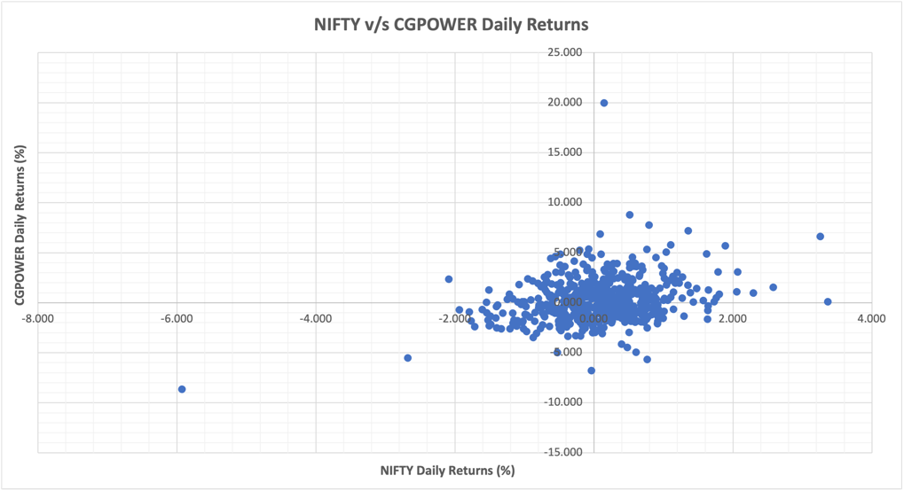 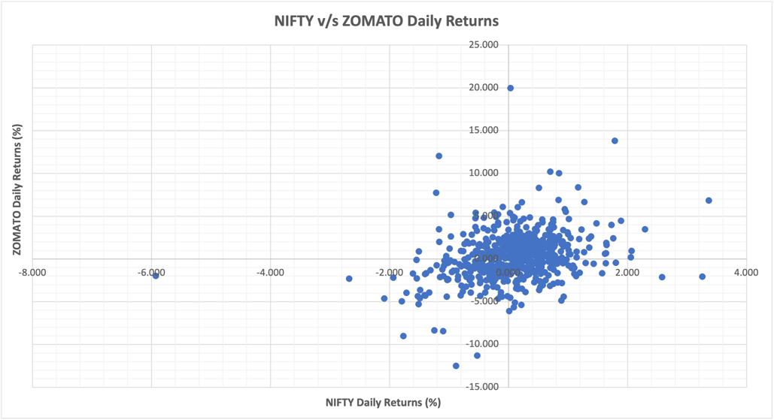

Graph 19: Correlation of NIFTY & CGPOWER Daily Returns Graph 20: Correlation of NIFTY & ZOMATO Daily Returns

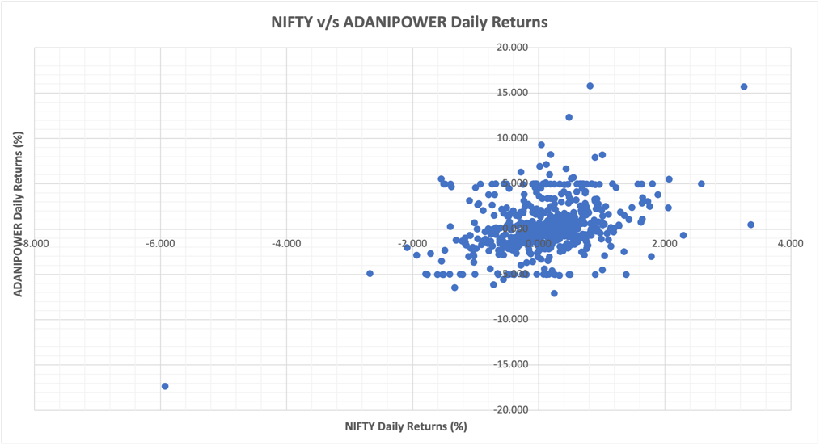 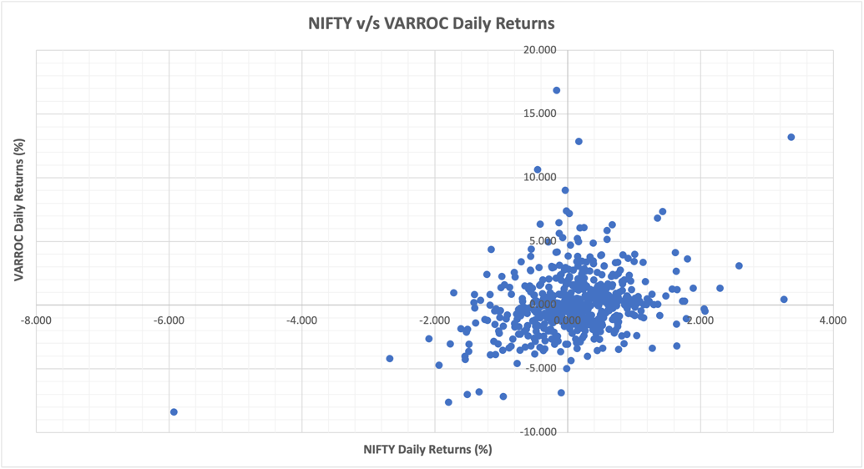

Graph 21: Correlation of NIFTY & ADANIPOWER Daily Returns Graph 22: Correlation of NIFTY & VARROC Daily Returns

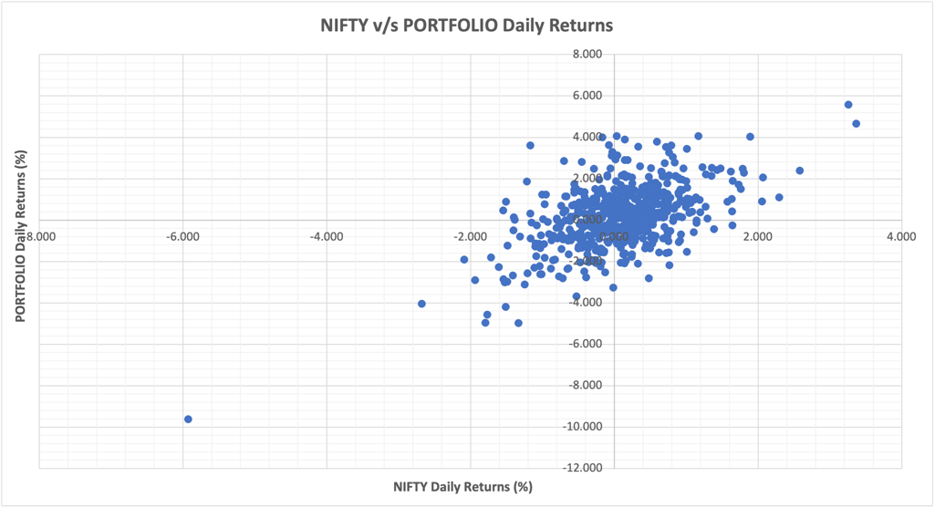 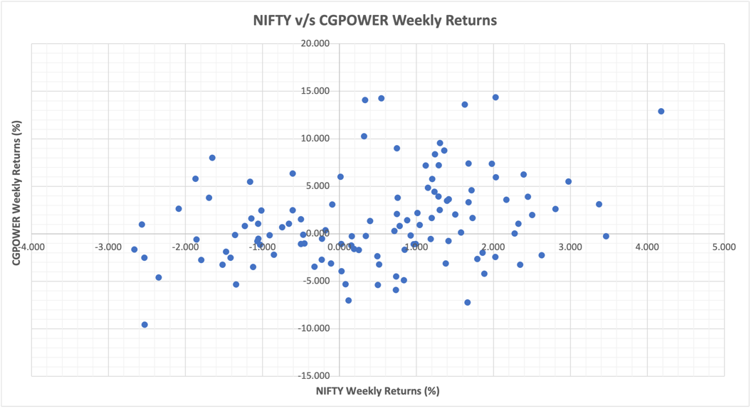

Graph 23: Correlation of NIFTY & PORTFOLIO Daily Returns Graph 24: Correlation of NIFTY & CGPOWER Weekly Returns

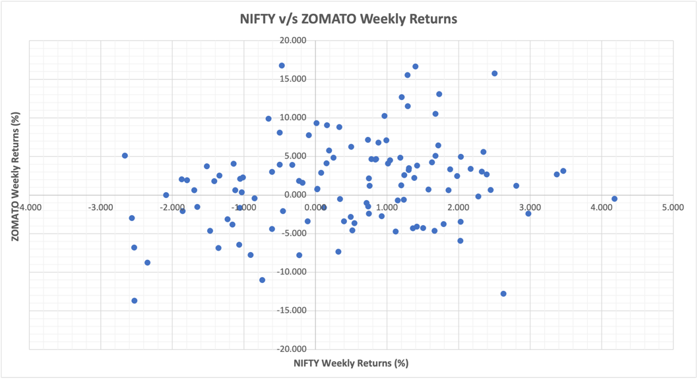 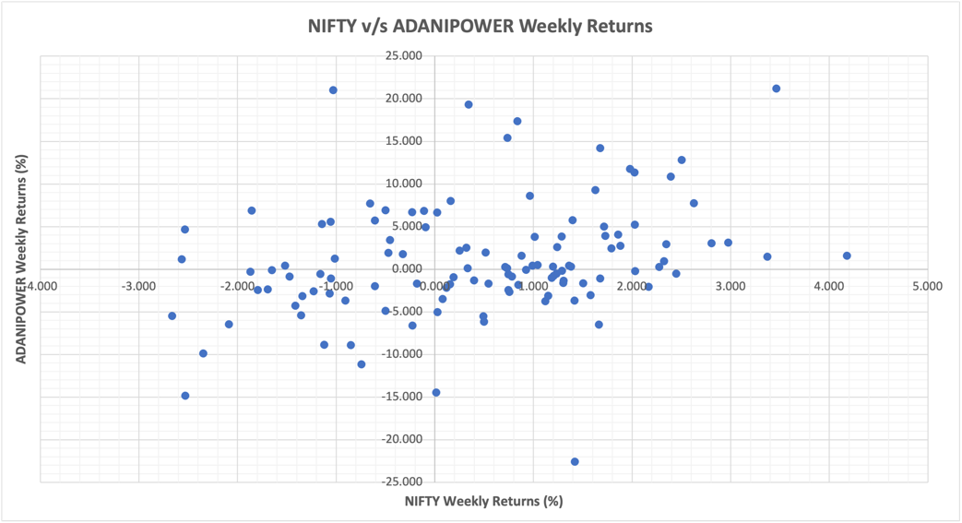

Graph 25: Correlation of NIFTY & ZOMATO Weekly Returns Graph 26: Correlation of NIFTY & ADANIPOWER Weekly Returns

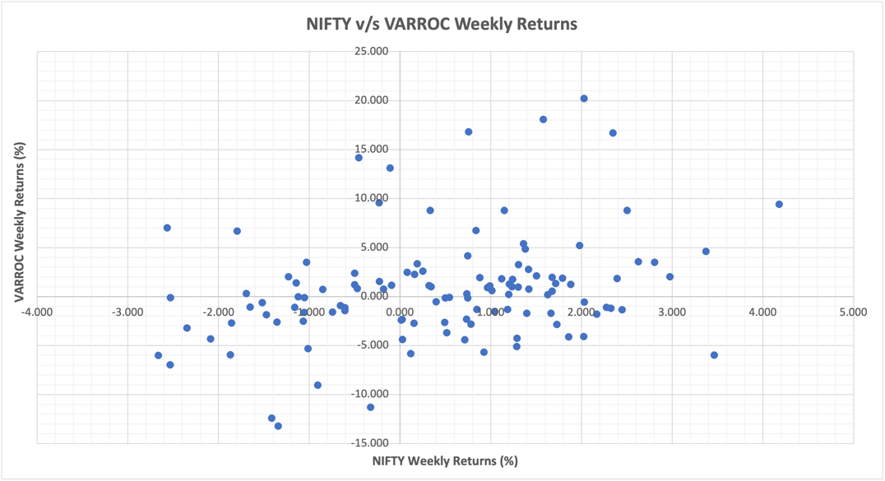 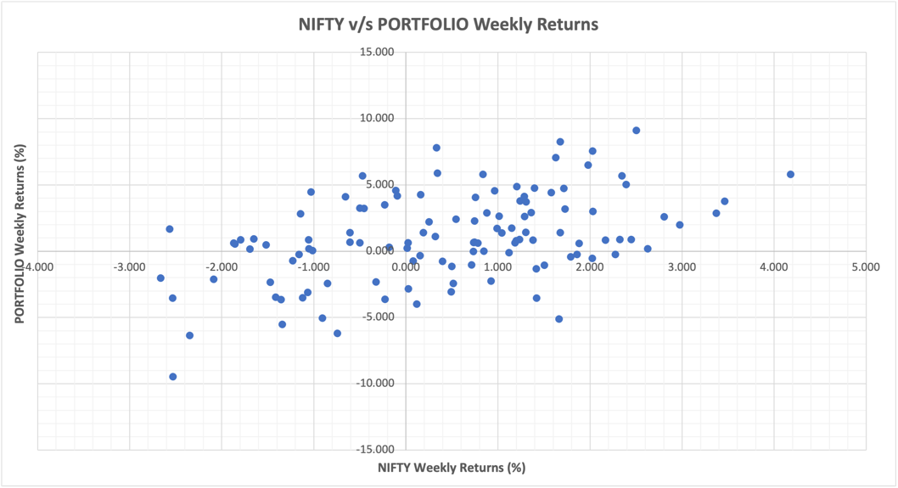

Graph 27: Correlation of NIFTY & VARROC Weekly Returns Graph 28: Correlation of NIFTY & PORTFOLIO Weekly Returns

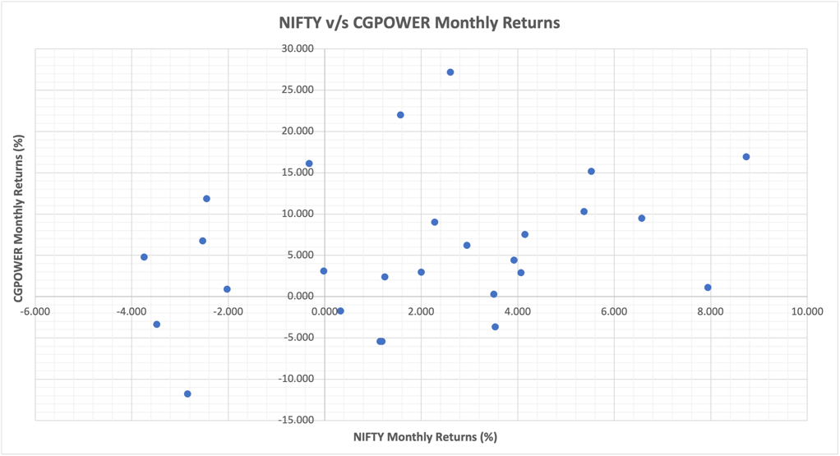 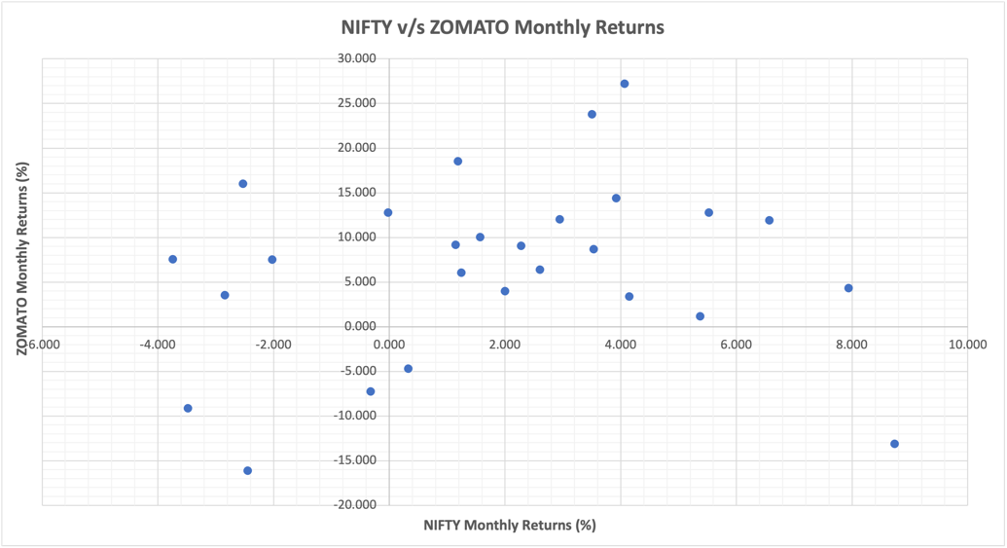

Graph 29: Correlation of NIFTY & CGPOWER Monthly Returns Graph 30: Correlation of NIFTY & ZOMATO Monthly Returns

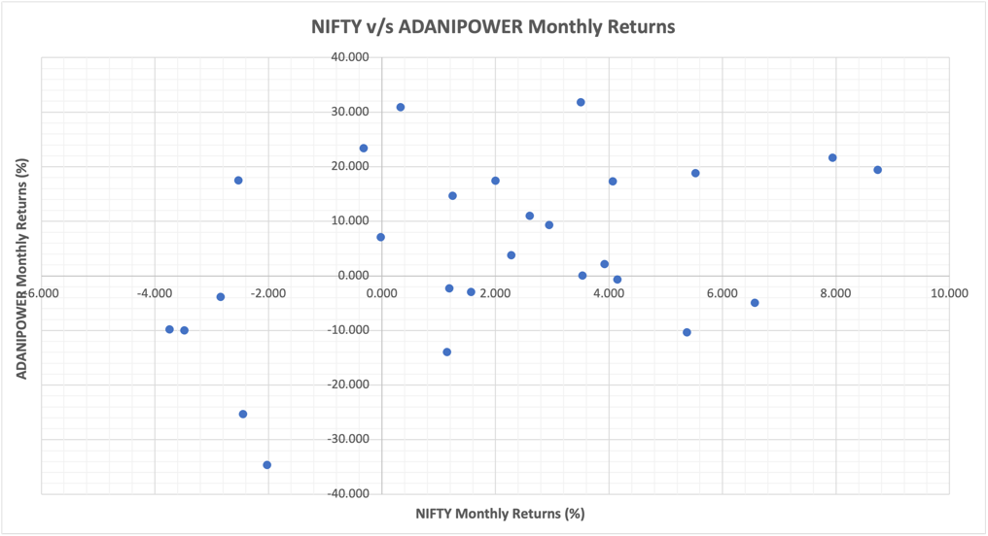 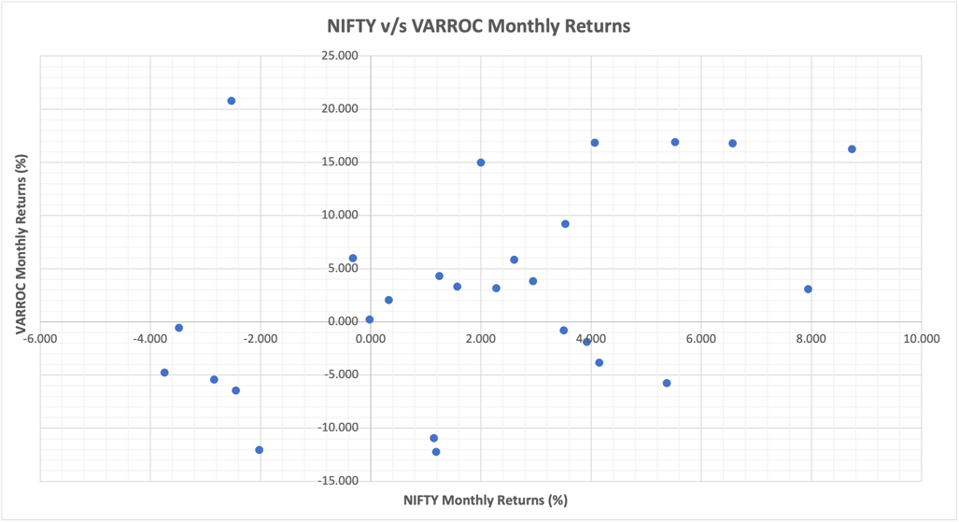

Graph 31: Correlation of NIFTY & ADANIPOWER Monthly Returns Graph 32: Correlation of NIFTY & VARROC Monthly Returns

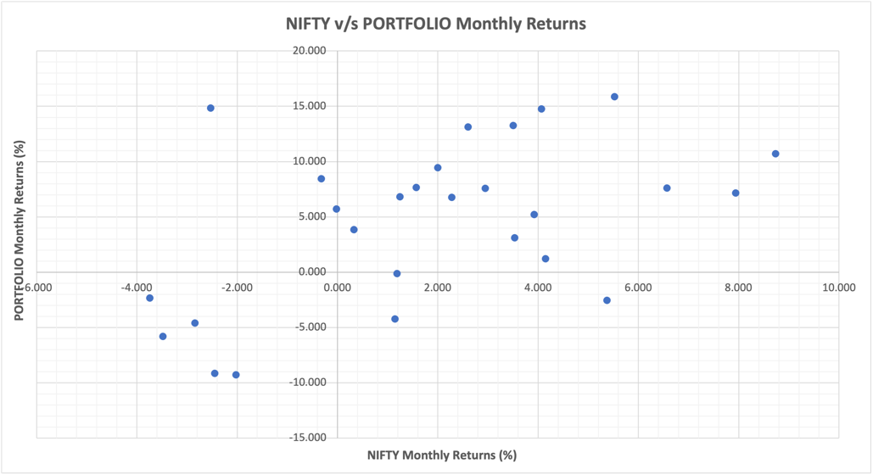

Graph 33: Correlation of NIFTY & PORTFOLIO Monthly Returns

Here is an analysis of the correlation patterns between each stock, the portfolio, and the NIFTY 50 index across daily, weekly, and monthly returns:

* **Daily Returns**
  1. **CGPOWER:** Mild Positive correlation (0.279), indicating a tendency to move with the NIFTY 50 on a daily basis, though not strongly.
  2. **ZOMATO:** Mild Positive correlation (0.299), showing slight alignment with NIFTY 50 trends on a daily basis.
  3. **ADANIPOWER:** Positive correlation (0.373), moderately aligning with the NIFTY 50’s daily movements.
  4. **VARROC:** Mild Positive correlation (0.299), suggesting a weak positive relationship with daily NIFTY 50 trends.
  5. **PORTFOLIO:** Positive correlation (0.545), moderately tracking the NIFTY 50 index on a daily basis.
* **Weekly Returns**
  1. **CGPOWER:** Positive correlation (0.302), indicating continued but slightly weaker weekly alignment with NIFTY 50.
  2. **ZOMATO:** Mild Positive correlation (0.232), showing a lower weekly correlation with the NIFTY 50 than on a daily basis.
  3. **ADANIPOWER:** Mild Positive correlation (0.285), maintaining a similar moderate alignment to weekly NIFTY 50 trends.
  4. **VARROC:** Mild Positive correlation (0.294), similar to daily trends, with a positive but weak weekly relationship.
  5. **PORTFOLIO:** Positive correlation (0.465), showing a moderate positive weekly alignment with NIFTY 50, slightly less than daily.
* **Monthly Returns**
  1. **CGPOWER:** Positive correlation (0.302), maintaining stability in correlation over the monthly horizon.
  2. **ZOMATO:** Mild Positive correlation (0.158), indicating a weaker monthly alignment with NIFTY 50.
  3. **ADANIPOWER:** Positive correlation (0.395), with an increase in monthly alignment to NIFTY 50 trends.
  4. **VARROC:** Positive correlation (0.398), showing stronger monthly alignment with NIFTY 50 compared to daily and weekly.
  5. **PORTFOLIO:** Positive correlation (0.511), indicating a stable and moderately strong positive relationship over the monthly horizon.

Across daily, weekly, and monthly returns, all stocks and the portfolio maintain a **positive correlation** with the NIFTY 50 index, indicating they tend to move in the same direction as the broader market. While some fluctuations occur, particularly with ZOMATO and ADANIPOWER as the time horizon extends, the general pattern remains positive across all durations. This consistent alignment suggests that the portfolio and its constituent stocks are broadly influenced by market trends, with a more stable correlation as the time horizon lengthens from daily to monthly.

# Hedging using Stock Futures.

In this portfolio, cross-hedging was necessary as none of the allocated stocks—CGPOWER, ZOMATO, ADANIPOWER, and VARROC—had direct futures available. Therefore, appropriate proxy stocks with similar sector exposure and market behaviour were selected for futures hedging.

* **BHEL futures for CGPOWER:** BHEL and CGPOWER both operate in the capital goods sector, focusing on engineering and infrastructure, with substantial exposure to industrial projects. BHEL futures provide a reasonable cross-hedge due to their similar market responses to changes in infrastructure investment and capital goods demand, which impact both companies’ financial performance.
* **NAUKRI futures for ZOMATO:** While ZOMATO operates in consumer services (food delivery), it shares high-growth digital market dynamics with NAUKRI (Info Edge). Both companies are influenced by digital adoption trends, consumer tech shifts, and online service demand, making NAUKRI futures a suitable hedge, particularly given both stocks’ volatility and growth potential in India’s digital economy.
* **NTPC futures for ADANIPOWER:** NTPC and ADANIPOWER are both key players in India’s power sector. NTPC’s market behaviour as a large power generation entity reflects broader industry trends, such as changes in energy prices and government energy policies, making NTPC futures a fitting hedge for ADANIPOWER.
* **BOSCHLTD futures for VARROC:** VARROC and BOSCHLTD both operate within the automobile components industry, impacted by similar trends in automotive demand and production cycles. BOSCHLTD futures thus offer an effective hedge due to the companies’ shared exposure to auto sector fluctuations.

These choices ensure that hedging aligns with sector-specific factors and market trends, achieving better risk mitigation in the absence of direct futures.

|  |  |  |  |
| --- | --- | --- | --- |
| Using 1 year data | | | |
| **OHR** | **Daily Returns** | **Weekly Returns** | **Monthly Returns** |
| CGPOWER | 0.101725602 | 0.158519023 | 0.325771251 |
| ZOMATO | 0.473712631 | 0.551875972 | -0.220037311 |
| ADANIPOWER | 0.532786784 | 1.033547798 | 1.499108146 |
| VARROC | 0.415613334 | 0.312983518 | 0.457786489 |
| Using 2 years data | | | |
| **OHR** | **Daily Returns** | **Weekly Returns** | **Monthly Returns** |
| CGPOWER | 0.135434128 | 0.113790956 | 0.319943581 |
| ZOMATO | 0.471515845 | 0.524137513 | 0.061725018 |
| ADANIPOWER | 0.726009823 | 0.789617696 | 1.021077314 |
| VARROC | 0.507064537 | 0.482000147 | -0.016864502 |

Table 3: Optimal Hedging Ratios (OHR) using daily, weekly, monthly returns of underlying stocks and futures for 1 year’s data and 2 year’s data.

The Optimal Hedge Ratio (OHR) exhibits sensitivity to the time frame of analysis, indicating that hedging effectiveness varies based on the duration used for returns calculations. Over a **one-year period**, the OHR generally shows smaller values for daily and weekly returns compared to monthly returns, suggesting that hedging effectiveness strengthens over longer time intervals. For example, CGPOWER’s OHR increases from 0.1017 (daily) to 0.3258 (monthly), while ADANIPOWER’s rises from 0.5328 (daily) to 1.4991 (monthly). This pattern reflects that longer return intervals capture broader market trends, providing a more stable basis for hedging.

In contrast, using **two-year data**, the OHR values tend to stabilize, showing that prolonged analysis introduces consistency in OHR across daily, weekly, and monthly returns. For instance, ADANIPOWER’s OHR rises more gradually, from 0.726 (daily) to 1.021 (monthly), compared to the one-year data. This suggests that as the time frame extends, hedging strategies become less sensitive to short-term fluctuations and more reflective of systemic trends, thereby improving long-term risk management.

|  |  |  |  |
| --- | --- | --- | --- |
| Using 1 year data | | | |
| **Optimal Contracts** | **Daily Returns** | **Weekly Returns** | **Monthly Returns** |
| CGPOWER | 2.692086485 | 4.195078828 | 8.621274934 |
| ZOMATO | 21.78759676 | 25.38258507 | -10.12023723 |
| ADANIPOWER | 20.21207004 | 39.20919425 | 56.87092809 |
| VARROC | 9.753540635 | 7.345042176 | 10.74325284 |
| Using 2 years data | | | |
| **Optimal Contracts** | **Daily Returns** | **Weekly Returns** | **Monthly Returns** |
| CGPOWER | 3.58415559 | 3.011386406 | 8.467050312 |
| ZOMATO | 21.68655941 | 24.10680242 | 2.838935924 |
| ADANIPOWER | 27.54227743 | 29.95533799 | 38.73610762 |
| VARROC | 11.89970139 | 11.31149469 | -0.395773175 |

Table 4: Optimal Contracts using daily, weekly, monthly returns of underlying stocks and futures. Using 1 year’s data and 2 year’s data.

|  |  |  |  |  |  |
| --- | --- | --- | --- | --- | --- |
| **Futures** | **Quantity** | **Price on 1st July 2024** | **Contract Multiplier** | **Value on 1st July 2024** | **Position** |
| BHEL SEPT FUT | 3 | ₹305.75 | 2625 | ₹24,07,781.25 | Short |
| NAUKRI SEPT FUT | 21 | ₹6,947.45 | 75 | ₹1,09,42,233.75 | Short |
| NTPC SEPT FUT | 27 | ₹378.00 | 1500 | ₹1,53,09,000.00 | Short |
| BOSCHLTD SEPT FUT | 11 | ₹33,543.80 | 25 | ₹92,24,545.00 | Short |

Table 5: Hedging Position in Stock Futures as on 1st July 2024.

To hedge the portfolio, we enter **short futures positions** in BHEL, NAUKRI, NTPC, and BOSCHLTD futures on **July 1, 2024**. Based on optimal contract calculations, the hedge requires **3 BHEL futures** at ₹305.75 (each with a 2,625 contract multiplier), **21 NAUKRI futures** at ₹6,947.45 (75 multiplier), **27 NTPC futures** at ₹378.00 (1,500 multiplier), and **11 BOSCHLTD futures** at ₹33,543.80 (25 multiplier). The total values for these positions amount to ₹24,07,781.25 for BHEL, ₹1,09,42,233.75 for NAUKRI, ₹1,53,09,000.00 for NTPC, and ₹92,24,545.00 for BOSCHLTD.

The positions are maintained over the hedging period and **closed on September 25, 2024**. By taking short futures positions, the hedge protects against adverse price movements in the underlying stocks, with the closing price on September 25 determining the hedge effectiveness.

|  |  |  |  |  |  |  |
| --- | --- | --- | --- | --- | --- | --- |
| **Stock** | **Quantity** | **Price on**  **1st July 2024** | **Value on**  **1st July 2024** | **Position on**  **1st July 2024** | **Price on**  **25th Sept 2024** | **Value on**  **25th Sept 2024** |
| CGPOWER | 30000 | ₹708.00 | ₹2,12,40,000.00 | Long | ₹775.85 | ₹2,32,75,500.00 |
| ZOMATO | 120000 | ₹199.71 | ₹2,39,65,200.00 | Long | ₹285.40 | ₹3,42,48,000.00 |
| ADANIPOWER | 30000 | ₹717.00 | ₹2,15,10,000.00 | Long | ₹667.35 | ₹2,00,20,500.00 |
| VARROC | 30000 | ₹656.00 | ₹1,96,80,000.00 | Long | ₹574.45 | ₹1,72,33,500.00 |

Table 6: Position in Stocks as on 1st July 2024 and 25th Sept 2024.

|  |  |  |  |  |  |  |  |
| --- | --- | --- | --- | --- | --- | --- | --- |
| **Futures** | **Quantity** | **Contract Multiplier** | **Price on**  **1st July 2024** | **Value on**  **1st July 2024** | **Position on**  **1st July 2024** | **Price on**  **25th Sept 2024** | **Value on**  **25th Sept 2024** |
| BHEL SEPT FUT | 3 | 2625 | ₹305.75 | ₹24,07,781.25 | Short | ₹282.25 | ₹22,22,718.75 |
| NAUKRI SEPT FUT | 21 | 75 | ₹6,947.45 | ₹1,09,42,233.75 | Short | ₹7,946.60 | ₹1,25,15,895.00 |
| NTPC SEPT FUT | 27 | 1500 | ₹378.00 | ₹1,53,09,000.00 | Short | ₹434.90 | ₹1,76,13,450.00 |
| BOSCHLTD SEPT FUT | 11 | 25 | ₹33,543.80 | ₹92,24,545.00 | Short | ₹37,004.45 | ₹1,01,76,223.75 |

Table 7: Hedging Position in Stock Futures as on 1st July 2024 and 25th Sept 2024.

|  |  |  |  |
| --- | --- | --- | --- |
| **Using Stock Futures** | **Stock Profits** | **Hedge Profits** | **Overall Profit** |
| CGPOWER / BHEL_SEPT_FUT | ₹20,35,500.00 | ₹1,85,062.50 | ₹22,20,562.50 |
| ZOMATO / NAUKRI_SEPT_FUT | ₹1,02,82,800.00 | -₹15,73,661.25 | ₹87,09,138.75 |
| ADANIPOWER / NTPC_SEPT_FUT | -₹14,89,500.00 | -₹23,04,450.00 | -₹37,93,950.00 |
| VARROC / BOSCH_SEPT_FUT | -₹24,46,500.00 | -₹9,51,678.75 | -₹33,98,178.75 |
| **PORTFOLIO Overall Return** | ₹83,82,300.00 | -₹46,44,727.50 | ₹37,37,572.50 |

Table 8: Portfolio Hedging Returns using Stock Futures.

# Hedging using Stock Index futures for the entire portfolio

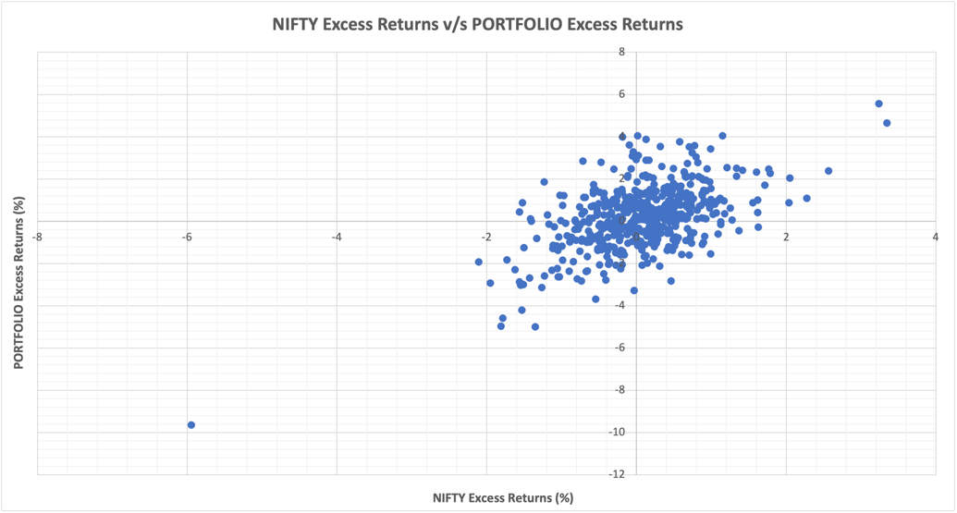

Graph 34: Correlation of NIFTY & PORTFOLIO Excess Returns

To hedge the overall portfolio against market risk by using **NIFTY September Index Futures**, as it provides a broad-based hedge aligned with the general market movements captured by the NIFTY 50 index.

* **Hedge Setup:**

1. **Instrument Used:** NIFTY September futures.
2. **Contract Details:** 155 NIFTY September futures contracts, each priced at ₹24,389.15 with a contract multiplier of 25.
3. **Position:** Short, to protect against a potential decline in the portfolio’s value due to adverse market movements.
4. **Total Value of Hedge Position:** ₹9,45,07,956.25, aligning closely with the overall portfolio value to ensure sufficient coverage.

* **Hedging Mechanics:**

1. By taking a short position in NIFTY futures, any decline in the portfolio’s value due to a market downturn can be offset by gains in the futures contracts, as they will appreciate in value when the NIFTY index falls.
2. This hedge is initiated on **July 1, 2024**, aiming to protect the portfolio from July through September 2024.

* **Closing Position:** The hedge will be closed out on **September 25, 2024**, coinciding with the NIFTY September contract’s expiry date, providing protection throughout the specified hedging period.
* **Benefits:** Using index futures offers a broad-based hedge, reducing reliance on individual stock movements and mitigating market-wide risk exposure efficiently and with high liquidity.

|  |  |  |  |  |  |  |
| --- | --- | --- | --- | --- | --- | --- |
| **Stock** | **Quantity** | **Price on**  **1st July 2024** | **Value on**  **1st July 2024** | **Position on**  **1st July 2024** | **Price on**  **25th Sept 2024** | **Value on**  **25th Sept 2024** |
| CGPOWER | 30000 | ₹708.00 | ₹2,12,40,000.00 | Long | ₹775.85 | ₹2,32,75,500.00 |
| ZOMATO | 120000 | ₹199.71 | ₹2,39,65,200.00 | Long | ₹285.40 | ₹3,42,48,000.00 |
| ADANIPOWER | 30000 | ₹717.00 | ₹2,15,10,000.00 | Long | ₹667.35 | ₹2,00,20,500.00 |
| VARROC | 30000 | ₹656.00 | ₹1,96,80,000.00 | Long | ₹574.45 | ₹1,72,33,500.00 |
| Total |  |  | ₹8,63,95,200.00 |  |  | ₹9,47,77,500.00 |

Table 9: Position in Stocks as on 1st July 2024 and 25th Sept 2024.

|  |  |  |  |  |  |  |  |
| --- | --- | --- | --- | --- | --- | --- | --- |
| **Futures** | **Quantity** | **Contract Multiplier** | **Price on**  **1st July 2024** | **Value on**  **1st July 2024** | **Position on**  **1st July 2024** | **Price on**  **25th Sept 2024** | **Value on**  **25th Sept 2024** |
| NIFTY SEPT FUT | 155 | 25 | ₹24,389.15 | ₹9,45,07,956.25 | Short | ₹25,998.20 | ₹10,07,43,025.00 |

Table 10: Hedging Position in Stock Index Futures as on 1st July 2024 and 25th Sept 2024

|  |  |  |  |
| --- | --- | --- | --- |
| **Using Stock Index Futures** | **Stock Profits** | **Hedge Profits** | **Overall Profit** |
| **PORTFOLIO Overall Return** | ₹83,82,300.00 | -₹62,35,068.75 | ₹21,47,231.25 |

Table 11: Portfolio Hedging Returns using Stock Index Futures

# Conclusion

|  |  |  |  |
| --- | --- | --- | --- |
| **Using Stock Futures** | **Stock Profits** | **Hedge Profits** | **Overall Profit** |
| CGPOWER / BHEL_SEPT_FUT | ₹20,35,500.00 | ₹1,85,062.50 | ₹22,20,562.50 |
| ZOMATO / NAUKRI_SEPT_FUT | ₹1,02,82,800.00 | -₹15,73,661.25 | ₹87,09,138.75 |
| ADANIPOWER / NTPC_SEPT_FUT | -₹14,89,500.00 | -₹23,04,450.00 | -₹37,93,950.00 |
| VARROC / BOSCH_SEPT_FUT | -₹24,46,500.00 | -₹9,51,678.75 | -₹33,98,178.75 |
| **PORTFOLIO Overall Return** | ₹83,82,300.00 | -₹46,44,727.50 | ₹37,37,572.50 |
|  |  |  |  |
| **Using Stock Index Futures** | **Stock Profits** | **Hedge Profits** | **Overall Profit** |
| **PORTFOLIO Overall Return** | ₹83,82,300.00 | -₹62,35,068.75 | ₹21,47,231.25 |

Table 12: Portfolio Hedging Returns using Stock Futures and Stock Index Futures

* **Stock Futures Hedge Analysis:**

1. Hedging with stock futures provided individual coverage tailored to each stock’s sector and specific market behaviour.
2. CGPOWER’s position resulted in a net gain of ₹22,20,562.50 due to profits from both the stock (₹20,35,500) and the hedge (₹1,85,062.50), showing the hedge was well-aligned.
3. ZOMATO’s hedge produced a positive net return of ₹87,09,138.75, as stock gains (₹1,02,82,800) outweighed hedge losses (₹15,73,661.25), indicating the stock’s strong upward movement wasn’t fully offset by the hedge.
4. ADANIPOWER and VARROC hedges yielded significant net losses of ₹37,93,950 and ₹33,98,178.75, respectively. In both cases, declines in stock value compounded by hedge losses highlight limited effectiveness in these specific hedges.
5. The portfolio overall achieved a modest positive return of ₹37,37,572.50 with stock futures, indicating some success, though sector-specific losses dampened the outcome.

* **Index Futures Hedge Analysis:**

1. The NIFTY index futures provided a broad market hedge by shorting the overall market trend, as seen in the larger hedge loss of ₹62,35,068.75.
2. This hedge performed better in reducing exposure to systematic risk but resulted in a lower overall return (₹21,47,231.25) due to the stronger impact of market-wide losses.
3. For CGPOWER and ZOMATO, positive stock returns were not as effectively supported by the index hedge, indicating that specific sector gains can be underrepresented in broad-based hedging.

* **Conclusion:**

1. The stock futures approach is better suited for this portfolio due to the sector-specific nature of gains and losses.
2. Stock futures allowed more targeted hedging, capturing specific stock behaviours more accurately than the broader index futures.
3. For a more diversified or index-correlated portfolio, the index futures might have been a better choice; however, in this case, stock futures resulted in a higher net portfolio return, reflecting a better overall fit.