LAN Chat Application Project Report

Project Title: Real-Time Local Area Network (LAN) Chat Application
Submitted by: Achyuta
Date: 25-11-2025

Abstract
This project implements a real-time, multi-user chat application designed to operate over a Local Area Network (LAN) without requiring an internet connection. Built using only Python’s standard libraries, the application enables seamless text-based communication between multiple devices on the same network. The system features a graphical user interface (GUI), message broadcasting, join/leave notifications.The solution is lightweight, secure for local use, and ideal for classrooms, offices, or home networks.
Introduction
In today’s digital age, instant communication is essential. While cloud-based messaging platforms dominate, they require internet connectivity and raise privacy concerns. This project addresses the need for a private, offline, real-time chat system that works exclusively within a local network. Using Python’s socket, threading, and tkinter modules, a client-server architecture was developed to allow multiple users to exchange messages instantly with minimal latency.
The primary objective was to create a simple, functional, and extensible LAN chat application with essential features such as multi-client handling, user nicknames, message logging, and basic commands.
Tools Used
The project was developed using Python 3 and the following standard libraries:
• socket – For TCP/IP network communication
• threading – To handle multiple clients concurrently
• tkinter – For creating the graphical user interface
• datetime – For timestamping messages and logs

Steps Involved in Building the Project

1. Server Design
• Created a TCP server using socket.socket()
• Bound to 192.168.56.1 to accept connections from any device on the LAN
• Used threading to handle multiple clients simultaneously
2. Client Connection Handling
• Clients connect by entering the server’s local IP address
• Upon connection, clients send a nickname for identification
3. Message Broadcasting
• Implemented a broadcast () function to send messages to all connected clients
• Added join/leave notifications for better user awareness
4. GUI Development with Tkinter
• Designed a clean interface with:
- Scrollable chat display
- Message input field
- Send button
• Messages displayed with timestamps
5. Command System
• Supported /exit to disconnect gracefully
• Implemented /mute toggle to temporarily hide incoming messages
6. Chat Logging
• All messages and events saved to chat_log.txt with timestamps
7. Testing
• Tested with two users on the same network
• Verified real-time delivery, logging, and command functionality

Sample output:

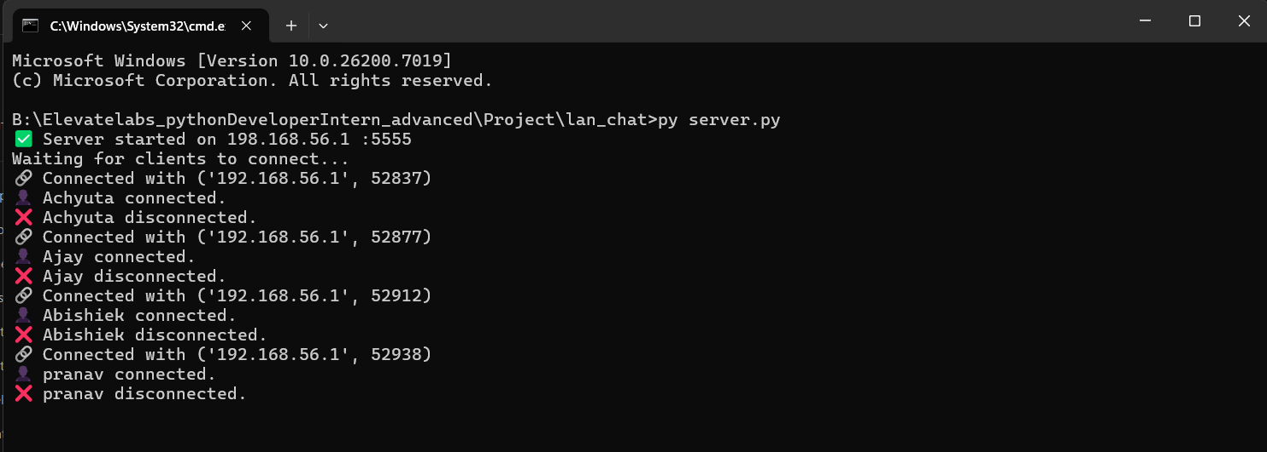

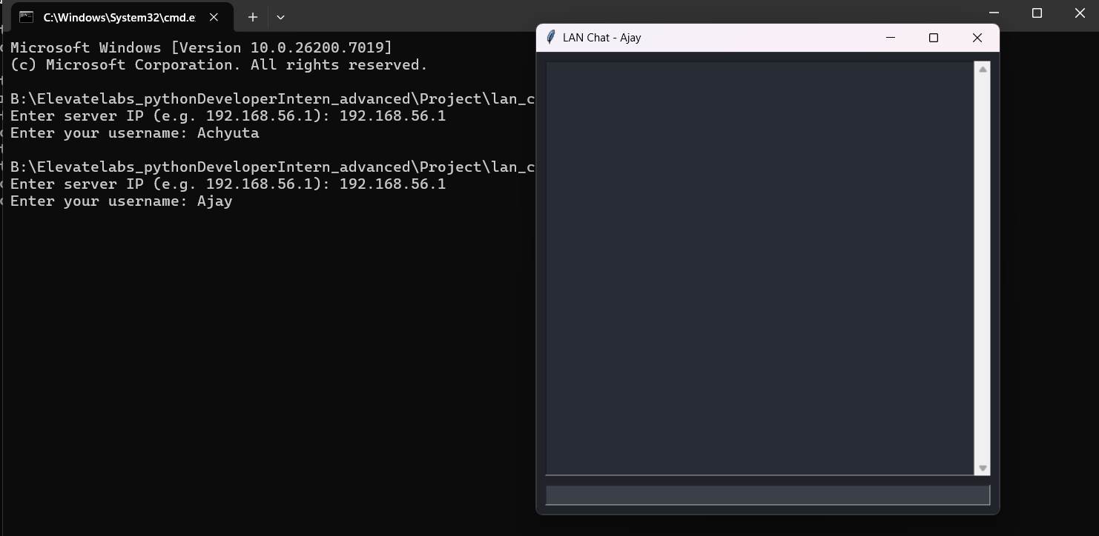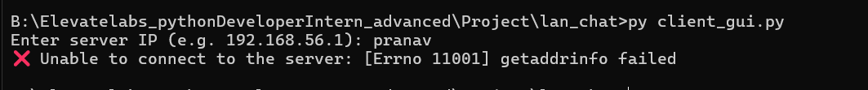

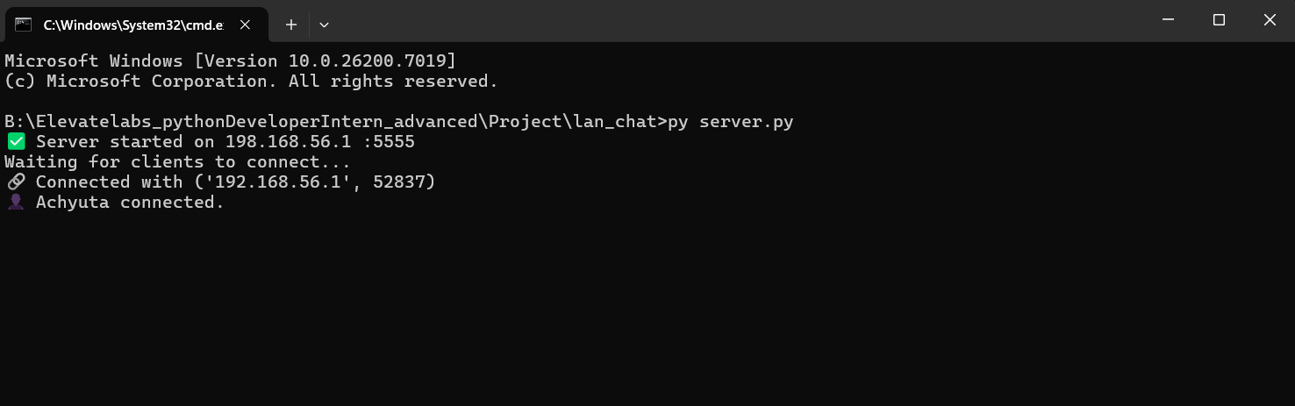
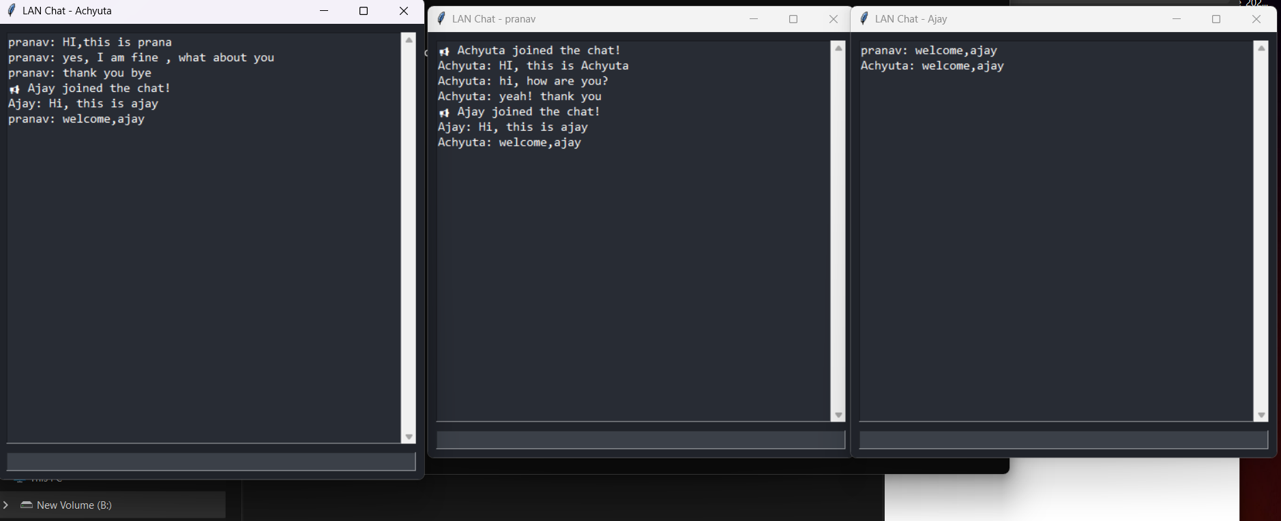

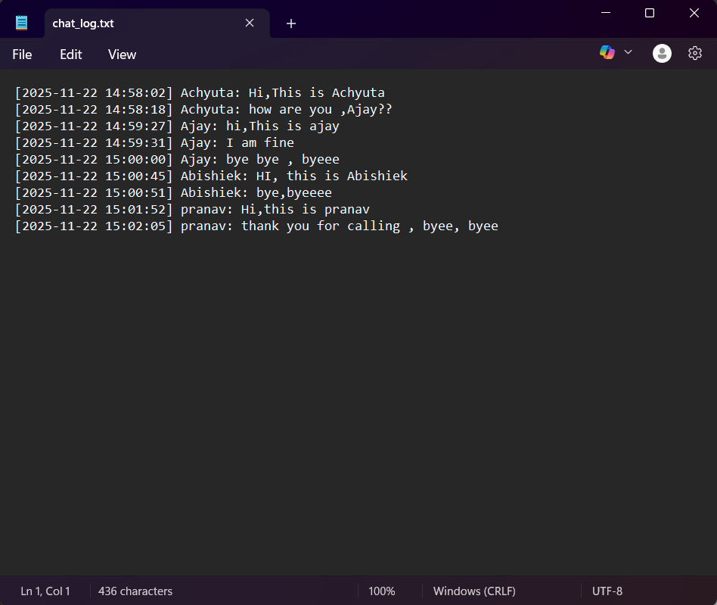

Conclusion
The LAN Chat Application was successfully developed and tested, meeting all specified objectives. It provides a fast, reliable, and private communication platform for local networks. The use of threading ensures smooth handling of multiple users, while the Tkinter GUI offers an intuitive experience. Features like message logging and command support enhance usability and control and this project demonstrates the power of Python’s standard libraries in building functional networked applications. Future enhancements could include private messaging, file transfer, and message encryption. The application is ready for deployment in educational institutions, small offices, or home networks where secure, offline communication is required.

