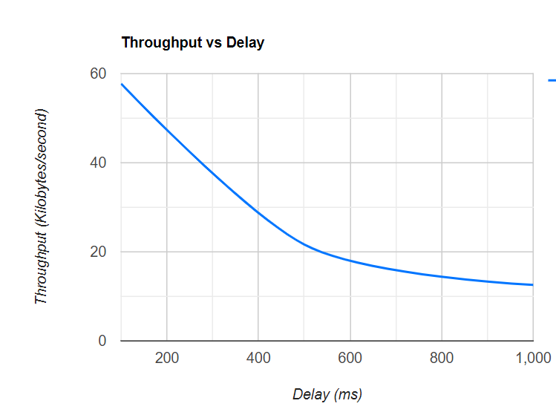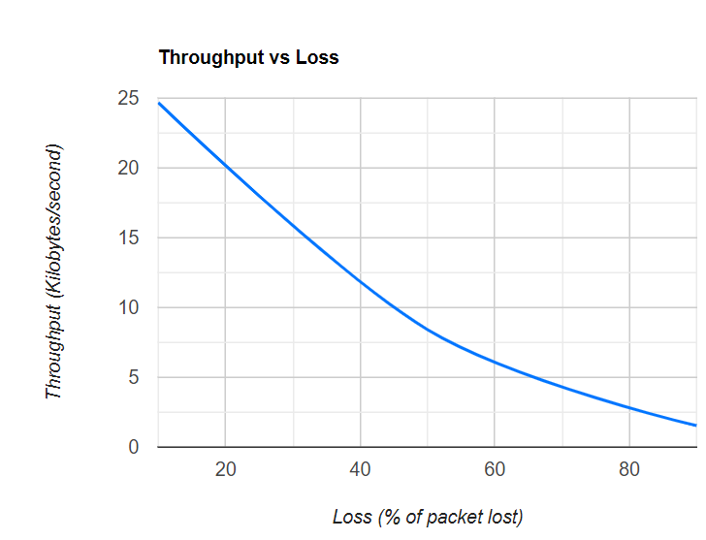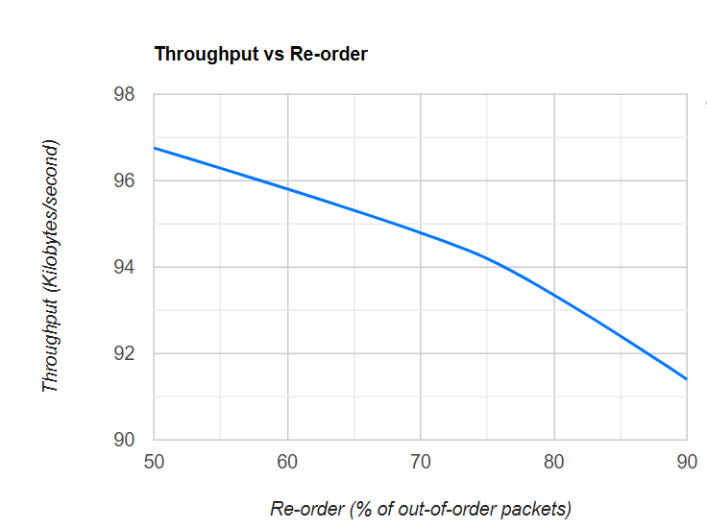

Commands used to simulate adverse network conditions:

* Delay:
  + tc qdisc add dev lo root netem delay 100ms
  + tc qdisc add dev lo root netem delay 250ms
  + tc qdisc add dev lo root netem delay 500ms
  + tc qdisc add dev lo root netem delay 750ms
  + tc qdisc add dev lo root netem delay 1000ms
* Loss:
  + tc qdisc change dev lo root netem loss 10%
  + tc qdisc change dev lo root netem loss 30%
  + tc qdisc change dev lo root netem loss 50%
  + tc qdisc change dev lo root netem loss 70%
  + tc qdisc change dev lo root netem loss 90%
* Re-order:
* tc qdisc change dev lo root netem delay 10ms reorder 10% 50%
* tc qdisc change dev lo root netem delay 10ms reorder 15% 50%
* tc qdisc change dev lo root netem delay 10ms reorder 25% 50%
* tc qdisc change dev lo root netem delay 10ms reorder 35% 50%
* tc qdisc change dev lo root netem delay 10ms reorder 50% 50%

#ACHYUTA KRISHNA V - 2018A7PS0165H

#ANIRUDH G - 2018A7PS0217H

#AJITH P J - 2018A7PS0040H

#J ALVIN RONNIE - 2018A7PS0029H

#MANEESH REDDY - 2018A7PS0462H