**COVID 19 CASES ANALYSIS**

**AI & ADS:**

A correlation study to assess the knowledge and self-expressed stigma regarding COVID-19 Outbreak among adults at selected society.

A global pandemic puts enormous stress on governments and healthcare services. Suddenly, there is a scramble to circulate the correct information and roll out products and services to deal with the crisis. **These challenges design problems that are desperate for a solution, and design thinking can help. bring together a blend of product design, experience design, and service**

Design thinking is a methodology that provides a solution-based approach to solving problems. It combines what’s desirable from a human point of view with what is technologically feasible and economically viable. It’s useful in tackling loosely defined, complex problems by understanding human needs.

**Design thinking** is unique compared with other forms of problem-solving methods in that it’s a non-linear process focused on delivering outcomes, rather than being focused on a precise problem definition. The design thinking process consists of five stages: **empathize, define, ideate, prototype, and test**. Each step needs to be given appropriate resources and the proper duration to create an end product that reliably meets user needs.

**Dataset Link:**[**https://www.kaggle.com/datasets/chakradharmattapalli/covid-19-cases**](https://www.kaggle.com/datasets/chakradharmattapalli/covid-19-cases)

Artificial Intelligence (AI) also started to play a role in the fight against it. In this section, we will cover several areas regarding AI and DL applications which are helping against COVID-19. The authors presented a detailed comparative analysis of AI-, ML-, and DL-based algorithms used to forecast and identify the epidemic and diagnose the consequences of COVID-19.The authors proposed a compound model for face mask detection. The proposed technique is a combination of both deep neural and traditional ML algorithms. In the first part of the DL algorithm, ResNet50 was used for high-level feature extraction. While in the second part, traditional ML algorithms named support vector machine, ensemble algorithms, and decision trees were used to detect face masks. Three different datasets were used in this research for the training and testing of the model. One dataset was for training while the other two datasets were used for the purpose of testing. The proposed technique achieved an average of 99.5% accuracy on all three datasets. The research offers a thorough evaluation of AI and ML as useful methods for tracking contacts, making predictions and forecasting. The authors discussed a thorough analysis of the current and promising use of AI and big data analytics (BDA) to manage the outbreak based on COVID-19 life cycle stages, such as detection, spread, management, and recovery. The authors also discussed the difficulties that BI in BDA in combat must face.

* Lowering the cost of and access to vaccines and medicines in the poorest countries.
* Using mobile money and microfinance to drive financial inclusion and small business development.
* Using community-based approaches to tackle malnutrition and sanitation.
* Using cash transfers to enhance food security.
* Using insurance and other adaptation measures to enhance resilience to disasters and climate change.

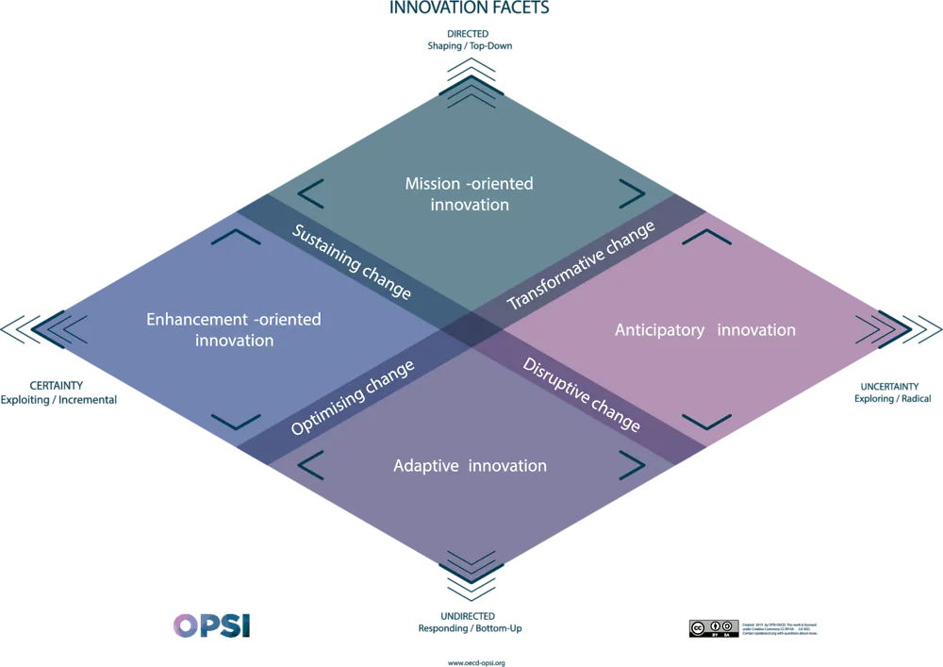

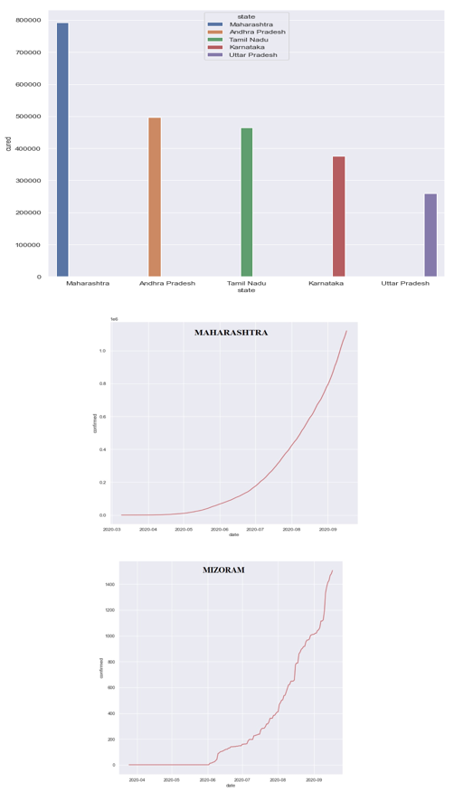

**DAC:**

The novel severe contagious respiratory syndrome coronavirus called COVID-19 has caused the most significant global challenge and public health, after the pandemic of influenza outbreak of 1918.

The adoption of the Internet of Things (IoT) and cloud computing in managing big data during an infectious disease outbreak has brought several opportunities. However, the required resources to collect such big data in a cloud-IoT platform are still a big challenge. Therefore, to efficiently manage an immense amount of data in an integrated Cloud-IoMT platform, this study recommends a framework for Cloud-IoMT-based big data analytics.

The data gathered from diverse wearable sensors such as body temperature, glucose sensors, heartbeat sensor, and chest were conveyed via IoMT gadgets to the integrated cloud with the data analytics layer. The cloud database Hadoop MapReduce methods can be used to process vast amounts of data collected during COVID-19 monitoring and surveillance in parallel.

For speedy tracking, evaluation, decision-making, and improved care approvals from doctors via IoMT devices to the advanced cloud and data analytics layer, data are gathered from diverse wearable sensors. The use of internal network by Cloud-IoMT-based big data analytics can help in tracking patient health conditions in real time globally, and this will reduce the workloads and pressure on the healthcare professionals, increase the accuracy of medical diagnosis, reduce healthcare costs, and lead to patient treatment satisfaction during the COVID-19 pandemic.

* **To provide basic knowledge of the disease and the risk that RTTs and Ca patients face**
* **To promote the effective implementation of infection control measures in order RTTs to continue to perform their duties safely**
* **To empower the wellbeing of them who have a key role in preserving their departments and their National Healthcare Systems**
* **To protect Ca patients from the COVID-19 threat, while treated**
* **To quantify hospital-based outcomes and deaths, including in relation to sociodemographic characteristics and comorbidities as ascertained from hospital AND general practice data.**
* **To estimate the strength of association between these outcomes and sociodemographic and health characteristics**.
* **Assess impacts of pandemics on people and forests.**
* **Identify and discuss possible responses that help mitigate impacts on people.**
* **Forests and help address the situation in the short term while at the same time.**
* **Contributing to building a more resilient and sustainable future;**
* **Propose follow-up steps, including policy dialogue and mobilizing of resources.**
* **Action that better enables the forest sector to help rebuild sustainable and resilient societies.**

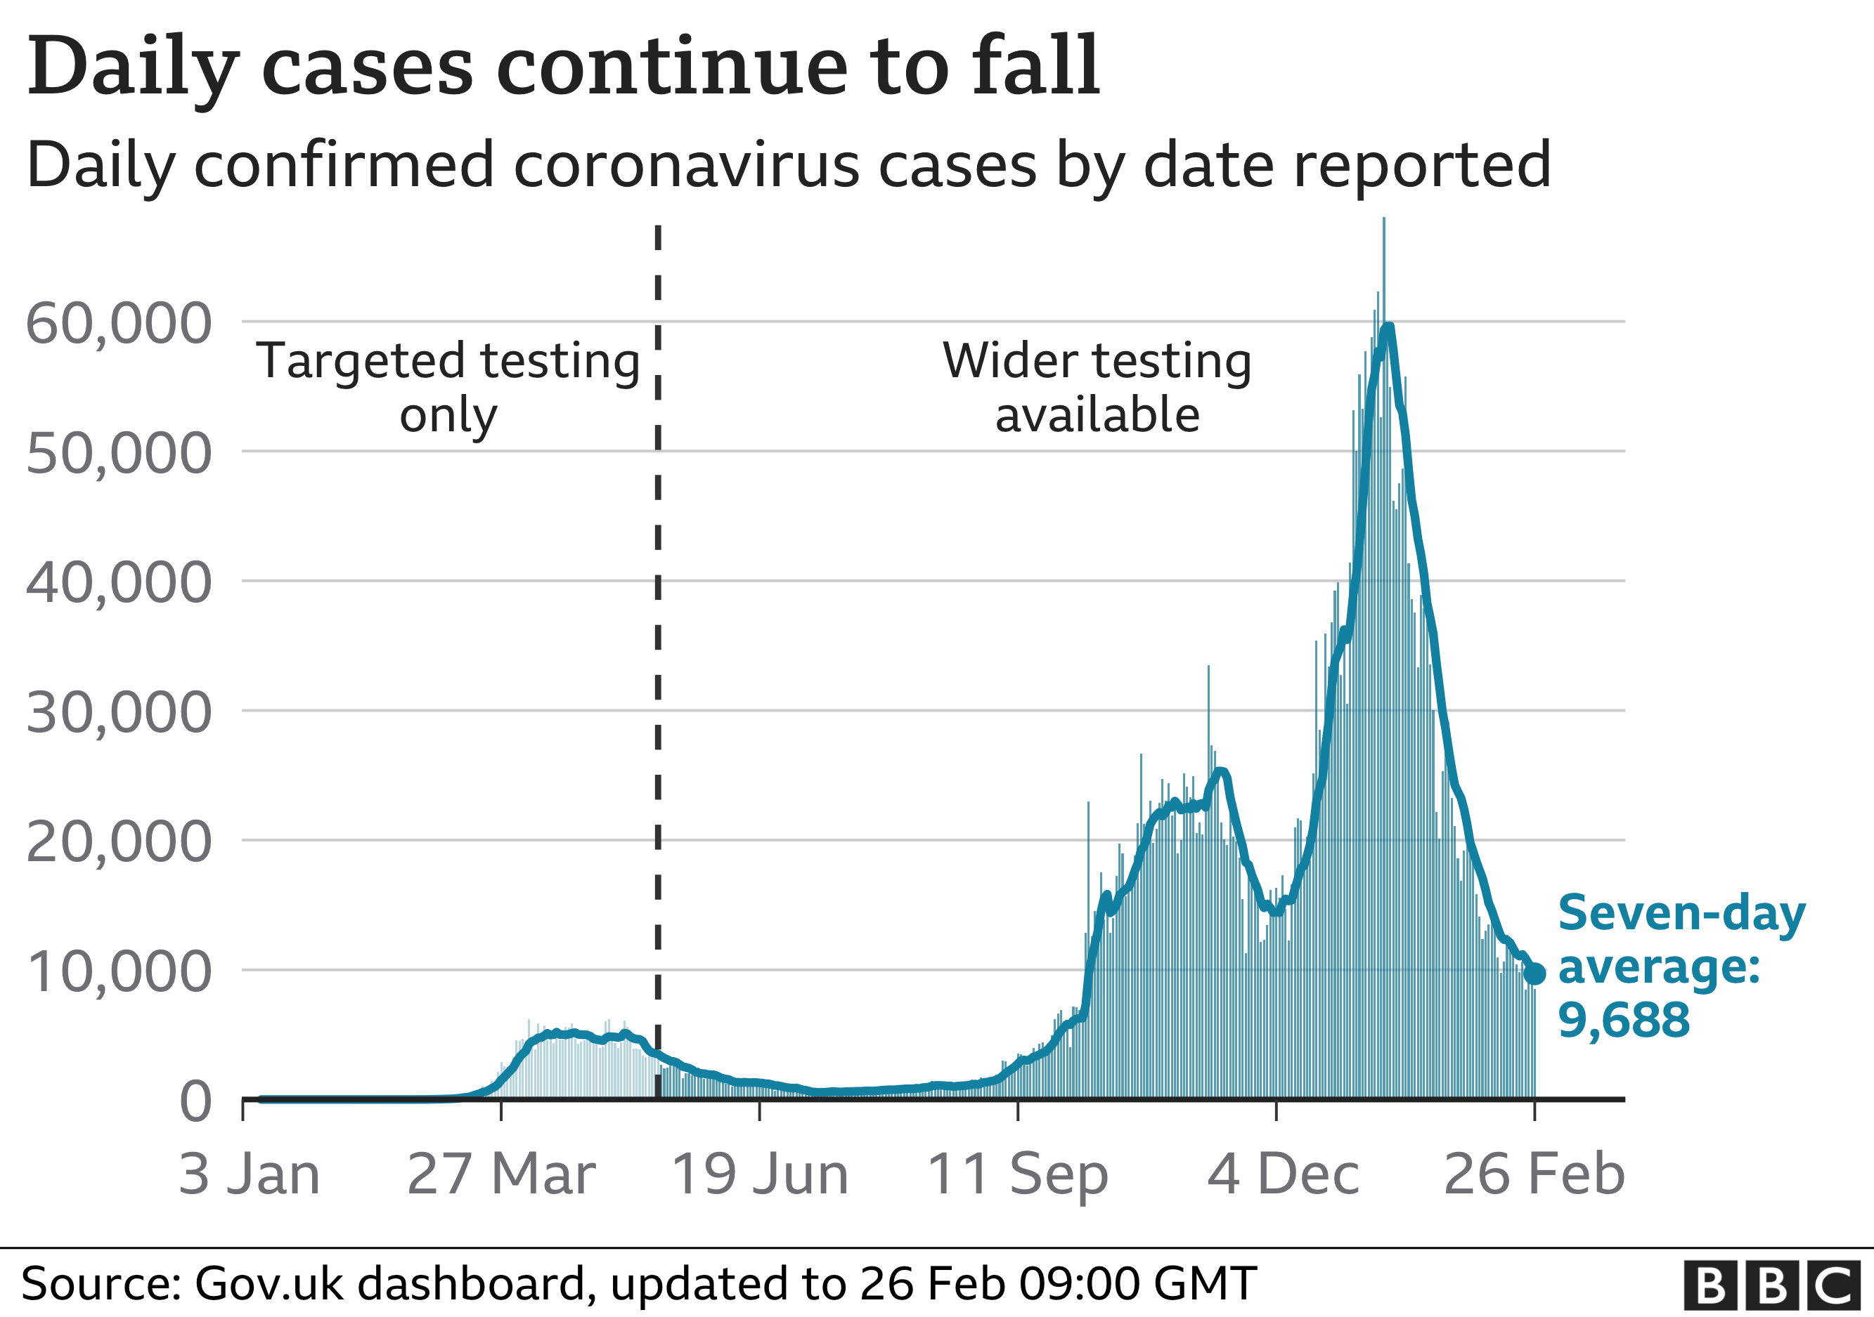

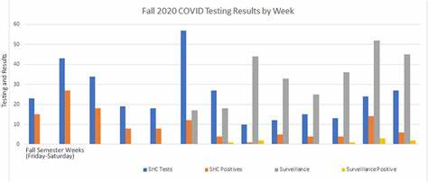

**IOT:**

The COVID-19 outbreak has unleashed a cataclysmic impact on the daily existence of humanity, triggering a widespread upheaval in public health and wreaking havoc on the economies of affected nations. This lethal disease has emerged as a leading cause of substantial mortality and morbidity around the globe, and the emergence of new virus variants has confronted humanitarian society with formidable difficulties. In this tumultuous period, the Internet of Things (IoT) has played an indispensable role.

IoT has offered various innovative solutions to curb the spread of the pandemic, providing a beacon of hope amidst the chaos. The current research delves into the literature on IoT-assisted COVID-19 research, utilizing a scientometric analysis to extensively examine the technological impact in the battle against the outbreak. It illuminates the multifaceted role of ICT in the ongoing pandemic by employing an array of empirical approaches such as publication patterns, citation structures, leading nations, literature co-citation network analysis, and knowledge mapping of scientific literature using the CiteSpace tool. Furthermore, the study uncovers the research frontiers, research hotspots, cluster analysis, and potential future directions in this knowledge domain, providing a visual narrative that inspires hope and a renewed commitment to our collective responsibility in the face of this global crisis.

The Internet of Things (IoT) represents a powerful new paradigm for connecting and communicating with the world around us. It has the potential to transform the way we live, work, and interact with our surroundings. IoT devices are transmitting information over the Internet, most of them with different data formats, despite they may be communicating similar concepts. This often leads to data incompatibilities and makes it difficult to extract the knowledge underlying that data. Because of the heterogeneity of IoT devices and data, interoperability is a challenge, and efforts are underway to overcome this through research and standardization. While data collection and monitoring in IoT systems are becoming more prevalent, contextualizing the data and taking appropriate actions to address issues in the monitored environment is still an ongoing concern. Context Awareness is a highly relevant topic in IoT, as it aims to provide a deeper understanding of the data collected and enable more informed decision-making.

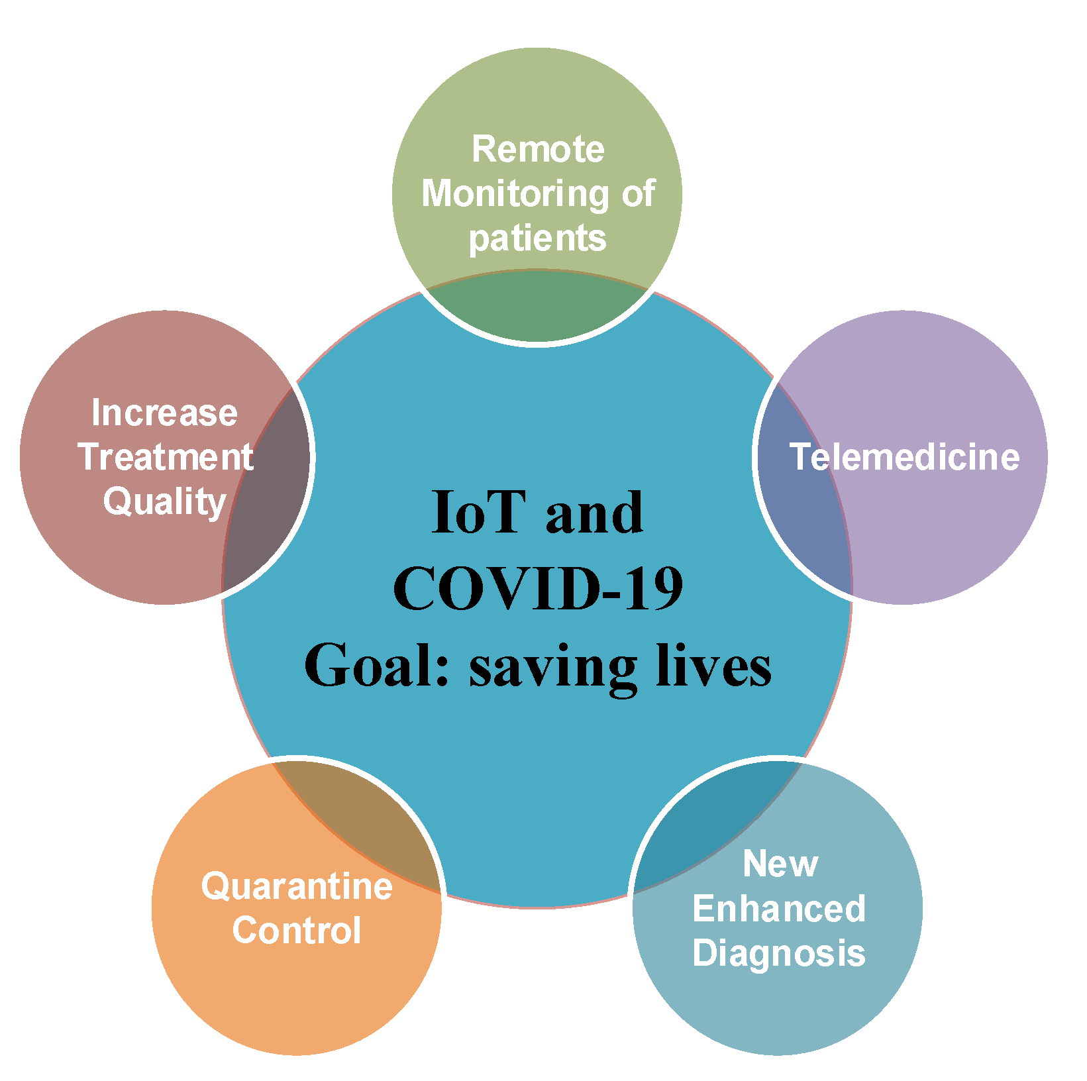

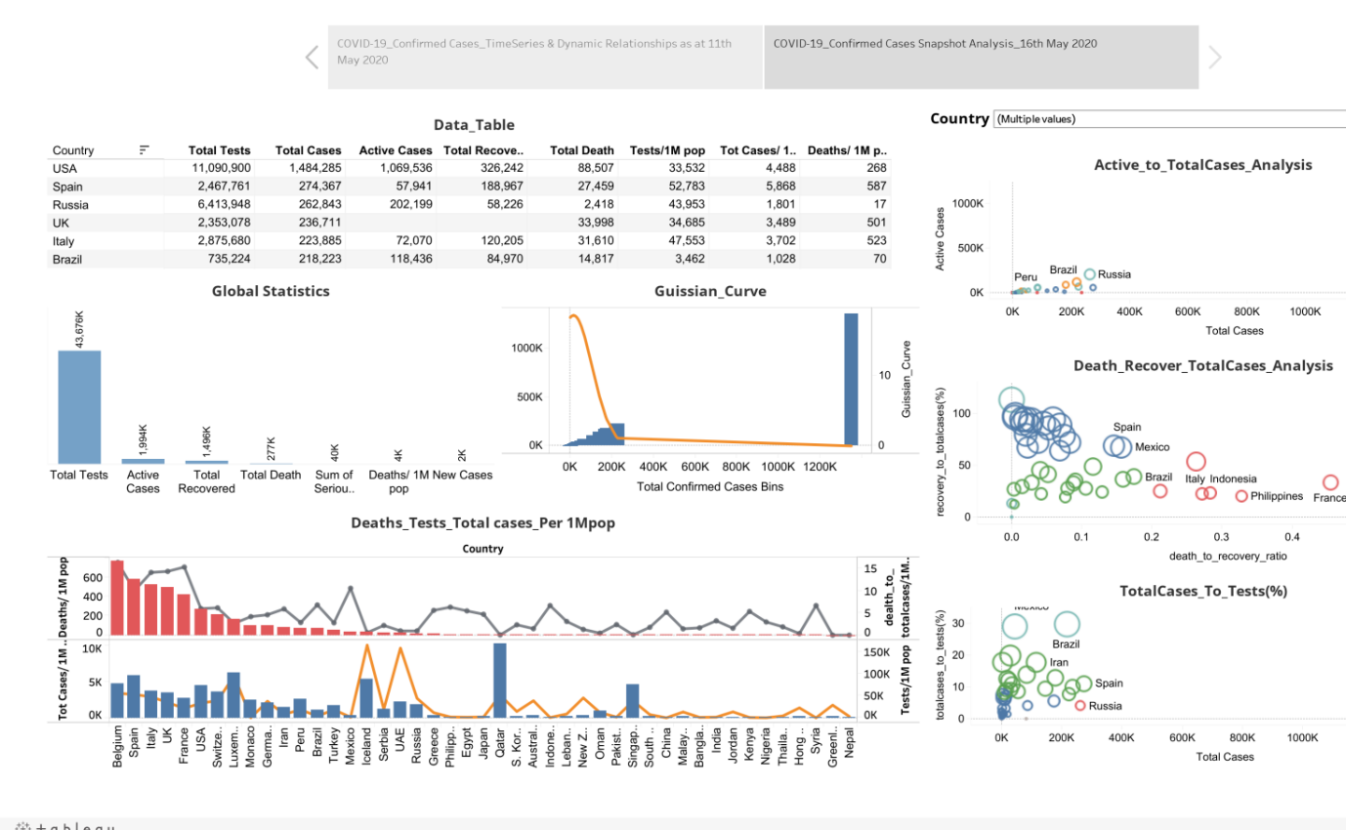

**CAD:**

Several infectious diseases have affected the lives of many people and have caused great dilemmas all over the world. COVID-19 was declared a pandemic caused by a newly discovered virus named Severe Acute Respiratory Syndrome Coronavirus 2 (SARS-CoV-2) by the World Health Organisation in 2019. RT-PCR is considered the golden standard for COVID-19 detection. Due to the limited RT-PCR resources, early diagnosis of the disease has become a challenge.

Radiographic images such as Ultrasound, CT scans, X-rays can be used for the detection of the deathly disease. Developing deep learning models using radiographic images for detecting COVID-19 can assist in countering the outbreak of the virus. This paper presents a computer-aided detection model utilizing chest X-ray images for combating the pandemic. Several pre-trained networks and their combinations have been used for developing the model. The method uses features extracted from pre-trained networks along with Sparse autoencoder for dimensionality reduction and a Feed Forward Neural Network (FFNN) for the detection of COVID-19. Two publicly available chest X-ray image datasets, consisting of 504 COVID-19 images and 542 non-COVID-19 images, have been combined to train the model.

The method was able to achieve an accuracy of 0.9578 and an AUC of 0.9821, using the combination of InceptionResnetV2 and Xception. Experiments have proved that the accuracy of the model improves with the usage of sparse autoencoder as the dimensionality reduction technique.

Github link: <https://github.com/Achyuth-code/python-code-phase5>

* **Use data visualization software like Tableau, Power BI, or Python libraries (e.g., Matplotlib, Seaborn) to create informative charts and graphs to illustrate COVID-19 case trends, such as daily infection rates, geographical spread, and vaccination coverage.**
* **Utilize GIS (Geographic Information Systems) software to map COVID-19 cases and analyze spatial patterns and hotspots.**
* **Employ machine learning tools and programming languages like 19 case numbers, given certain parameters.**
* **Conduct epidemiological studies using statistical software to analyze the progression of the pandemic, calculate infection rates, mortality rates, and evaluate the impact of interventions.**
* **Use data analysis to assess healthcare resource needs, such as ICU beds, ventilators, and medical staff, based on COVID-19 case projections.**
* **Optimize vaccine distribution strategies using mathematical modeling and simulation tools to ensure efficient and equitable vaccination campaigns.**
* **Analyze social media and news data to gauge public sentiment and misinformation related to COVID-19.**
* **Create contact tracing algorithms to track and manage the spread of the virus within communities.**

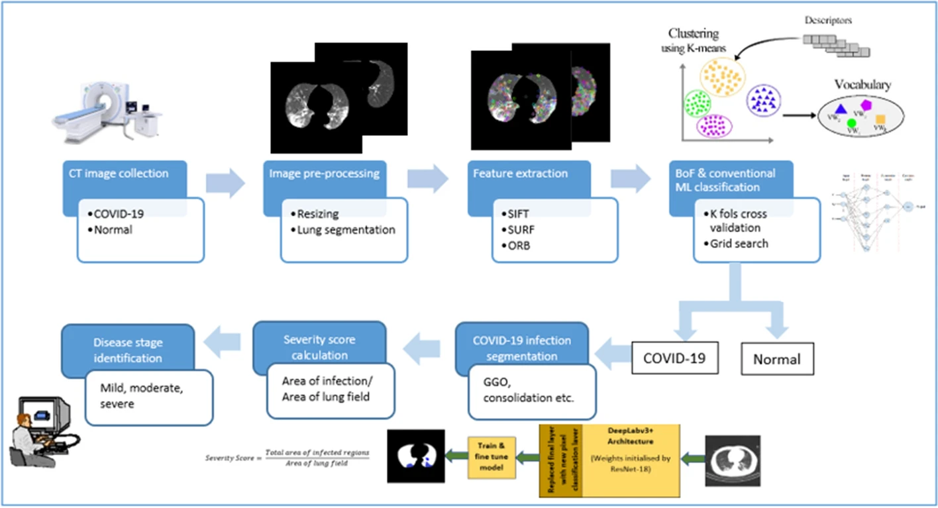

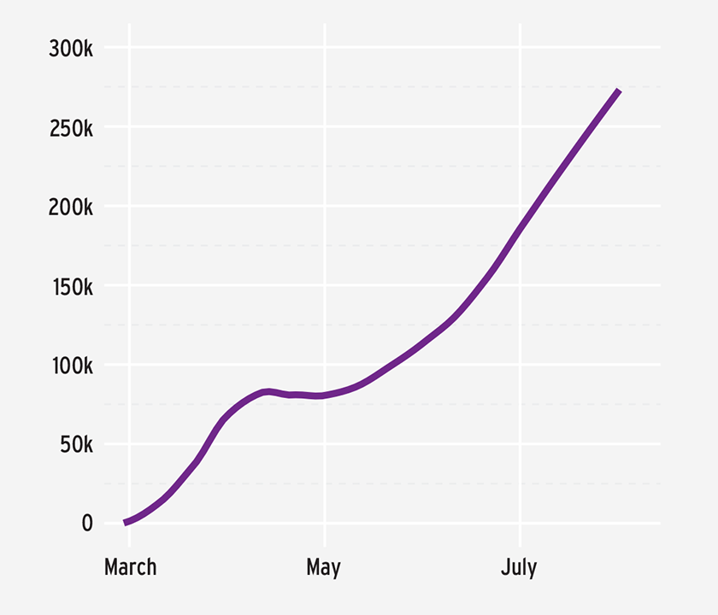

These technologies can complement each other to create a comprehensive ecosystem for managing and analyzing COVID-19 cases, from prediction and diagnostics to data management and healthcare system optimization. However, the successful deployment of these technologies should also consider privacy, security, and ethical considerations, especially when dealing with sensitive health data.

**Submitted by**

**Achyuth Kumar. V**

**Au720921243059**