JEE ADVANCED

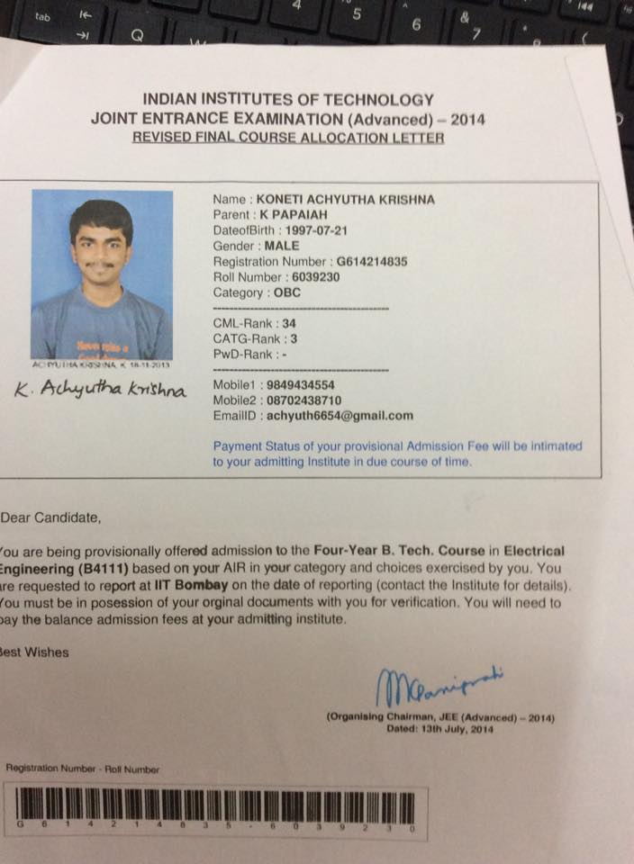

JEE main B Tech and B Arch

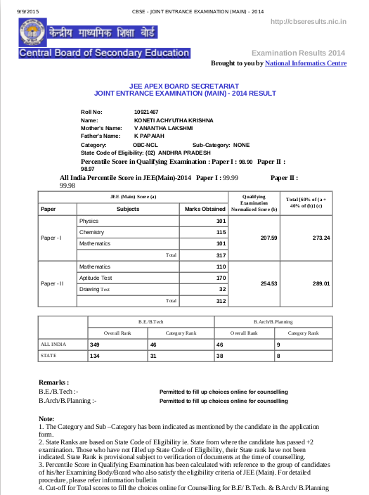
KVPY
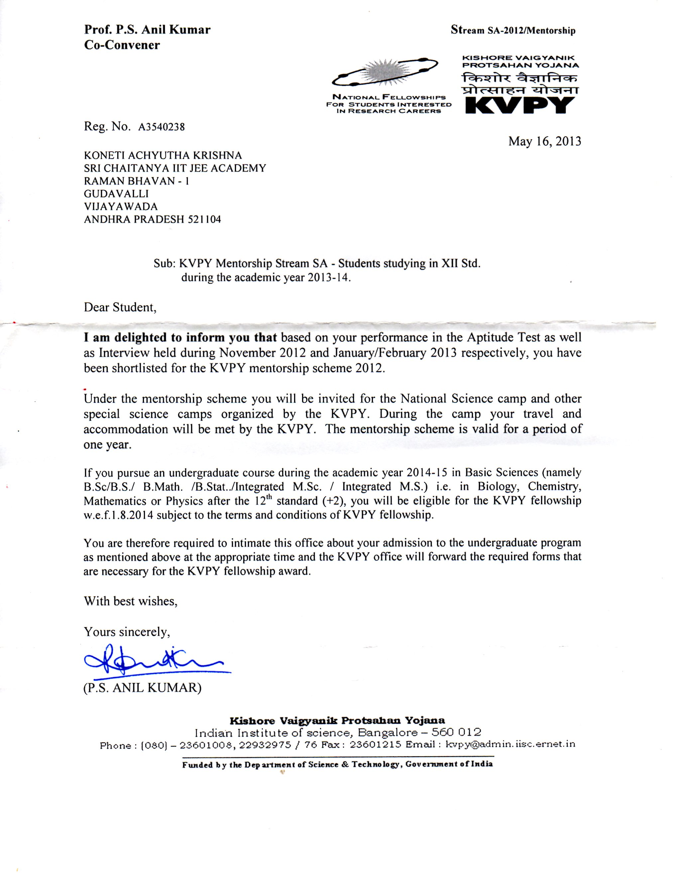
SIMO
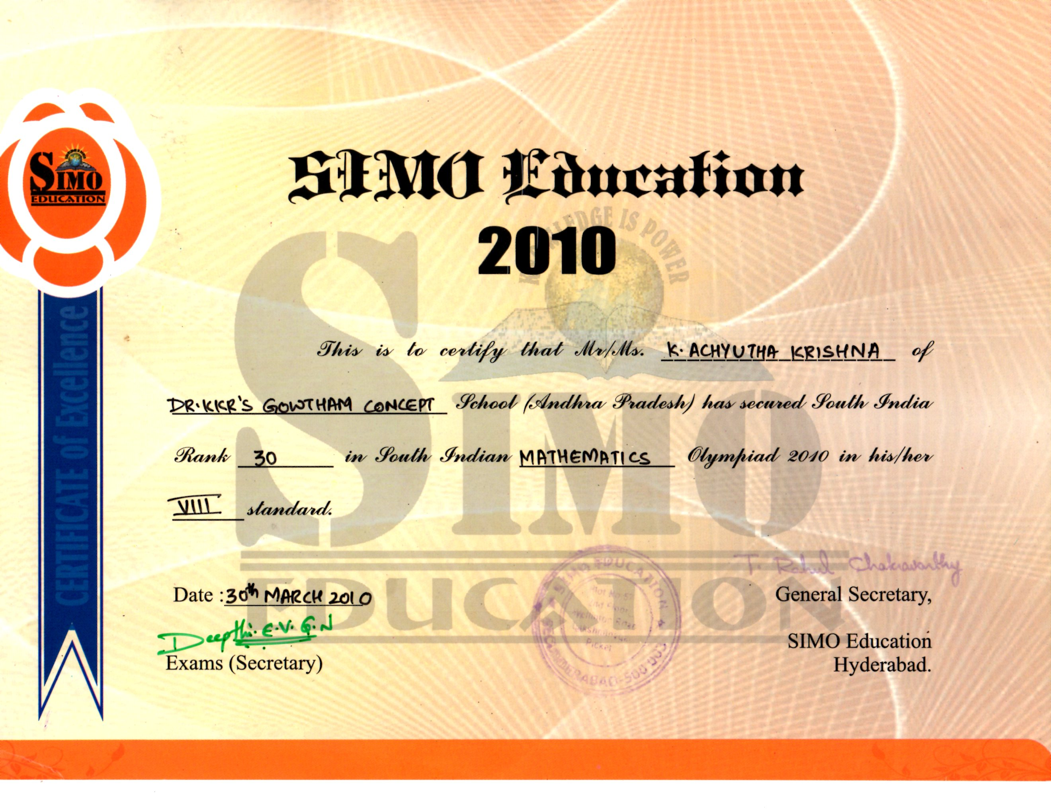

UCO
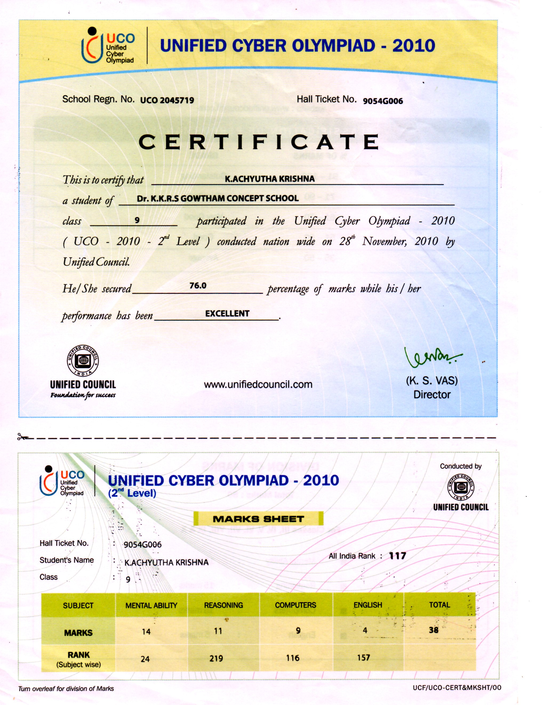

NSO

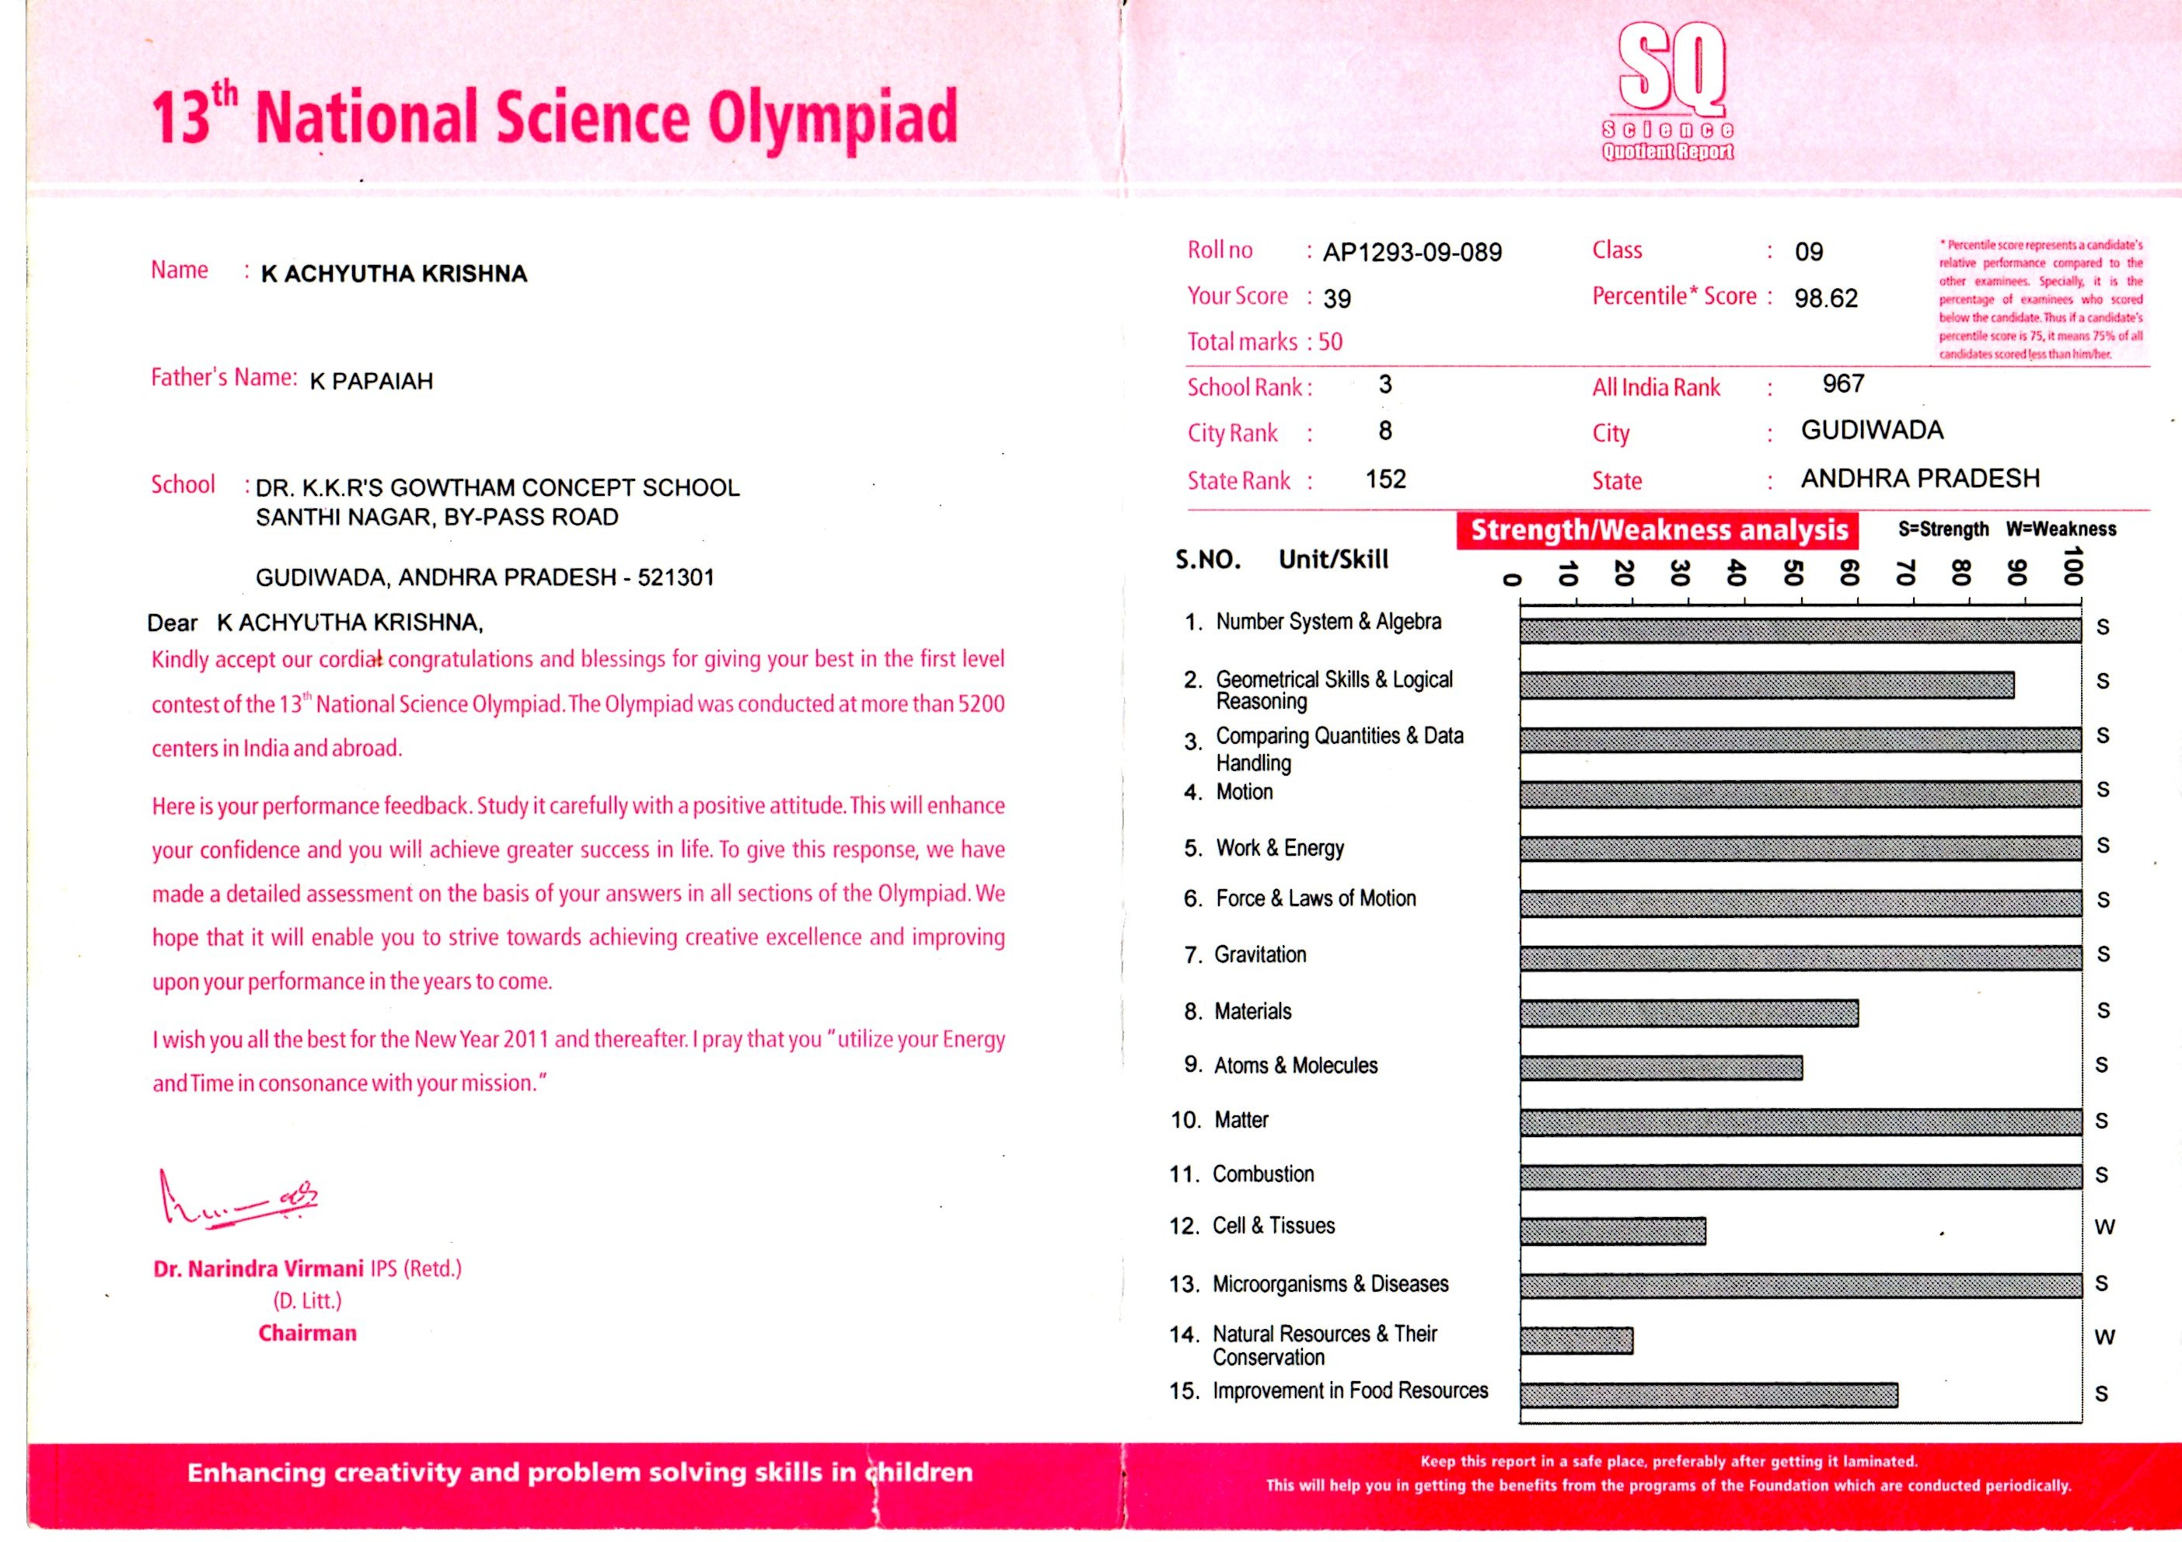

NCO

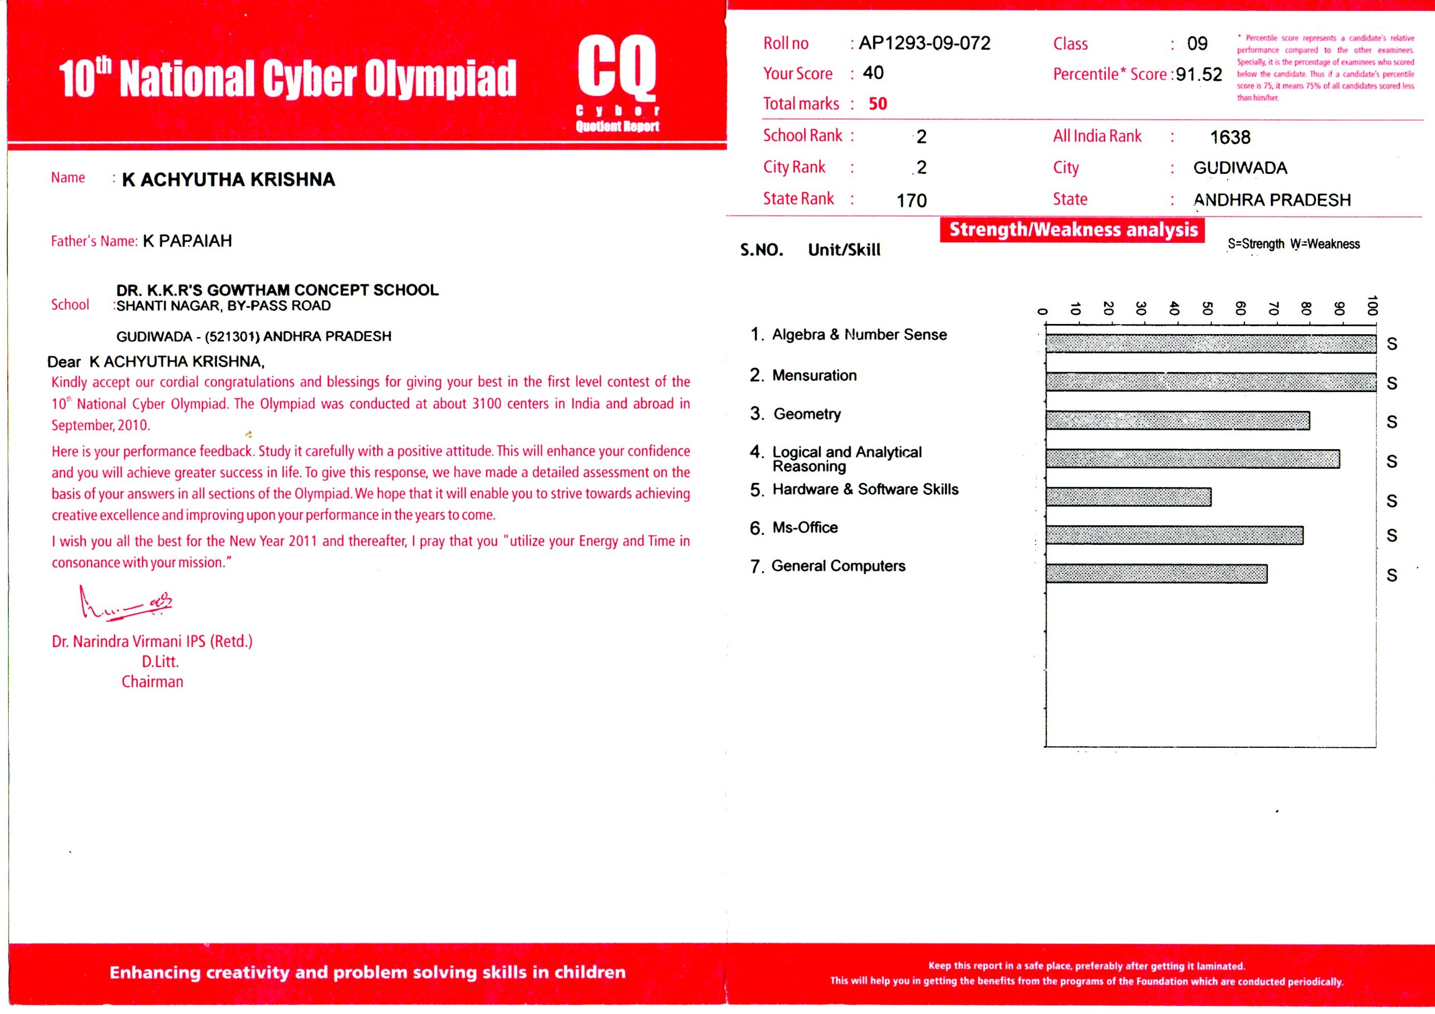

IITB Racing

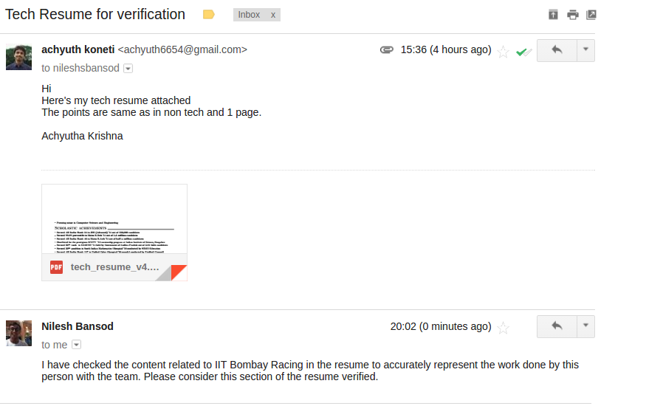

ISOLATED DIGIT RECOGNITION

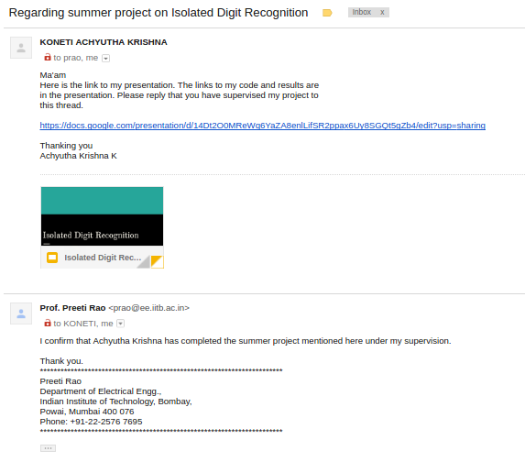

MOBILE FLASHLIGHT COMMUNICATION

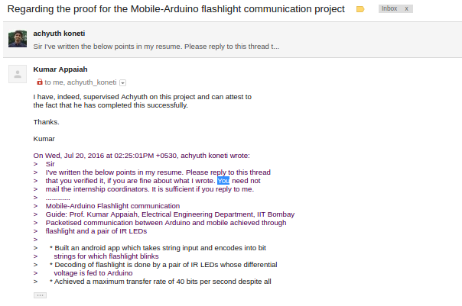

Reliability and Performance of Trap based 3D NAND memories

prof.Soiuvik mahapatra

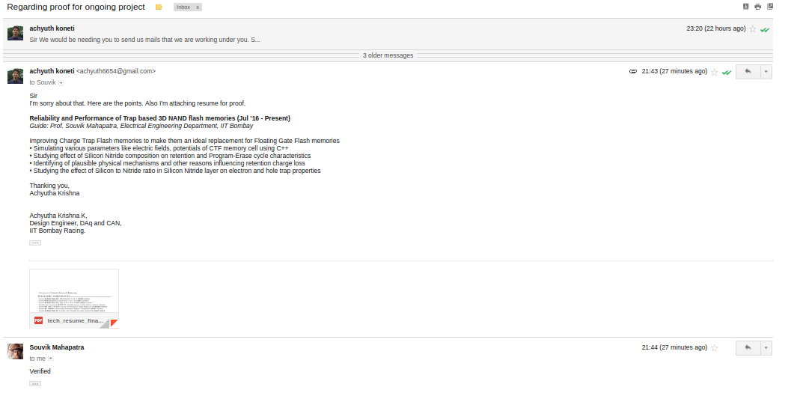

Projector Keyboard
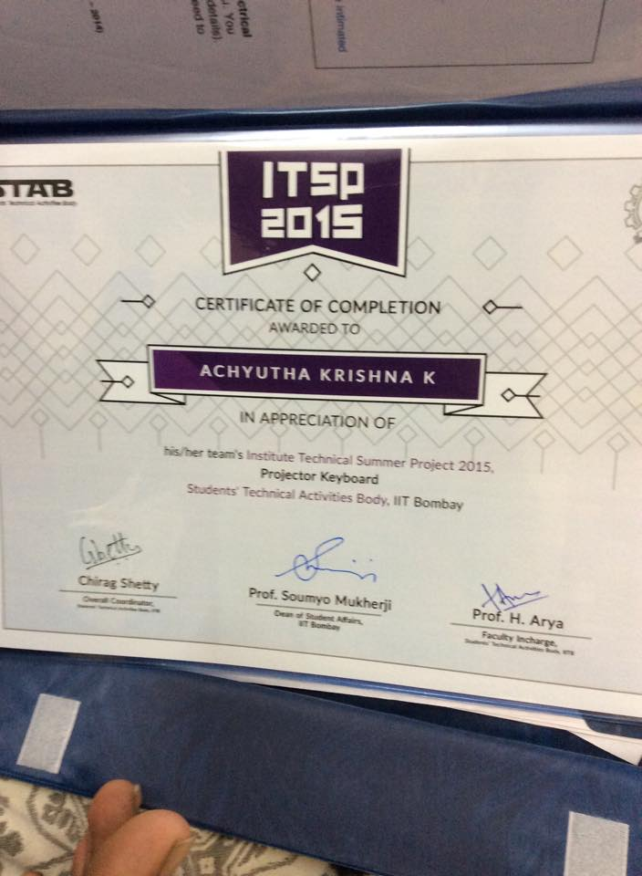

Class Represntative

Mail from Ex Department GSec

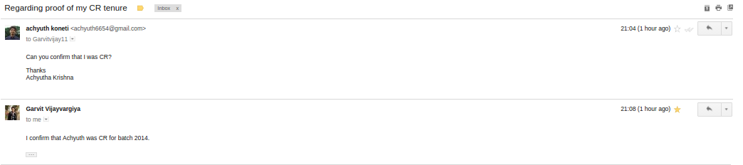

4

Coordinator Team Web Ecell

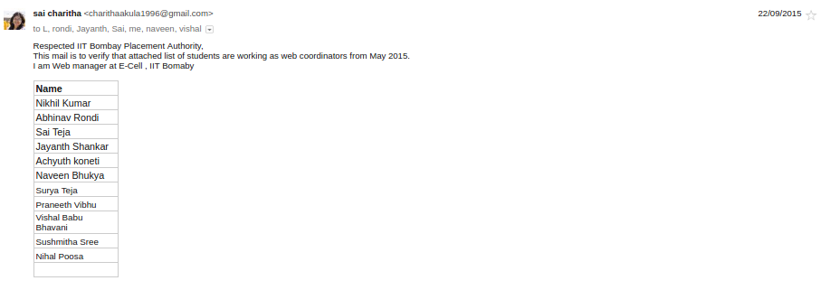

Organizer Techfest Lectures

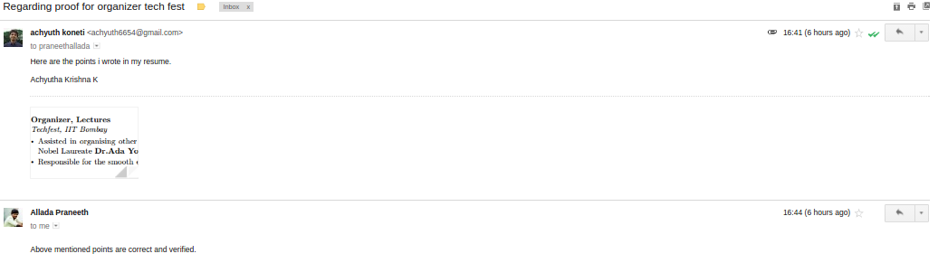

Organizer Informals

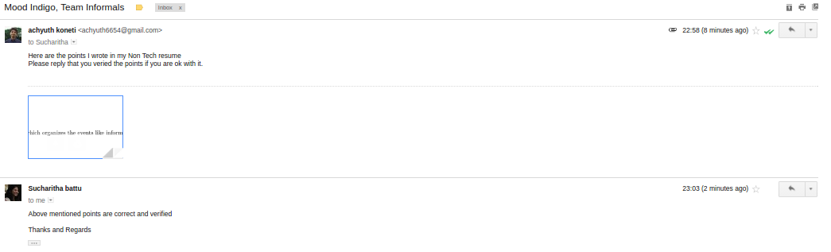

X- CLASS CERTI
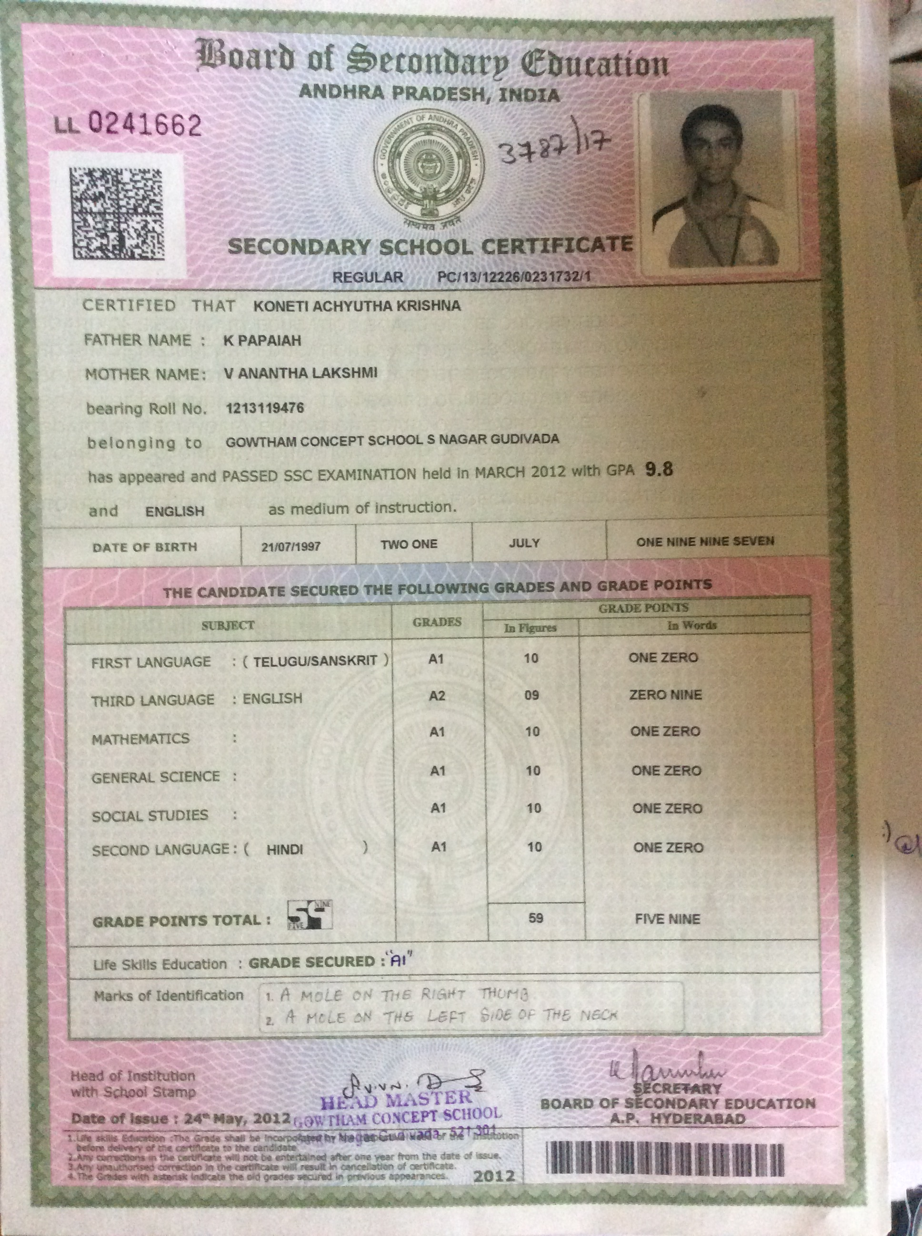

+2 marks certificate



