Assignment 2-1
Achyutha Krishna K
Athul A R
Report can be found at https://achyuth1.github.io/projects.html

Assumptions made:
- Cycle is on ground i.e., if one wheel rotates the other wheel also rotates.
- Angular velocity of both wheels will be equal and twice that of pedal’s angular velocity
- For future development the angular velocity of front wheel can be made a function of the angle it is rotated which is more realistic.
- Front view is the default view mode.
User Manual:
- Use key ‘1’ to select Pedalling mode
- Use key ‘2’ to select the steering/handle mode
- Use key ‘0’ to select the view changing mode

Steering / Handle mode:
- Use Left and Right arrow keys to rotate the handle
- It’s rotation is bounded to [-90º, 90⁰ ]
Pedalling mode:
- Use Up and Down arrow keys for pedalling the cycle
- Up Arrow results in forward motion of bicycle
- Down arrow doesnt move the bicycle, only rotates the pedals( Realistic! :D ).
- For handle and Pedals the remaining rotations are disabled
View changing mode:
- Up and Down arrows for rotation about X- axis
- Left and Right arrows for rotation about Y- axis
- Page Up and Page Down keys for rotation about Z-axis

Referred Links:
- For solid torus
- For cylinder
- For Solid cube
- Tutorial 4 uploaded by professor.
- BMX cycle for coloring purposes
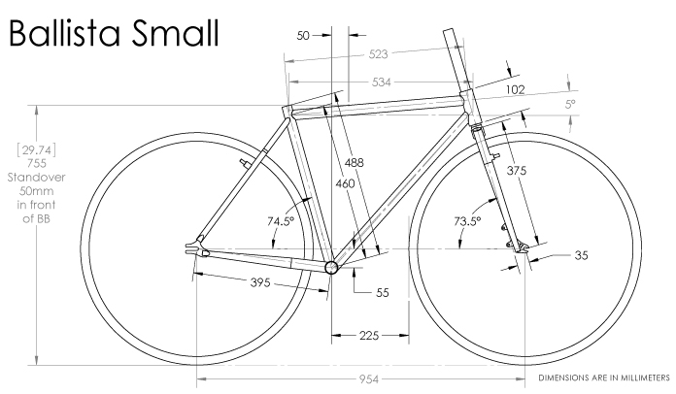
- Cycle frame dimensions used:

