|  |
| --- |
| **FETAL HEARTBEAT EXTRACTION** |

**Involved Members**

**PROJECT INCHARGE:** Irina Gertsovich**,** Venu Gopal Puripanda

**Group Members**

NAME: Preetam Sai Mynampati NAME: Maddukuri Achyutha Ramarao

P.NO : 940921-3510 P.NO : 950630-9138

EMAIL : [prmy16@student.bth.se](mailto:prmy16@student.bth.se) EMAIL : acma16@student.bth.se

|  |
| --- |
| **PREFACE** |

Fetal Heartbeat extraction has a vital role in medical diagnosis during pregnancy. In this project, a method for removal of background noise and from fetal electrocardiogram (FECG) signals using adaptive filters is proposed. The proposed method uses adaptive noise cancellation and digital filters for FECG extraction. Proposed FECG extraction algorithm is implemented in MATLAB using Simulink models. Simulation results show the extracted FECG noise free signal.

|  |
| --- |
| **ABSTRACT** |

**­­­­­**

As Fetal Heartbeat from the abdomen is usually corrupted or has interfered by Maternal Heartbeat which basically can be categorized as noise. So here we extract the Fetal Heartbeat from interfered Maternal Heartbeat. Adaptive Noise Canceller (ANC) is used to de-noise the noise corrupted signal through adaptive filtering techniques. Different schemes implemented are Single Input Single Output (SISO) and Multiple Input Single Output (MISO) on ANC where adaptive algorithms like least mean squares (LMS), Normalized least mean squares (NLMS) and leaky least mean squares (LLMS) are implemented in MATLAB where simulation results show the extracted FECG noise free signal.

­­

|  |
| --- |
| **CONTENTS** |

**Preface 1**

**Abstract 2**

1. **INTRODUCTION 4**

1.1 Data Acquisition 4

1. **ADAPTIVE FILTERING 6**

2.1 Adaptive Noise Cancellation 6

2.2 Single Input Single Output System 7

2.3 Multiple Input Single Output System 8

2.4 Adaptive Algorithms 9

2.4.1: Least mean square algorithm 10

2.4.2: Normalized least mean square algorithm 10

2.4.3: Leaky least mean square algorithm10

1. **RESULTS AND DISCUSSIONS 11**

3.1 SISO Input and Output Signals 11

3.2 MISO Input and Output Signals 13

1. **CONCLUSION 15**

**List of Figures 16**

**Bibliography 17  
Appendix 18**

|  |
| --- |
| **INTRODUCTION** |

ECG signal describes the electrical activity of the heart [1]. Fetal ECG (FECG) signal reflect the electrical activity of the fetal heart and provides valuable information of its physiological state. Non-invasive FECG has been used to obtain valuable clinical information about the fetal condition during pregnancy by using skin electrodes placed on the maternal abdomen [3]. However, abdominal ECG (AECG) is always corrupted with power line interference, maternal ECG (MECG). The detection of R-peaks i.e., the peaks of the QRS complex in an (AECG) signal provides information on the heart rate and hence it is an important tool for the physician to identify abnormalities in the heart activities [2].

Various research efforts have been proposed to extract the FECG from the AECG such as adaptive filtering, correlation techniques, blind source separation and a combination of wavelet analysis and blind source separation methods. Fetal heart rate (FHR) can be calculated by determining the R-R intervals from the extracted FECG.

**1.1 Data Acquisition**

ECG signals are commonly measured at two locations: chest and abdomen which is clearly shown on **Fig. 1**. The abdominal leads pick up a composite signal, consisting of the contributions from maternal electrocardiogram (MECG) and the fetal electrocardiogram (FECG) while the chest leads contains MECG only [4].

The measured fetal electrocardiogram signal from the abdomen of the mother is usually dominated by the maternal heartbeat signal that propagates from the chest cavity to the abdomen [5].

The maternal electrocardiogram signal is obtained from the chest of the mother. The goal of the adaptive noise canceller in this task is to adaptively remove the maternal heartbeat signal from the fetal electrocardiogram signal. The noise canceller needs a reference signal generated from the maternal electrocardiogram to perform this task. Just like the fetal electrocardiogram signal, the maternal electrocardiogram signal will contain some additive broadband noise.

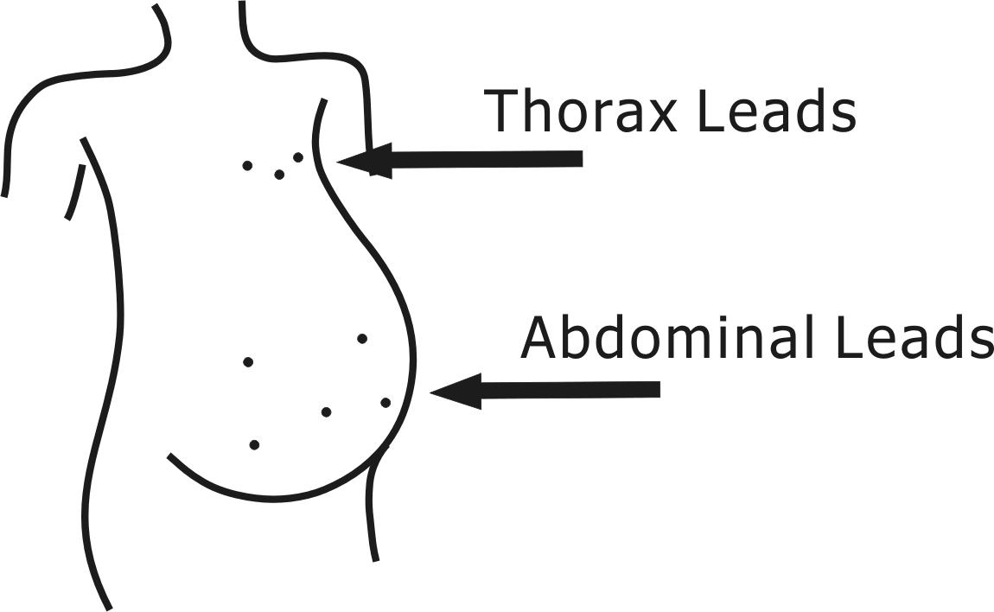 **Figure1:** Lead locations of ECG signal measurements  
 in a pregnant woman.

*ECG is measured at two parts*

1. *Thoracic part  
   (Mothers heartbeat)*
2. *Abdominal part  
   (Maternal + Fetal heartbeat)*

|  |
| --- |
| **ADAPTIVE FILTERING** |

Various research efforts have been proposed to extract the FECG from the AECG such as adaptive filtering [1].

**2.1 Adaptive Noise Cancellation (ANC)**

The aim of an ANC is to get an estimate of the fetus signal from the noise corrupted heartbeat. Removal of background noise and artifacts from FECG signals using adaptive filters necessitates the application of two input signals:

The primary signal is FECG signal added with MECG signal and the secondary signal is the reference signal which is the noise to be canceled i.e., MECG signal. The secondary noise signal must be well-correlated with the noise in the primary signal [2]. Adaptive filters are used in fetal electrocardiography, in which a maternal heartbeat signal is adaptively removed from a fetal heartbeat signal.

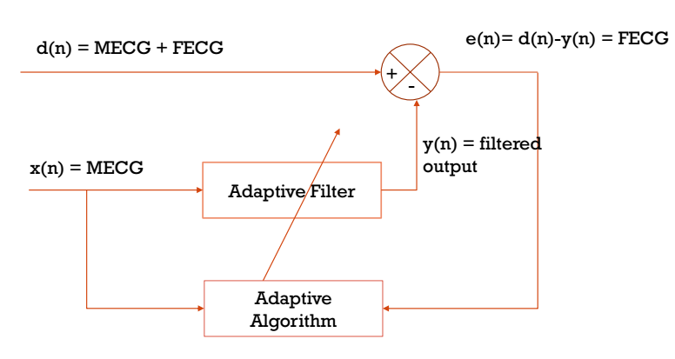

**Figure2:** Adaptive Noise cancellation (ANC) structure

From the **Fig 2** ANC structure is shown. In this d (n) is the input signal which consists of both the desired signal and the noise signal.

𝑑 (𝑛) = s (n) + , (1)

where s (n) is desired signal, is noise signal (i.e. ***s (n)* ≈ FECG** & **MECG** ). Here and s (n) are uncorrelated and a reference input is given to the adaptive filter which is a similar to i.e. both and are correlated signals.

The reference signal is used to estimate and estimated signal from the adaptive filter is subtracted from 𝑑 (𝑛) to obtain an estimate of s (n)

s (𝑛) =d (𝑛) − (𝑛) , (2)

where (𝑛) is the estimate of

The error signal e (n) in the ANC gives us the desired signal which is further used by the adaptive filter to update the filter weights automatically. Here different adaptive algorithms such as LMS, NLMS and LLMS were used to minimize the error of the desired signal.

Different schemes are implemented in ANC technique  
1. Single Input Single Output (SISO)

2. Multiple Inputs Single Output (MISO)

**2.2 Single Input Single Output system (SISO)**

For SISO system for a single input we obtain a single output. In SISO the average of Thoracic mother signals (mother signals) are given as reference signal and the average of abdomen signals (mother + fetal) is given as the input signals to the system and the desired fetal heartbeat signal is obtained at the error side.

The average of the fetal signals are taken at the input side and it is represented as d (n) and these two signals (reference and input) are given to a summer so that the final output is our desired fetal heartbeat signals.

e (n) = d(n)-y(n) = fetal heartbeat

Obtained error e (n) is fed back to the adaptive filter and the filter weights are updated in the adaptive filter and the process is repeated back for the optimized output of fetal heartbeat signal. Here only one adaptive filter is used as shown in **Fig 3**.

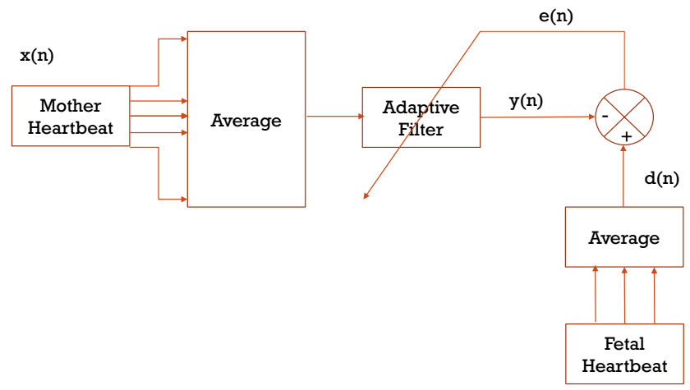

**Figure3:** SISO system

**2.3 Multiple Inputs Single Output System (MISO)**

For MISO system we obtained single output for multiple inputs. Multiple adaptive filters are used for adaptive noise cancellation for which individual thoracic signals (mother) x (n) are given reference for the adaptive filters and the average of filter outputs are given to the summer. And the average of abdomen signals d (n) is again given to the summer so that the fetal heartbeat signal is obtained as the output.

e (n) = d(n)-y(n) = fetal heartbeat

In MISO the reference signal (or) individual mother signals is given as multiple inputs to the adaptive, so in MISO mainly different adaptive filters are used for different mother signals. At the error side e (n) desired fetal heartbeat signal is obtained.

The adaptive algorithms like LMS, NLMS and LLMS are used in adaptive filter and the output is analysed for these algorithms and find the better adaptive algorithm for the fetal heartbeat extraction with minimal noise.

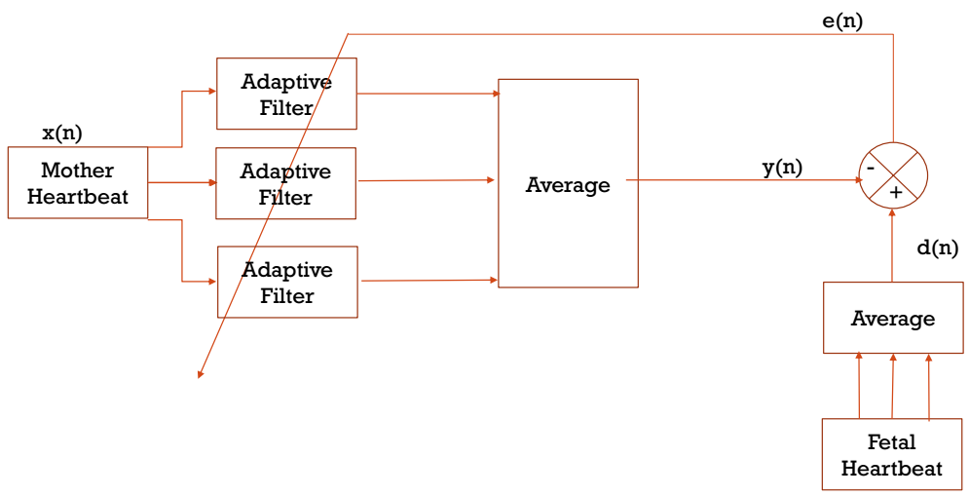

**Figure4:** MISO system

**2.4 Adaptive Algorithms**

Different types of adaptive algorithms that are used in an adaptive filter.

(i) LMS (Least Mean Squares).  
(ii) NLMS (Normalized Least Mean Squares).  
(iii) LLMS (Leaky Least Mean Squares).

**2.4.1 Least Mean Square algorithm (LMS)**

Eq.4 shows how filter weights / coefficients are updated in LMS.

The error signal e (n) is given by

e (n) = d (n) – y (n) (3)

Updated filter weights / coefficients given by

, (4)

where μ is the [step size](http://zone.ni.com/reference/en-XX/help/372357A-01/lvaftconcepts/aft_choose_stepsize/) of the adaptive filter, is the filter coefficients vector, e (n) is the error and is the filter input.

* Utilizes fewer computations to obtain the error minimization.
* Slow in convergence and sensitive to variations in step size parameter.
* Requires number of iterations equals to dimensionality of the input.
* It has range between *0< µ <*

**2.4.2 Normalized Least Mean Square algorithm (NLMS)**

Eq.5 shows how filter weights / coefficients are updated in NLMS.

(5)

* Modified form of the standard LMS algorithm.
* Time-varying step size.
* This step size improves the convergence speed of the adaptive filter.
* Convergence range of is in between 0 and 2.

**2.4.3 Leaky Least Mean Square algorithm (LLMS)**

Eq.6 shows how filter weights / coefficients are updated in LLMS.

(6)

* If  =0, the leaky LMS algorithm becomes the same as the LMS algorithm.
* Large leaky factor results in a large steady error.
* More stable compared to LMS due to the introduction of leaky factor.
* It has range between 0 < *< 0.001.*

|  |
| --- |
| **RESULTS AND DISCUSSIONS** |

**3.1 SISO system**

Here **Fig.5** represent the average of all abdominal signals is taken as primary input and average of all thoracic signals is taken as reference input to SISO system.

The **Fig.6** represents filter output in SISO system using all algorithms.

|  |  |
| --- | --- |
| **Figure5:** Data Signals | **Figure6:** Interfered Mother H.B (**filter output**) comparison |

**Fig.7,8,9** represent the comparison of child with mother heartbeat using different algorithms, **Fig.10** represent the child heartbeat obtained in using different algorithms.

|  |  |
| --- | --- |
| **Figure7**: Child & Mother H.B (LMS) | **Figure8**: Child & Mother H.B (NLMS) |
| **Figure9**: Child & Mother H.B (LLMS) | **Figure10**: Child H.B (**error**) comparison |

Here in LMS algorithm the chosen step size µ is equal to 0.00000001.

So the normalized step size as 𝞫= 0.00009 as per condition (0<𝞫<2).

For LLMS algorithm we choose leaky coefficient as = 0.0005 as per condition 0 < <1.

From **Fig.11** we can observe that in L-LMS (**Red ---** near 0.8 sec) peaks look smaller when compared to LMS and NLMS which makes us understand that noise ( i.e. MECG) still present in NLMS & LMS.

So from the extracted fetal plots we can say that LLMS has better extracted fetal heart beat with less noise also with better convergence speed.

**3.2 MISO system**

Every thoracic signal (Mother signal) is given as input to the reference signals to individual filter and then average is calculated.

**Fig.11,12,13** represent the comparison of child with mother heartbeat using different algorithms, **Fig.14** represent the child heartbeat obtained in using different algorithms.

|  |  |
| --- | --- |
| **Figure11:** Child & Mother H.B (LMS) | **Figure12:** Child & Mother H.B (NLMS) |

|  |  |
| --- | --- |
| **Figure13:** Child & Mother H.B (L-LMS) | **Figure14:** Child H.B (**error**) comparison |

Here **Fig.15** represents the filter output in MISO system

|  |
| --- |
| **Figure15:** Interfered Mother H.B (filter output) comparison |

* Here in LMS algorithm the chosen step size µ equal to 0.0000005.
* So the normalized step size a 𝞫 = 0.009 as per condition (0 < 𝞫 < 2).
* For LLMS algorithm we choose leaky coefficient as = 0.001 as per condition 0 < <1.

From **Fig.14** we can observe that in L-LMS (**magenta ---** near 0.8 sec) peaks look smaller when compared to LMS and NLMS which makes us understand that noise ( i.e. MECG) still present in NLMS & LMS.

So from the extracted fetal plots we can say that LLMS has better extracted fetal heart beat with less noise also with better convergence speed.

**SISO vs. MISO:**

|  |
| --- |
|  |
| **Figure16:** Child heartbeat comparison in SISO & MISO system |

From the **Fig.16** we can observe that the peak magnitudes in MISO are low compared to SISO, where the noise from abdominal is optimized up to maximum extent.

|  |
| --- |
| **CONCLUSION** |

1. From the obtained results we can say that in LLMS has better convergence speed compared to LMS and NLMS due to its varying step size and leaky factor. Also by observing the fetus ECG plot we can say LLMS peak is smaller when compared to LMS and NLMS, which represents fetal heart beat with less noise. So from the extracted fetal heartbeat plots we can say that LLMS has better extracted fetal heart beat with less noise.
2. Also when compared with different ANC systems (i.e. SISO & MISO) we can observe that MISO resulted in reduced error and optimization along with its stability compared with SISO.

|  |
| --- |
| **LIST OF FIGURES** |

### Figure Pg:no

**Figure1:** Location of ECG signals 5

**Figure2:** Adaptive Noise Cancellation (ANC) 6

**Figure3:** SISO system 8

**Figure4:** MISO system 9

**Figure5:** Data signals 11

**Figure6:** SISO filter output 11

**Figure7:** SISO Fetal Heartbeat LMS 12

**Figure8:** SISO Fetal Heartbeat NLMS 12

**Figure9:** SISO Fetal Heartbeat LLMS 12

**Figure10:** SISO Fetal Heartbeat comparisons 12

**Figure11:** MISO Fetal Heartbeat LMS 13

**Figure12:** MISO Fetal Heartbeat NLMS 13

**Figure13:** MISO Fetal Heartbeat LLMS 13

**Figure14:** MISO Fetal Heartbeat comparisons 13

**Figure15:** MISO system filter output 14

**Figure16:** Child heartbeat comparison in SISO & MISO system 14

|  |
| --- |
| **BIBILOGRAPHY** |

[1] IEEE An Intelligent Adaptive Noise Cancellation System for the Extraction of Fetal Electrocardiogram, RAVI KUMAR JATOTH, SALADI S V K K ANOOP, ISBN: 978-960-474-054-3.

[2] IEEE Fetal ECG Extraction Using Adaptive Filters, Arun A, Balakrishnan.

[3] Kumar, A., Dewan, L., Singh, M., and Kurukshetra, H., “Realtime monitoring system for ECG signal using virtual instrumentation”, IEEE Transactions on Biology and Biomedicine, vol. 3, pp. 638–643, 2006.

[4] Ferrara, E. R., and Widrow, B., “Fetal electrocardiogram enhancement by time-sequenced adaptive filtering”, IEEE Trans. Biomed. Eng. 29, pp. 458–460, 1982.

[5] Muhammad Wasimuddin and Navarun Gupta, “Design and Implementation of Least Mean Square Adaptive Filter on Fetal Electrocardiography’’,ISBN: 978-1-4799-5233-5.

|  |
| --- |
| **APPENDIX** |

**MATLAB CODE (SISO)**

%clearing commands%

clc;

clear all;

close all;

%loading input signal%

load foetal_ecg.dat

t = foetal_ecg(:,1);%loading time

abdominal = foetal_ecg(:,2:6); %loading abdominal signals

thoraic = foetal_ecg(:,7:9) ; %loading thoraic signals

avg_abdominal= mean(abdominal,2); %Average of abdominal signals

avg_thoraic= mean(thoraic,2); %Average of thoraic signals

reference=avg_thoraic;

figure

subplot(211);

plot(t,avg_abdominal);

title('Average of Abdominal Signals')

xlabel('Time [sec]');

ylabel('Amplitude [mV]');

subplot(212);%

plot(t,reference,'r');

title('Average of Thoraic Signals')

xlabel('Time [sec]');

ylabel('Amplitude [mV]');

%%

% GENERATING ANC

% USING LMS ALGORITHM%

nord1 = 8; %order of the filter

mu = .00000001; %value of step size

[W1,Child_E1,Maternal_Y1] = lms(reference,avg_abdominal,mu,nord1);

figure

plot(t,reference,'--k');

hold on

plot(t,Child_E1,'r')

title('SISO System Filter Error & Thoraic LMS');

xlabel('Time [Sec]');

ylabel('Amplitude [mV]');

legend('Mother HB','Child HB');

% USING NLMS ALGORITHM%

nord2 = 8; %order of the filter

beta = 0.00009; %value of beta in NLMS

[W2,Child_E2,Maternal_Y2] = nlms(reference,avg_abdominal,beta,nord2);

figure

plot(t,reference,'--k');

hold on

plot(t,Child_E2,'r')

title('SISO System Filter Error & Thoraic NLMS');

xlabel('Time [Sec]');

ylabel('Amplitude [mV]');

legend('Mother HB','Child HB');

% USING L-LMS ALGORITHM%

nord3 = 20; %order of the filter

gamma = 0.0005; %value of gamma in LLMS

ss3 = 0.000000075; % value of step size

[W3,Child_E3,Maternal_Y3] = llms(reference,avg_abdominal,ss3,gamma,nord3);

figure

plot(t,reference,'--k');

hold on

plot(t,Child_E3,'r')

title('SISO System Filter Error & Thoraic L-LMS');

xlabel('Time [Sec]');

ylabel('Amplitude [mV]');

legend('Mother HB','Child HB');

%%

% SISO Fetus signals

figure

subplot(211)

plot(t,Child_E1)

hold on;

plot(t,Child_E2,'--g')

hold on;

plot(t,Child_E3,'--r')

title('SISO Fetus signals using LMS,NLMS,L-LMS');

xlabel('Time [Sec]');

ylabel('Amplitude [mV]');

axis([0 5 -40 40]);

legend('LMS','NLMS','L-LMS')

%%

%ZOOMED SISO Fetus signals

subplot(212)

plot(t,Child_E1)

hold on;

plot(t,Child_E2,'--g')

hold on;

plot(t,Child_E3,'--r')

title('ZOOMED SISO System Fetus signals using LMS,NLMS,L-LMS');

xlabel('Time [Sec]');

ylabel('Amplitude [mV]');

axis([0 1 -25 14]);

legend('LMS','NLMS','L-LMS')

%%

% SISO Filter outputs

figure

plot(t,Maternal_Y1)

hold on;

plot(t,Maternal_Y2,'--r')

hold on;

plot(t,Maternal_Y3,'--c')

title('SISO System Filter outputs using LMS,NLMS,L-LMS');

xlabel('Time [Sec]');

ylabel('Amplitude [mV]');

legend('LMS','NLMS','L-LMS')

ylabel('Amplitude [mV]');

legend('LMS','NLMS','L-LMS')

**MATLAB CODE (MISO)**

clc;

clear all;

close all;

% loading input signal%

load foetal_ecg.dat

t = foetal_ecg(:,1); % loading time

abdominal = foetal_ecg(:,2:6); % loading abdominal signals

thoraic = foetal_ecg(:,7:9) ; % loading thoraic signals

avg_abdominal= mean(abdominal,2);% Average of abdominal signals

reference=thoraic;

avg_thoraic= mean(thoraic,2);

mu=0.0000005; % Value of stepsize in LMS%

gamma=0.001; % Value of leakyfactor in LLMS%

beta=0.009; % Value of stepsize in NLMS%

nord=15; % order of the filter

%%

%GENERATING ANC%

%USING LMS ALGORITHM%

[A1,Child_E1,Maternal_Y1] = lms1(reference,avg_abdominal,mu,nord);

figure

plot(t,avg_thoraic,'--k');

hold on

plot(t,Child_E1,'r')

title('MISO System Error & Thoraic LMS');

xlabel('Time [Sec]');

ylabel('Amplitude [mV]');

legend('Mother HB','Child HB');

%USING NLMS ALGORITHM%

[A2,Child_E2,Maternal_Y2] = nlms1(reference,avg_abdominal,beta,nord);

figure

plot(t,avg_thoraic,'--k');

hold on

plot(t,Child_E2,'r')

title('MISO System Error & Thoraic NLMS');

xlabel('Time [Sec]');

ylabel('Amplitude [mV]');

legend('Mother HB','Child HB');

% USING L-LMS ALGORITHM%

[A3,Child_E3,Maternal_Y3] = llms1(reference,avg_abdominal,mu,gamma,nord);

figure

plot(t,avg_thoraic,'--k');

hold on

plot(t,Child_E3,'r')

title('MISO System Error & Thoraic L-LMS');

xlabel('Time [Sec]');

ylabel('Amplitude [mV]');

legend('Mother HB','Child HB');

%%

% MISO Fetus signals

figure

subplot(211)

plot(t,Child_E1)

hold on;

plot(t,Child_E2,'--g')

hold on;

plot(t,Child_E3,'--r')

hold off;

title('MISO Fetus signals using LMS,NLMS,L-LMS');

xlabel('Time [Sec]');

ylabel('Amplitude [mV]');

axis([0 5 -40 40]);

legend('LMS','NLMS','L-LMS')

%%

%ZOOMED MISO Fetus signals

subplot(212)

plot(t,Child_E1)

hold on;

plot(t,Child_E2,'--g')

hold on;

plot(t,Child_E3,'--r')

title('ZOOMED MISO System Fetus signals using LMS,NLMS,L-LMS');

xlabel('Time [Sec]');

ylabel('Amplitude [mV]');

axis([0 1 -30 20]);

legend('LMS','NLMS','L-LMS')

%%

% MISO Filter outputs

figure

plot(t,Maternal_Y1)

hold on;

plot(t,Maternal_Y2,'--r')

hold on;

plot(t,Maternal_Y3,'--c')

title('MISO System Filter outputs using LMS,NLMS,L-LMS');

xlabel('Time [Sec]');

ylabel('Amplitude [mV]');

legend('LMS','NLMS','L-LMS')

ylabel('Amplitude [mV]');

legend('LMS','NLMS','L-LMS')