***Web Elements***

Achyuth J Shankar

Automation Testing Stream

1. **Web Elements on Login Page.**

**Username:**

name: username

placeholder: Username

xpath: //input[@name= “username”]

**Password:**

name: password

type: password

placeholder: Password

xpath: //input[@name= “password”]

**Login Button:**

type: submit

class: oxd-button oxd-button--medium oxd-button--main orangehrm-login-button

linkText: “Login”

xpath: //button

**Forgot your Password:**

class: oxd-text oxd-text--p orangehrm-login-forgot-header

linkText: “Forgot your password?”

1. **Elements present on Dashboards**

**Admin in sidebar**

xpath: //li[1]

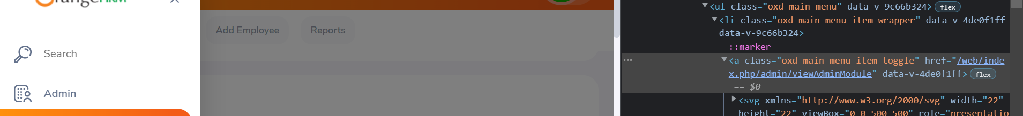

**PIM header**

Class: oxd-text oxd-text--h6 oxd-topbar-header-breadcrumb-module

Xpath: //h6

**Configurations**

Xpath: //span[@class='oxd-topbar-body-nav-tab-item']

linkText: “Configuration”



**Add button**

Xpath: //div[@class='orangehrm-header-container']/button

Type: button

Class: oxd-button oxd-button--medium oxd-button—secondary

