Anusha Nelluri – [anhx2@umsystem.edu](mailto:anhx2@umsystem.edu)

GitHub Link - <https://github.com/AchyuthValeti/Demo_Remote/tree/main/Webpart/ICP2>

Achyuth Kumar Valeti – [avgh3@umsystem.edu](mailto:avgh3@umsystem.edu)

GitHub Link - <https://github.com/AchyuthValeti/Demo_Remote/tree/main/Webpart/ICP2>

**ICP2**

**Introduction, HTML and CSS**

**Introduction:**

HTML is the foundation for creating any webpage. It is used to define structure of a webpage. CSS defines its style. To create any webpage, you need to know about HTML and CSS. You can create amazing websites using both.

**Tasks:**

1. Initially we have created a HTML file in the source folder of ICP2.

1. A webpage created using HTML and CSS. Each element of webpage is explained below. Initially we have created a Title called ICP2-WEB.

**HTML Code:**

**Web Page:**

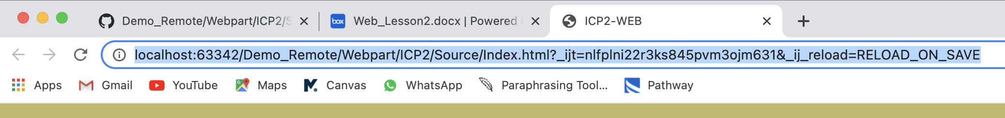

* **Heading:** To display our titles or subheadings in a webpage we use Headings in HTML. Headings can be displayed by using h tags (<h1 >to <h6>) based on the size you want to present. We have shown “Web Assignment” as main heading.
* **Paragraph:** To write the content inside a webpage we use paragraph in HTML. Paragraph can be displayed by using <p> tag. We have written our team information in paragraph.
* **Ordered List:** An order list (<ol> tag) in HTML is used when you want to show a list in an order with a number. We have shown the ICP2 Tasks using this.
* **Unordered List:** An unorder list (<ul> tag) in HTML is used when you want to show a list without any number. In webpage it will display with a dot for every list you want show. We have shown the ICP2 Tasks using this.

**Web Page:**

**HTML code:**

* **Div and Span Elements:** A div element is used for Block level elements organization and Span element is used to show the Inline element organization. If we want to represent a group of elements with a specific style, then we use Div element using <div> tag. In case if you want to change style of specific text then we can use Span element using <span> tag. We have shown guidelines and Note of ICP assignment to show the Div and Span elements.

**Web Page:**



**HTML Code:**

* **Block elements:** HTML elements historically were categorized as either "block-level" elements or "inline-level" elements. Since this is a presentational characteristic, it is nowadays specified by CSS. A Block-level element occupies the entire horizontal space of its parent element (container), and vertical space equal to the height of its contents, thereby creating a "block". We have taken 2 ICP assignments, our contact email to show the Block elements. Tags used <dl>, <dt>, <dd>, <address>.

**Tag Description:**

<dl> - used to define a description list

<dt> - used to define a name/term in description list and it should be followed by <dd>

<address> - used to define the contact/address of a person.

**Web Page:**

**HTML Code:**

* **Inline Elements:** Inline elements are those which only occupy the space bounded by the tags defining the element, instead of breaking the flow of the content. We have used Inline tags like <i>, <strong>, <a>, <b>, <span> in our code.

**Tag Description:**

**<i> -** used to make Italic text

<strong> - used to highlight the important word

<b>- used to show the text in bold color

<span> - used to change the color of specific text

<a> - used to hyperlink the text

**Web Page:**



**HTML Code:**

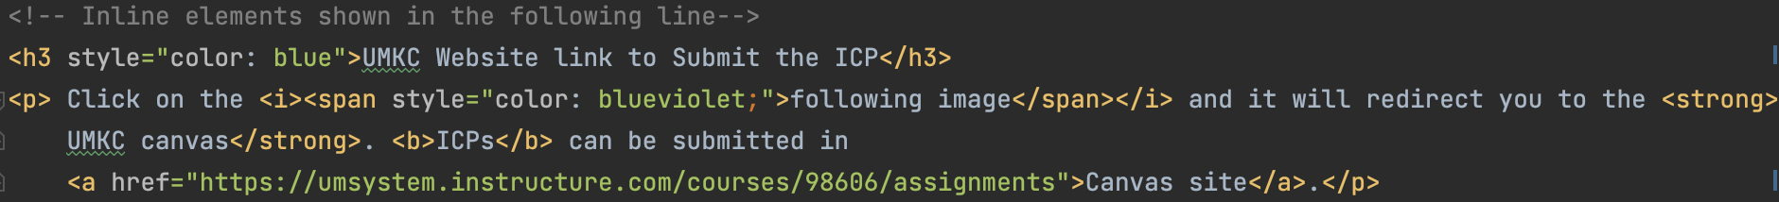

* **Embedded Image:** We have taken UMKC image, when you click the image, it will redirect to the image location. We have use <img> tag for executing.

**Web Page:**

**HTML Code:**

* **Embedded video:** We have used a YouTube video explaining the HTML tags. Embedded video has play, pause options as well.

**Web Page:**

**HTML Code:**

**Contribution**

We have contributed equally.

**Conclusion**

In this ICP2, we have learned various HTML Tags, CSS Tags, and their applications in creation of a webpage.

And, we have not faced any major challenges while doing the assignment.