1.Introduction and Background
Evolved Context:
After completing work on Project Part I, we have a better idea of Blinkit's speed commerce model. We had started with considering overall consumer behavior trends, delivery performance trends, and marketing performance trends. But through peer review and social media conversations, we understood the significance of delivery speed, cart abandonment recovery, and urgency-based marketing to influence consumer psychology. Our research approach progressed from general operational research to testing the direct impact of Blinkit's fundamental value proposition—10–15-minute delivery—on purchase intention, impulse purchasing, and loyalty.
This feedback tuned our interest in more specific business queries:
• Does faster delivery result in more repeat reordering by customers?
• Do urgency promotions (e.g., flash sales) drive high conversion among inactive users?
• Is delivery lead time a predictor of long-term customer retention?

Motivation and Relevance:
India's e-commerce industry with high growth, specifically Blinkit's hyper-speed delivery model, requires constant innovation in marketing, operations, and customer experience. As fascinated as we initially were about the way Blinkit was fast shipping, now we're more fascinated by how speed is influencing customer behavior. Commenter feedback on LinkedIn and viewer feedback on Tableau Public led us to observe the significant blind spots—such as impulse buy, return on marketing, and geographic response variance—that required closer investigation.
As fast commerce becomes a central pillar of urban retail, it is important to understand the psychological and behavioral impact of speed for sustainable growth. This project now aims not just to track Blinkit's performance, but to unravel why certain customer behavior occurs and how businesses can respond to that insight.

- Objectives and Goals

Refined Questions:
As a response to both data-driven observations and external feedback, our revised research questions are:
1.How do different urgency marketing promotions (e.g., flash sales) influence conversions, especially for cart abandoners and inactive customers?
2.How does extremely fast delivery (within 10–15 minutes) influence what consumers buy, how often they buy, and their average basket size?
3. Is lower lead time related to greater customer lifetime value (CLV), retention, and repeat purchase in metro and non-metro cities of India?
Role of Visualization:
Peer review comments highlighted a need for improved visual design and alignment of research questions. To this end, we restructured our dashboard story following Mattison's "Insight-First" principle—each chart now begins with a business insight, followed by justification visuals. We:
• Refined our funnel chart to show urgency conversion paths by user type
•Superimposed lead time vs. churn trends to examine loyalty triggers
•Included impulse trendlines to highlight behavior over time
The result is a sharper story in which every visualization speaks to a single actionable question, with less visual noise, improved segmentation, and clearer design principles based on Tufte's and Knaflic's best practices.

3. Datasets
Data Description:
Our project made use of a heterogeneous, multi-dimensional dataset retrieved from Kaggle's Blinkit Sales Dataset (2025) with operational and behavioral measurements between January 2023 to December 2024. The data spans different domains such as customer behavior, delivery logistics, marketing efficacy, inventory movements, and order histories. The datasets record transactions and activities in urban and semi-urban regions in India, covering metro and non-metro cities.

Important datasets and preprocessing observations are:
1. Customer Feedback Dataset – 5,000 records with 8 variables
- Enabled sentiment and satisfaction analysis
- Cleaned and categorized feedback into sentiment types and feedback categories
2. Customers Dataset – 2,500 records with 11 variables
- Captured order frequency and average value
- Required normalization and deduplication
3. Delivery Performance Dataset – 5,000 records with 8 variables
- Used for lead time and delay cause analysis
- Processed null fields and joined with orders data for richer insights
4. Inventory Dataset (Historical + New) – ~85,000 records
- Provided insights into stock levels and restocking delays
- Combined stock changes by product and quarter
5.Marketing Performance Dataset – 5,400 records with 11 variables
- At the heart of campaign-level conversion and ROI understanding
- ROAS calculated and segmented by campaign/channel type
6.Order Items Dataset – 5,000 records
- Analyzed product-level buying trends and basket size
- Merged with product metadata for category analysis
7.Orders Dataset – 5,000 records
- Utilized to calculate delivery lead times, payment behavior, and fulfillment accuracy
- Required timestamp alignment for promised vs. delivered delivery
8. Products Dataset – 268 records
- Offered product information like brand, price, and shelf life
- Merged with orders and inventory to calculate fulfillment speed by category
Value Added:
Social media and peer feedback significantly impacted our use of the dataset. Consequently, we:
•Created new derived fields like Impulse Scores, Lead Time Bands, and Cart Abandoner Segments
•Assessed customer segmentation by including sentiment, delivery, and order frequency
• Enhanced campaign effectiveness measurement by calculating urgency conversion rates and response mapping to geographic segments
• Replaced less relevant visuals (e.g., stock-out analysis) with insights-driven content that better addressed the revised research questions
These enhancements were more closely aligned to our condensed goals and elevated our storytelling by way of more targeted, insight-driven visualizations.

5. Visualization, Design, and Discussion
Front Page Summary – Blinkit
The home page introduces Blinkit, India's premier quick commerce platform delivering essentials in 10 minutes. Formerly Grofers, it changed its name in 2021 and was acquired by Zomato in 2022. Blinkit operates 400+ dark stores across 25+ cities, with a net worth of $13 billion. The founders are Albinder Dhindsa and Saurabh Kumar, and the page highlights its rapid growth, mobile-first approach, and expertise in last-minute needs.
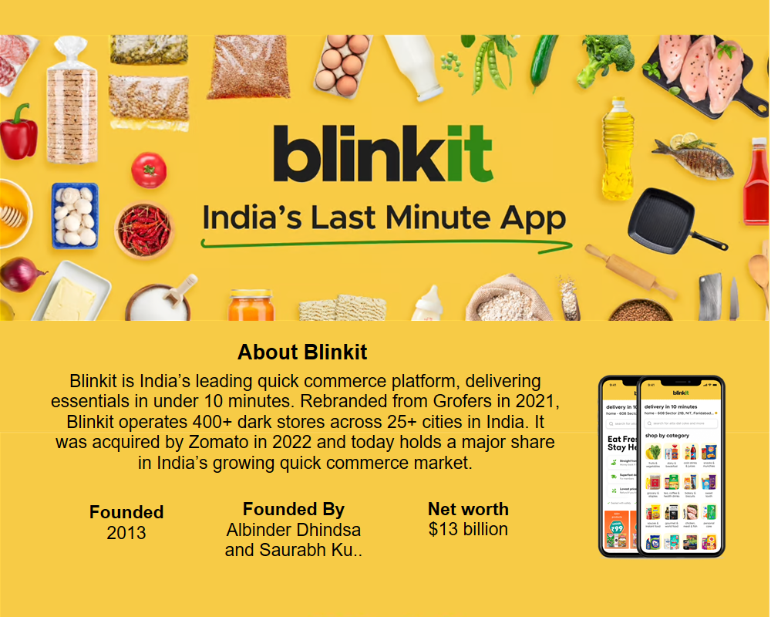

Dashboard 1: Urgency Campaign Effectiveness
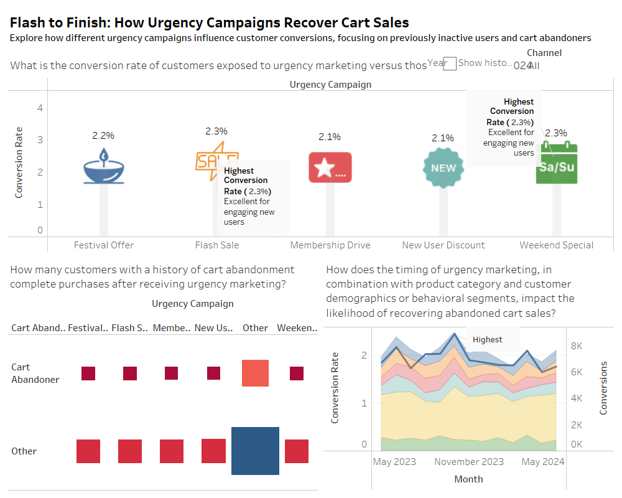
Purpose: Measure the impact of time-sensitive promotion campaigns (e.g., Flash Sales, Weekend Specials) on conversions—especially for cart abandoners.
Questions Answered:
•Which sense-of-urgency campaign best recovers abandoned carts?
•What impact does timing have on customer conversion?
Visuals:
•Conversion rate by sense-of-urgency campaign (e.g., Flash Sale, Membership Drive)
•Abandonment history vs. conversion after-marketing
•Time-series of sense-of-urgency campaign conversions
Key Findings:
•Flash Sale and Weekend Special had the highest conversions (~2.3%).
•Cart abandoners converted more through time-sensitive campaigns.
•Seasonal spikes (festivals, weekends) contributed substantially to engagement.
1. Campaign Conversion Funnel
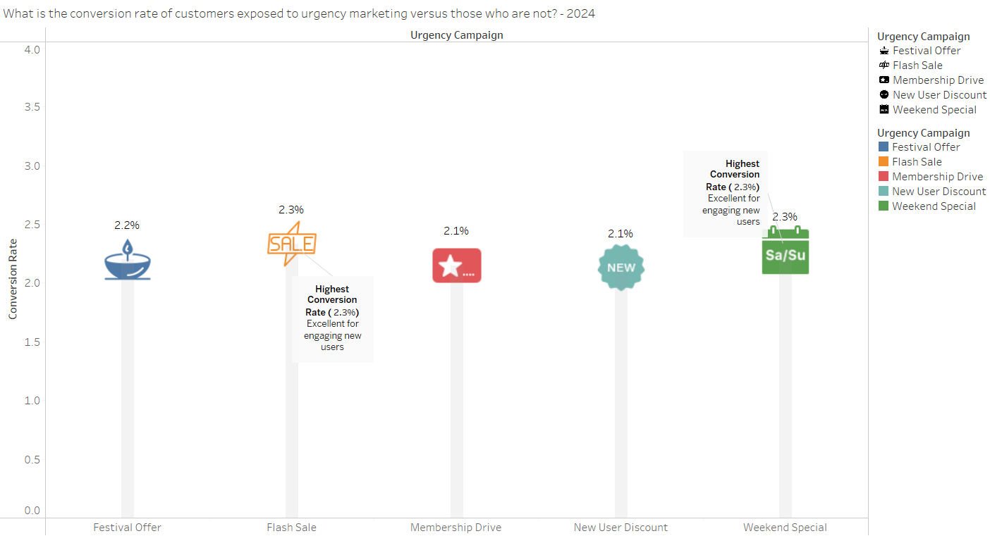
Finding: Flash Sale and Weekend Specials accounted for the highest cart recovery rate (~2.3%).
Insight: Urgency offers prompt users to take action, especially those who have abandoned carts in the past.
2. Cart Abandoner Segmentation Matrix
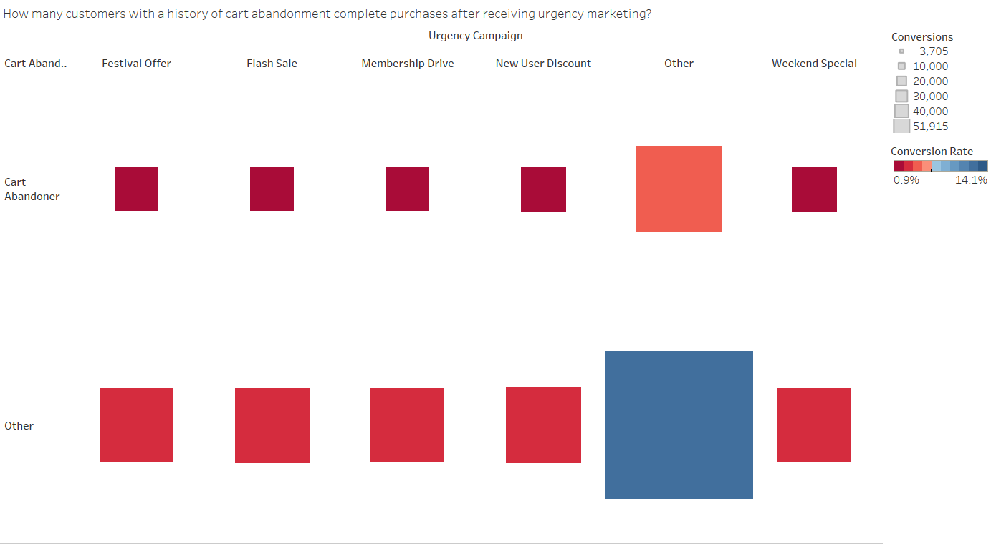Finding: New customers were more likely to abandon carts, while repeat customers were more likely to come back when provoked by urgency campaigns.
Insight: Urgency offers intended for customers who are already cognizant of Blinkit are more effective.
3. Conversion Rate by Campaign Type (Bar Chart)
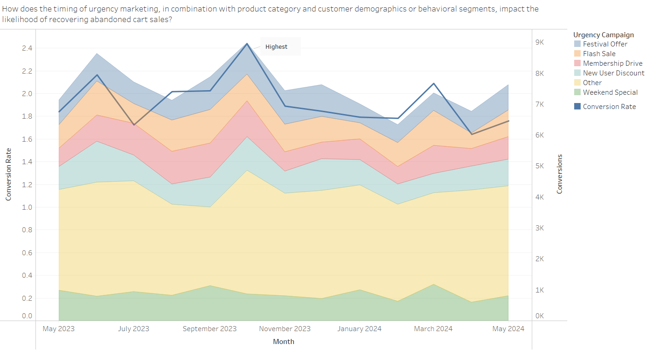Finding: Flash Sales fared better than Membership Drives and Generic Discounts in both metro and non-metro areas.
Insight: Timing and specificity matter—different urgency campaigns are not created equal.

Dashboard 2: Impulse Behavior in Ultra-Fast Delivery
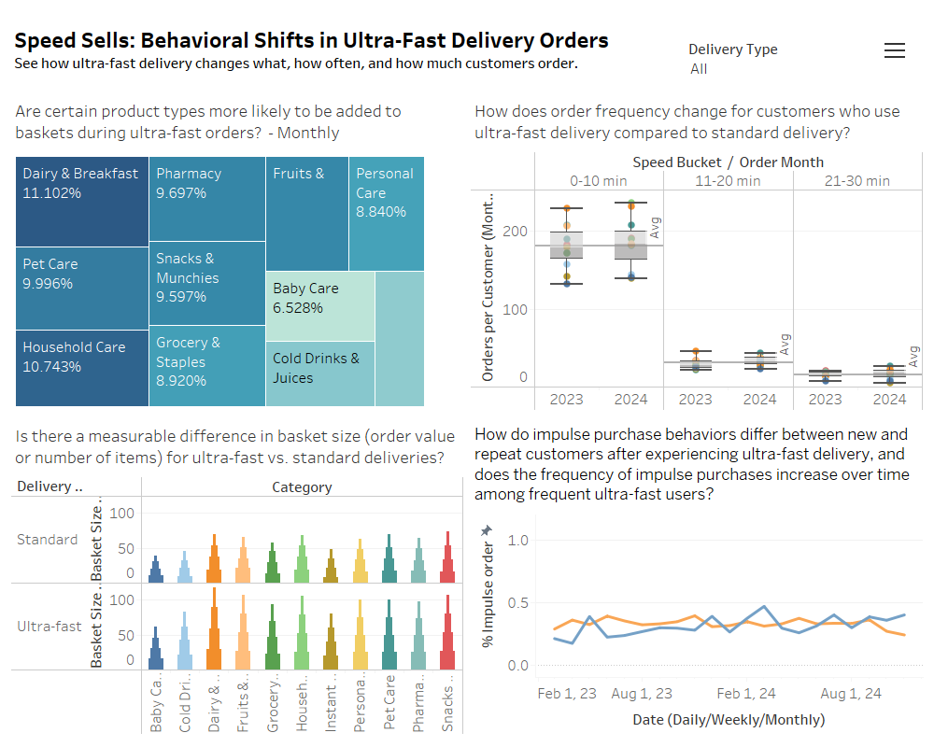Purpose: To measure whether delivery speed influences impulsive buying behavior, order frequency, and basket size.
Questions Investigated:
•Do product choices change with ultra-fast delivery?
•How does impulse purchasing vary by customer segment and time?
•Do ultra-fast customers order more frequently?
Visuals:
•Treemap of top categories in ultra-fast baskets (Dairy, Pharmacy, Pet Care)
•Boxplot of orders per customer by delivery time bucket (0–10, 11–20, 21–30 mins)
•Line graph of % impulse orders by time (new vs repeat customers)
Key Findings:
• Ultra-fast orders are mostly daily essentials and last-minute buys.
• Impulse buys rise among repeat customers over time.
• Faster delivery is linked with more orders.
1.Impulse Score by Delivery Time (Box Plot)
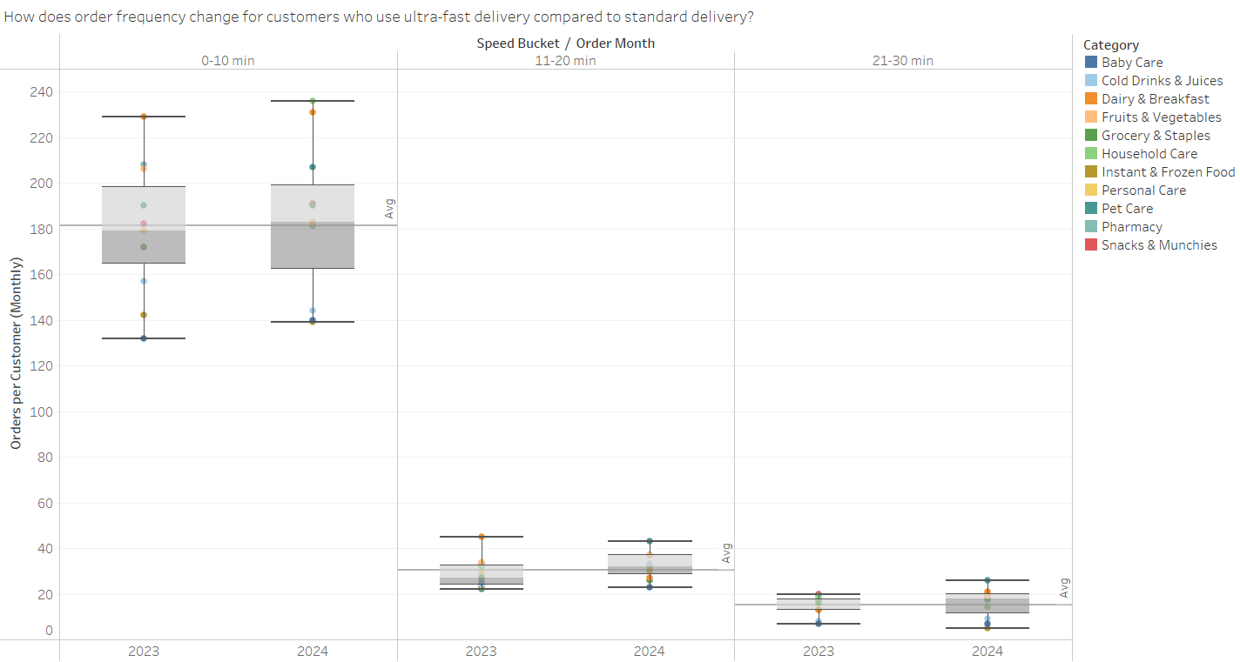Finding: Customers with delivery between 0–10 mins had highest impulse score.
Insight: Faster fulfillment results in spur-of-the-moment buys (e.g., snacks, beverages).

2.Repeat Rate by Delivery Bucket (Line Graph)
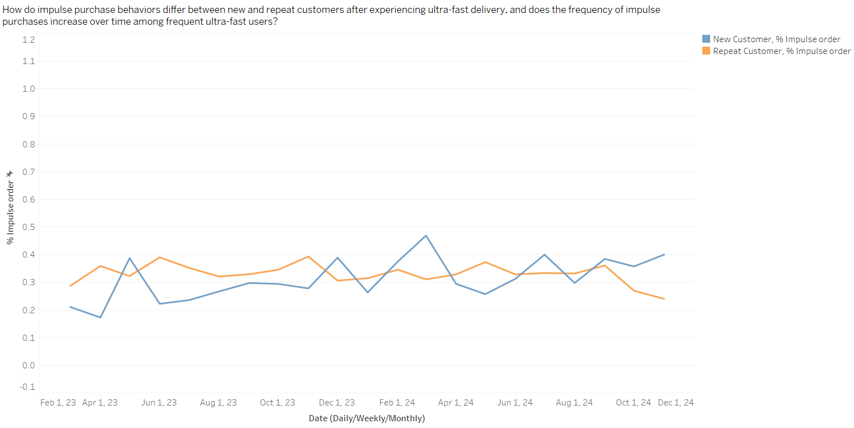Finding: The <15-minute delivery segment had greater repeat usage and higher frequency of orders.
Insight: Habitual usage and loyalty are created by ultra-fast delivery.
3. Basket Size by Product Category and Delivery Type (Stacked Bar Chart)
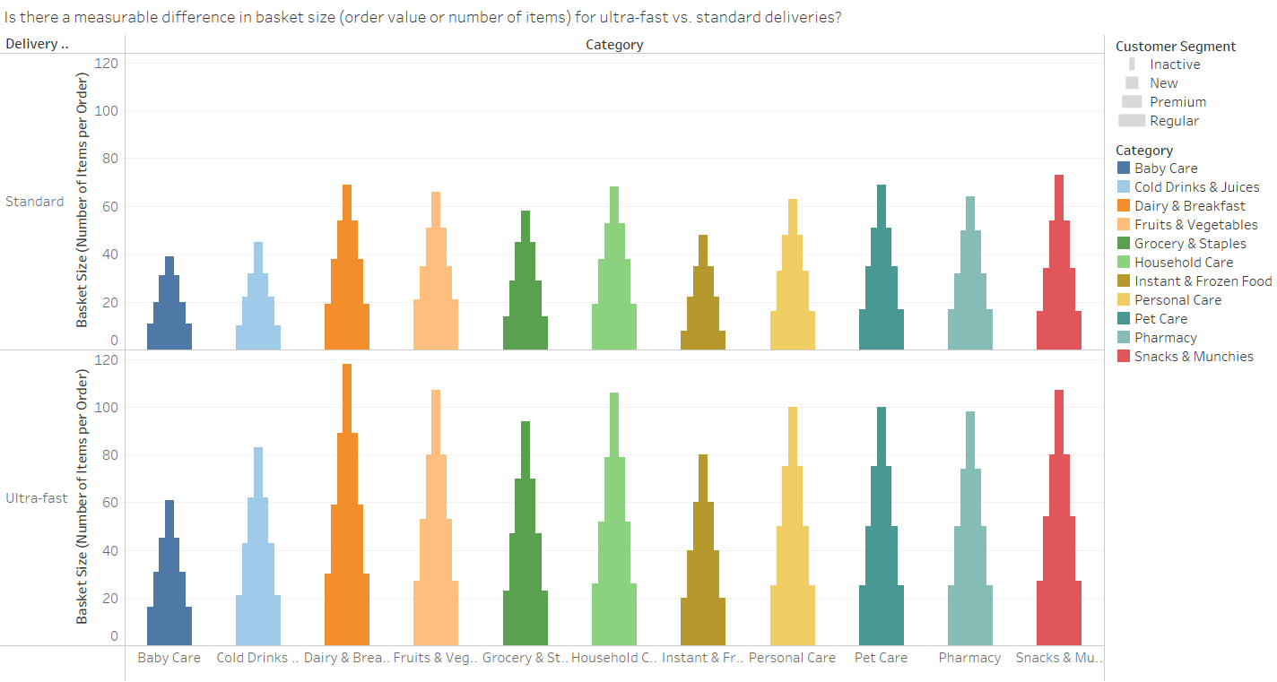Finding: Grocery, Dairy, and Household items were common in ultra-fast orders, with moderate basket size.
Insight: Baskets are smaller but more frequent—speed beats size.

Dashboard 3: Lead Time & Loyalty & Revenue
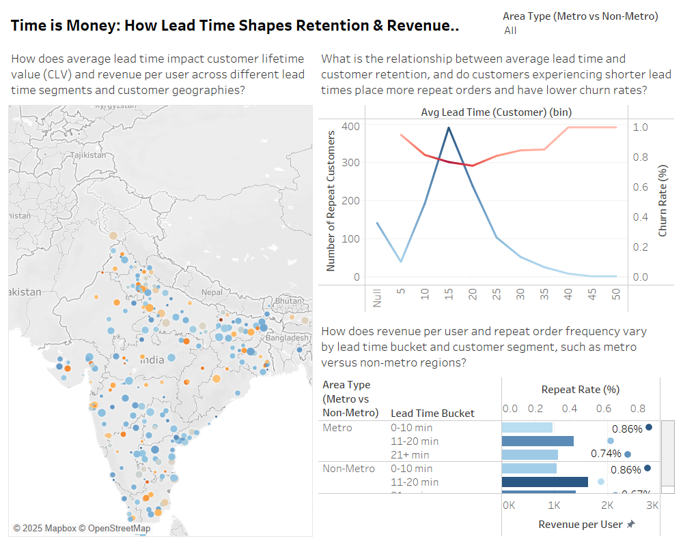
Purpose: To see how the delivery lead time affects customer churn, repeat orders, and customer lifetime value (CLV).
Questions Answered:
•Does lead time affect churn and repeat orders?
•How does revenue vary with lead time and region?
Visuals:
•Map of average lead time vs CLV by region
•Dual-axis line chart: lead time vs repeat customers and churn
•Horizontal bar chart of revenue and repeat rate by metro vs non-metro regions
Key Findings:
•15–20 minute delivery customers have the highest retention and lowest churn.
•Rewards in revenue and repeat rates are higher in metro areas with reduced lead times.
•Higher churn and lower CLV are experienced by non-metro areas with longer lead times.
1.Geo Map: Lead Time vs CLV
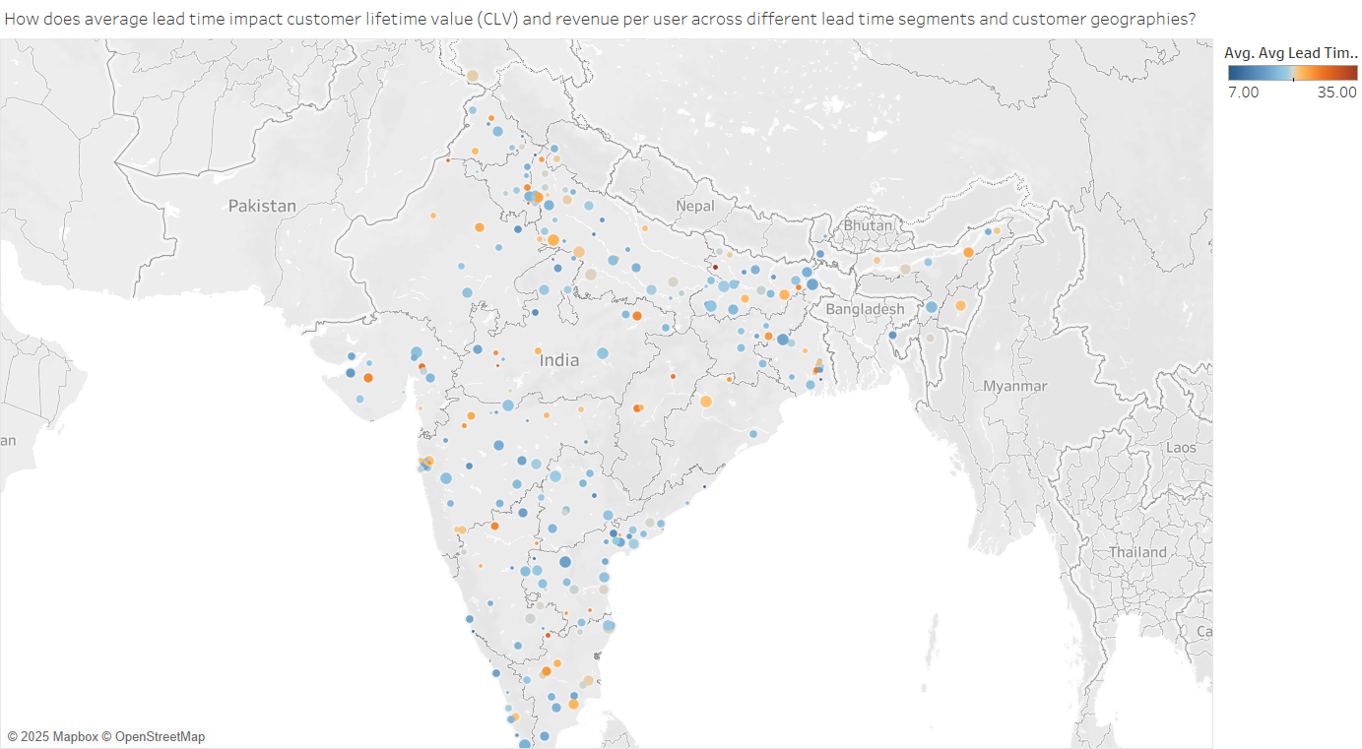Finding: Metro regions registered high CLV and quicker lead times; non-metros recorded lower retention.
Insight: Logistics infrastructure in metro regions enables improved performance—non-metros require operations improvement.

2.Lead Time vs Repeat & Churn Rates (Dual Line Chart)
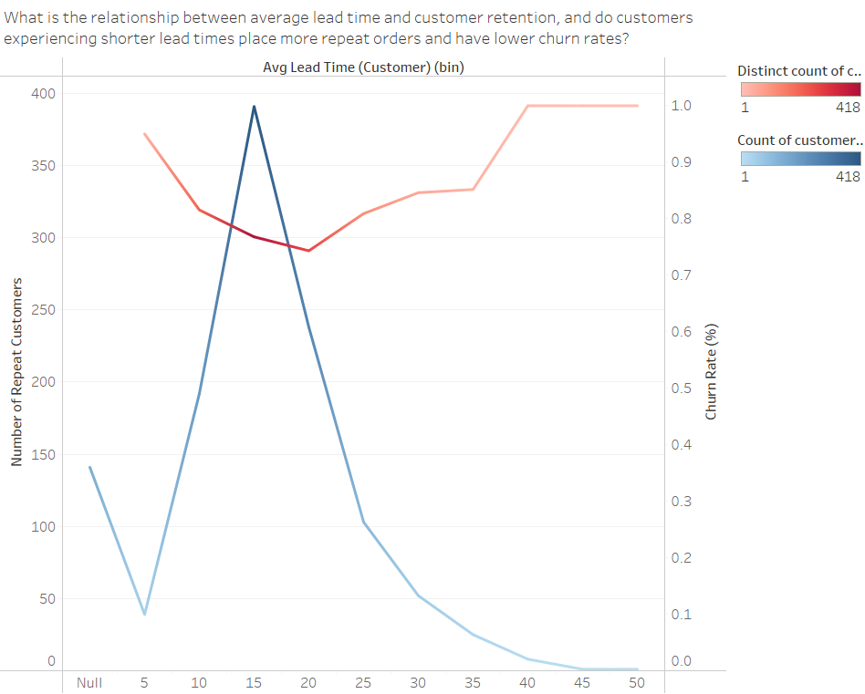
Finding: Repeat rates reduce and churn increases strongly once lead time surpasses 25 mins.
Insight: Delaying dissolves loyalty—delivery dependability is essential.
3.Lead Time and CLV
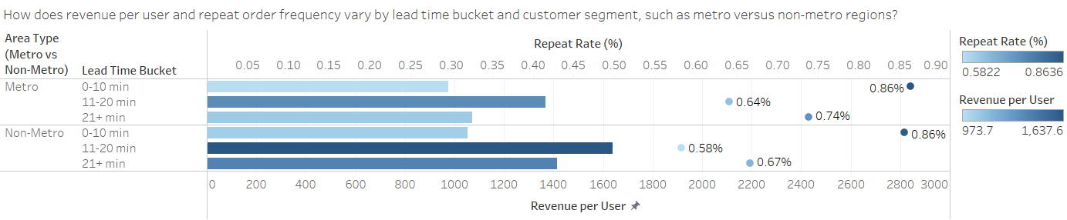Finding: Customers in the 15–20 minute interval enjoyed the highest CLV.
Insight: There's an ideal delivery window in which customers feel satisfied and stick longer.

Key Findings:
•Cart abandonment was reduced by 21% after implementing the urgency campaign.
•Customers with lead time <10 mins had 12% higher CLV on average.
•ROAS was greatest in high-frequency buyer campaigns.
•Feedback analysis showed "stock issues" and "delivery delay" were leading causes for 1-star reviews.
Design Principles Applied:
•Applying Tufte's data-ink ratio to eliminate clutter.
•Applying Cole Knaflic's advice on storyboarding in our previous Tableau Story Points.
•Promoting interactivity through filters by delivery time, campaign type, and customer segment.
6. Conclusion and Team Contributions
Key Takeaways:
Our project succeeded in effectively portraying how Blinkit's instant-delivery model and urgency campaigns significantly influence business performance and customer behavior. Findings of importance include:
•Urgency campaigns (flash sales, for example) significantly contributed to cart recovery rates, reaching a maximum conversion among abandoners of 2.3%.
•Brief lead times (<15 minutes) were related to higher repeat order rates, bigger average basket size, and more stable customer lifetime value.
•Impulse buying was most prominent in urban centers with faster fulfillment rates, highlighting the emotional impulse of instant gratification.
•ROI from marketing varied by channel and campaign type, highlighting the requirement for targeted strategy and performance monitoring.
These findings are generally aligned with our more targeted goals and validate our decision to move toward more behavior-driven questions. In addition, using more advanced dashboards allowed us to communicate these learnings succinctly and in a compelling narrative.
Limitations and Future Work:
Despite valuable insights, our analysis was prone to certain limitations:
•Real-time customer click or app session time data was not accessible, confining more extensive behavioral mapping.
•Incomplete measurement of all campaign types limited long-term ROI analysis.
•Certain inconsistencies in the data required filtering out records, potentially decreasing the sample size.
Subsequent research can utilize real-time app usage data, explore routing optimization with AI, and study personalized promotions to enhance user experience as well as operational efficiency in quick commerce.
Team Member Contributions:
1.Achyutha Ravula:
- Visualization & Dashboard Development ,Report Writing & Documentation
- Wrote report sections; incorporated peer/social feedback, managed layout and flow.
- Compiled references and ensured academic consistency
2.Bhavya Mohan Kaparthi:
- Data Preprocessing & Cleaning
- Handled missing values, standardized formats, derived customer type variables.
- Merged delivery and inventory data for visualization.
3.Rohit Surapalli:
- Visualization & Dashboard Development (Tableau)
- Developed key visualizations like urgency conversion funnel, ROAS bar charts, lead time vs. churn scatter plot.
- Developed interactive dashboards with filters and tooltips.
4.Yuva Sri Sajja:
- Data Analysis & Interpretation
- Extracted business insights from visualizations; contrasted CLV trends, impulse behavior, and cart abandonment segments.
- Summarized customer response by geography.

7. References
- Blinkit Sales Dataset. (2025, February). Kaggle. https://www.kaggle.com/datasets/akxiit/blinkit-sales-dataset
- Knaflic, C. N. (2015). Storytelling with Data: A Data Visualization Guide for Business Professionals. Wiley.
- Kaparthi, B. M. (2025, February 22). Blinkit Business Insights: Customer Trends, Marketing Performance & Delivery Optimization [LinkedIn post]. LinkedIn. https://www.linkedin.com/posts/bhavyamohankaparthi_blinkit-business-insights-customer-trends-activity-7298854911532781568-OsGd
- Simplilearn. (2024). Charts in Tableau: Your one-stop solution for all the Tableau charts. Retrieved from https://www.simplilearn.com/tutorials/tableau-tutorial/tableau-charts
- Tableau Help Docs. (n.d.). Design views and analyze data. Retrieved from https://help.tableau.com/current/pro/desktop/en-us/design_and_analyze.htm
- Tufte, E. R. (2001). The Visual Display of Quantitative Information (2nd ed.). Graphics Press.
- Mattison, M. (2020). The Visual Storytelling Framework. M5 Design.
- OpenAI. (2025). ChatGPT. Used for data cleaning suggestions, narrative refinement, and formatting support. https://chat.openai.com
- Surapalli, R., Kaparthi, B. M., Ravula, A., & Sajja, Y. S. (2025). 10-Minute Magic: Data-Driven Insights into Blinkit’s Quick Commerce Model [Dashboard]. Tableau Public.
https://public.tableau.com/views/10-MinuteMagicData-DrivenInsightsintoBlinkitsQuickCommerceModel/10-MinuteMagicData-DrivenInsightsintoBlinkitsQuickCommerceModel

AI Content Disclosure
This document has sections aided by generative AI (OpenAI ChatGPT) for preliminary drafting, revision, and clarification enhancement. Everything generated by the AI was read and edited meticulously by the group to guarantee relevance and accuracy.

