Project Report
Loan Approval Classification Using Big Data Analytics
DSCI 5350 – Big Data Analytics
G. Brint Ryan College of Business
University of North Texas
Denton, TX
December 2024
Executive Summary
Objective: "To analyze loan application data using big data tools to identify key factors influencing loan approval."
Key Findings:
- Previous_loan_defaults and loan_percent_income are the strongest predictors of loan approval.Applicants with previous_loan_defaults are less likely to get approved.
- The Random Forest model achieved higher accuracy than linear regression model with 93%.
Impact: "The findings help financial institutions improve risk assessment and streamline loan processing."
Project motivation/background
- Loan approval is vital for financial institutions, affecting profitability and applicants' financial opportunities. With the rise of digital transactions, manual evaluations become inefficient.
- The availability of rich datasets provides an opportunity to leverage machine learning techniques to improve prediction accuracy.
- Minimizing loan defaults by identifying high-risk applicants helps reduce financial losses.
- Benefits:
  - For Financial Institutions: Increases efficiency, accuracy, and reduces risks.
  - For Applicants: Ensures fair, transparent, and fast decisions, boosting customer satisfaction and inclusion.
Dataset Description
This dataset is retrieved from Kaggle.com. The dataset contains 45000 rows and 14 columns for classifying loan approval status based on the applicant details. The attributes for each applicant are as follows:
Person_age | Age of the applicant
Person_gender | Gender of the applicant
Person_education | Highest level of education of the applicant
Person_income | Annual income of the applicant
Person_emp_exp | Employment experience in years
Person_home_ownership | Home ownership status of the applicant
Loan_amnt | Requested loan amount
Loan_intent | Purpose of the loan
loan_int_rate | Interest applied to the loan
Loan_percent_income | Loan amount with respect to the percentage of annual income
cb_person_cred_hist_length | Years of credit history
Credit_score | Credit score of the applicant
Previous_loan_defaults_on_file | Categorical indicator of previous loan defaults
Loan_status | Status of the loan ( 1 = approved, 0 = rejection

Key Variables:
- Demographics: Age, Gender, Education, Employment Experience.
- Financials: Income, Home Ownership, Credit Score, Loan Amount.
- Loan Features: Interest Rate, Loan Purpose, Loan Status.
- Summary Statistics:
  - Average credit score: 632
  - Average loan amount: 9583
  - Approval rate: 22%
Data Preparation
- Checked for missing values: None found.
- Replaced person_age greater than 100 with median values.
- Applied feature encoding (binary, ordinal, one-hot) for categorical variables.
- Scaled numerical features using standard scalar.
- Split data into training and testing sets (e.g., 80/20 split).
- Apache Spark was used to handle data preprocessing and model training efficiently at scale.
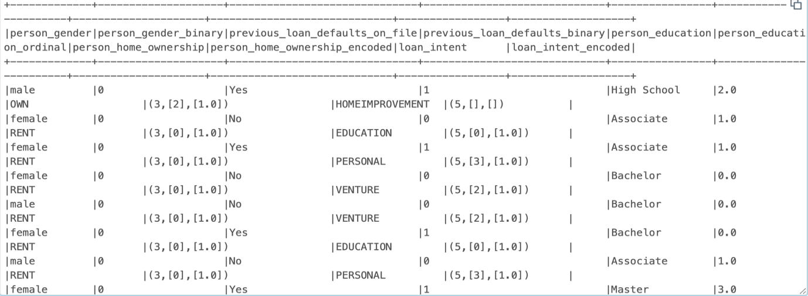
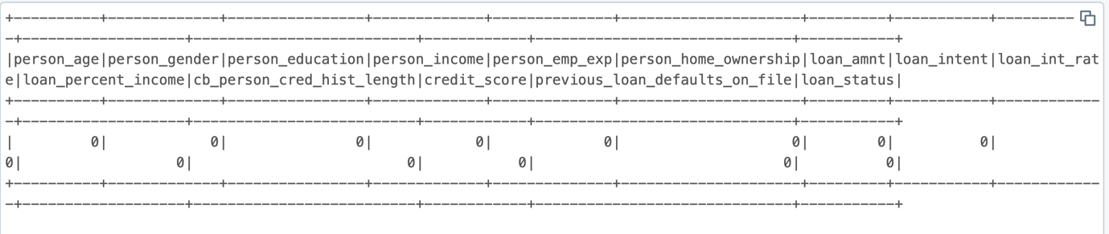
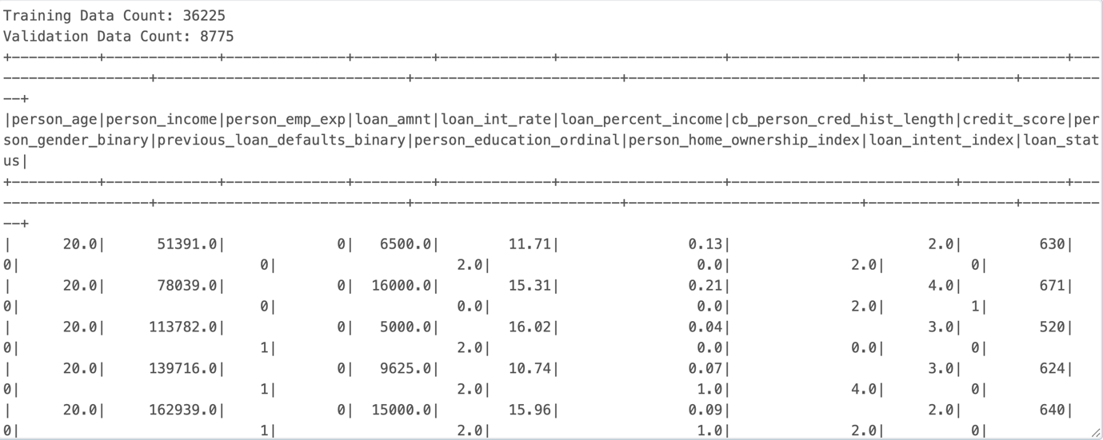

Exploratory Data Analysis (EDA)
Target Variable Distribution – Key Observations
- The target variable exhibits a significant class imbalance, with rejected loan applications (0) comprising the majority of the dataset.
- Approved loans (1) represent approximately 22% of total observations.
- This imbalance emphasizes the need for evaluation metrics beyond accuracy, as a naive classifier could achieve high accuracy by favoring the majority class.
- To address this challenge, tree-based models such as Random Forest were explored to better capture complex patterns within the minority approval class.
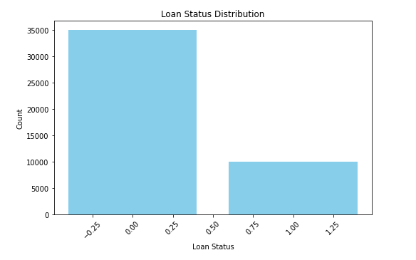
Categorical Variable Analysis:
- Gender:
Loan approval outcomes show minimal variation across genders, suggesting limited bias in approval decisions.
- Education Level:
Applicants with Bachelor’s and Master’s degrees exhibit relatively higher approval counts compared to other education categories.
- Home Ownership:
Renters account for a higher volume of applications and rejections, while mortgage holders display comparatively lower approval rates, indicating home ownership as an important risk indicator.
- Loan Intent:
Loan purpose influences approval outcomes, with medical and debt consolidation loans showing higher approval counts than venture and education loans.
- Modeling Insight:
These categorical patterns provide early insights into applicant risk profiles and support informed feature selection for predictive modeling.

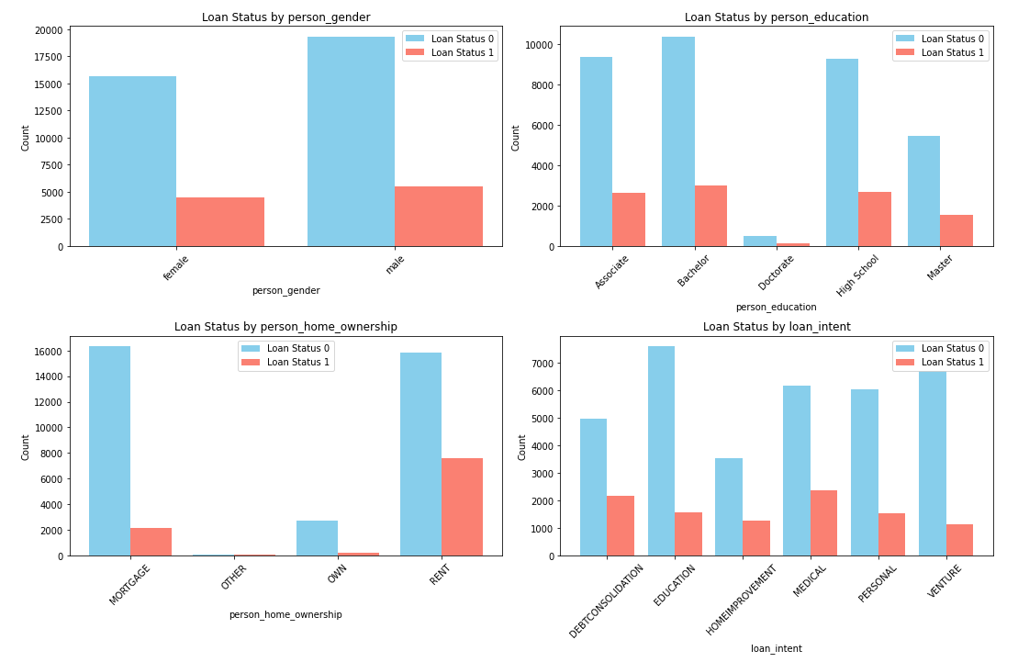
Correlation Heatmap:
- Variables like person_income and loan_amnt show a high correlation (close to 0.59), suggesting that as income increases, the loan amount also tends to increase.
- previous_loan_defaults_binary and loan_status show a negative correlation (-0.54), suggesting that previous defaults negatively impact loan approval.
- person_gender_binary has made no contribution for classification of approval or rejection of loan.
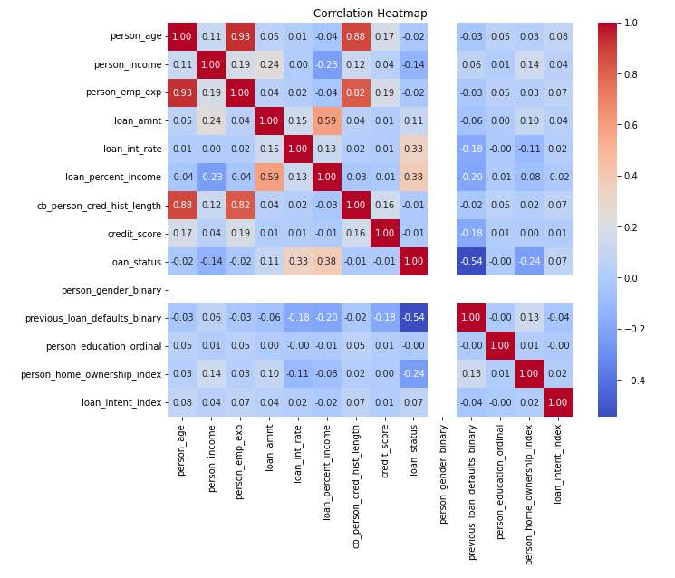
- loan_percent_income (0.38) and loan_int_rate (0.33) show significant positive correlations with loan_status.
- This suggests these features may be influential in determining loan approval.
- previous_loan_defaults_binary (-0.54) has a strong negative correlation, indicating that previous loan defaults significantly reduce the likelihood of loan approval.
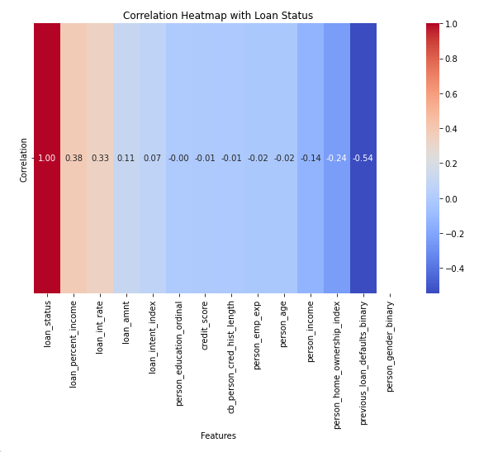
Data Analytics 1 – Logistic Regression
- Logistic Regression was used as a baseline model.
- - Achieved an accuracy of 89%.
- - Key insights: Higher loan-to-income ratios and no previous defaults increase approval chances.
- True Positives (TP):1431 instances were correctly classified as 1 (approved loans).
- False Negatives (FN):506 instances of 1 (approved loans) were misclassified as 0 (rejected loans). This indicates the model is missing a significant portion of approved loans.
- True Negatives (TN):6,393 instances were correctly classified as 0 (rejected loans).
- False Positives (FP):445 instances of 0 (rejected loans) were misclassified as 1 (approved loans).
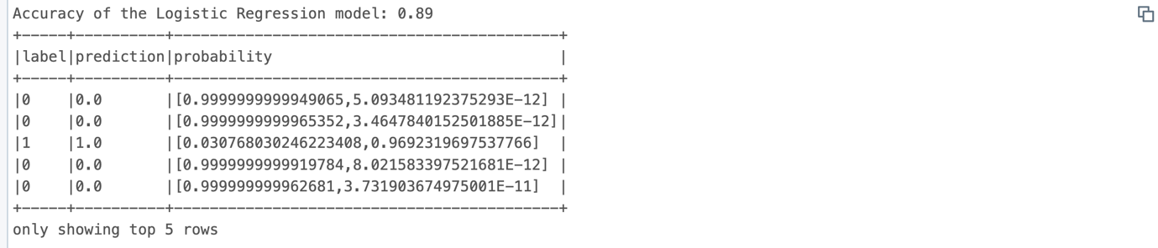

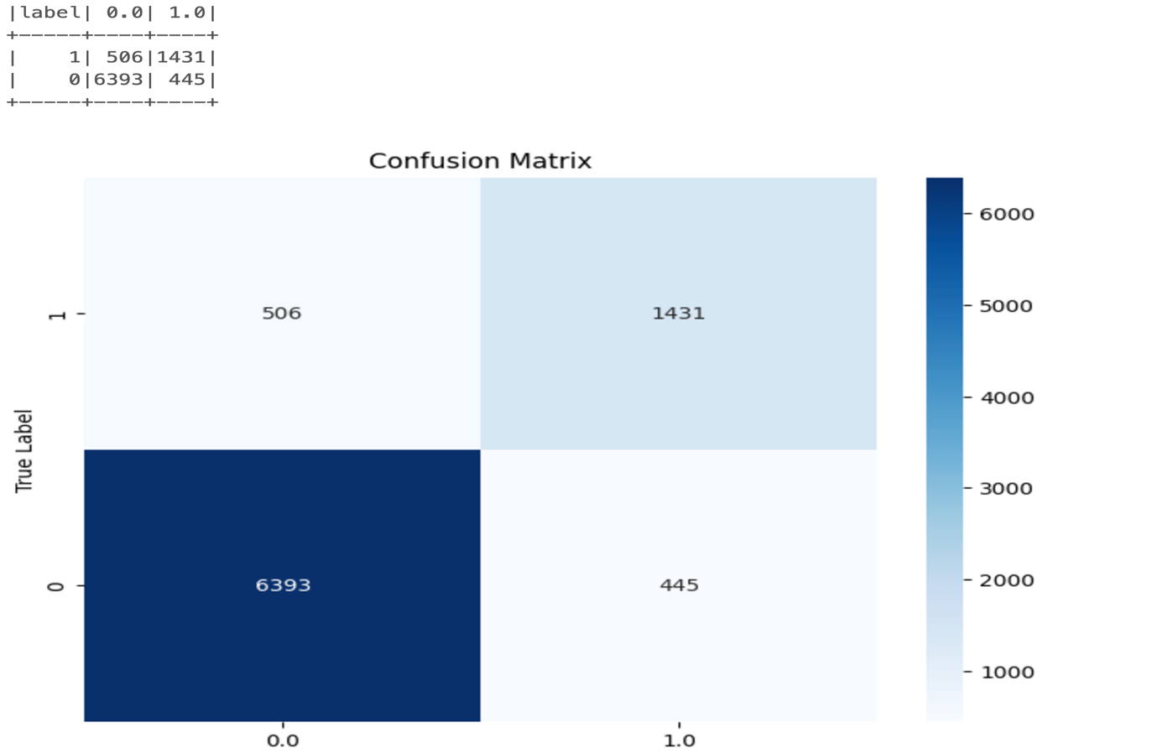

Data Analytics 2 – Random Forest
- Achieved accuracy of 93%
- Feature importance identified previous_loan_defaults,loan_percent_income ,loan_int_rate are most influential.
- True Positives (TP):1477 instances were correctly classified as 1 (approved loans).
- False Negatives (FN):460 instances of 1 (approved loans) were misclassified as 0 (rejected loans). This indicates the model is missing a significant portion of approved loans.
- True Negatives (TN):6,691 instances were correctly classified as 0 (rejected loans).
- False Positives (FP):147 instances of 0 (rejected loans) were misclassified as 1 (approved loans).
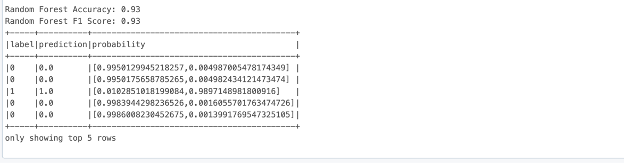
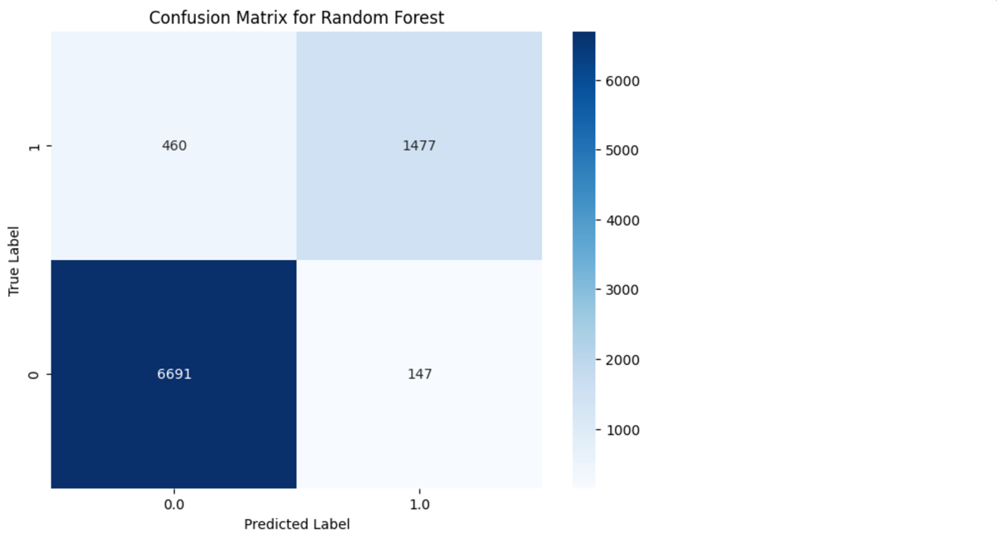

Findings
- Key Insights:
- loan_percent_income, loan_int_rate, and previous_loan_defaults_binary are critical drivers.
- Random Forest outperformed Logistic Regression with an accuracy of 93%
- Impact:
- Models provide a reliable basis for predicting loan approvals.
- Renters and applicants with education loans have slightly higher rejection rates.

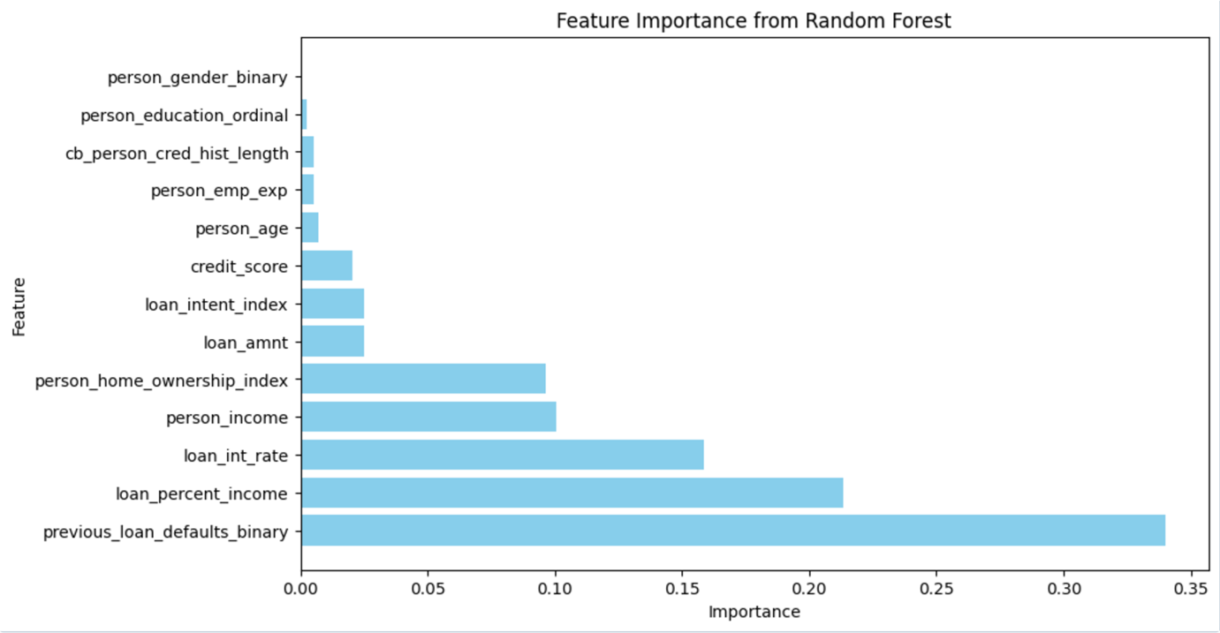
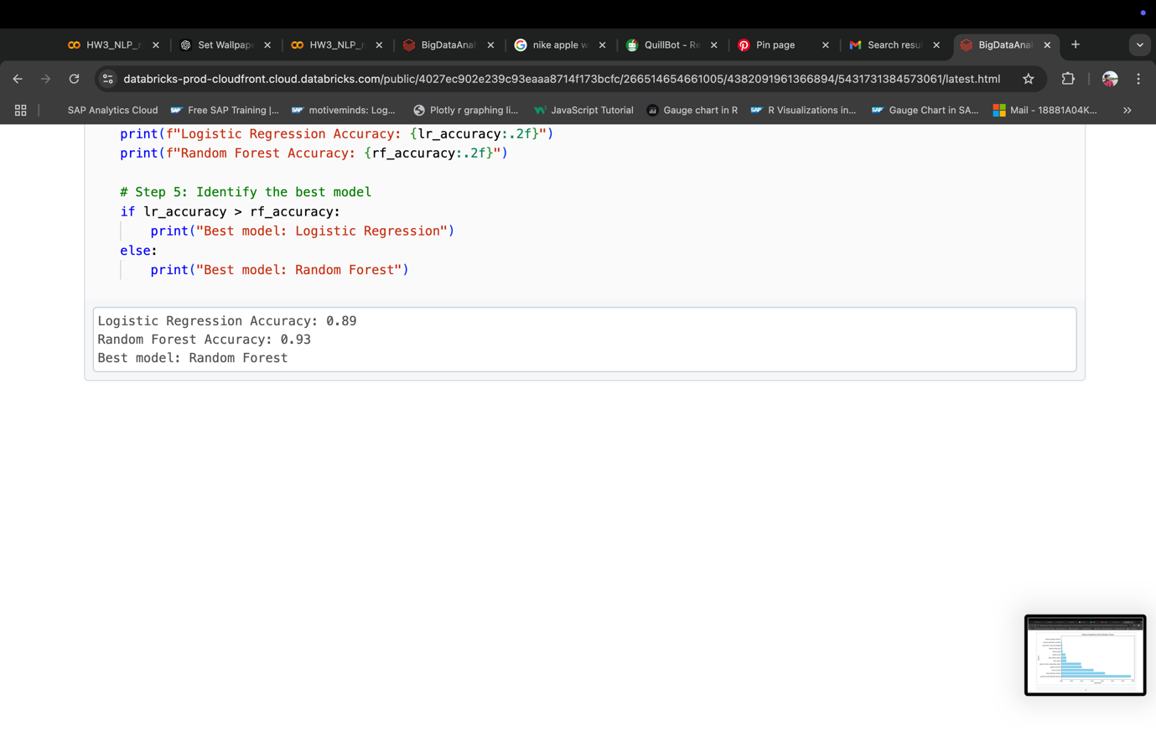

Business Implications/Intelligence
Actionable Recommendations:
- Focus on applicants with high loan_percent_income for targeted loan offers.
- Reduce risk by closely evaluating applicants with previous_loan_defaults_binary = 1.
- Optimize loan approval processes using model classifications.
Potential Benefits:
- Increase approval efficiency.
- Income and Credit History are key predictors of loan approval; prioritize these factors in decision-making
- Employment Status and Education Level should be factored into loan decisions for improved applicant profiling
- Implement strategies to assist borrowers with prior defaults in improving creditworthiness.
- Target educational programs to improve financial literacy among potential applicants.

Conclusion:
- The project successfully identified key factors influencing loan approvals.
- Random forest emerged as the best predictive model with 93% accuracy.
- Insights can guide policy adjustments and targeted customer support
Future Work:
- Experiment with other advanced models (e.g., Gradient Boosting).
- Gather additional data to improve model accuracy further

References
- https://www.kaggle.com/datasets/taweilo/loan-approval-classification-data
- https://www.incharge.org/blog/what-affects-your-ability-to-get-a-home-loan/
- Han, J., Kamber, M., & Pei, J. (2011). Data mining: Concepts and techniques (3rd ed.). Morgan Kaufmann

Appendix

