# 第一次作业

**上机作业1**

1. 代码：

syms x;

f = sin(sin(x))/x - 1;

limit(f,x,0)

结果：

ans = 0

1. 代码：

syms n;

f = (tan(pi/4+1/n))^n;

limit(f,n,inf)

结果：

ans = exp(2)

1. 代码：

syms x;

f = 1/(1+exp(1/(x-1)));

limit(f,x,1,'left') %1-

limit(f,x,1,'right') %1+

结果：

当x-> $1^{-}$,ans = 1

当x-> $1^{+}$,ans = 0

**上机作业2**

（注：用y替代ρ，x替代θ；）

代码：

x = 0:0.01:2*pi;

y = 3*cos(3*x);

plot(x, y);

title('y = 3*cos(3x)');

xlabel('x');

ylabel('y');

grid on;

结果如图所示：



x范围为：[0,2*pi];

1. 代码：

t = 0:0.01:2*pi;

x = 2 * (t + sin(t));

y = 2 * (cos(t) - 1);

plot(x,y);

title('x = 2(t+sin(t)), y = 2(cos(t)-1)');

grid on;

结果如图：



t范围：[0.2*pi];

1. 代码：

x = -20:0.01:20;

y = (x.^2).^(1/3);

plot(x,y);

title('y = x^(2/3)');

xlabel('x');

ylabel('y');

grid on;

结果：



x范围：[-20，20];

1. 代码：

x = -10:0.01:10;

y = x.*sin(x);

plot(x,y);

xlabel('x');

ylabel('y');

title('y=x*sin(x)');

grid on;



x范围：[-10,10];

**上机作业3**

1. 代码：

syms x;

f = sin(x);

y = taylor(f, 'Order', 3);

x_val = deg2rad(3);

value = subs(y, x, x_val);

sin_approx = double(value);

disp(['sin(3°) 的近似值为：', num2str(sin_approx)]);

结果：

sin(3°) 的近似值为：0.05236

1. 代码：

syms t a;

x = a*(t-sin(t));

y = a*(1-cos(t));

dx_dt = diff(x, t);

dy_dt = diff(y, t);

dy_dx = simplify(dy_dt / dx_dt);

ddx_dt = diff(dx_dt, t);

ddy_dt = diff(dy_dt, t);

ddy_dx_dx = simplify(ddy_dt / dx_dt);

disp(['dy/dx = ', char(dy_dx)]);

disp(['d^2(y)/dx^2 = ', char(ddy_dx_dx)]);

结果：

dy/dx = -sin(t)/(cos(t) - 1)

d^2(y)/dx^2 = -cos(t)/(cos(t) - 1)

1. 代码：

syms x y;

F = exp(y) + x*y - exp(x);

Fx = diff(F,x);

Fy = diff(F,y);

dy_dx = -Fx/Fy

结果：dy_dx = -(y - exp(x))/(x + exp(y))

**上机作业4**

1. 代码：

syms x C;

y1 = x^3*exp(-x^2);

ans1 = int(y1) + C

y2 = 1/(x*(x^2+1)^(1/2));

ans2 = int(y2) + C

结果：

ans 1 = C - (exp(-x^2)*(x^2 + 1))/2

ans2 = C - atanh((x^2 + 1)^(1/2))

2、代码：

syms x;

y1 = x/((sin(x))^2);

ans1 = int(y1,x,pi/3,pi/4)

y2 = (sin(x))^4*(cos(x))^2;

ans2 = int(y2,x,pi/2,0)

结果：

ans1 = (pi*3^(1/2))/9 - log((2^(1/2)*3^(1/2))/2) - pi/4

ans2 = -pi/32

3、代码：

syms x;

f = 3 - x^2;

g = 2*x;

pubpoints = solve(f == g, x);

x1 = min(pubpoints);

x2 = max(pubpoints);

area = abs(int(f - g, x, x1, x2));

disp(['两条曲线所围成图形的面积为：', char(area)]);

结果：

两条曲线所围成图形的面积为：32/3

4、代码：

syms x;

f = x*(sin(x))^2;

V_x = pi * int(f^2, x, 0, pi);

V_y = 2*pi*int(f,x,0,pi);

disp(['绕x轴立体的体积为：', char(V_x)]);

disp(['绕y轴立体的体积为：', char(V_y)]);

结果：

绕x轴立体的体积为：(pi^2*(8*pi^2 - 15))/64

绕y轴立体的体积为：pi^3/2

# 第二次作业

**上机作业1**

1、代码：  
 [x, y] = meshgrid(linspace(-5, 5, 50));

z = sqrt(x.^2 - y.^2);

z(imag(z) ~= 0) = NaN;

figure;

surf(x, y, real(z), 'FaceAlpha', 0.9, 'EdgeColor', 'k');

hold on;

surf(x, y, -real(z), 'FaceAlpha', 0.9, 'EdgeColor', 'k');

xlabel('x');

ylabel('y');

zlabel('z');

title('z^2 = x^2 - y^2 的图形');

view(3);

grid on;

axis equal;

hold off;

运行结果：

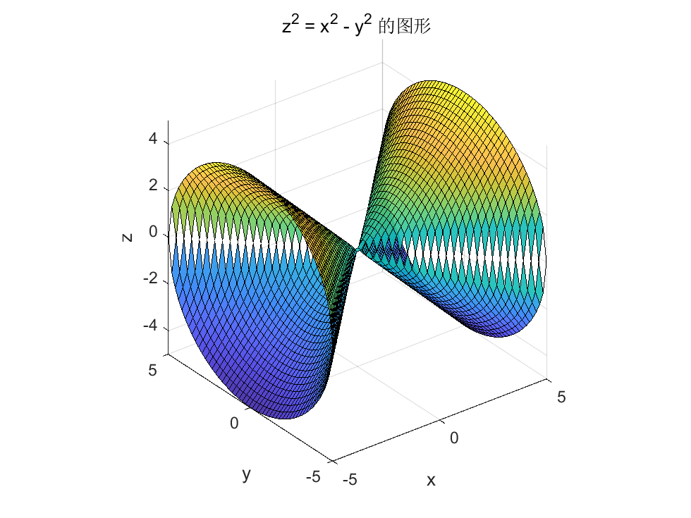

注：x:[-5,5] y:[-5,5]

1. 代码：

v = 0:0.01:2*pi;

x = 2*cos(v);

y = 2*sin(v);

z = 3*v;

plot3(x,y,z);

xlabel('x');

ylabel('y');

zlabel('z');

运行结果：

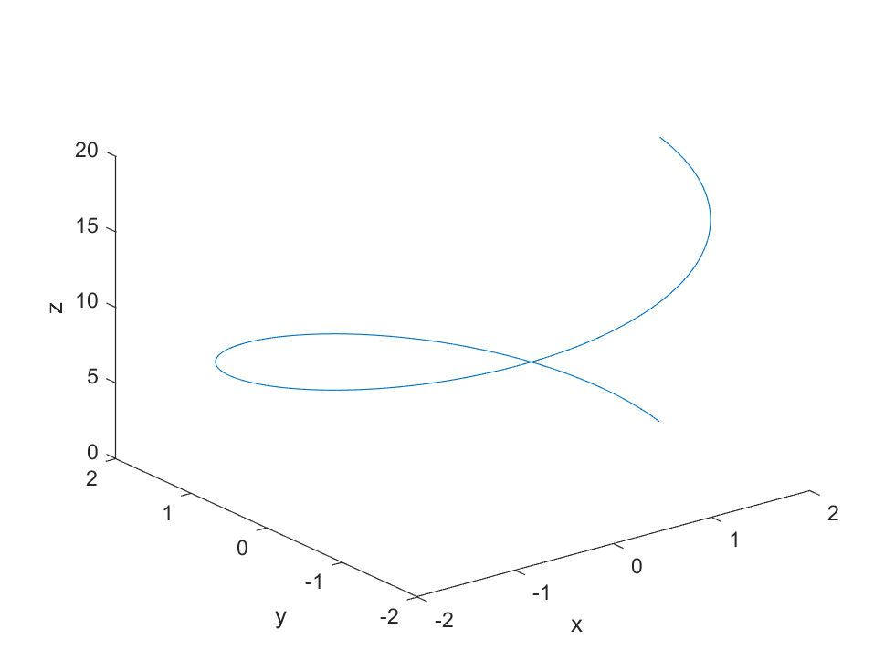

1. 代码：

[X, Y] = meshgrid(-5:0.1:5, -5:0.1:5);

k_values = [1, 10, -10];

colors = {'c', [1, 0.5, 0], 'b'};

figure;

hold on;

for i = 1:length(k_values)

k = k_values(i);

Z = X.^2 + Y.^2 + k*X.*Y;

surf(X, Y, Z, 'FaceAlpha', 0.5, 'EdgeColor', 'none', 'FaceColor', colors{i});

end

hold off;

xlabel('x');

ylabel('y');

zlabel('z');

legend('z = x^2 + y^2 + 1xy', 'z = x^2 + y^2 + 10xy', 'z = x^2 + y^2 + -10xy');

title('曲面：z=x^2+y^2+kxy对不同的k值');

view(3);

grid on;

运行结果：

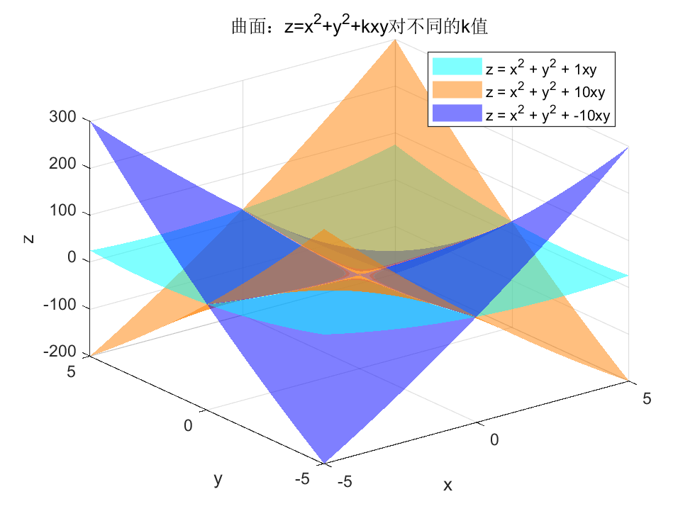

1. 代码：

x = -4:0.1:4;

y = -4:0.1:4;

[mx,my] = meshgrid(x,y);

mz = mx.^2 - my.^2;

mesh(mx,my,mz)

box on;

z1 = mx(my==1).^2 - my(my==1).^2;

hold on;

plot3(mx(my==1),my(my==1),z1,'r*-')

运行结果：

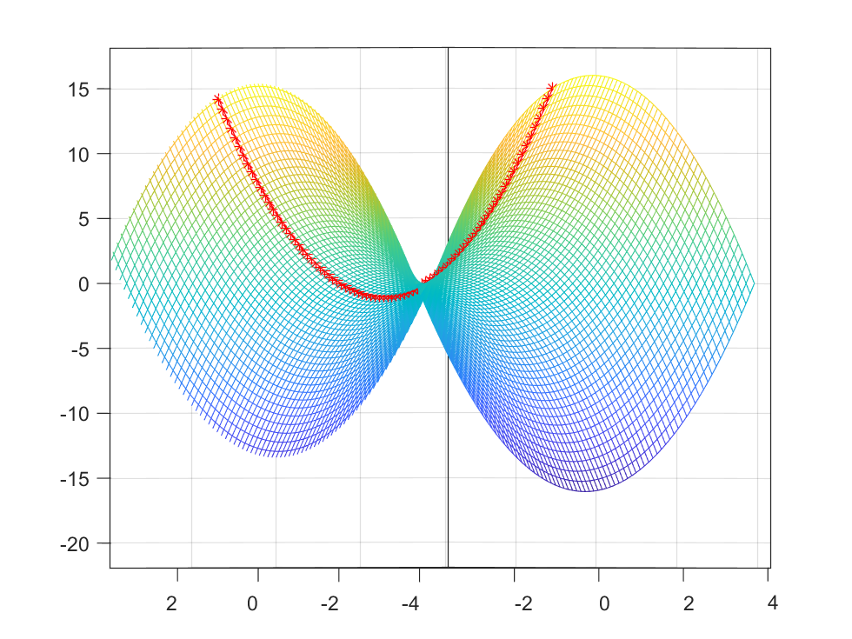

**上机作业2**

1. 代码：

syms x y z;

z = sqrt(x^2 + y^2);

% 求一阶偏导数

dz_dx = diff(z, x);

dz_dy = diff(z, y);

% 求全微分

syms dx dy;

dz = dz_dx*dx + dz_dy*dy;

disp(['全微分 dz= ', char(dz)]);

% 求二阶偏导数

d2z_dx2 = diff(dz_dx, x);

d2z_dy2 = diff(dz_dy, y);

d2z_dxdy = diff(dz_dx, y);

disp(['二阶偏导数 d^2z/dx^2: ', char(d2z_dx2)]);

disp(['二阶偏导数 d^2z/dy^2: ', char(d2z_dy2)]);

disp(['二阶偏导数 d^2z/dxdy: ', char(d2z_dxdy)]);

运行结果：

全微分 dz= (dx*x)/(x^2 + y^2)^(1/2) + (dy*y)/(x^2 + y^2)^(1/2)

二阶偏导数 d^2z/dx^2: 1/(x^2 + y^2)^(1/2) - x^2/(x^2 + y^2)^(3/2)

二阶偏导数 d^2z/dy^2: 1/(x^2 + y^2)^(1/2) - y^2/(x^2 + y^2)^(3/2)

二阶偏导数 d^2z/dxdy: -(x*y)/(x^2 + y^2)^(3/2)

1. 代码：

syms x y

f = x^4 - 8*x*y + 2*y^2 - 3;

df_dx = diff(f, x);

df_dy = diff(f, y);

% 求解偏导数为0的方程组，找到驻点

sols = solve([df_dx == 0, df_dy == 0], [x, y]);

d2f_dx2 = diff(df_dx, x);

d2f_dy2 = diff(df_dy, y);

d2f_dxdy = diff(df_dx, y);

% 遍历驻点，计算二阶偏导数并判断极值类型

for i = 1:length(sols.x)

x_val = double(sols.x(i));

y_val = double(sols.y(i));

d2f_dx2_val = double(subs(d2f_dx2, [x, y], [x_val, y_val]));

d2f_dy2_val = double(subs(d2f_dy2, [x, y], [x_val, y_val]));

d2f_dxdy_val = double(subs(d2f_dxdy, [x, y], [x_val, y_val]));

H = [d2f_dx2_val, d2f_dxdy_val; d2f_dxdy_val, d2f_dy2_val];

det_H = det(H);

if det_H > 0

if d2f_dx2_val > 0

f_val = double(subs(f, [x, y], [x_val, y_val]));

disp(['极小值点为 (', num2str(x_val), ', ', num2str(y_val), ')，极小值为 ', num2str(f_val)]);

else

f_val = double(subs(f, [x, y], [x_val, y_val]));

disp(['极大值点为 (', num2str(x_val), ', ', num2str(y_val), ')，极大值为 ', num2str(f_val)]);

end

end

end

运行结果：

极小值点为 (-2, -4)，极小值为 -19

极小值点为 (2, 4)，极小值为 -19

**上机作业3**

1. 代码：

syms x y

f = x^2 + y^2;

result = int(int(f, x, 0, 1-y), y, 0, 1)

ans1 = 4 * result;

disp("结果为：");

disp(ans1);

运行结果：

结果为：

2/3

1. 代码：

syms a b r

f = r^4 * (sin(b))^3;

int(int(int(f,r,1,2),b,0,pi/2),a,0,2*pi)

运行结果为：

(124*pi)/15