Mark Witt

CSD-310

Assignment 4.2

Initial load of MySQL Client:

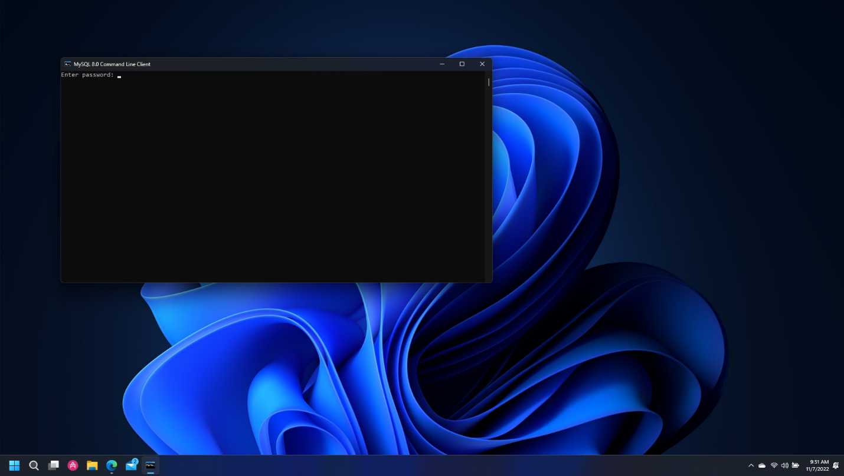

Create csd310 database and show databases:

