Mark Witt

CSD-310

Assignment 5.2

The first SQL method/function I chose was LocalTimeStamp, which returns the current date and time. This could be useful for attaching a date and time stamp to many different types of data, such as changes made to the database, or user login’s to keep track of attendance of remote workers. An appropriate alias/column header could be “Current Date/Time”

Syntax:

SELECT LOCALTIMESTAMP() as ‘Current Date/Time’;

Results:

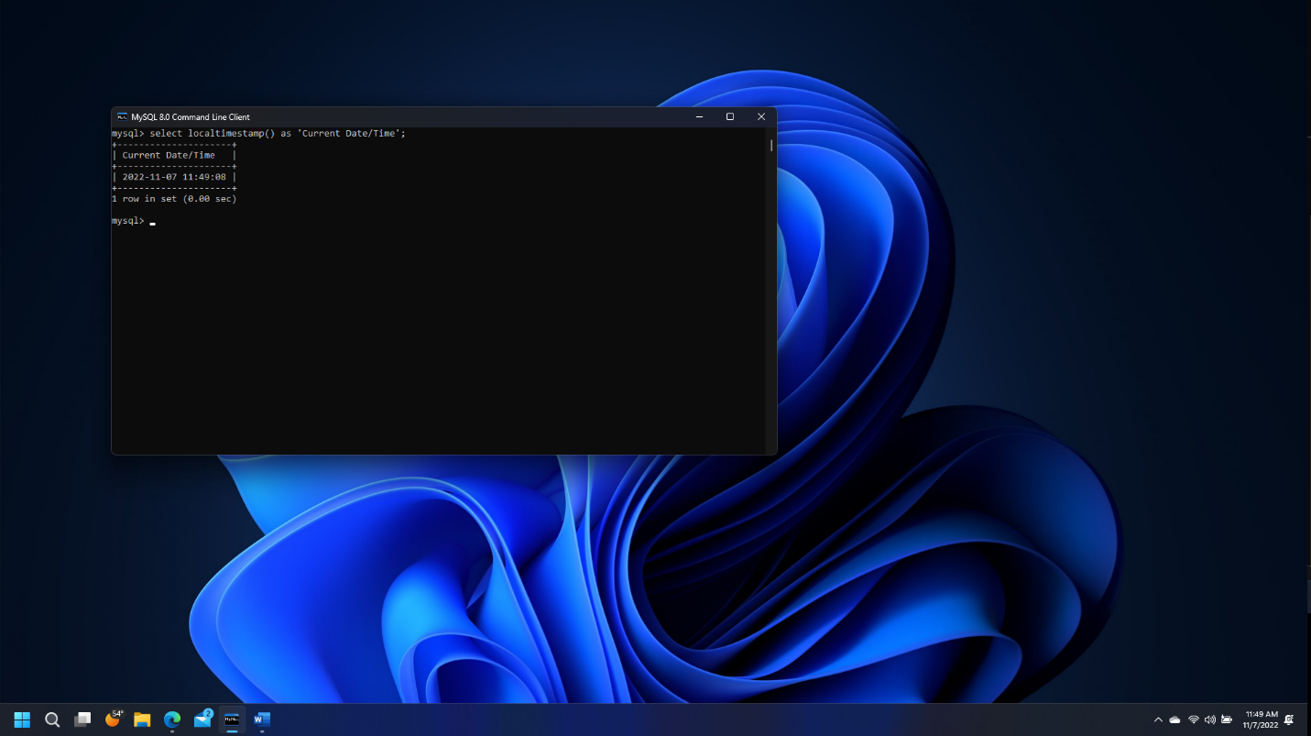

The second method/function chosen was DateFormat. This function returns a date or time value and allows for customized formatting of the output. This could be used to return a wide combination of formatting for dates and times, such as “Monday November 7, 2022” or however the user wants to format the date/time data. This can make the returned data displayed in a more user-friendly format. An appropriate alias/column naming for this could be “Formatted Date/Time”.

Syntax used:

select date_format(localtimestamp(), "%a, %b %D, %Y, %h:%i %p") as 'Formatted Current Date';

Results:

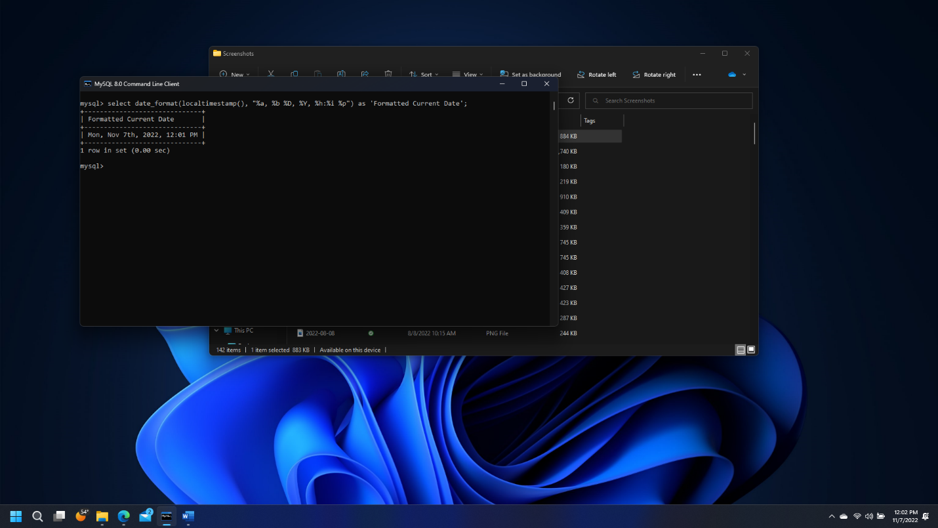

The third method/function chosen was TRUNCATE. Following in a similar thought process of the date/time formatting, this function allows for the user to dictate the number of decimal places displayed on the returned numerical data. The difference with this method is that the returned value is not rounded to the nearest specified decimal place, but merely limited on how many decimal places are displayed. If one wanted to have the returned value rounded, they could use the ROUND() function instead. An appropriate alias/column name could be “Truncated Result”.

Syntax:

Select truncate(pi(), 12);

Note: this returns the value of pi using the pi function, and truncates to 12 decimal places. Inherently SQL only holds 15 decimal places of pi, which is shown in the second command in the screenshot:

Select truncate(pi(), 100);

Results:

