Strategic Goal: Position reputation as a dynamic asset that requires intentional design to secure a legacy.
- Primary Header: Your Reputation is Your Greatest Asset. Build the Influence (A Personal Brand) That Opens Doors.
- Sub-header: Strategic Authority and Reputation Management for Global Leaders Who Value Authenticity (and Impact?) as Much as Results.
- Hero Body Copy: You’re a decisive doer and thoughtful leader who’s made great strides in your career. But in a world increasingly shaped by AI and digital noise, your voice can get lost in the shuffle. I help global executives transition from being "highly skilled" to becoming trusted influencers (should we say influence instead? The word influencer just doesn’t sound appropriate for the target) who lead with both authority and heart.
- The LIDA360 Framework (Replacing automotive icons):
  - Executive Branding: Architect a brand DNA that commands respect and opens doors to elite opportunities.
  - Reputation Recovery: Protect your professional capital. Move from crisis to control with a confidential, high-stakes strategy.
  - The Human Advantage (Speaking): Equip your organization with the frameworks for authentic influence that technology cannot replicate.
- Primary CTA: [Button] Secure Your Strategic Authority (Work With Lida)
- Missing from current site:
It’s time for a new career strategy
One that plays to your strengths, aligns with your values, and puts you in control of your destiny.
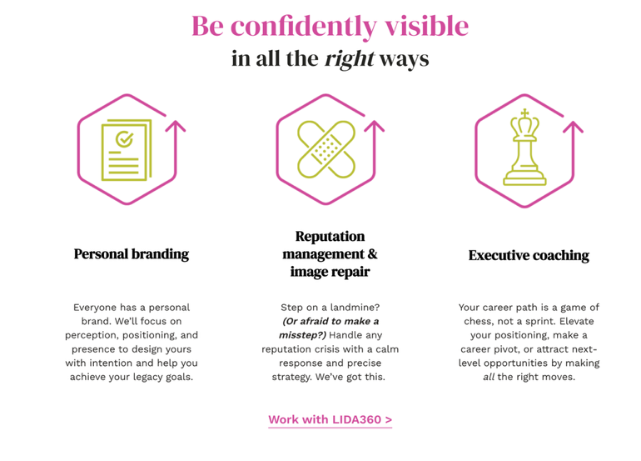
** change to: Executive Coaching, Speaking, Podcast

I’m Lida Citroën, executive coach, personal branding expert, influence builder, and reputation management pro.
For 20+ years, I’ve helped hundreds of global executives, entrepreneurs, and thought leaders like you impact the way they’re perceived by the people who matter to them.
A published author (7x), TEDx speaker, and LinkedIn Learning instructor, I’m also a trusted consultant to clients like Google, Disney, and SiriusXM.
Making a meaningful, lasting difference is my mission. I live my values and am passionate about giving back to military veterans transitioning to civilian life and work.
Read more about my values and approach >
Make your next move a strategic one.
Let’s explore your goals, and see if we’re a fit. From there, we’ll schedule a consultation. Ready to get started?
Get in touch >
Create your personal brand on purpose, with purpose.
Get my best tips, insights, and resources on managing your personal brand and reputation, delivered straight to your inbox monthly. (link goes to newsletter signup)

